UNITED STATES
SECURITIES AND EXCHANGE COMMISSION
Washington, DC 20549
__________________________________________________________________
FORM 10-K
__________________________________________________________________
(Mark One)
x |  |  | ANNUAL REPORT UNDER SECTION 13 OR 15(d) OF THE SECURITIES EXCHANGE ACT OF 1934
For the fiscal year ended September 30, 2023.
o |  |  | TRANSITION REPORT UNDER SECTION 13 OR 15(d) OF THE SECURITIES EXCHANGE ACT OF 1934
For the transition period from to
Commission file number 001-38042
__________________________________________________________________
ARROWHEAD PHARMACEUTICALS, INC.
(Exact name of registrant as specified in its charter)
__________________________________________________________________
Delaware |  |  | 46-0408024
(State or other jurisdiction of incorporation or organization) |  |  | (I.R.S. Employer Identification No.)
(626) 304-3400
177 E. Colorado Blvd, Suite 700
Pasadena, California 91105
(Address and telephone number of principal executive offices)
__________________________________________________________________
Securities registered pursuant to Section 12(b) of the Exchange Act:
Title of each class |  |  | Trading Symbol(s) |  |  | Name of each exchange on which registered
Common Stock, $0.001 par value |  |  | ARWR |  |  | The Nasdaq Global Select Market
Securities registered pursuant to Section 12(g) of the Exchange Act: None
Indicate by a check mark if the registrant is a well-known seasoned issuer, as defined in Rule 405 of the Securities Act. Yes x No o
Indicate by a check mark if the registrant is not required to file reports pursuant to Section 13 or 15(d) of the Act. Yes o No x
Indicate by check mark whether the registrant (1) has filed all reports required to be filed by Section 13 or 15(d) of the Securities Exchange Act of 1934 during the preceding 12 months (or for such shorter period that the registrant was required to file such reports), and (2) has been subject to such filing requirements for the past 90 days. Yes x No o
Indicate by check mark whether the registrant has submitted electronically every Interactive Data File required to be submitted pursuant to Rule 405 of Regulation S-T (§ 232.405 of this chapter) during the preceding 12 months (or for such shorter period that the registrant was required to submit such files). Yes x No o
Indicate by check mark whether the registrant is a large accelerated filer, an accelerated filer, a non-accelerated filer, a smaller reporting company, or an emerging growth company. See the definitions of “large accelerated filer,” “accelerated filer,” “smaller reporting company” and “emerging growth company” in Rule 12b-2 of the Exchange Act.
Large accelerated filer |  |  | x |  |  |  |  |  | Accelerated filer |  |  | o |  |  |  |  |  | Non-accelerated filer |  |  | o |  |  |  |  |  | Smaller reporting company |  |  | o
Emerging growth company |  |  | o
If an emerging growth company, indicate by check mark if the registrant has elected not to use the extended transition period for complying with any new or revised financial accounting standards provided pursuant to Section 13(a) of the Exchange Act. o
Indicate by check mark whether the registrant has filed a report on and attestation to its management’s assessment of the effectiveness of its internal control over financial reporting under Section 404(b) of the Sarbanes-Oxley Act (15 U.S.C. 7262(b)) by the registered public accounting firm that prepared or issued its audit report. x
Indicate by check mark whether the registrant is a shell company (as defined in Rule 12b-2 of the Act). Yes o No x
If securities are registered pursuant to Section 12(b) of the Act, indicate by check mark whether the financial statements of the registrant included in the filing reflect the correction of an error to previously issued financial statements. ☐

Indicate by check mark whether any of those error corrections are restatements that required a recovery analysis of incentive-based compensation received by any of the registrant’s executive officers during the relevant recovery period pursuant to §240.10D-1(b). ☐
The aggregate market value of issuer’s voting and non-voting outstanding common stock held by non-affiliates was approximately $2.3 billion based upon the closing stock price of issuer’s common stock on March 31, 2023. Shares of common stock held by each officer and director and by each person who is known to own 10% or more of the outstanding common stock have been excluded in that such persons may be deemed to be affiliates of the Company. This determination of affiliate status is not necessarily a conclusive determination for other purposes.
As of November 20, 2023, 107,432,210 shares of the issuer’s Common Stock were issued and outstanding.

DOCUMENTS INCORPORATED BY REFERENCE
Portions of the Definitive Proxy Statement to be filed for Arrowhead Pharmaceuticals Inc.’s 2024 Annual Meeting of Stockholders are incorporated by reference into Part III hereof.

PART I
ITEM 1. |  |  | BUSINESS |  |  | 1
ITEM 1A. |  |  | RISK FACTORS |  |  | 33
ITEM 1B. |  |  | UNRESOLVED STAFF COMMENTS |  |  | 56
ITEM 2. |  |  | PROPERTIES |  |  | 56
ITEM 3. |  |  | LEGAL PROCEEDINGS |  |  | 56
ITEM 4. |  |  | MINE SAFETY DISCLOSURES |  |  | 56
PART II
ITEM 5. |  |  | MARKET FOR THE REGISTRANT’S COMMON EQUITY, RELATED STOCKHOLDER MATTERS AND ISSUER PURCHASES OF EQUITY SECURITIES |  |  | 57
ITEM 6. |  |  | Reserved |  |  | 58
ITEM 7. |  |  | MANAGEMENT’S DISCUSSION AND ANALYSIS OF FINANCIAL CONDITION AND RESULTS OF OPERATIONS |  |  | 58
ITEM 7A. |  |  | QUANTITATIVE AND QUALITATIVE DISCLOSURES ABOUT MARKET RISK |  |  | 69
ITEM 8. |  |  | FINANCIAL STATEMENTS AND SUPPLEMENTARY DATA |  |  | 69
ITEM 9. |  |  | CHANGES IN AND DISAGREEMENTS WITH ACCOUNTANTS ON ACCOUNTING AND FINANCIAL DISCLOSURE |  |  | 69
ITEM 9A. |  |  | CONTROLS AND PROCEDURES |  |  | 70
ITEM 9B. |  |  | OTHER INFORMATION |  |  | 71
ITEM 9C. |  |  | DISCLOSURE REGARDING FOREIGN JURISDICTIONS THAT PREVENT INSPECTIONS |  |  | 71
PART III
ITEM 10. |  |  | DIRECTORS, EXECUTIVE OFFICERS, AND CORPORATE GOVERNANCE |  |  | 71
ITEM 11. |  |  | EXECUTIVE COMPENSATION |  |  | 71
ITEM 12. |  |  | SECURITY OWNERSHIP OF CERTAIN BENEFICIAL OWNERS AND MANAGEMENT AND RELATED STOCKHOLDER MATTERS |  |  | 71
ITEM 13. |  |  | CERTAIN RELATIONSHIPS, RELATED TRANSACTIONS AND DIRECTORS INDEPENDENCE |  |  | 71
ITEM 14. |  |  | PRINCIPAL ACCOUNTANT FEES AND SERVICES |  |  | 72
PART IV
ITEM 15. |  |  | EXHIBITS AND FINANCIAL STATEMENT SCHEDULES |  |  | 72
ITEM 16. |  |  | FORM 10-K SUMMARY |  |  | 75
SIGNATURE
INDEX TO FINANCIAL STATEMENTS AND SCHEDULES |  |  |  |  |  | F-1

FORWARD-LOOKING STATEMENTS
This Annual Report on Form 10-K contains certain forward-looking statements within the meaning of Section 27A of the Securities Act of 1933, as amended, and Section 21E of the Securities Exchange Act of 1934, as amended, and we intend that such forward-looking statements be subject to the safe harbors created thereby. For this purpose, any statements contained in this Annual Report on Form 10-K except for historical information may be deemed to be forward-looking statements. Without limiting the generality of the foregoing, words such as “may,” “will,” “expect,” “believe,” “anticipate,” “goal,” “endeavor,” “strive,” “intend,” “plan,” “project,” “could,” “estimate,” “target,” “forecast,” or “continue” or the negative of these words or other variations thereof or comparable terminology are intended to identify forward-looking statements. In addition, any statements that refer to projections of our future financial performance, trends in our business, or other characterizations of future events or circumstances are forward-looking statements. These forward-looking statements include, but are not limited to, statements about the initiation, timing, progress and results of our preclinical studies and clinical trials, our research and development programs, and our “20 in 25” pipeline goal; our expectations regarding the potential benefits of the partnership, licensing and/or collaboration arrangements and other strategic arrangements and transactions we have entered into or may enter into in the future; our beliefs and expectations regarding the amount and timing of future milestone, royalty or other payments that could be due to or from third parties under existing agreements; and our estimates regarding future revenues, research and development expenses, capital requirements and payments to third parties.
The forward-looking statements included herein are based on current expectations of our management based on available information and involve a number of risks and uncertainties, all of which are difficult or impossible to predict accurately, and many of which are beyond our control. As such, our actual results and timing of certain events may differ materially from the results discussed, projected, anticipated or indicated in any forward-looking statements. Forward-looking statements are not guarantees of future performance and our actual results of operations, financial condition and cash flows may differ materially. Factors that may cause or contribute to such differences include, but are not limited to, those discussed in more detail in “Item 1. Business” and “Item 1A. Risk Factors” of Part I and “Item 7. Management’s Discussion and Analysis of Financial Condition and Results of Operations” of Part II of this Annual Report on Form 10-K. Readers should carefully review these risks, as well as the additional risks described in other documents we file from time to time with the Securities and Exchange Commission (the “SEC”). In light of the significant risks and uncertainties inherent in the forward-looking information included herein, the inclusion of such information should not be regarded as a representation by us or any other person that such results will be achieved, and readers are cautioned not to place undue reliance on such forward-looking information. Statements made herein are as of the date of the filing of this Annual Report on Form 10-K with the SEC and should not be relied upon as of any subsequent date. Except as may be required by law, we disclaim any intent to revise the forward-looking statements contained herein to reflect events or circumstances after the date hereof or to reflect the occurrence of unanticipated events.

PART I
Unless otherwise noted, (1) the term “Arrowhead” refers to Arrowhead Pharmaceuticals, Inc., a Delaware corporation and its Subsidiaries, (2) the terms “Company,” “we,” “us,” and “our,” refer to the ongoing business operations of Arrowhead and its Subsidiaries, whether conducted through Arrowhead or a subsidiary of Arrowhead, (3) the term “Subsidiaries” refers to Arrowhead Madison Inc. (“Arrowhead Madison”), Arrowhead Australia Pty Ltd (“Arrowhead Australia”), and Visirna Therapeutics Inc. (“Visirna”) (4) the term “common stock” refers to Arrowhead’s common stock, (5) the term “preferred stock” refers to Arrowhead’s preferred stock and (6) the term “stockholder(s)” refers to the holders of Arrowhead common stock.

ITEM 1.BUSINESS
Overview
The Company develops medicines that treat intractable diseases by silencing the genes that cause them. Using a broad portfolio of RNA chemistries and efficient modes of delivery, the Company’s therapies trigger the RNA interference mechanism to induce rapid, deep and durable knockdown of target genes.
The Company’s pipeline of 14 clinical stage investigational medicines range in development stage from Phase 1 to Phase 3. In addition, the Company has a robust discovery stage pipeline which is capable of generating multiple new clinical candidates each year.
“20 in 25” Pipeline Development Strategy
The Company believes that there is no shortage of need that it can endeavor to serve and no shortage of lives that potentially can be touched by the versatility of RNAi technology. The Company endeavors to serve unmet needs and change lives leveraging the versatility of RNAi technology. The Company is acutely aware of the urgent need to develop solutions for the many diseases that have genetic targets that are otherwise undruggable by small molecules or biologics. To that end, the Company embraced its bold goal and strives to have 20 individual drugs, either partnered or wholly owned, in clinical trials or on the market in 2025.
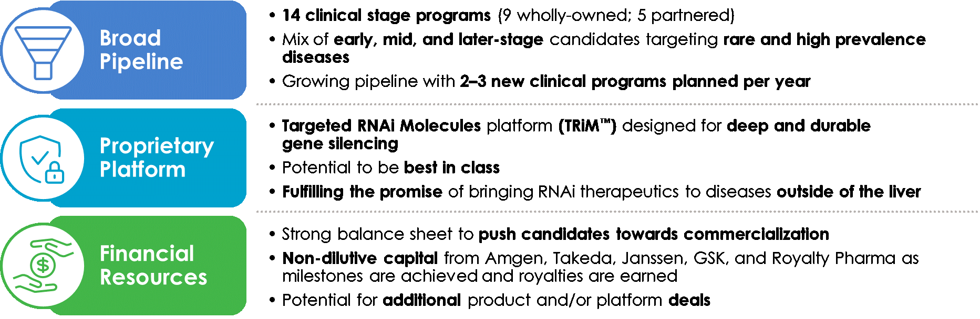
RNA Interference and the Benefits of RNAi Therapeutics
RNA interference (“RNAi”) is a mechanism present in living cells that inhibits the expression of a specific gene, thereby affecting the production of a specific protein. RNAi-based therapeutics may leverage this natural pathway of gene silencing to target and shut down specific disease-causing genes.
Small molecule and antibody drugs have proven effective at inhibiting certain cell surface, intracellular, and extracellular targets. However, other drug targets have proven difficult to inhibit with traditional drug-based and biologic therapeutics. Developing effective drugs for these targets would have the potential to address large underserved markets for the treatment of many diseases. Using the ability to specifically silence any gene, RNAi therapeutics may be able to address previously “undruggable” targets, unlocking the market potential of such targets.
1

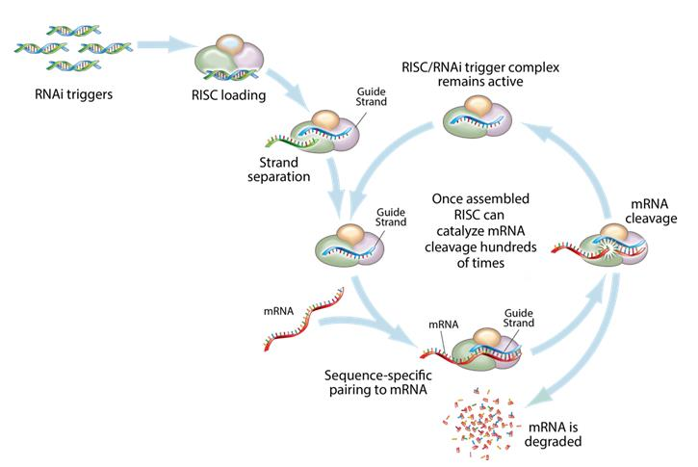
This figure depicts the mechanism by which gene silencing occurs. Double stranded RNAi triggers are introduced into a cell and are loaded into the RNA-induced silencing complex, (“RISC”). The strands are then separated, leaving an active RISC/RNAi trigger complex. This complex can then pair with and degrade the complementary messenger RNAs (“mRNA”) and stop the production of the target proteins. RNAi is a catalytic process, so each RNAi trigger can degrade mRNA hundreds of times, which results in a relatively long duration of effect for RNAi therapeutics.
Key Benefits of RNAi as a Therapeutic Modality
•Silences the expression of disease associated genes;
•Potential to address any target in the transcriptome including previously “undruggable” targets;
•Rapid lead identification;
•High specificity;
•Opportunity to use multiple RNA sequences in one drug product for synergistic silencing of related targets; and
•RNAi therapeutics are uniquely suited for personalized medicine through target and cell specific delivery and gene knockdown.
Targeted RNAi Molecule (TRiMTM) Platform
The Company’s Targeted RNAi Molecule (TRiMTM) platform utilizes ligand-mediated delivery and is designed to enable tissue-specific targeting while being structurally simple. Targeting has been core to the Company’s development philosophy and the TRiMTM platform builds on more than a decade of work on actively targeted drug delivery vehicles. The Company’s scientists have discovered ways to progressively “TRiM” away extraneous features and chemistries and retain optimal pharmacologic activity.
The TRiMTM platform is comprised of a highly potent RNA trigger identified using the Company’s proprietary trigger selection rules and algorithms with the following components optimized, as needed, for each drug candidate: a high affinity targeting ligand; various linker and chemistries; structures that enhance pharmacokinetics; and highly potent RNAi triggers with sequence specific stabilization chemistries.
Therapeutics developed with the TRiMTM platform offer several advantages: simplified manufacturing and reduced costs; multiple routes of administration; and potential for improved safety because there are less metabolites from smaller molecules, thereby reducing the risk of intracellular buildup. The Company also believes that for RNAi to reach its true potential, it must target organs outside the liver. The Company is leading this expansion with the TRiMTM platform, which has shown the potential to reach multiple tissues, including liver, lung, central nervous system (CNS), muscle, and adipose tissue.

2

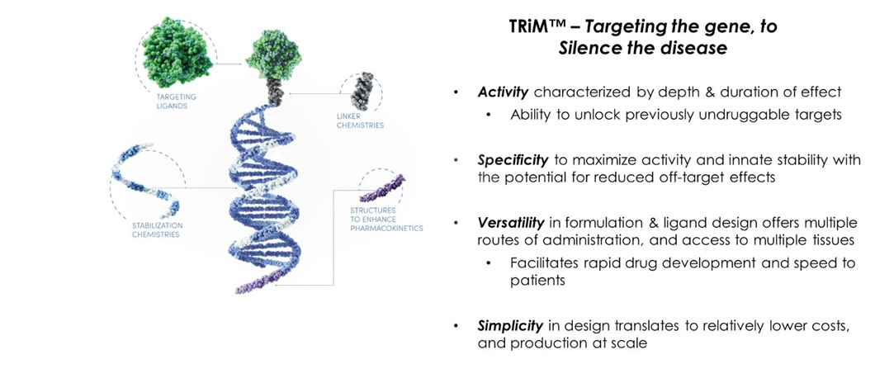
RNA Chemistries
The structure and chemistries of the oligonucleotide molecules used to trigger the RNAi mechanism can be tailored for optimal activity. The Company’s broad portfolio of RNA trigger structures and chemistries, including some proprietary structures, enable the Company to optimize each drug candidate on a target-by-target basis and utilize the combination of structure and chemical modifications that yield the most potent RNAi trigger.
As a component of the TRiMTM platform, the Company’s design philosophy for RNA chemical modifications is to start with a structurally simple molecule and add only selective modification and stabilization chemistries as necessary to achieve the desired level of target knockdown and duration of effect. The conceptual framework for the stabilization strategy starts with a more sophisticated RNAi trigger screening and selection process that identifies potent sequences rapidly in locations that others may miss.
Pipeline
The Company is focused on developing innovative drugs for diseases with a genetic basis, typically characterized by the overproduction of one or more proteins that are involved with disease. The depth and versatility of the Company’s RNAi technologies enables the Company to potentially address conditions in virtually any therapeutic area and pursue disease targets that are not otherwise addressable by small molecules and biologic. The Company is focused on bringing the promise of RNAi to address diseases outside of the liver, and its pipeline now includes disease targets in the liver, lung, muscle and CNS.

3

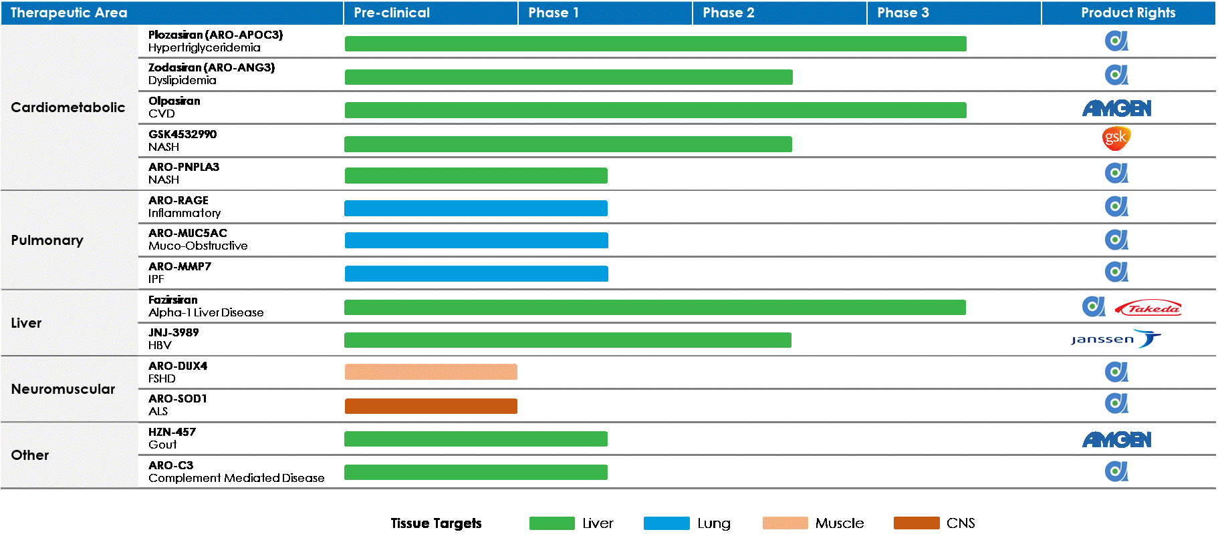
Plozasiran (ARO-APOC3)
Plozasiran (formerly ARO-APOC3) is designed to reduce production of Apolipoprotein C-III (apoC-III), a component of triglyceride rich lipoproteins (TRLs) including Very Low Density Lipoprotein (VLDL) and chylomicrons and a key regulator of triglyceride metabolism. The Company believes that knocking down the hepatic production of apoC-III may result in reduced VLDL synthesis and assembly, enhanced breakdown of TRLs, and better clearance of VLDL and chylomicron remnants. The Company is currently investigating plozasiran in two Phase 2b clinical trials, one Phase 3 clinical trial, and additional Phase 3 clinical trials on schedule to begin in 2024.
Hypertriglyceridemia: Elevated triglyceride levels are an independent risk factor for cardiovascular disease. Severely elevated triglycerides (often over 2,000 mg/dL) in patients with familial chylomicronemia syndrome (FCS), a rare genetic disorder, can result in potentially fatal acute pancreatitis.
Study Name: Study to Evaluate ARO-APOC3 in Adults With Severe Hypertriglyceridemia (SHASTA-2)
A Double-Blind, Placebo-Controlled Phase 2b Study to Evaluate the Efficacy and Safety of ARO-APOC3 in Adults With Severe Hypertriglyceridemia
ClinicalTrials.gov Identifier: NCT04720534
Study Name: Study of ARO-APOC3 in Adults With Mixed Dyslipidemia (MUIR)
A Double-Blind, Placebo-Controlled Phase 2b Study to Evaluate the Efficacy and Safety of ARO-APOC3 in Adults With Mixed Dyslipidemia
ClinicalTrials.gov Identifier: NCT04998201
Study Name: Study of ARO-APOC3 in Adults With FCS (PALISADE)
A Phase 3 Study to Evaluate the Efficacy and Safety of ARO-APOC3 in Adults With Familial Chylomicronemia Syndrome
ClinicalTrials.gov Identifier: NCT05089084
Zodasiran (ARO-ANG3)
Zodasiran (formerly ARO-ANG3) is designed to reduce production of angiopoietin-like protein 3 (ANGPTL3), a liver synthesized inhibitor of lipoprotein lipase and endothelial lipase. ANGPTL3 inhibition has been shown to lower serum LDL, serum and liver triglyceride and has genetic validation as a novel target for cardiovascular disease. The Company is currently investigating zodasiran in two Phase 2b clinical trials.
Dyslipidemia and Hypertriglyceridemia: Dyslipidemia and hypertriglyceridemia are risk factors for atherosclerotic coronary heart disease and cardiovascular events.
Study Name: Study of ARO-ANG3 in Adults With Mixed Dyslipidemia (ARCHES-2)
A Double-blind, Placebo-controlled Phase 2b Study to Evaluate the Efficacy and Safety of ARO-ANG3 in Adults With Mixed Dyslipidemia
ClinicalTrials.gov Identifier: NCT04832971
4

Study Name: Study of ARO-ANG3 in Participants With Homozygous Familial Hypercholesterolemia (HoFH) (GATEWAY)
Phase 2 Study to Evaluate the Safety and Efficacy of ARO-ANG3 in Subjects with Homozygous Familial Hypercholesterolemia (HoFH)
ClinicalTrials.gov Identifier: NCT05217667
ARO-PNPLA3
ARO-PNPLA3 (formerly JNJ-75220795) is an investigational RNAi therapeutic designed to reduce liver expression of patatin-like phospholipase domain containing 3 (PNPLA3) as a potential treatment for patients with non-alcoholic steatohepatitis (NASH). PNPLA3 has strong genetic and preclinical validation as a driver of fat accumulation and damage in the livers of patients who carry the common I148M mutation. Former licensee Janssen Pharmaceuticals, Inc. investigated ARO-PNPLA3 in two Phase 1 clinical trials and the Company is currently designing a Phase 2 clinical trial.
NASH: NASH is a subgroup of non-alcoholic fatty liver disease (NAFLD) in which hepatic cell injury and inflammation has developed over background steatosis. The I148M genetic variant in the PNPLA3 gene is involved with the underlying pathophysiology and is a known risk factor for hepatic steatosis, steatohepatitis, elevated plasma liver enzyme levels, hepatic fibrosis and cirrhosis. The rising prevalence of NASH presents a significant health burden in many developed countries.
ARO-RAGE
ARO-RAGE is designed to reduce production of the Receptor for Advanced Glycation End products (RAGE) as a potential treatment for various inflammatory pulmonary diseases. The Company is currently investigating ARO-RAGE in a Phase 1/2a clinical trial.
Study Name: Study of ARO-RAGE in Healthy Subjects and Patients With Inflammatory Lung Disease
A Phase 1/2a Study Evaluating the Effects of ARO-RAGE in Healthy Subjects and Patients With Inflammatory Lung Disease
ClinicalTrials.gov Identifier: NCT05276570
ARO-MUC5AC
ARO-MUC5AC is designed to reduce production of mucin 5AC (MUC5AC) as a potential treatment for various muco-obstructive pulmonary diseases. The Company is currently investigating ARO-MUC5AC in a phase 1/2a clinical trial.
Study Name: Study of ARO-MUC5AC in Healthy Subjects and Patients With Muco-Obstructive Lung Disease
A Phase 1/2a Study to Evaluate the Effects of ARO-MUC5AC in Healthy Subjects and Patients with Muco-Obstructive Lung Disease
ClinicalTrials.gov Identifier: NCT05292950
ARO-MMP7
ARO-MMP7 is designed to reduce expression of matrix metalloproteinase 7 (MMP7) as a potential treatment for idiopathic Pulmonary Fibrosis (IPF). The Company is currently investigating ARO-MMP7 in a Phase 1/2a clinical trial.
Study Name: Study of ARO-MMP7 Inhalation Solution in Healthy Subjects and Patients With Idiopathic Pulmonary Fibrosis
A Phase 1/2a Study Evaluating the Effects of ARO-MMP7 Inhalation Solution in Healthy Subjects and Patients With Idiopathic Pulmonary Fibrosis
ClinicalTrials.gov Identifier: NCT05537025
ARO-DUX4
ARO-DUX4 is designed to target the gene that encodes human double homeobox 4 (DUX4) protein as a potential treatment for patients with facioscapulohumeral muscular dystrophy.
Facioscapulohumeral Muscular Dystrophy: Facioscapulohumeral muscular dystrophy (FSHD) is an autosomal dominant disease associated with the failure to maintain complete epigenetic suppression of DUX4 expression in differentiated skeletal muscle, leading to overexpression of DUX4, which is myotoxic and can lead to muscle degeneration. As DUX4 expression is recognized as the cause of muscle pathology in FSHD patients, the Company believes that the selective targeting and knockdown of DUX4 using RNAi may prevent or reverse downstream myotoxicity and lead to muscle repair and improvement in muscle function in patients. There are currently no effective treatments specifically for FSHD.
5

ClinicalTrials.gov Identifier: NCT06131983
ARO-SOD1
ARO-SOD1 is designed to target the gene that encodes human superoxide dismutase 1 (SOD1) protein as a potential treatment for patients with amyotrophic lateral sclerosis (ALS) harboring a SOD1 mutations.
Amyotrophic Lateral Sclerosis (ALS): ALS is a fatal motoneuronal disorder that causes progressive degeneration of upper and lower motor neurons in the primary motor cortex, brainstem, and spinal cord. Among the genetically defined ALS cases, about 15% are associated with dominantly inherited mutations in the SOD1 gene. Although the exact disease-causing mechanism of SOD1 mutations remains incompletely understood, there is a consensus that there is a toxic gain-of-function leading to toxicity induced by aggregation of mutant SOD1 in neurons.
Study Name: Study of AROSOD-1 in Adult Participants With Amyotrophic Lateral Sclerosis (ALS)
A Phase 1 Randomized Placebo-Controlled Dose Escalation Study to Evaluate the Safety, Tolerability, Pharmacokinetics and Pharmacodynamics of ARO-SOD1 in Adult Patients With Amyotrophic Lateral Sclerosis Harboring a Superoxide Dismutase-1 Mutation Considered to be Causative of Amyotrophic Lateral Sclerosis
ClinicalTrials.gov Identifier: NCT05949294
ARO-C3
ARO-C3 is designed to reduce production of complement component 3 (C3) as a potential therapy for patients with various complement mediated or complement associated renal diseases. The Company is currently investigating ARO-C3 in a Phase 1/2a clinical trial.
Complement-Mediated Renal Disease: A number of rare renal diseases result from uncontrolled activation of the alternative pathway of complement, leading to progressive glomerular damage, proteinuria, hematuria, and impaired kidney function, and often resulting in end-stage renal disease (ESRD). In addition, dysregulation of the alternative complement pathway has been shown to play a role in the pathogenesis and progression of disease in some of the more common glomerulopathies. Silencing C3 may be a therapeutic approach for treatment of these conditions.
Study Name: Study of ARO-C3 in Adult Healthy Volunteers and Patients With Complement-Mediated Renal Disease
A Phase 1/2a Dose-Escalating Study to Evaluate the Safety, Tolerability, Pharmacokinetics, and/or Pharmacodynamics of ARO-C3 in Adult Healthy Volunteers and in Adult Patients With Complement-Mediated Renal Disease
ClinicalTrials.gov Identifier: NCT05083364
Collaboration and License Agreements
Glaxosmithkline Intellectual Property (No. 3) Limited (“GSK”)
On November 22, 2021, GSK and the Company entered into an Exclusive License Agreement (the “GSK License Agreement”). Under the GSK License Agreement, GSK has received an exclusive license for GSK-4532990 (formerly ARO-HSD). The exclusive license is worldwide with the exception of greater China. GSK is wholly responsible for all clinical development and commercialization of GSK-4532990 in its territory.
Under the terms of the agreement, the Company received an upfront payment of $120.0 million, and an additional payment of $30.0 million was received at the start of a Phase 2 clinical trial. The Company is also eligible for an additional payment of $100.0 million upon achieving the first patient dosed in a Phase 3 trial. Furthermore, should the Phase 3 trial read out positively, and the potential new medicine receives regulatory approval in major markets, the deal provides for commercial milestone payments to the Company of up to $190.0 million at first commercial sale, and up to $590.0 million in sales-related milestone payments. The Company is further eligible to receive tiered royalties on net product sales in a range of mid-teens to twenty percent.
GSK-4532990
GSK-4532990 (formerly ARO-HSD) is designed to reduce production of HSD17B13, a hydroxysteroid dehydrogenase involved in the metabolism of hormones, fatty acids and bile acids. Published human genetic data indicate that a loss of function mutation in HSD17B13 provides strong protection against nonalcoholic steatohepatitis (NASH) cirrhosis and alcoholic hepatitis and cirrhosis. GSK is conducting a Phase 2b clinical trial.
Nonalcoholic Steatohepatitis: NASH is liver inflammation and damage caused by a buildup of fat in the liver. This can cause scarring of the liver and in advanced cases can lead to cirrhosis.
Study Name: Phase 2b Study of GSK4532990 in Adults With NASH (HORIZON)
6

17 β-Hydroxysteroid Dehydrogenase Type 13 Minimization for the Treatment of NASH (HORIZON): A Double-Blind, Placebo-Controlled Phase 2b Study to Evaluate the Efficacy and Safety of GSK4532990 in Adults With Pre-Cirrhotic Nonalcoholic Steatohepatitis
ClinicalTrials.gov Identifier: NCT05583344
Horizon Therapeutics Ireland DAC (“Horizon”)
On June 18, 2021, Horizon and the Company entered into a collaboration and license agreement (the “Horizon License Agreement”). Under the terms of the Horizon License Agreement, Horizon received a worldwide exclusive license for HZN-457, a clinical-stage medicine being developed by Horizon as a potential treatment for people with uncontrolled gout. Horizon is wholly responsible for clinical development and commercialization of HZN-457. On October 6, 2023, Amgen completed its acquisition of Horizon.
Under the terms of the agreement, the Company received an upfront payment of $40.0 million, and an additional payment of $15.0 million was received at the start of a Phase 1 clinical trial. On November 21, 2023, the Company received notice from Horizon that it has elected to terminate the Horizon License Agreement. Horizon exercised its right to terminate the Horizon License Agreement for convenience. The termination will take effect on December 21, 2023.
HZN-457
HZN-457 is designed to reduce production of xanthine dehydrogenase (XDH) as a potential treatment for people with uncontrolled gout. Gout is a serious and painful form of arthritis that is caused by excess uric acid in the blood. In the United States, there are more than nine million gout patients and approximately one-third of those patients are treated with oral urate-lowering therapies. However, a meaningful portion of treated patients do not respond sufficiently to treatment and therefore continue to experience painful and debilitating gout symptoms. XDH represents a clinically validated target that is the primary source of serum uric acid (sUA). High levels of sUA, if left untreated or undertreated, can potentially lead to serious long-term or even permanent damage to the bones, joints and organs.
Study Name: Study to Evaluate HZN-457 in Healthy Volunteers
A Phase 1 Randomized, Placebo-Controlled Single Ascending Dose Study to Evaluate the Safety, Tolerability, Pharmacokinetics and Pharmacodynamics of HZN-457 in Healthy Volunteers
ClinicalTrials.gov Identifier: NCT05565768
Takeda Pharmaceutical Company Limited (“Takeda”)
On October 7, 2020, Takeda and the Company entered into an Exclusive License and Co-Funding Agreement (the “Takeda License Agreement”). Under the Takeda License Agreement, Takeda and the Company co-develop the Company’s Fazirsiran program (formerly TAK-999 and ARO-AAT), the Company’s second-generation subcutaneously administered RNAi therapeutic candidate being developed as a treatment for liver disease associated with alpha-1 antitrypsin deficiency. Within the United States, fazirsiran, if approved, will be co-commercialized under a 50/50 profit sharing structure. Outside the United States, Takeda received an exclusive license to commercialize fazirsiran and will lead the global commercialization strategy, while the Company will be eligible to receive tiered royalties of 20% to 25% on net sales.
Under the terms of the agreement, the Company received $300.0 million as an upfront payment and an additional payment of $40.0 million at the start of Phase 3. The Company is also eligible to receive up to $527.5 million in additional potential development, regulatory and commercial milestones.
Fazirsiran
Fazirsiran is a subcutaneously administered RNAi therapeutic being developed as a treatment for liver disease associated with alpha-1 antitrypsin deficiency (AATD), which is a rare genetic disorder that severely damages the liver and lungs of affected individuals. Fazirsiran is designed to reduce production of the mutant Z-AAT protein by silencing the AAT gene in order to prevent accumulation of Z-AAT in the liver, allow clearance of the accumulated Z-AAT protein, prevent repeated cycles of cellular damage, and possibly prevent or even reverse the progression of liver fibrosis.
Goal of Fazirsiran Treatment: The goal of Fazirsiran treatment is prevention and potential reversal of Z-AAT accumulation-related liver injury and fibrosis. Reduction of inflammatory Z-AAT protein, which has been clearly defined as the cause of progressive liver disease in AATD patients, is important as it is expected to halt the progression of liver disease and allow fibrotic tissue repair.
Alpha-1 Antitrypsin Deficiency (AATD): AATD is a genetic disorder associated with liver disease in children and adults, and pulmonary disease in adults. AAT is a circulating glycoprotein protease inhibitor that is primarily synthesized and secreted by liver hepatocytes. Its physiologic function is the inhibition of neutrophil protease to
7

protect healthy lung tissues during inflammation and prevent tissue damage. The most common disease variant, the Z mutant, has a single amino acid substitution that results in improper folding of the protein. The mutant protein cannot be effectively secreted and accumulates in globules in the hepatocytes. This triggers continuous hepatocyte injury, leading to fibrosis, cirrhosis, and increased risk of hepatocellular carcinoma.
Current Treatments: Individuals with the homozygous PiZZ genotype have severe deficiency of functional AAT leading to pulmonary disease and hepatocyte injury and liver disease. Lung disease in this patient population is frequently treated with AAT augmentation therapy. However, augmentation therapy does nothing to treat liver disease, and there is no specific therapy for hepatic manifestations. There is a significant unmet need as liver transplant, with its attendant morbidity and mortality, is currently the only available treatment.
Clinical Trials:
Study Name: Study to Check the Safety of Fazirsiran and Learn if Fazirsiran Can Help People With Liver Disease and Scarring (Fibrosis) Due to an Abnormal Version of Alpha-1 Antitrypsin Protein (REDWOOD)
REDWOOD – A Randomized, Double-blind, Placebo-Controlled, Phase 3 Study to Evaluate the Efficacy and Safety of fazirsiran in the Treatment of Alpha-1 Antitrypsin Deficiency-Associated Liver Disease With METAVIR Stage F2 to F4 Fibrosis
ClinicalTrials.gov Identifier: NCT05677971
Study Name: An Extension Study to Learn About the Long-Term Safety of Fazirsiran and if Fazirsiran Can Help People With Alpha-1 Antitrypsin Liver Disease
A Phase 3, Open-Label Extension Study to Evaluate the Long-Term Safety and Efficacy of fazirsiran in Participants With Alpha-1 Antitrypsin Deficiency-Associated Liver Disease
ClinicalTrials.gov Identifier: NCT05899673
Janssen Pharmaceuticals, Inc. (“Janssen”)
On October 3, 2018, Janssen, part of the Janssen Pharmaceutical Companies of Johnson & Johnson, and the Company entered into a License Agreement (the “Janssen License Agreement”). The Company also entered into a stock purchase agreement with JJDC, Inc. (“JJDC”), Johnson & Johnson’s venture capital arm (the “JJDC Stock Purchase Agreement”). Under the Janssen License Agreement, Janssen received a worldwide, exclusive license to the Company’s JNJ-3989 (formerly ARO-HBV) program, the Company’s third-generation subcutaneously administered RNAi therapeutic candidate being developed as a potential therapy for patients with chronic hepatitis B virus infection. Beyond the Company’s Phase 1/2 study of JNJ-3989, which the Company was responsible for completing, Janssen is wholly responsible for clinical development and commercialization of JNJ-3989.
Under the terms of the Janssen License Agreement, the Company received $175.0 million as an upfront payment, $75.0 million in the form of an equity investment by JJDC in the Company’s common stock under the JJDC Stock Purchase Agreement, and milestone and option payments totaling $73.0 million. The Company may receive up to $825.0 million in development and sales milestone payments for the Janssen License Agreement. The Company is further eligible to receive tiered royalties on product sales up to mid-teens under the Janssen License Agreement.
On April 7, 2023, Janssen voluntarily terminated its collaboration agreement with the Company, dated October 3, 2018. Upon termination of the collaboration agreement, the Company regained full rights to ARO-PNPLA3, formerly called JNJ-75220795. ARO-PNPLA3 is in Phase 1 clinical trials that are now being developed by the Company.
JNJ-3989 (also referred to as JNJ-73763989)
JNJ-3989 is being developed by Janssen as a potential therapy for patients with chronic hepatitis B infection, when used in combination with other therapeutic modalities. JNJ-3989 is a subcutaneous RNAi therapy candidate which is designed to silence all HBV gene products and intervenes upstream of the reverse transcription process where current standard-of-care nucleotide and nucleoside analogues act. The Company believes this, especially the elimination of hepatitis B surface antigen (HBsAg), may allow the body’s natural immune defenses to clear the virus and potentially lead to a functional cure. JNJ-3989 is currently being investigated in multiple Phase 2 clinical trials being conducted by Janssen. The Phase 1/2a study and its preceding studies were conducted by the Company.
Clinical Trials:
Study Name: A Study of JNJ-73763989 + Nucleos(t)Ide Analog in Participants Co-Infected With Hepatitis B and Hepatitis D Virus (REEF-D)
A Phase 2, Multicenter, Randomized, Double-blind, Placebo-Controlled Study With Deferred Active Treatment to Investigate the Efficacy, Safety, and Pharmacokinetics of JNJ-73763989 + Nucleos(t)Ide Analog in Participants Co-Infected With Hepatitis B and Hepatitis D Virus
8

ClinicalTrials.gov Identifier: NCT04535544
Study Name: A Study of JNJ-73763989 Pegylated Interferon Alpha-2a, Nucleos(t)Ide Analog (NA) With or Without JNJ-56136379 in Treatment-Naive Participants With Hepatitis B e Antigen (HBeAg) Positive Chronic Hepatitis B Virus (HBV) Infection
A Phase 2, Randomized, Open-label, Multicenter Study to Evaluate Efficacy, Pharmacokinetics, Safety, and Tolerability of Treatment With JNJ-73763989, Pegylated Interferon Alpha-2a, Nucleos(t)Ide Analog With or Without JNJ-56136379 in Treatment-naive Patients With HBeAg Positive Chronic Hepatitis B Virus Infection
ClinicalTrials.gov Identifier: NCT04439539
Study Name: A Study to Assess Intrahepatic and Peripheral Changes of Immunologic and Virologic Markers in Chronic Hepatitis B Virus Infection (INSIGHT)
A Phase 2 Randomized, Open-label, Parallel-group, Multicenter Study to Assess Intrahepatic and Peripheral Changes of Immunologic and Virologic Markers in Response to Combination Regimens Containing JNJ-73763989 and Nucleos(t)Ide Analog With or Without JNJ-56136379 in Patients With Chronic Hepatitis B Virus Infection
ClinicalTrials.gov Identifier: NCT04585789
Study Name: An Efficacy and Safety Study of a Combination of JNJ-73763989, Nucleos(t)Ide Analogs (NA), and a Programmed Cell Death Protein Receptor-1 (PD-1) Inhibitor in Chronic Hepatitis B Participants (OCTOPUS-1)
A Phase 2 Open-label Trial to Evaluate Safety, Efficacy, Tolerability, and Pharmacodynamics of a Combination of JNJ-73763989, Nucleos(t)Ide Analogs, and a PD-1 Inhibitor in Chronic Hepatitis B Patients
ClinicalTrials.gov Identifier: NCT05275023
Study Name: A Study of JNJ-73763989, JNJ-64300535, and Nucleos(t)Ide Analogs in Virologically Suppressed, Hepatitis B e Antigen (HBeAg)- Negative Participants With Chronic Hepatitis B Virus Infection (OSPREY)
A Phase 1b, Open-label, Single-arm, Multicenter Study to Assess Efficacy, Safety, and Tolerability of Treatment With JNJ-73763989, JNJ-64300535, and Nucleos(t)Ide Analogs in Virologically Suppressed, HBeAg-negative Participants With Chronic Hepatitis B Virus Infection
ClinicalTrials.gov Identifier: NCT05123599
Amgen Inc. (“Amgen”)
On September 28, 2016, Amgen and the Company entered into two collaboration and license agreements and a common stock purchase agreement. Under the Second Collaboration and License Agreement (the “Olpasiran Agreement”), Amgen received a worldwide, exclusive license to the Company’s novel RNAi olpasiran (previously referred to as AMG 890 or ARO-LPA) program. These RNAi molecules are designed to reduce elevated lipoprotein(a), which is a genetically validated, independent risk factor for atherosclerotic cardiovascular disease. Under the Olpasiran Agreement, Amgen is wholly responsible for clinical development and commercialization.
Under the terms of the Olpasiran Agreement, the Company has received $35.0 million in upfront payments, $21.5 million in the form of an equity investment by Amgen in the Company’s common stock, and $55.0 million in milestone payments. The Company has substantially completed its performance obligations under the Olpasiran Agreement.
In November 2022, Royalty Pharma Investments 2019 ICAV (“Royalty Pharma”) and the Company entered into a Royalty Purchase Agreement (the “Royalty Pharma Agreement”). In consideration for the payments under the Royalty Pharma Agreement, Royalty Pharma is entitled to receive all royalties otherwise payable by Amgen to the Company under the Olpasiran Agreement. The Company remains eligible to receive up to an additional $535.0 million in remaining development, regulatory and sales milestone payments payable from Amgen and Royalty Pharma.
Olpasiran
Olpasiran is designed to reduce production of apolipoprotein A, a key component of lipoprotein(a), which has been genetically linked with increased risk of cardiovascular diseases, independent of cholesterol and LDL levels. Amgen completed a Phase 2 clinical study evaluating the efficacy, safety, and tolerability of olpasiran in subjects with elevated levels of lipoprotein(a). Amgen reported Phase 2 clinical results at the American Heart Association (AHA) Scientific Sessions in November 2022 and simultaneously published in the New England Journal of Medicine. Amgen began evaluating olpasiran in a Phase 3 study to assess the impact of olpasiran on major cardiovascular events in participants with atherosclerotic cardiovascular disease and elevated lipoprotein(a), in a double-blind, randomized, placebo-controlled, multi center study in December 2022, which triggered a $25 million milestone payment to the Company.
ClinicalTrials.gov Identifier: (NCT05581303)
9

Joint Venture and License Agreement with Visirna Therapeutics, Inc. (“Visirna”)
On April 25, 2022, Visirna and the Company entered into a License Agreement (the “Visirna License Agreement”), pursuant to which Visirna received an exclusive license to develop, manufacture and commercialize four of the Company’s RNAi-based investigational cardiometabolic medicines in Greater China (including the People’s Republic of China, Hong Kong, Macau and Taiwan). Pursuant to a Share Purchase Agreement entered into simultaneously with the Visirna License Agreement (the “Visirna SPA”), the Company acquired a majority stake in Visirna (after accounting for shares reserved for Visirna’s employee stock ownership plan) as partial consideration for the Visirna License Agreement. Under the Visirna SPA, entities affiliated with Vivo Capital also acquired a minority stake in Visirna in exchange for $60.0 million in upfront capital to support the operations of Visirna. As further consideration under the Visirna License Agreement, the Company is also eligible to receive potential royalties on commercial sales.
Intellectual Property and Other Key Agreements
The Company controls approximately 534 issued patents (including 342 directed to RNAi trigger molecules; 89 directed to targeting groups or targeting compounds; and one for hydrodynamic gene delivery), including European validations, and approximately 793 currently pending patent applications worldwide from 79 different patent families. The Company’s patent applications have been filed throughout the world, including, in the United States, Argentina, ARIPO (Africa Regional Intellectual Property Organization), Australia, Brazil, Canada, Chile, China, Eurasian Patent Organization, Europe, GCC (Gulf Cooperation Council), Hong Kong, Israel, India, Indonesia, Iraq, Jordan, Japan, Lebanon, Mexico, New Zealand, OAPI (African Intellectual Property Organization), Peru, Philippines, Russian Federation, South Africa, Saudi Arabia, Singapore, South Korea, Thailand, Taiwan, Uruguay, Venezuela, and Vietnam.
RNAi Triggers: The Company owns issued patents or has filed patent applications directed to RNAi trigger molecules, which serve as the foundation of the Company’s TRiMTM platform, and are targeted to reduce expression of various gene targets. However, the Company cannot be certain that issued patents will be enforceable or provide adequate protection or that pending patent applications will result in issued patents. These patents and patent applications include the following:
10

Patent Group |  |  | Estimated Year(s) of Expiration*
AAT |  |  | 2035, 2038
APOC3 |  |  | 2035, 2038
ANGPTL3 |  |  | 2038
PNPLA3 |  |  | 2041
HSD17B13 |  |  | 2039
MUC5AC |  |  | 2042
RAGE (AGER) |  |  | 2042
MMP7 |  |  | 2042
DUX4 |  |  | 2041
XDH |  |  | 2042
HBV |  |  | 2032, 2036, 2037
LPA |  |  | 2036
COVID |  |  | 2043
HIF2α |  |  | 2034, 2036, 2040
Factor 12 |  |  | 2036, 2038
RRM2 |  |  | 2031
α-ENaC |  |  | 2028, 2038
β-ENaC |  |  | 2031, 2040
β-Catenin |  |  | 2033
Cx43 |  |  | 2029
HIF1A |  |  | 2026
HRH1 |  |  | 2027
HSF1 |  |  | 2030, 2032
FRP-1 |  |  | 2026
KRAS |  |  | 2033
P2X3 |  |  | 2027
Mob-5 |  |  | 2027
PDtype4 |  |  | 2026
PI4Kinase |  |  | 2028
SYK |  |  | 2027
TNF-α |  |  | 2027, 2028
*Assuming issuance of any pending patent applications, and excluding any patent term adjustments or patent term extensions.
Delivery Technologies: The delivery technology-related patents and patent applications, which include components used in the Company’s TRiMTM platform, have been filed and/or issued in various jurisdictions worldwide including the United States, Argentina, Australia, Brazil, Canada, China, Eurasian Patent Organization, Europe (including validations in France, Germany, Italy, Spain, Switzerland, United Kingdom), GCC (Gulf Cooperation Council), Israel, India, Japan, Lebanon, Mexico, New Zealand, Philippines, Russia, South Africa, South Korea, Singapore, Taiwan, and Uruguay. The Company also controls a patent directed to hydrodynamic nucleic acid delivery that issued in the United States. The approximate year of expiration for each of these various groups of patents and applications are set forth below:
11

Patent Group |  |  | Estimated Year(s) of Expiration*
Targeting ligands and other RNAi delivery and platform technologies
Targeting groups (Galactose derivative trimer-PK) |  |  | 2031
Targeting groups (αvβ3/αvβ5 integrin) |  |  | 2034, 2038, 2039
Targeting groups (αvβ6 integrin) |  |  | 2037, 2038, 2041
Targeting groups (Galactose derivative ligands) |  |  | 2037, 2037
RNAi agent design (5′-phosphate mimic) |  |  | 2037
Physiologically labile linkers |  |  | 2036
Biologically cleavable linkers |  |  | 2036
Trialkyne linkers |  |  | 2039
Muscle delivery platform |  |  | 2041, 2041
PK/PD lipid modifiers |  |  | 2041
Transferrin targeting |  |  | 2028
LDLR targeting |  |  | 2028
Peptide targeting (CPP-Arg) |  |  | 2028
Peptide targeting (YM3-10H) |  |  | 2032
Hydrodynamic delivery
Third iteration |  |  | 2024
*Assuming issuance of any pending patent applications, and excluding any patent term adjustments or patent term extensions.
The RNAi and drug delivery patent landscapes are complex and rapidly evolving. As such, the Company may need to obtain additional patent licenses prior to commercialization of its candidates. Please see “Risk Factors” in Part I, Item 1A of this Annual Report on Form 10-K.
Acquisition of Assets from Novartis
On March 3, 2015, Novartis and the Company entered into an Asset Purchase and Exclusive License Agreement (the “RNAi Purchase Agreement”) pursuant to which the Company acquired Novartis’s RNAi assets and rights thereunder. Pursuant to the RNAi Purchase Agreement, the Company acquired or was granted a license to certain patents and patent applications owned or controlled by Novartis related to RNAi therapeutics, was assigned Novartis’s rights under a license from Alnylam Pharmaceuticals, Inc. (“Alnylam”) (the “Alnylam-Novartis License”) and acquired a license to certain additional Novartis assets (the “Licensed Novartis Assets”). The patents acquired from Novartis include multiple patent families covering delivery technologies and RNAi-trigger design rules and modifications. The Licensed Novartis Assets include an exclusive, worldwide right and license, solely in the RNAi field, with the right to grant sublicenses through multiple tiers under or with respect to certain patent rights and know how relating to delivery technologies and RNAi-trigger design rules and modifications. Under the assigned Alnylam-Novartis License, the Company acquired a worldwide, royalty-bearing, exclusive license with limited sublicensing rights to existing and future Alnylam intellectual property (including intellectual property that came under Alnylam’s control on or before March 31, 2016), excluding intellectual property concerning delivery technology, to research, develop and commercialize 30 undisclosed gene targets.
Non-Exclusively Licensed Patent Rights from Roche
On October 21, 2011, the Company acquired the RNAi therapeutics business of Hoffmann-La Roche, Inc. and F. Hoffmann-La Roche Ltd. (collectively, “Roche”). The acquisition provided the Company with two primary sources of value:
•Broad freedom to operate with respect to key patents directed to the primary RNAi-trigger formats: canonical, UNA, meroduplex, and dicer substrate structures; and
•A large team of scientists experienced in RNAi and oligonucleotide delivery.
Pursuant to this acquisition, Roche assigned to the Company its entire rights under certain licenses including: the License and Collaboration Agreement between Roche and Alnylam dated July 8, 2007 (the “Alnylam License”); the Non-Exclusive Patent License Agreement between Roche and MDRNA, Inc. dated February 12, 2009 (“MDRNA License”);
12

and the Non-Exclusive License Agreement between Roche and City of Hope dated September 19, 2011 (the “COH License”) (collectively the “RNAi Licenses”).
The RNAi Licenses include licenses to patents related to modifications of double-stranded oligonucleotides, including modifications to the base, sugar, or internucleoside linkage, nucleotide mimetics, and end modifications, which do not abolish the RNAi activity of the double-stranded oligonucleotides. Also included are patents relating to modified double-stranded oligonucleotides, such as meroduplexes described in U.S. Patent No. 9,074,205 assigned to Marina Biotech (f/k/a MDRNA, Inc.), as well as U.S. Patent Nos. 8,314,227, 9,051,570, and 9,303,260 related to unlocked nucleotide analogs (“UNA”). The UNA patents were assigned by Marina Biotech to Arcturus Therapeutics, Inc., but remain part of the MDRNA License. The RNAi Licenses further include patents related to dicer substrates and uses of the double-stranded oligonucleotides that function through the mechanism of RNA interference, such as described in City of Hope’s U.S. Patent Nos. 8,084,599, 8,658,356, 8,691,786, 8,796,444, 8,809,515, and 9,518,262.
Government Regulation
Government authorities in the United States, at the federal, state, and local levels, and in other countries and jurisdictions, including the European Union (“EU”), extensively regulate, among other things, the research, development, testing, product approval, manufacture, quality control, manufacturing changes, packaging, storage, recordkeeping, labeling, promotion, advertising, sales, distribution, marketing, and import and export of drugs and biologic products. All of the Company’s current product candidates are expected to be regulated as drugs. The processes for obtaining regulatory approval in the United States and in foreign countries and jurisdictions, along with compliance with applicable statutes and regulations and other regulatory authorities both pre- and post-commercialization, are a significant factor in the production and marketing of the Company’s products and its R&D activities and require the expenditure of substantial time and financial resources.
Review and Approval of Drugs in the United States
The United States Food and Drug Administration (the “FDA”) and other government entities regulate drugs under the Federal Food, Drug, and Cosmetic Act (the “FDCA”), the Public Health Service Act, and the regulations promulgated under those statutes, as well as other federal and state statutes and regulations. Failure to comply with applicable legal and regulatory requirements in the United States at any time during the product development process, approval process, or after approval, may subject us to a variety of administrative or judicial sanctions, such as a delay in approving or refusal by the FDA to approve pending applications, withdrawal of approvals, delay or suspension of clinical trials, issuance of warning letters and other types of regulatory letters, product recalls, product seizures, total or partial suspension of production or distribution, injunctions, fines, civil monetary penalties, refusals of or debarment from government contracts, exclusion from the federal healthcare programs, restitution, disgorgement of profits, civil or criminal investigations by the FDA, U.S. Department of Justice, State Attorneys General, and/or other agencies, False Claims Act suits and/or other litigation, and/or criminal prosecutions.
An applicant seeking approval to market and distribute a new drug in the United States must typically undertake the following:
(1) completion of preclinical laboratory tests, which may include animal and in vitro studies, and formulation studies in compliance with the FDA’s good laboratory practice (“GLP”) regulations;
(2) submission to the FDA of an Investigational New Drug (“IND”) for human clinical testing, which must become effective without FDA objection before human clinical trials may begin;
(3) approval by an independent institutional review board (“IRB”), representing each clinical site before each clinical trial may be initiated;
(4) performance of adequate and well-controlled human clinical trials in accordance with the FDA’s current good clinical practice (“cGCP”) regulations, to establish the safety and effectiveness of the proposed drug product for each indication for which approval is sought;
(5) preparation and submission to the FDA of a New Drug Application (“NDA”);
(6) satisfactory review of the NDA by an FDA advisory committee, where appropriate or if applicable;
(7) satisfactory completion of one or more FDA inspections of the manufacturing facility or facilities at which the drug product, and the active pharmaceutical ingredient or ingredients thereof, are produced to assess compliance with current good manufacturing practice (“cGMP”) regulations and to assure that the facilities, methods, and controls are adequate to ensure the product’s identity, strength, quality, and purity;
(8) payment of user fees, as applicable, and securing FDA approval of the NDA; and
13

(9) compliance with any post-approval requirements, such as any Risk Evaluation and Mitigation Strategies (“REMS”) or post-approval studies required by the FDA.
Preclinical Studies and an IND
Preclinical studies can include in vitro and animal studies to assess the potential for adverse events and, in some cases, to establish a rationale for therapeutic use. The conduct of preclinical studies is subject to federal regulations and requirements, including GLP regulations. Other studies include laboratory evaluation of the purity, stability and physical form of the manufactured drug substance or active pharmaceutical ingredient and the physical properties, stability and reproducibility of the formulated drug or drug product. An IND sponsor must submit the results of the preclinical tests, together with manufacturing information, analytical data, any available clinical data or literature and plans for clinical studies, among other things, to the FDA as part of an IND. Some preclinical testing, such as longer-term toxicity testing, animal tests of reproductive adverse events and carcinogenicity, may continue after the IND is submitted. An IND automatically becomes effective 30 days after receipt by the FDA, unless before that time the FDA raises concerns or questions related to a proposed clinical trial and places the trial on clinical hold. In such a case, the IND sponsor and the FDA must resolve any outstanding concerns before the clinical trial can begin. As a result, submission of an IND may not result in the FDA allowing clinical trials to commence.
Following commencement of a clinical trial under an IND, the FDA may place a clinical hold on that trial. A clinical hold is an order issued by the FDA to the sponsor to delay a proposed clinical investigation or to suspend an ongoing investigation. A partial clinical hold is a delay or suspension of only part of the clinical work requested under the IND. For example, a specific protocol or part of a protocol is not allowed to proceed, while other protocols may do so. No more than 30 days after imposition of a clinical hold or partial clinical hold, the FDA will provide the sponsor a written explanation of the basis for the hold. Following issuance of a clinical hold or partial clinical hold, an investigation may only resume after the FDA has notified the sponsor that the investigation may proceed. The FDA will base that determination on information provided by the sponsor correcting the deficiencies previously cited or otherwise satisfying the FDA that the investigation can proceed.
Human Clinical Studies in Support of an NDA
Clinical trials involve the administration of the investigational product to human subjects under the supervision of qualified investigators in accordance with cGCP requirements, which include, among other things, the requirement that all research subjects provide their informed consent in writing before their participation in any clinical trial. Clinical trials are conducted under written study protocols detailing, among other things, the objectives of the study, the parameters to be used in monitoring safety and the effectiveness criteria to be evaluated. A protocol for each clinical trial and any subsequent protocol amendments must be submitted to the FDA as part of the IND. In addition, an IRB representing each institution participating in the clinical trial must review and approve the plan for any clinical trial before it commences at that institution, and the IRB must conduct continuing review and reapprove the study at least annually. The IRB must review and approve, among other things, the study protocol and informed consent information to be provided to study subjects. An IRB must operate in compliance with FDA regulations. Information about certain clinical trials must be submitted within specific timeframes to the National Institutes of Health for public dissemination on its ClinicalTrials.gov website.
Human clinical trials are typically conducted in three sequential phases, which may overlap or be combined:
Phase 1: The product candidate is initially introduced into healthy human subjects or patients with the target disease or condition and tested for safety, dosage tolerance, absorption, metabolism, distribution, excretion and, if possible, to gain an early indication of its effectiveness.
Phase 2: The product candidate is administered to a limited patient population to identify possible adverse effects and safety risks, to preliminarily evaluate the efficacy of the product for specific targeted diseases and to determine dosage tolerance and optimal dosage.
Phase 3: The product candidate is administered to an expanded patient population, generally at geographically dispersed clinical trial sites, in well-controlled clinical trials to generate enough data to statistically evaluate the efficacy and safety of the product for approval, to establish the overall risk-benefit profile of the product, and to provide adequate information for the labeling of the product.
Progress reports detailing the results of the clinical trials must be submitted at least annually to the FDA and more frequently if serious adverse events occur. Phase 1, Phase 2, and Phase 3 clinical trials may not be completed successfully within any specified period, or at all. Furthermore, the FDA or the sponsor may suspend or terminate a clinical trial at any time on various grounds, including a finding that the research subjects are being exposed to an unacceptable health risk. Similarly, an IRB can suspend or terminate approval of a clinical trial at its institution, or an institution it represents, if the
14

clinical trial is not being conducted in accordance with the IRB’s requirements or if the drug has been associated with unexpected serious harm to patients. The FDA will typically inspect one or more clinical sites in late-stage clinical trials to assure compliance with cGCP and the integrity of the clinical data submitted.
A sponsor may choose, but is not required, to conduct a foreign clinical study under an IND. When a foreign clinical study is conducted under an IND, all IND requirements must be met unless waived. When the foreign clinical study is not conducted under an IND, the sponsor must ensure that the study complies with certain FDA regulatory requirements in order to use the study as support for an IND or application for marketing approval or licensure, including that the study was conducted in accordance with GCP, including review and approval by an independent ethics committee and use of proper procedures for obtaining informed consent from subjects, and the FDA is able to validate the data from the study through an onsite inspection if the FDA deems such inspection necessary. The GCP requirements encompass both ethical and data integrity standards for clinical studies.
Submission of an NDA to the FDA
Assuming successful completion of required clinical testing and other requirements, the results of the preclinical and clinical studies, together with detailed information relating to the product’s chemistry, manufacture, controls and proposed labeling, among other things, are submitted to the FDA as part of an NDA requesting approval to market the drug product for one or more indications. Under federal law, the submission of most NDAs is additionally subject to an application user fee, currently approximately $4.0 million for fiscal year 2024, for applications requiring clinical data, and the sponsor of an approved NDA is also subject to an annual program fee, currently approximately $0.4 million for fiscal year 2024. These fees are adjusted annually.
Under certain circumstances, the FDA will waive the application fee for the first human drug application that a small business, defined as a company with less than 500 employees, including employees of affiliates, submits for review. An affiliate is defined as a business entity that has a relationship with a second business entity if one business entity controls, or has the power to control, the other business entity, or a third-party controls, or has the power to control, both entities. In addition, an application to market a prescription drug product that has received orphan designation is not subject to a prescription drug user fee unless the application includes an indication for other than the rare disease or condition for which the drug was designated.
The FDA conducts a preliminary review of an NDA within 60 days of its receipt and informs the sponsor by the 74th day after the FDA’s receipt of the submission to determine whether the application is sufficiently complete to permit substantive review. The FDA may request additional information rather than accept an NDA for filing. In this event, the application must be resubmitted with the additional information. The resubmitted application is also subject to review before the FDA accepts it for filing. Once the submission is accepted for filing, the FDA begins an in-depth substantive review. The FDA has agreed to specified performance goals in the review process of NDAs. Most such applications are meant to be reviewed within ten months from the date of filing, and most applications for “priority review” products are meant to be reviewed within six months of filing. The review process may be extended by the FDA for three additional months to consider new information or clarification provided by the applicant to address an outstanding deficiency identified by the FDA following the original submission.
Before approving an NDA, the FDA typically will inspect the facility or facilities where the product is manufactured. The FDA will not approve an application unless it determines that the manufacturing processes and facilities are in compliance with cGMP requirements and adequate to assure consistent production of the product within required specifications. Additionally, before approving an NDA, the FDA will typically inspect one or more clinical sites to assure compliance with cGCP.
The FDA also may require submission of a REMS plan to mitigate any identified or suspected serious risks. The REMS plan could include medication guides, physician communication plans, assessment plans, and elements to assure safe use, such as restricted distribution methods, patient registries, or other risk minimization tools.
The FDA is required to refer an application for a novel drug to an advisory committee or explain why such referral was not made. Typically, an advisory committee is a panel of independent experts, including clinicians and other scientific experts, that reviews, evaluates and provides a recommendation as to whether the application should be approved and under what conditions. The FDA is not bound by the recommendations of an advisory committee, but it considers such recommendations carefully when making decisions.
The FDA’s Decision on an NDA
On the basis of the FDA’s evaluation of the NDA and accompanying information, including the results of the inspection of the manufacturing facilities, the FDA may issue an approval letter or a complete response letter. An approval letter authorizes commercial marketing of the product with specific prescribing information for specific indications. A
15

complete response letter generally outlines the deficiencies in the submission and may require substantial additional testing or information in order for the FDA to reconsider the application. If and when those deficiencies have been addressed to the FDA’s satisfaction in a resubmission of the NDA, the FDA will issue an approval letter. The FDA has committed to reviewing such resubmissions in two or six months depending on the type of information included. Even with submission of this additional information, the FDA ultimately may decide that the application does not satisfy the regulatory criteria for approval.
If the FDA approves a product, it may limit the approved indications for use for the product, require that contraindications, warnings or precautions be included in the product labeling, require that post-approval studies be conducted to further assess the drug’s safety after approval, require testing and surveillance programs to monitor the product after commercialization, or impose other conditions, including distribution restrictions or other risk management mechanisms, including REMS, which can materially affect the potential market and profitability of the product. After approval, the FDA may seek to prevent or limit further marketing of a product based on the results of post-market studies or surveillance programs. Some types of changes to the approved product, such as adding new indications, manufacturing changes and additional labeling claims, are subject to further testing requirements and FDA review and approval.
The product may also be subject to official lot release, meaning that the manufacturer is required to perform certain tests on each lot of the product before it is released for distribution. If the product is subject to official lot release, the manufacturer must submit samples of each lot, together with a release protocol showing a summary of the history of manufacture of the lot and the results of all of the manufacturer’s tests performed on the lot, to the FDA. The FDA may in addition perform certain confirmatory tests on lots of some products before releasing the lots for distribution. Finally, the FDA will conduct laboratory research related to the safety and effectiveness of drug products.
Under the Orphan Drug Act, the FDA may grant orphan drug designation to a drug intended to treat a rare disease or condition, which is generally a disease or condition that affects fewer than 200,000 individuals in the United States, or more than 200,000 individuals in the United States and for which there is no reasonable expectation that the cost of developing and making available in the United States a drug for this type of disease or condition will be recovered from sales in the United States for that drug. Orphan drug designation entitles the applicant to incentives such as grant funding towards clinical study costs, tax advantages, and waivers of FDA user fees. Orphan drug designation must be requested before submitting an NDA, and both the drug and the disease or condition must meet certain criteria specified in the Orphan Drug Act and FDA’s implementing regulations at 21 C.F.R. Part 316. The granting of an orphan drug designation does not alter the standard regulatory requirements and process for obtaining marketing approval. Safety and effectiveness of a drug must be established through adequate and well-controlled studies.
After the FDA grants orphan drug designation, the identity of the therapeutic agent and its potential orphan use are disclosed publicly by the FDA. If a product that has orphan drug designation subsequently receives the first FDA approval for the disease for which it has such designation, the product is entitled to orphan product exclusivity, which means that the FDA may not approve any other application to market the same drug for the same indication, except in very limited circumstances, for seven years. Orphan drug exclusivity does not prevent the FDA from approving a different drug for the same disease or condition, or the same drug for a different disease or condition.
The FDA’s interpretation of the scope of orphan drug exclusivity may change. The FDA’s longstanding interpretation of the Orphan Drug Act is that exclusivity is specific to the orphan indication for which the drug was actually approved. As a result, the scope of exclusivity has been narrow and protected only against competition from the same “use or indication” rather than the broader “disease or condition.” In the September 2021 case Catalyst Pharmaceuticals, Inc. v. FDA, a federal circuit court set aside the FDA’s narrow interpretation and ruled that orphan drug exclusivity covers the full scope of the orphan-designated disease or condition regardless of whether the drug obtains approval only for a narrower use. The decision concerned amifampridine, a drug used to treat Lambert-Eaton myasthenic syndrome (LEMS). Depending on how the FDA applies the decision beyond this case, it may limit the drugs that can receive exclusivity.
Expedited Review and Accelerated Approval Programs
A sponsor may seek approval of its product candidate under programs designed to accelerate the FDA’s review and approval of NDAs. For example, Fast Track Designation may be granted to a drug intended for treatment of a serious or life-threatening disease or condition and data demonstrate its potential to address unmet medical needs for the disease or condition. The key benefits of Fast Track Designation are the eligibility for priority review, rolling review (submission of portions of an application before the complete marketing application is submitted), and accelerated approval, if relevant criteria are met. The FDA may grant the NDA a priority review designation, which sets the target date for FDA action on the application at six months after the FDA accepts the application for filing. Priority review is granted where there is evidence that the proposed product would be a significant improvement in the safety or effectiveness of the treatment, diagnosis, or prevention of a serious condition. Priority review designation does not change the scientific/medical standard for approval or the quality of evidence necessary to support approval.
16

The FDA may approve an NDA under the accelerated approval program if the drug treats a serious condition, provides a meaningful advantage over available therapies, and demonstrates an effect on either (1) a surrogate endpoint that is reasonably likely to predict clinical benefit, or (2) on a clinical endpoint that can be measured earlier than irreversible morbidity or mortality, that is reasonably likely to predict an effect on irreversible morbidity or mortality or other clinical benefit, taking into account the severity, rarity, or prevalence of the condition and the availability or lack of alternative treatments. Post-marketing studies or completion of ongoing studies after marketing approval are generally required to verify the drug’s clinical benefit in relationship to the surrogate endpoint or ultimate outcome in relationship to the clinical benefit. Under the Food and Drug Omnibus Reform Act of 2022 (“FDORA”), the FDA may require, as appropriate, that such studies be underway prior to approval or within a specific time period after the date of approval for a product granted accelerated approval. The FDA also has increased authority for expedited procedures to withdraw approval of a product or indication approved under accelerated approval if the sponsor fails to conduct the required post-marketing studies or if such studies fail to verify the predicted clinical benefit. In addition, the FDA currently requires as a condition for accelerated approval pre-approval of promotional materials, which could adversely impact the timing of the commercial launch of the product.
In addition, the Food and Drug Administration Safety and Innovation Act of 2012 (“FDASIA”) established the Breakthrough Therapy designation. A sponsor may seek FDA designation of its product candidate as a breakthrough therapy if the drug is intended, alone or in combination with one or more other drugs, to treat a serious or life-threatening disease or condition and preliminary clinical evidence indicates that the drug may demonstrate substantial improvement over existing therapies on one or more clinically significant endpoints, such as substantial treatment effects observed early in clinical development. If a drug is designated as breakthrough therapy, FDA will provide more intensive guidance on the drug development program and expedite its review.
Post-Approval Requirements
Drugs manufactured or distributed pursuant to FDA approvals are subject to pervasive and continuing regulation by the FDA, including, among other things, requirements relating to recordkeeping, periodic reporting, product sampling and distribution, advertising and promotion and reporting of adverse experiences with the product. After approval, most changes to the approved product, such as adding new indications or other labeling claims, are subject to prior FDA review and approval. There also are continuing, annual user fee requirements for any marketed products and the establishments at which such products are manufactured, as well as new application fees for supplemental applications with clinical data.
In addition, drug manufacturers and other entities involved in the manufacture and distribution of approved drugs are required to register their establishments with the FDA and state agencies and are subject to periodic unannounced inspections by the FDA and these state agencies for compliance with cGMP requirements. Changes to the manufacturing process are strictly regulated and often require prior FDA approval before being implemented. FDA regulations also require investigation and correction of any deviations from cGMP and impose reporting and documentation requirements upon the sponsor and any third-party manufacturers that the sponsor may decide to use. Accordingly, manufacturers must continue to expend time, money, and effort in the area of production and quality control to maintain cGMP compliance.
Once an approval is granted, the FDA may withdraw the approval if compliance with regulatory requirements and standards is not maintained or if problems occur after the product reaches the market. Later discovery of previously unknown problems with a product, including adverse events or problems with manufacturing processes of unanticipated severity or frequency, or failure to comply with regulatory requirements, may result in revisions to the approved labeling to add new safety information; imposition of post-market studies or clinical trials to assess new safety risks; or imposition of distribution or other restrictions under a REMS program. Other potential consequences include, among other things:
•restrictions on the marketing or manufacturing of the product, complete withdrawal of the product from the market or product recalls;
•fines, warning letters or holds on post-approval clinical trials;
•refusal of the FDA to approve pending NDAs or supplements to approved NDAs, or suspension or revocation of product license approvals;
•product seizure or detention, or refusal to permit the import or export of products; or
•injunctions or the imposition of civil or criminal penalties.
The FDA strictly regulates marketing, labeling, advertising and promotion of products that are placed on the market. Drugs may be promoted only for the approved indications and in accordance with the provisions of the approved label. The FDA and other agencies actively enforce the laws and regulations prohibiting the promotion of off-label uses, and a company that is found to have improperly promoted off-label uses may be subject to significant liability.
17

In addition, the distribution of prescription pharmaceutical products is subject to the Prescription Drug Marketing Act (“PDMA”), which regulates the distribution of drugs and drug samples at the federal level and sets minimum standards for the registration and regulation of drug distributors by the states. Both the PDMA and state laws limit the distribution of prescription pharmaceutical product samples and impose requirements to ensure accountability in distribution.
Abbreviated New Drug Applications for Generic Drugs
In 1984, with passage of the Drug Price Competition and Patent Term Restoration Act of 1984 (commonly referred to as the “Hatch-Waxman Amendments”) amending the FDCA, Congress authorized the FDA to approve generic drugs that are the same as drugs previously approved by the FDA under the NDA provisions of the statute. To obtain approval of a generic drug, an applicant must submit an abbreviated new drug application (“ANDA”) to the agency. In support of such applications, a generic manufacturer may rely on the preclinical and clinical testing previously conducted for a drug product previously approved under an NDA, known as the reference listed drug (“RLD”). To reference that information, however, the ANDA applicant must demonstrate, and the FDA must conclude, that the generic drug does, in fact, perform in the same way as the RLD it purports to copy. Specifically, in order for an ANDA to be approved, the FDA must find that the generic version is identical to the RLD with respect to the active ingredients, the route of administration, the dosage form, and the strength of the drug. However, an applicant may submit an ANDA suitability petition to request the FDA’s prior permission to submit an abbreviated application for a drug that differs from the RLD in route of administration, dosage form, or strength, or for a drug that has one different active ingredient in a fixed combination drug product (i.e., a drug product with multiple active ingredients).
At the same time, the FDA must also determine that the generic drug is “bioequivalent” to the innovator drug. Under the statute, a generic drug is bioequivalent to a RLD if “the rate and extent of absorption of the generic drug do not show a significant difference from the rate and extent of absorption of the RLD.” Upon approval of an ANDA, the FDA indicates that the generic product is “therapeutically equivalent” to the RLD and it assigns a therapeutic equivalence rating to the approved generic drug in its publication “Approved Drug Products with Therapeutic Equivalence Evaluations,” also referred to as the “Orange Book.” Physicians and pharmacists consider the therapeutic equivalence rating to mean that a generic drug is fully substitutable for the RLD. In addition, by operation of certain state laws and numerous health insurance programs, the FDA’s designation of a therapeutic equivalence rating often results in substitution of the generic drug without the knowledge or consent of either the prescribing physician or patient.
Under the Hatch-Waxman Amendments, the FDA may not approve an ANDA until any applicable period of nonpatent exclusivity for the RLD has expired. The FDCA provides a period of five years of data exclusivity for NDAs containing a new chemical entity. In cases where such exclusivity has been granted, an ANDA may not be filed with the FDA until the expiration of five years unless the submission is accompanied by a Paragraph IV certification, in which case the applicant may submit its application four years following the original product approval. The FDCA also provides for a period of three years of exclusivity if the NDA includes reports of one or more new clinical investigations, other than bioavailability or bioequivalence studies, that were conducted by or for the applicant and are essential to the approval of the application. This three-year exclusivity period often protects changes to a previously approved drug product, such as a new dosage form, route of administration, combination or indication.
Hatch-Waxman Patent Certification and the 30 Month Stay
Upon approval of an NDA or a supplement thereto, NDA sponsors are required to list with the FDA each patent with claims that cover the applicant’s product or a method of using the product. Each of the patents listed by the NDA sponsor is published in the Orange Book. When an ANDA applicant files its application with the FDA, the applicant is required to certify to the FDA concerning any patents listed for the reference product in the Orange Book, except for patents covering methods of use for which the ANDA applicant is not seeking approval.
Specifically, the applicant must certify with respect to each patent that:
•the required patent information has not been filed;
•the listed patent has expired;
•the listed patent has not expired, but will expire on a particular date and approval is sought after patent expiration; or
•the listed patent is invalid, unenforceable or will not be infringed by the new product.
A certification that the new product will not infringe the already approved product’s listed patents or that such patents are invalid or unenforceable is called a Paragraph IV certification. If the applicant does not challenge the listed patents or indicate that it is not seeking approval of a patented method of use, the ANDA application will not be approved until all the listed patents claiming the referenced product have expired. If the ANDA applicant has provided a Paragraph IV
18

certification to the FDA, the applicant must also send notice of the Paragraph IV certification to the NDA and patent holders once the ANDA has been accepted for filing by the FDA. The NDA and patent holders may then initiate a patent infringement lawsuit in response to the notice of the Paragraph IV certification. The filing of a patent infringement lawsuit within 45 days after the receipt of a Paragraph IV certification automatically prevents the FDA from approving the ANDA until the earlier of 30 months, expiration of the patent, settlement of the lawsuit or a decision in the infringement case that is favorable to the ANDA applicant.
505(b)(2) New Drug Applications
As an alternative path to FDA approval for modifications to formulations or uses of products previously approved by the FDA pursuant to an NDA, an applicant may submit an NDA under Section 505(b)(2) of the FDCA. Section 505(b)(2) was enacted as part of the Hatch-Waxman Amendments and permits the filing of an NDA where at least some of the information required for approval comes from studies not conducted by, or for, the applicant, and for which the applicant has not obtained a right of reference. If the 505(b)(2) applicant can establish that reliance on the FDA’s previous findings of safety and effectiveness is scientifically and legally appropriate, it may eliminate the need to conduct certain preclinical studies or clinical trials of the new product. The FDA may also require companies to perform additional bridging studies or measurements, including clinical trials, to support the change from the previously approved reference drug. The FDA may then approve the new drug candidate for all, or some, of the label indications for which the reference drug has been approved, as well as for any new indication sought by the 505(b)(2) applicant.
To the extent that a Section 505(b)(2) applicant is relying on studies conducted for an already approved product, the applicant is required to certify to the FDA concerning any patents listed for the approved product in the Orange Book to the same extent that an ANDA applicant would. As a result, approval of a 505(b)(2) NDA can be stalled until all the listed patents claiming the referenced product have expired, until any non-patent exclusivity, such as exclusivity for obtaining approval of a new chemical entity, listed in the Orange Book for the referenced product has expired, and, in the case of a Paragraph IV certification and subsequent patent infringement suit, until the earlier of 30 months, settlement of the lawsuit or a decision in the infringement case that is favorable to the Section 505(b)(2) applicant.
Pediatric Studies and Exclusivity
Under the Pediatric Research Equity Act of 2003, an NDA or supplement thereto must contain data that are adequate to assess the safety and effectiveness of the drug product for the claimed indications in all relevant pediatric subpopulations, and to support dosing and administration for each pediatric subpopulation for which the product is safe and effective. With the enactment of FDASIA, sponsors must also submit pediatric study plans prior to the assessment data. Those plans must contain an outline of the proposed pediatric study or studies the applicant plans to conduct, including study objectives and design, any deferral or waiver requests, and other information required by regulation. The applicant, the FDA, and the FDA’s internal review committee must then review the information submitted, consult with each other, and agree upon a final plan. The FDA or the applicant may request an amendment to the plan at any time.
The FDA may, on its own initiative or at the request of the applicant, grant deferrals for submission of some or all pediatric data until after approval of the product for use in adults, or full or partial waivers from the pediatric data requirements. Additional requirements and procedures relating to deferral requests and requests for extension of deferrals are contained in FDASIA. Unless otherwise required by regulation, the pediatric data requirements do not apply to products with orphan designation.
Pediatric exclusivity is another type of non-patent marketing exclusivity in the United States and, if granted, provides for the attachment of an additional six months of marketing protection to the term of any existing regulatory exclusivity, including the non-patent and orphan exclusivity. This six-month exclusivity may be granted if an NDA sponsor submits pediatric data that fairly respond to a written request from the FDA for such data. The data do not need to show the product to be effective in the pediatric population studied; rather, if the clinical trial is deemed to fairly respond to the FDA’s request, the additional protection is granted. If reports of requested pediatric studies are submitted to and accepted by the FDA within the statutory time limits, whatever statutory or regulatory periods of exclusivity or patent protection cover the product are extended by six months. This is not a patent term extension, but it effectively extends the regulatory period during which the FDA cannot accept or approve another application.
Patent Term Restoration and Extension
A patent claiming a new drug product may be eligible for a limited patent term extension under the Hatch-Waxman Amendments. Those Amendments permit a patent restoration of up to five years for patent term lost during product development and the FDA regulatory review. The restoration period granted is typically one-half the time between the effective date of an IND and the submission date of a NDA, plus the time between the submission date of a NDA and ultimate approval. Patent term restoration cannot be used to extend the remaining term of a patent past a total of 14 years from the product’s approval date. Only one patent applicable to an approved drug product is eligible for the extension, and
19

the application for the extension must be submitted prior to the expiration of the patent in question. The U.S. Patent and Trademark Office reviews and approves the application for any patent term extension or restoration in consultation with the FDA.
Review and Approval of Drugs in the European Union and United Kingdom
In order to market any pharmaceutical product outside of the United States, a company must also comply with numerous and varying regulatory requirements of other countries and jurisdictions governing, among other things, research and development, testing, manufacturing, quality control, safety, efficacy, labeling, clinical trials, marketing authorization, packaging, storage, record keeping, reporting, export and import, advertising, marketing and other promotional practices involving pharmaceutical products, as well as commercial sales, distribution, authorization, approval and post-approval monitoring and reporting of its products. Whether or not a company obtains FDA approval for a pharmaceutical product, the company would need to obtain the necessary approvals by the comparable foreign regulatory authorities before it can commence clinical trials or marketing of the pharmaceutical product in those countries or jurisdictions. The approval process ultimately varies between countries and jurisdictions and can involve additional product testing and additional administrative review periods. The time required to obtain approval in other countries and jurisdictions might differ from and be longer than that required to obtain FDA approval. Regulatory approval in one country or jurisdiction does not ensure regulatory approval in another, but a failure or delay in obtaining regulatory approval in one country or jurisdiction may negatively impact the regulatory process in others.
The United Kingdom (“UK”) formally left the EU on January 31, 2020 (“Brexit”) and EU laws now only apply to the UK in respect of Northern Ireland as laid out in the Protocol on Ireland and Northern Ireland. The EU and the UK have agreed on a trade and cooperation agreement (“TCA”) which includes provisions affecting the life sciences sector (including on customs and tariffs). There are some specific provisions concerning pharmaceuticals, including the mutual recognition of Good Manufacturing Practice (“GMP”) and issued GMP documents. The TCA does not, however, contain wholesale mutual recognition of UK and EU pharmaceutical regulations and product standards.
The UK government has enacted the Medicines and Medical Devices Act 2021. The purpose of the act is to enable the existing regulatory frameworks in relation to human medicines and clinical trials of human medicines, among others, to be updated. The powers under the act may only be exercised in relation to specified matters and must safeguard public health.
The Medicines and Medical Devices Act 2021 supplements the UK Medical Devices Regulations 2002 (“UK Regulations”), which are based on the EU Medical Devices Directive as amended to reflect the UK’s post-Brexit regulatory regime. Notably, the UK Regulations do not include any of the revisions that have been made by the EU Medical Devices Regulation (EU) 2017/745, which, since May 26, 2021, applies in all EU member states.
The UK’s Medicines and Healthcare products Regulatory Agency (“MHRA”) conducted a comprehensive consultation in 2021 on proposals to develop a new UK regime for medical devices in the UK. The proposals include more closely aligning definitions for medical devices and in vitro medical devices with internationally recognized definitions and changing the classification of medical devices according to levels or risk. The proposals are intended to improve patient and public safety and increase the appeal of the UK market. Core aspects of the new regime are planned to come into force on July 1, 2025, with strengthened post-market surveillance proposals to be introduced ahead of this in 2023.
Under the Medical Devices (Amendment) (Great Britain) Regulations 2023, CE marked European medical devices will continue to be accepted for sale in the UK until 2028 or 2030 (depending on the type of device).
Drug and Biologic Development Process
The conduct of clinical trials in the EU is governed by the EU Clinical Trials Regulation (EU) No. 536/2014 (“CTR”) which entered into force on January 31, 2022. The CTR replaced the Clinical Trials Directive 2001/20/EC, (Clinical Trials Directive) and introduced a complete overhaul of the existing regulation of clinical trials for medicinal products in the EU.
Under the former regime, which will expire after a transition period of one or three years, respectively, as outlined below in more detail, before a clinical trial can be initiated, it must be approved in each EU member state where there is a site at which the clinical trial is to be conducted. The approval must be obtained from two separate entities: the National Competent Authority (“NCA”), and one or more Ethics Committees. The NCA of the EU member states in which the clinical trial will be conducted must authorize the conduct of the trial, and the independent Ethics Committee must grant a positive opinion in relation to the conduct of the clinical trial in the relevant EU member state before the commencement of the trial. Any substantial changes to the trial protocol or other information submitted with the Clinical Trial Applications (“CTA”) must be submitted to or approved by the relevant NCA and Ethics Committees. Under the current regime all
20

suspected unexpected serious adverse reactions to the investigated drug that occur during the clinical trial must be reported to the NCA and to the Ethics Committees of the EU member state where they occur.
A more unified procedure will apply under the new CTR. A sponsor will be able to submit a single application for approval of a clinical trial through the a centralized EU clinical trials portal. One national regulatory authority (the reporting EU member state proposed by the applicant) will take the lead in validating and evaluating the application, and consult and coordinate with the other concerned EU member states. If an application is rejected, it may be amended and resubmitted through the EU clinical trials portal. If an approval is issued, the sponsor may start the clinical trial in all concerned EU member states. However, a concerned EU member state may in limited circumstances declare an “opt-out” from an approval and prevent the clinical trial from being conducted in such EU member state. The CTR also aims to streamline and simplify the rules on safety reporting and introduces enhanced transparency requirements such as mandatory submission of a summary of the clinical trial results to the EU Database (“CTIS”). The CTR includes a three-year transition period. Member states will work in CTIS immediately after the system has gone live. Since January 31, 2023, submission of initial CTA via CTIS is mandatory, and by January 31, 2025, all ongoing trials approved under the former Clinical Trials Directive will need to comply with the CTR and have to be transitioned to CTIS.
Under both the former regime and the new CTR, national laws, regulations, and the applicable Good Clinical Practice (“GCP”) and Good Laboratory Practice standards must also be respected during the conduct of the trials, including the International Council for Harmonization of Technical Requirements for Pharmaceuticals for Human Use (“ICH”) guidelines on GCP, and the ethical principles that have their origin in the Declaration of Helsinki.
During the development of a medicinal product, the European Medicines Agency (“EMA”) and national regulators within the EU provide the opportunity for dialogue and guidance on the development program. At the EMA level, this is usually done in the form of scientific advice, which is given by the Committee for Medicinal Products for Human Use (“CHMP”) on the recommendation of the Scientific Advice Working Party (“SAWP”). A fee is incurred with each scientific advice procedure, but is significantly reduced for designated orphan medicines. Advice from the EMA is typically provided based on questions concerning, for example, quality (chemistry, manufacturing and controls testing), nonclinical testing and clinical studies, and pharmacovigilance plans and risk-management programs. Advice is not legally binding with regard to any future Marketing Authorization Application (“MAA”) of the product concerned.
Marketing Authorization Procedures
In the EU and in Iceland, Norway and Liechtenstein (together the European Economic Area or “EEA”), after completion of all required clinical testing, pharmaceutical products may only be placed on the market after obtaining a Marketing Authorization (“MA”). To obtain an MA of a drug under EU regulatory systems, an applicant can submit a MAA through, amongst others, a centralized or decentralized procedure.
The centralized procedure provides for the grant of a single MA by the European Commission (“EC”) that is valid for all EU member states and, after respective national implementing decisions, in the three additional member states of the EEA. The centralized procedure is compulsory for specific pharmaceutical products, including for medicines developed by means of certain biotechnological processes, products designated as orphan pharmaceutical products, advanced therapy pharmaceutical products and pharmaceutical products with a new active substance indicated for the treatment of certain diseases (AIDS, cancer, neurodegenerative disorders, diabetes, auto-immune and viral diseases). For pharmaceutical products containing a new active substance not yet authorized in the European Economic Area before May 20, 2004 and indicated for the treatment of other diseases, pharmaceutical products that constitute significant therapeutic, scientific or technical innovations or for which the grant of a MA through the centralized procedure would be in the interest of public health at EU level, an applicant may voluntarily submit an application for a marketing authorization through the centralized procedure.
Under the centralized procedure, the CHMP established at the EMA is responsible for conducting the initial assessment of a drug. The CHMP is also responsible for several post-authorization and maintenance activities, such as the assessment of modifications or extensions to an existing marketing authorization. Under the centralized procedure, the timeframe for the evaluation of an MAA by the EMA’s CHMP is, in principle, 210 days from receipt of a valid MAA. However, this timeline excludes clock stops, when additional written or oral information is to be provided by the applicant in response to questions asked by the CHMP, so the overall process typically takes a year or more, unless the application is eligible for an accelerated assessment. Accelerated assessment might be granted by the CHMP in exceptional cases when a pharmaceutical product is expected to be of major public health interest, particularly from the point of therapeutic innovation. On request, the CHMP can reduce the time frame to 150 days if the applicant provides sufficient justification for an accelerated assessment. The CHMP will provide a positive opinion regarding the application only if it meets certain quality, safety and efficacy requirements. However, the EC has final authority for granting the MA within 67 days after receipt of the CHMP opinion.
21

The decentralized procedure permits companies to file identical MA applications for a pharmaceutical product to the competent authorities in various EU member states simultaneously if such pharmaceutical product has not received marketing approval in any EU member state before. This procedure is available for pharmaceutical products not falling within the mandatory scope of the centralized procedure. The competent authority of a single EU member state, known as the reference EU member state, is appointed to review the application and provide an assessment report. Under this procedure, an applicant submits an application based on identical dossiers and related materials, including a draft summary of product characteristics, and draft labeling and package leaflet, to the reference EU member state and concerned EU member states. The reference EU member state prepares a draft assessment report and drafts of the related materials within 120 days after receipt of a valid application. Subsequently, each concerned EU member state must decide whether to approve the assessment report and related materials.
If an EU member state cannot approve the assessment report and related materials on the grounds of potential serious risk to public health, the disputed points are subject to a dispute resolution mechanism and may eventually be referred to the EC, whose decision is binding for all EU member states.
All new MAAs must include a Risk Management Plan (“RMP”), describing the risk management system that the company will put in place and documenting measures to prevent or minimize the risks associated with the product. RMPs are continually modified and updated throughout the lifetime of the medicine as new information becomes available. New RMPs are required to be submitted (i) at the request of EMA or a national competent authority, or (ii) whenever the risk-management system is modified, especially as the result of new information being received that may lead to a significant change to the benefit-risk profile or as a result of an important pharmacovigilance or risk-minimization milestone being reached. The regulatory authorities may also impose specific obligations as a condition of the MA. Since October 20, 2023, all RMPs for centrally authorized products are published by the EMA subject to only limited redactions.
Marketing Authorizations have an initial duration of five years. After these five years, the authorization may subsequently be renewed on the basis of a reevaluation of the risk-benefit balance. Once renewed, the MA is valid for an unlimited period unless the EC or the national competent authority decides, on justified grounds relating to pharmacovigilance, to proceed with only one additional five-year renewal. Applications for renewal must be made to the EMA at least nine months before the five-year period expires.
Data and Market Exclusivity in the European Union
As in the United States, it may be possible to obtain a period of market and / or data exclusivity in the EU that would have the effect of postponing the entry into the marketplace of a competitor’s generic, hybrid or biosimilar product (even if the pharmaceutical product has already received an MA) and prohibiting another applicant from relying on the MA holder’s pharmacological, toxicological and clinical data in support of another MA for the purposes of submitting an application, obtaining MA or placing the product on the market. New Chemical Entities (“NCE”) approved in the EU qualify for eight years of data exclusivity and ten years of marketing exclusivity. The overall ten-year period can be extended to a maximum of eleven years if, during the first eight years of those ten years, the marketing authorization holder obtains an authorization for one or more new therapeutic indications which, during the scientific evaluation prior to their authorization, are deemed to bring a significant clinical benefit in comparison with existing therapies.
The data exclusivity period begins on the date of the product’s first MA in the EU. After eight years, a generic product application may be submitted and generic companies may rely on the MA holder’s data. However, a generic product cannot launch until two years later (or a total of 10 years after the first MA in the EU of the innovator product), or three years later (or a total of 11 years after the first MA in the EU of the innovator product) if the MA holder obtains MA for a new indication with significant clinical benefit within the eight-year data exclusivity period. Additionally, another noncumulative one-year period of data exclusivity can be added to the eight years of data exclusivity where an application is made for a new indication for a well-established substance, provided that significant preclinical or clinical studies were carried out in relation to the new indication. Another year of data exclusivity may be added to the eight years, where a change of classification of a pharmaceutical product has been authorized on the basis of significant pre-trial tests or clinical trials (when examining an application by another applicant for or holder of market authorization for a change of classification of the same substance the competent authority will not refer to the results of those tests or trials for one year after the initial change was authorized).
Products may not be granted data exclusivity since there is no guarantee that a product will be considered by the EU’s regulatory authorities to include a NCE. Even if a compound is considered to be a NCE and the MA applicant is able to gain the prescribed period of data exclusivity, another company nevertheless could also market another version of the pharmaceutical product if such company can complete a full MAA with their own complete database of pharmaceutical tests, preclinical studies and clinical trials and obtain MA of its pharmaceutical product.
22

On April 26, 2023, the EC submitted a proposal for the reform of the European pharmaceutical legislation. The current draft envisages e.g., a shortening of the periods of data exclusivity, however, there is currently neither a final version of this draft nor a date for its entry into force.
Orphan Designation and Exclusivity
The criteria for designating an orphan medicinal product in the EU are similar in principle to those in the United States. The EMA grants orphan drug designation if the medicinal product is intended for the diagnosis, prevention or treatment of a life-threatening or chronically debilitating condition affecting no more than five in 10,000 persons in the EU (prevalence criterion). In addition, Orphan Drug Designation can be granted if, for economic reasons, the medicinal product would be unlikely to be developed without incentives and if there is no other satisfactory method approved in the EU of diagnosing, preventing, or treating the condition, or if such a method exists, the proposed medicinal product is a significant benefit to patients affected by the condition. An application for orphan drug designation (which is not a marketing authorization, as not all orphan-designated medicines reach the authorization application stage) must be submitted first before an application for marketing authorization of the medicinal product is submitted. The applicant will receive a fee reduction for the marketing authorization application if the orphan drug designation has been granted, but not if the designation is still pending at the time the marketing authorization is submitted, and sponsors must submit an annual report to EMA summarizing the status of development of the medicine. Orphan drug designation does not convey any advantage in, or shorten the duration of, the regulatory review and approval process. Designated orphan medicines are eligible for conditional marketing authorization.
The EMA’s Committee for Orphan Medicinal Products reassesses the orphan drug designation of a product in parallel with the review for a marketing authorization; for a product to benefit from market exclusivity it must maintain its orphan drug designation at the time of marketing authorization review by the EMA and approval by the EC. Additionally, any marketing authorization granted for an orphan medicinal product must only cover the therapeutic indication(s) that are covered by the orphan drug designation. Upon the grant of a marketing authorization, orphan drug designation provides up to ten years of market exclusivity in the orphan indication.
During the 10-year period of market exclusivity, with a limited number of exceptions, the regulatory authorities of the EU member states and the EMA may not accept applications for marketing authorization, accept an application to extend an existing marketing authorization or grant marketing authorization for other similar medicinal products for the same therapeutic indication. A similar medicinal product is defined as a medicinal product containing a similar active substance or substances as contained in a currently authorized orphan medicinal product, and which is intended for the same therapeutic indication. An orphan medicinal product can also obtain an additional two years of market exclusivity for an orphan-designated condition when the results of specific studies are reflected in the Summary of Product Characteristics (“SmPC”), addressing the pediatric population and completed in accordance with a fully compliant Pediatric Investigation Plan (“PIP”). No extension to any supplementary protection certificate can be granted on the basis of pediatric studies for orphan indications.
The 10-year market exclusivity may be reduced to six years if, at the end of the fifth year, it is established that the product no longer meets the criteria for orphan designation, i.e. the condition prevalence or financial returns criteria under Article 3 of Regulation (EC) No. 141/2000 on orphan medicinal products. When the period of orphan market exclusivity for an indication ends, the orphan drug designation for that indication expires as well. Orphan exclusivity runs in parallel with normal rules on data exclusivity and market protection. Additionally, a marketing authorization may be granted to a similar medicinal product (orphan or not) for the same or overlapping indication subject to certain requirements.
Pediatric Development
In the EU, companies developing a new pharmaceutical product are obligated to study their product in children and must therefore submit a PIP together with a request for agreement to the EMA. The EMA issues a decision on the PIP based on an opinion of the EMA’s Pediatric Committee (“PDCO”). Companies must conduct pediatric clinical trials in accordance with the PIP approved by the EMA, unless a deferral (e.g. until enough information to demonstrate its effectiveness and safety in adults is available) or waiver (e.g. because the relevant disease or condition occurs only in adults) has been granted by the EMA. The MAA for the pharmaceutical product must include the results of all pediatric clinical trials performed and details of all information collected in compliance with the approved PIP, unless a waiver or a deferral has been granted, in which case the pediatric clinical trials may be completed at a later date. Pharmaceutical products that are granted a marketing authorization on the basis of the pediatric clinical trials conducted in accordance with the approved PIP are eligible for a six month extension of the protection under a supplementary protection certificate (if any is in effect at the time of approval) or, in the case of orphan pharmaceutical products, a two year extension of the orphan market exclusivity. This pediatric reward is subject to specific conditions and is not automatically available when data in compliance with the approved PIP are developed and submitted. An approved PIP is also required when a
23

marketing authorization holder wants to add a new indication, pharmaceutical form or route of administration for a medicine that is already authorized and covered by intellectual property rights.
Post-Approval Regulation
Similar to the United States, both MA holders and manufacturers of pharmaceutical products are subject to comprehensive regulatory oversight by the EMA, the EC and/or the competent regulatory authorities of the EU member states. This oversight applies both before and after grant of manufacturing licenses and marketing authorizations. It includes control of compliance with EU good manufacturing practices rules, manufacturing authorizations, pharmacovigilance rules and requirements governing advertising, promotion, sale, and distribution, recordkeeping, importing and exporting of pharmaceutical products.
Failure by us or by any of our third-party partners, including suppliers, manufacturers and distributors to comply with EU laws and the related national laws of individual EU member states governing the conduct of clinical trials, manufacturing approval, MA of pharmaceutical products and marketing of such products, both before and after grant of MA, manufacturing of pharmaceutical products, statutory health insurance, bribery and anti-corruption or other applicable regulatory requirements may result in administrative, civil or criminal penalties. These penalties could include delays or refusal to authorize the conduct of clinical trials or to grant MA, product withdrawals and recalls, product seizures, suspension, withdrawal or variation of the MA, total or partial suspension of production, distribution, manufacturing or clinical trials, operating restrictions, injunctions, suspension of licenses, fines and criminal penalties.
The holder of an EU MA for a pharmaceutical product must also comply with EU pharmacovigilance legislation and its related regulations and guidelines, which entail many requirements for conducting pharmacovigilance, or the assessment and monitoring of the safety of pharmaceutical products.
These pharmacovigilance rules can impose on holders of MAs the obligation to conduct a labor intensive collection of data regarding the risks and benefits of marketed pharmaceutical products and to engage in ongoing assessments of those risks and benefits, including the possible requirement to conduct additional clinical studies or post-authorization safety studies to obtain further information on a medicine’s safety, or to measure the effectiveness of risk-management measures, which may be time consuming and expensive and could impact our profitability. MA holders must establish and maintain a pharmacovigilance system and appoint an individual qualified person for pharmacovigilance who is responsible for oversight of that system. Key obligations include expedited reporting of suspected serious adverse reactions and submission of Periodic Safety Update Reports (“PSURs”) in relation to pharmaceutical products for which they hold MAs. The EMA reviews PSURs for pharmaceutical products authorized through the centralized procedure. If the EMA has concerns that the risk-benefit profile of a product has varied, it can adopt an opinion advising that the existing MA for the product be suspended, withdrawn or varied. The agency can advise that the MA holder be obliged to conduct post-authorization Phase 4 safety studies. If the EC agrees with the opinion, it can adopt a decision varying the existing MA. Failure by the MA holder to fulfill the obligations for which the European Commission’s decision provides can undermine the on-going validity of the MA.
More generally, non-compliance with pharmacovigilance obligations can lead to the variation, suspension or withdrawal of the marketing authorization for the pharmaceutical product or imposition of financial penalties or other enforcement measures.
The manufacturing process for pharmaceutical products in the EU is highly regulated and regulators may shut down manufacturing facilities that they believe do not comply with regulations. Manufacturing requires a manufacturing authorization, and the manufacturing authorization holder must comply with various requirements set out in the applicable EU laws, regulations and guidance, including Directive 2001/83/EC, Directive 2003/94/EC, Regulation (EC) No 726/2004 and the European Commission Guidelines for Good Manufacturing Practice (“GMP”). These requirements include compliance with EU GMP standards when manufacturing pharmaceutical products and active pharmaceutical ingredients, including the manufacture of active pharmaceutical ingredients outside of the EU with the intention to import the active pharmaceutical ingredients into the EU.
Similarly, the distribution of pharmaceutical products into and within the EU is subject to compliance with the applicable EU laws, regulations and guidelines, including the requirement to hold appropriate authorizations for distribution granted by the competent authorities of the EU member states. The manufacturer or importer must have a qualified person who is responsible for certifying that each batch of product has been manufactured in accordance with GMP, before releasing the product for commercial distribution in the EU or for use in a clinical trial. Manufacturing facilities are subject to periodic inspections by the competent authorities for compliance with GMP.
24

Advertising and Promotion
The advertising and promotion of our products is also subject to EU laws concerning promotion of pharmaceutical products, interactions with physicians, misleading and comparative advertising and unfair commercial practices. In addition, other national legislation of individual EU member states may apply to the advertising and promotion of pharmaceutical products and may differ from one country to another. These laws require that promotional materials and advertising in relation to pharmaceutical products comply with the product’s SmPC as approved by the competent regulatory authorities. The SmPC is the document that provides information to physicians concerning the safe and effective use of the pharmaceutical product. It forms an intrinsic and integral part of the marketing authorization granted for the pharmaceutical product. Promotion of a pharmaceutical product that does not comply with the SmPC is considered to constitute off-label promotion. All advertising and promotional activities for the product must be consistent with the approved SmPC and therefore all off-label promotion of pharmaceutical products is prohibited in the EU. Direct-to-consumer advertising of prescription-only pharmaceutical products is prohibited in the EU. Violations of the rules governing the promotion of pharmaceutical products in the EU could be penalized by administrative measures, fines and imprisonment. These laws may further limit or restrict the advertising and promotion of our products to the general public and may also impose limitations on its promotional activities with healthcare professionals.
Pricing and Reimbursement Environment
Even if a pharmaceutical product obtains a marketing authorization in the EU, there can be no assurance that reimbursement for such product will be secured on a timely basis or at all. The EU member states are free to restrict the range of pharmaceutical products for which their national health insurance systems provide reimbursement, and to control the prices and reimbursement levels of pharmaceutical products for human use. An EU member state may approve a specific price or level of reimbursement for the pharmaceutical product, or alternatively adopt a system of direct or indirect controls on the profitability of the company responsible for placing the pharmaceutical product on the market, including volume-based arrangements, caps and reference pricing mechanisms.
Reference pricing used by various EU member states and parallel distribution, or arbitrage between low-priced and high-priced member states, can further reduce prices. In some countries, we may be required to conduct a clinical study or other studies that compare the cost-effectiveness of our product candidates, if any, to other available therapies in order to obtain or maintain reimbursement or pricing approval. There can be no assurance that any country that has price controls or reimbursement limitations for pharmaceutical products will allow favorable reimbursement and pricing arrangements for any of our products. Historically, pharmaceutical products launched in the EU do not follow price structures of the United States and generally published and actual prices tend to be significantly lower. Publication of discounts by third-party payers or authorities and public tenders may lead to further pressure on the prices or reimbursement levels within the country of publication and other countries.
The so-called health technology assessment (“HTA”) of pharmaceutical products is becoming an increasingly common part of the pricing and reimbursement procedures in some EU member states, including France, Germany, Ireland, Italy and Sweden. The HTA process, which is governed by the national laws of these countries, is the procedure according to which the assessment of the public health impact, therapeutic impact, and the economic and societal impact of use of a given pharmaceutical product in the national healthcare systems of the individual country is conducted. HTA generally focuses on the clinical efficacy and effectiveness, safety, cost, and cost-effectiveness of individual pharmaceutical products as well as their potential implications for the healthcare system. Those elements of pharmaceutical products are compared with other treatment options available on the market. The outcome of HTA regarding specific pharmaceutical products will often influence the pricing and reimbursement status granted to pharmaceutical products by the regulatory authorities of individual EU member states. A negative HTA of one of our products by a leading and recognized HTA body could not only undermine our ability to obtain reimbursement for such product in the EU member state in which such negative assessment was issued, but also in other EU member states. For example, EU member states that have not yet developed HTA mechanisms could rely to some extent on the HTA performed in other countries with a developed HTA framework, when adopting decisions concerning the pricing and reimbursement of a specific pharmaceutical product.
On January 31, 2018, the European Commission adopted a proposal for a regulation on health technology assessment. This legislative proposal is intended to boost EU level cooperation among EU member states in assessing health technologies, including new pharmaceutical products, and providing the basis for cooperation at the EU level for joint clinical assessments in these areas. The proposal provides that EU member states will be able to use common HTA tools, methodologies and procedures across the EU, working together in four main areas, including joint clinical assessment of the innovative health technologies with the most potential impact for patients, joint scientific consultations whereby developers can seek advice from HTA authorities, identification of emerging health technologies to identify promising technologies early, and continuing voluntary cooperation in other areas. Individual EU member states will
25

continue to be responsible for assessing non-clinical (e.g., economic, social, ethical) aspects of health technology, and making decisions on pricing and reimbursement. While EU member states could choose to delay participation in the joint work until three years after the rules enter into force, it will become mandatory after six years. The European Commission has stated that the role of the HTA regulation is not to influence pricing and reimbursement decisions in the individual EU member states, but there can be no assurance that the HTA regulation will not have effects on pricing and reimbursement decisions. The HTA entered into force on January 11, 2022 and applies as of January 2025 followed by a further three-year transitional period during which EU member states must fully adapt to the new system.
To obtain reimbursement or pricing approval in some countries, including the EU member states, we may be required to conduct studies that compare the cost-effectiveness of our product candidates to other therapies that are considered the local standard of care. There can be no assurance that any country will allow favorable pricing, reimbursement and market access conditions for any of our products, or that we will be feasible to conduct additional cost-effectiveness studies, if required.
In certain of the EU member states, pharmaceutical products that are designated as orphan pharmaceutical products may be exempted or waived from having to provide certain clinical, cost-effectiveness and other economic data in connection with their filings for pricing/reimbursement approval.
Data Privacy and Security Laws
There are numerous U.S. federal, state, and local laws and regulations, as well as foreign legislation, in particular in the EU and UK, which regulate personal information, including how that information may be used, processed, and disclosed. These regulations also cover sensitive and confidential personal information, including medical and health information, and impose requirements on entities that handle such information to implement certain privacy and security measures. We and/or our partners may be subject to these laws.
In the United States, at the federal level, the regulations promulgated under the Health Insurance Portability and Accountability Act of 1996 (“HIPAA”), as amended by the Health Information Technology for Economic and Clinical Health Act of 2009 (“HITECH Act”), impose data privacy, security and data breach reporting obligations with respect to protected health information (“PHI”) on covered entities—which include health plans, healthcare clearinghouses and certain healthcare providers—and business associates—which include persons or entities that perform certain functions or activities that involve the use or disclosure of PHI on behalf of, or in connection with providing a service for, a covered entity.
There are also a number of U.S. state privacy laws, such as the California Consumer Privacy Act of 2018 (“CCPA”), as amended by the California Privacy Rights Act of 2020 (“CPRA”), that govern the privacy and security of personal information in certain circumstances. The CCPA/CPRA applies to personal data of consumers, business representatives, and employees, and imposes obligations on certain businesses that do business in California, including to provide specific disclosures in privacy notices, rights to California residents in relation to their personal information. Health information falls under the CCPA/CPRA’s definition of personal information where it identifies, relates to, describes, or is reasonably capable of being associated with or could reasonably be linked with a particular consumer or household—unless it is subject to HIPAA—and is included under a new category of personal information, “sensitive personal information,” which is offered greater protection. Some of these laws and regulations impose different, and in certain instances, more stringent requirements than HIPAA. Failing comply with these laws and regulations can result in significant civil and/or criminal penalties, as well as exposure to private litigation, all of which can result in financial and reputational risks.
The collection and use of personal health data and other personal data in the EU is governed by the provisions of the European General Data Protection Regulation (EU) 2016/679 (“GDPR”), which came into force in May 2018 and related implementing laws in individual EU member states. The GDPR has a number of significant practical consequences, in particular for international data transfers, competent supervisory authorities and enforcement of the GDPR. The GDPR increased responsibility and liability in relation to personal data that we process.
The GDPR imposes a number of strict obligations and restrictions on the ability to process (processing includes collection, analysis and transfer of) personal data of individuals in the EEA, including health data from clinical trials and adverse event reporting. The GDPR also includes requirements relating to the consent of the individuals to whom the personal data relates, the information provided to the individuals prior to processing their personal data or personal health data, notification obligations to the national data protection authorities and the security and confidentiality of the personal data. EU member states may also impose additional requirements in relation to health, genetic and biometric data through their national implementing legislation.
The GDPR also imposes specific restrictions on the transfer of personal data to countries outside of the EEA that are not considered by the European Commission to provide an adequate level of data protection. Appropriate safeguards are required to enable such transfers. Among the appropriate safeguards that can be used, the data exporter may use the
26

standard contractual clauses (“SCCs”). In this respect, recent legal developments in Europe have created complexity and compliance uncertainty regarding certain transfers of personal data from the EEA. For example, following the Schrems II decision of the Court of Justice of the EU on July 16, 2020, in which the Court invalidated the Privacy Shield under which personal data could be transferred from the EEA to U.S. entities who had self-certified under the Privacy Shield scheme, there is uncertainty as to the general permissibility of international data transfers under the GDPR. The Court did not invalidate the then current SCCs, but ruled that data exporters relying on these SCCs are required to verify, on a case-by-case basis, if the law of the third country ensures an adequate level of data protection that is essentially equivalent to that guaranteed in the EEA. In light of the implications of this decision, we may face difficulties regarding the transfer of personal data from the EEA to third countries. On June 4, 2021, the EU Commission has issued a new set of SCCs which replace the old sets of SCCs that were adopted under the previous European Data Protection Directive 95/46. In addition, when relying on SCCs, the data exporters are required to conduct a transfer risk assessment to verify if anything in the law and/or practices of the third country may impinge on the effectiveness of the SCCs in the context of the transfer at stake and, if so, to identify and adopt supplementary measures that are necessary to bring the level of protection of the data transferred to the EU standard of essential equivalence. Where no supplementary measure is suitable, the data exporter should avoid, suspend or terminate the transfer. On June 18, 2021, the European Data Protection Board has adopted recommendations to assist data exporters with such assessment and their duty to identify and implement supplementary measures where they are needed to ensure compliance with the EU level of protection to the personal data they transfer to third countries. With regard to the transfer of data from the EEA to the US, on July 10, 2023, the European Commission adopted its adequacy decision for the EU-US Data Privacy Framework. On the basis of the new adequacy decision, personal data can flow from the EEA to US companies participating in the framework.
Failure to comply with the requirements of the GDPR and the related national data protection laws of the EU member states may result in significant monetary fines for noncompliance of up to €20 million or 4% of the annual global revenues of the noncompliant company, whichever is greater, other administrative penalties and a number of criminal offenses (punishable by uncapped fines) for organizations and in certain cases their directors and officers as well as civil liability claims from individuals whose personal data was processed. Data protection authorities from the different EU member states may still implement certain variations, enforce the GDPR and national data protection laws differently, and introduce additional national regulations and guidelines, which adds to the complexity of processing personal data in the EU. Guidance developed at both EU level and at the national level in individual EU member states concerning implementation and compliance practices are often updated or otherwise revised.
There is, moreover, a growing trend towards required public disclosure of clinical trial data in the EU which adds to the complexity of obligations relating to processing health data from clinical trials. Such public disclosure obligations are provided in the new EU Clinical Trials Regulation, EMA disclosure initiatives and voluntary commitments by industry. Failing to comply with these obligations could lead to government enforcement actions and significant penalties against us, harm to our reputation, and adversely impact our business and operating results. The uncertainty regarding the interplay between different regulatory frameworks, such as the Clinical Trials Regulation and the GDPR, further adds to the complexity that we face with regard to data protection regulation.
With regard to the transfer of data from the EEA to the UK, on June 28, 2021 the European Commission adopted two adequacy decisions for the UK: one under the GDPR and the other for the Law Enforcement Directive. Personal data may now freely flow from the EU to the UK since the UK is deemed to have an adequate data protection level for the purposes of the EU regime. However, the adequacy of decisions are subject to a ‘sunset clause’ which entails that the decisions will automatically expire four years after their entry into force, unless renewed. Additionally, following the UK’s withdrawal from the EEA, companies also have to comply with the UK’s data protection laws (including the GDPR as incorporated into UK national law), the latter regime having the ability to impose fines up to the greater of £17.5 million or 4% of global turnover. Furthermore, transfers from the UK to other countries, including to the EEA, are subject to specific transfer rules under the UK regime; personal data may freely flow from the UK to the EEA, since the EEA is deemed to have an adequate data protection level for purposes of the UK regime. These UK international transfer rules broadly mirror the EU GDPR rules. On February 2, 2022, the UK Secretary of State laid before the UK Parliament the international data transfer agreement (IDTA) and the international data transfer addendum to the European Commission’s standard contractual clauses for international data transfers (Addendum) and a document setting out transitional provisions. The IDTA and Addendum came into force on March 21, 2022 and replaced the old EU SCCs for the purposes of the UK regime. However, the transitional provisions, adopted with the IDTA and the Addendum, provide that contracts concluded on or before September 21, 2022 on the basis of any old EU SCCs continue to provide appropriate safeguards for the purpose of the UK regime until March 21, 2024, provided that the processing operations that are the subject matter of the contract remain unchanged and reliance on those clauses ensures that the transfer of personal data is subject to appropriate safeguards.
27

With regard to the transfer of data from the UK to the US, the UK government has adopted an adequacy decision for the US, the UK-US Data Bridge, which came into force on October 12, 2023. The UK-US Data Bridge recognizes the US as offering an adequate level of data protection where the transfer is to a US company participating in the EU-US Data Privacy Framework and the UK Extension.
Promotional Activities
In the EU, interactions between pharmaceutical companies and physicians are also governed by strict laws, regulations, industry self-regulation codes of conduct and physicians’ codes of professional conduct both at EU level and in the individual EU member states. The provision of benefits or advantages to physicians to induce or encourage the prescription, recommendation, endorsement, purchase, supply, order or use of pharmaceutical products is prohibited in the EU. The provision of benefits or advantages to physicians is also governed by the national anti-bribery laws of the EU member states. Violation of these laws could result in substantial fines and imprisonment.
Payments made to physicians in certain EU member states must be publicly disclosed. Moreover, agreements with physicians must often be the subject of prior notification and approval by the physician’s employer, his/her regulatory professional organization, and/or the competent authorities of the individual EU member states. These requirements are provided in the national laws, industry codes, or professional codes of conduct, applicable in the individual EU member states. Failure to comply with these requirements could result in reputational risk, public reprimands, administrative penalties, fines or imprisonment.
While the UK has left the EU, as mentioned above, it should be noted that the UK still has the strictest anti-bribery regime in Europe, the UK Bribery Act 2010. The Act is applicable English law and continues to apply to any company incorporated in or “carrying on business” in the UK, irrespective of where in the world the alleged bribery activity occurs.
Other Legislation Regarding Marketing, Authorization and Pricing of Pharmaceutical Products in the European Union
Other core legislation relating to the marketing, authorization and pricing of pharmaceutical products in the EU exists as regulations and directives, while the implementing acts and guidelines based on these may vary in each EU member state. In addition, the respective national provisions of the member states, as well as self-committed codes of the pharmaceutical industry, must be observed. Such regulations and directives include the following:
•Directive 2001/83/EC, establishing the requirements and procedures governing the marketing authorization for medicinal products for human use, as well as the rules for the constant supervision of products following authorization. This Directive has been amended several times, most recently by Directive 2012/26/EU regarding pharmacovigilance, and the Falsified Medicines Directive 2011/62/EU.
•Regulation (EC) 726/2004, as amended, establishing procedures for the authorization, supervision and pharmacovigilance of medicinal products for human and veterinary use and establishing the EMA.
•Regulation (EC) 469/2009, establishing the requirements necessary to obtain a Supplementary Protection Certificate, which extends the period of patent protection applicable to medicinal products at the EU-level.
•Directive 89/105/EEC, ensuring the transparency of measures taken by the EU member states to set the prices and reimbursements of medicinal products. Specifically, while each member state has competence over the pricing and reimbursement of medicines for human use, they must also comply with this Directive, which establishes procedures to ensure that member state decisions and policies do not obstruct trade in medicinal products. The European Commission proposed to repeal and replace Directive 89/105/EEC, but this proposal was withdrawn in 2015.
•Directive 2003/94/EC, laying down the principles of good manufacturing practice in respect of medicinal products and investigational medicinal products for human use (the “GMP Directive”); repealed by Directive 2017/1572 on January 31, 2022; this directive also lays out standards and principles for manufacturing practices of medicinal products for human use and investigational medicinal products for human use.
•Directive 2005/28/EC of April 8, 2005, laying down principles and detailed guidelines for good clinical practice as regards investigational medicinal products for human use, as well as the requirements for authorization of the manufacturing or importation of such products (the “GCP Directive”).
•Directives 2004/9/EC and 2004/10/EC laying down principles of GLP including on the organizational process under which non-clinical health and safety studies are performed.
•Directive 2010/84/EU and Regulation (EU) 1235/2010 on pharmacovigilance laying down procedures for the authorization and supervision of medicinal products for human and veterinary use.
•Directive 2006/114/EC concerning misleading and comparative advertising.
•Directive 2005/29/EC regulating unfair business-to-consumer commercial practices that occur before, during and after a business-to-consumer transaction.
28

•Regulation (EC) 1223/2009 on Cosmetic Products, setting mandatory requirements for cosmetics which are available on the market within the EU.
•Regulation (EC) 1901/2006 on Pediatric Use, laying down rules to ensure that medicines for use in children are researched, developed and authorized appropriately.
•Directive (2004/109/EC) on Transparency laying down rules to improves the harmonization of information duties of issuers, whose securities are listed at a regulated market at a stock exchange within the EU; amended by Directive (EU) 2022/2464 with effect from May 1, 2023 as regards corporate sustainability reporting.
Pharmaceutical Coverage, Pricing and Reimbursement
Significant uncertainty exists as to the coverage and reimbursement status of products approved by the FDA and other government authorities. Sales of products will depend, in part, on the extent to which the costs of the products will be covered by third-party payors, including government health programs such as, in the United States, Medicare and Medicaid, commercial health insurers and managed care organizations. The process for determining whether a payor will provide coverage for a product may be separate from the process for setting the price or reimbursement rate that the payor will pay for the product once coverage is approved. Third-party payors may limit coverage to specific products on an approved list, or formulary, which might not include all of the approved products for a particular indication.
In order to secure coverage and reimbursement for any product that might be approved for sale, a company may need to conduct expensive pharmacoeconomic studies in order to demonstrate the medical necessity and cost-effectiveness of the product, in addition to the costs required to obtain FDA or other comparable regulatory approvals. A payor’s decision to provide coverage for a drug product does not necessarily imply that an adequate reimbursement rate will be approved. Third-party reimbursement may not be sufficient to maintain price levels high enough to realize an appropriate return on our investment in product development.
The containment of healthcare costs has become a priority of federal, state and foreign governments, and the prices of drugs have been a focus in this effort. Third-party payors are increasingly challenging the prices charged for medical products and services and examining the medical necessity and cost-effectiveness of medical products and services, in addition to their safety and efficacy. If these third-party payors do not consider a product to be cost effective compared to other available therapies, they may not cover the product after approval as a benefit under their plans or, if they do, the level of payment may not be sufficient to allow a company to sell its products at a profit. The U.S. government, state legislatures and foreign governments have shown significant interest in implementing cost containment programs to limit the growth of government-paid health care costs, including price controls, risk sharing, restrictions on reimbursement and requirements for substitution of generic products for branded prescription drugs. Recently, the U.S. government passed the Inflation Reduction Act (“IRA”), which authorizes the U.S. Department of Health and Human Services to negotiate prices of certain drugs with participating manufacturers in federal healthcare programs. Adoption of such controls and measures and tightening of restrictive policies in jurisdictions with existing controls and measures, could limit payments for pharmaceuticals. As a result, the marketability of any product which receives regulatory approval for commercial sale may suffer if the government and third-party payors fail to provide adequate coverage and reimbursement.
In addition, an increasing emphasis on managed care in the United States has increased and will continue to increase the pressure on drug pricing. Coverage policies, third-party reimbursement rates and drug pricing regulation may change at any time. In particular, the Patient Protection and Affordable Care Act, as amended by the Health Care and Education Affordability Reconciliation Act, contains provisions that may reduce the profitability of drug products, including, for example, increased rebates for drugs sold to Medicaid programs, extension of Medicaid rebates to Medicaid managed care plans, mandatory discounts for certain Medicare Part D beneficiaries and annual fees based on pharmaceutical companies’ share of sales to federal health care programs. Even if favorable coverage and reimbursement status is attained for one or more products that receive regulatory approval, less favorable coverage policies and reimbursement rates may be implemented in the future.
In the EU, pricing and reimbursement schemes vary widely between member states. Some countries provide that drug products may be marketed only after a reimbursement price has been agreed. Some member states may require the completion of additional studies that compare the cost-effectiveness of a particular product candidate to currently available therapies. For example, the EU provides options for its member states to restrict the range of drug products for which their national health insurance systems provide reimbursement and to control the prices of medicinal products for human use. EU member states may approve a specific price for a drug product or it may instead adopt a system of direct or indirect controls on the profitability of the company placing the drug product on the market. Other member states allow companies to fix their own prices for drug products but monitor and control company profits. The downward pressure on health care costs in general, particularly prescription drugs, has become intense. As a result, increasingly high barriers are being erected to the entry of new products. In addition, in some countries, cross-border imports from low-priced markets exert
29

competitive pressure that may reduce pricing within a country. Any country that has price controls or reimbursement limitations for drug products may not allow favorable reimbursement and pricing arrangements for any of our products.
Healthcare Laws and Regulations
Healthcare providers, physicians and third-party payors play important roles in the recommendation and prescription of drug products that are granted marketing approval. Arrangements with healthcare providers, physicians, third-party payors and customers are subject to broadly applicable fraud and abuse and other healthcare laws and regulations that may constrain the business or financial arrangements and relationships through which the Company markets, sells and distributes products for which it obtains marketing approval. Restrictions under applicable federal and state healthcare laws and regulations, include the following:
•the federal Anti-Kickback Statute prohibits, among other things, persons from knowingly and willfully soliciting, offering, receiving or providing any remuneration (in cash or in kind), directly or indirectly, to induce or reward either the referral of an individual for, or the purchase, lease, order or recommendation of, any item, facility or service for which payment may be made in whole or in part under a federal healthcare program such as Medicare and Medicaid;
•the federal Foreign Corrupt Practices Act prohibits, among other things, U.S. corporations and persons acting on their behalf from offering, promising, authorizing or making payments to any foreign government official (including certain healthcare professionals in many countries), political party, or political candidate in an attempt to obtain or retain business or otherwise seek preferential treatment abroad;
•the federal False Claims Act, which may be enforced by the U.S. Department of Justice or private whistleblowers who bring civil actions (qui tam actions) on behalf of the federal government, imposes civil penalties, as well as liability for treble damages and for attorneys’ fees and costs, on individuals or entities for knowingly presenting, or causing to be presented, to the federal government, claims for payment that are false or fraudulent, making a false statement material to a false or fraudulent claim, or improperly avoiding, decreasing, or concealing an obligation to pay money to the federal government;
•the U.S. Department of Health and Human Services’ Civil Monetary Penalty authorities, which imposes administrative sanctions for, among other things, presenting or causing to be presented false claims for government payment and providing remuneration to government health program beneficiaries to influence them to order or receive healthcare items or services;
•HIPAA imposes criminal and civil liability for, among other conduct, executing a scheme to defraud any healthcare benefit program and making false statements relating to healthcare matters;
•HIPAA, as amended by the HITECH Act and its implementing regulations, also imposes criminal and civil liability and penalties on those who violate requirements, including mandatory contractual terms, intended to safeguard the privacy, security, transmission and use of individually identifiable health information;
•the federal false statements statute relating to healthcare matters imposes criminal liability for knowingly and willfully falsifying, concealing or covering up a material fact or making any materially false statement in connection with the delivery of or payment for healthcare benefits, items or services;
•the federal Physician Payment Sunshine Act requires manufacturers of drugs (among other products) to report to the Centers for Medicare and Medicaid Services within the U.S. Department of Health and Human Services information related to payments and other transfers of value to various healthcare professionals including physicians, physician assistants, nurse practitioners, clinical nurse specialists, certified nurse anesthetists, certified nurse-midwives and teaching hospitals, as well as physician ownership and investment interests in the reporting manufacturers;
•similar state and foreign laws and regulations, such as state anti-kickback and false claims laws, may apply (e.g., in the EU, where the implementation of EU-wide regulations as well as independent national legislation may vary for each EU member state) to sales or marketing arrangements and claims involving healthcare items or services reimbursed by nongovernmental third-party payors, including private insurers; and
•certain state laws require pharmaceutical companies to comply with voluntary compliance guidelines promulgated by a pharmaceutical industry association and relevant compliance guidance issues by the U.S. Department of Health and Human Services Office of Inspector General; bar drug manufacturers from offering or providing certain types of payments or gifts to physicians and other health care providers; and/or require disclosure of gifts or payments to physicians and other healthcare providers.
30

Various state and foreign laws also govern the privacy and security of health information in some circumstances; many of these laws differ from each other in significant ways and often are not preempted by HIPAA, thus complicating compliance efforts.
Research and Development Facilities
The Company operates lab facilities in San Diego, California and Madison, Wisconsin where its research and development activities, including the development of RNAi therapeutics, take place. The Company’s principal executive offices are located in Pasadena, California. A summary of research and development resources is provided below:
•432 R&D personnel as of September 30, 2023;
•State-of-the-art laboratories comprising more than 255,000 total square feet;
•Cell culture laboratories;
•Complete animal facilities;
•Primate colony housed at the Wisconsin National Primate Research Center, an affiliate of the University of Wisconsin, and at other contract research organizations;
•Animal efficacy models for numerous diseases, including cardio metabolic, viral, liver, skeletal muscle, ocular, CNS and lung diseases;
•Animal safety screening and assessment;
•Clinical pathology laboratories and in-house histopathology capabilities;
•Drug metabolism and pharmacokinetics (DMPK), bioanalytical, biodistribution, and clearance assessment and methodology capabilities;
•Pharmacodynamic method development and analysis and translational biomarker development capabilities;
•Conventional and confocal microscopy, flow cytometry, Luminex platform, qRT-PCR and clinical chemistry analytics;
•Oligonucleotide, peptide, and small molecule discovery, synthesis, and analytics capabilities (for example, HPLC, NMR, LCMS);
•In-house drug substance manufacturing capabilities to produce and release GMP material (API) and capabilities to release finished drug product.
Human Capital Management
As of September 30, 2023, the Company employed 525 full time employees based at three facilities in the United States, including Pasadena and San Diego, California, and Madison, Wisconsin. The following table presents total number of employees as of September 30 by location.
Site |  |  | 2023 |  |  |  |  |  | 2022
Pasadena, CA |  |  | 137 |  |  |  |  |  | 115
Madison, WI |  |  | 284 |  |  |  |  |  | 225
San Diego, CA |  |  | 104 |  |  |  |  |  | 57
Total |  |  | 525 |  |  |  |  |  | 397
The Company continued to add additional employees in fiscal year 2023 with a focus on expanding its in-house manufacturing capacity, as well as increasing expertise and throughput in clinical and preclinical research and development. The Company continually evaluates the business need and opportunity and balances in-house expertise and capacity with outsourced expertise and capacity. Currently, the Company outsources substantial clinical trial work to clinical research organizations and certain drug manufacturing to contract manufacturers.
Drug development is a complex endeavor which requires deep expertise and experience across a broad array of disciplines. Pharmaceutical companies both large and small compete for a limited number of qualified applicants to fill specialized positions. To attract qualified applicants to the Company, it offers a total compensation package consisting of base salary and cash target bonus targeting the 50th to 75th percentile of market, and offers a comprehensive benefit package and equity compensation to every employee. Bonus opportunity and equity compensation increase as a percentage of total compensation based on level of responsibility. Actual bonus payout is based on performance.
31

A significant portion of the Company’s employees have obtained advanced degrees in their professions. The Company supports its employees’ further development with individualized development plans, mentoring, coaching, group training, conference attendance and financial support including tuition reimbursement.
Diversity and Inclusion
The Company is committed to maintaining a welcome, healthy and equitable environment where all employees can excel and contribute to its mission of bringing safe and effective medicine to patients in need. The Company continues the formal training and processes initiated in 2021 to promote awareness of inclusion and diversity issues for management and employees, including anti-bias training and employee outreach and engagement. In fiscal year 2022, the Company formed a Diversity, Equity, and Inclusion (DEI) committee comprised of a diverse group of employees across each of its worksites. The Company’s DEI committee meets regularly, provides well-attended education and outreach opportunities to its employee base, and offers advice to its senior management concerning the Company’s efforts to build a more diverse, equitable, and inclusive workplace.
Investor Information
The Company’s website address is http://www.arrowheadpharma.com. The Company’s website address is not intended to function as a hyperlink and the information contained on its website is not, and should not be considered part of, and is not incorporated by reference into, this Annual Report on Form 10-K. The Company’s reports filed or furnished pursuant to Section 13(a) or 15(d) of the Securities Exchange Act of 1934, as amended (the “Exchange Act”), including its Annual Reports on Form 10-K, Quarterly Reports on Form 10-Q, Current Reports on Form 8-K, Proxy Statements, and amendments to such periodic reports and Proxy Statements, are accessible through its website, free of charge, as soon as reasonably practicable after these reports are filed electronically with, or otherwise furnished to, the SEC. These SEC reports can be accessed through the “Investors” section of the Company’s website.
The SEC maintains an Internet website that contains reports, proxy and information statements, and other information regarding the Company and other issuers that file electronically with the SEC. The SEC’s Internet website address is http://www.sec.gov.

32

ITEM 1A.RISK FACTORS
The Company’s business involves various risks and uncertainties in addition to the normal risks of business, some of which are discussed in this section. It should be noted that the Company’s business may be adversely affected by general economic conditions and other forces beyond the Company’s control. In addition, other risks and uncertainties not presently known or that the Company currently believes to be immaterial may also adversely affect the Company’s business. Any such risks or uncertainties, or any of the following risks or uncertainties, that develop into actual events could result in a material and adverse effect on the Company’s business, financial condition, results of operations, or liquidity.
The information discussed below should be considered carefully with the other information contained in this Annual Report on Form 10-K and the other documents and materials filed by the Company with the SEC, as well as news releases and other information publicly disseminated by the Company from time to time.
Risk Factors Summary

Risks Related to Our Discovery, Development, and Commercialization of Medicines
•Our prospects substantially depend on the success of our clinical-stage product candidates. If we and our licensees are unable to obtain approval for and commercialize these product candidates, our business could be materially harmed.
•There are substantial risks inherent in attempting to commercialize our new drugs, and, as a result, we may not be able to successfully develop products for commercial use.
•Our product candidates are in clinical development, which is a lengthy and expensive process with uncertain outcomes and the potential for substantial delays. There can be no assurance that our product candidates will obtain regulatory approval, which is necessary before they can be commercialized.
•Our clinical trials may not yield successful results for the product candidates that we may identify and pursue for their intended uses, which would prevent, delay or limit the scope of regulatory approval and commercialization.
•Our clinical trials may reveal significant adverse events, toxicities or other side effects and may result in a safety profile that could inhibit regulatory approval or market acceptance of any of our product candidates.
•Results of earlier studies or clinical trials may not be predictive of future clinical trial results, and initial studies or clinical trials may not establish an adequate safety or efficacy profile for our product candidates to justify proceeding to advanced clinical trials or an application for regulatory approval.
•We face potential product liability exposure, and if successful claims are brought against us, we may incur substantial liability for a product candidate and may have to limit its commercialization.
•The successful commercialization of our product candidates, if approved, will depend in part on the extent to which government authorities and health insurers establish adequate reimbursement levels and pricing policies.
Risks Related to Regulatory Review and Approval of Our Candidates
•A Fast Track product designation may not lead to a faster development or regulatory review or approval process, and it does not increase the likelihood that our product candidates will receive marketing approval.
•We and our licensees conduct clinical trials for product candidates outside the United States, and the FDA and comparable foreign regulatory authorities may not accept data from such trials.
•Even if we obtain FDA approval for products in the United States, we may never obtain approval to commercialize any product candidates outside of the United States, which would limit our ability to realize their full market potential.
•Even if our product candidates are approved for commercialization, failure to comply with regulatory requirements or unanticipated problems with our products may result in various adverse actions such as the suspension or withdrawal of one or more of our products, closure of a facility or enforcement of substantial penalties or fines.
Risks Related to Our Intellectual Property
•Our ability to protect our patents and other proprietary rights is uncertain, exposing us to the possible loss of competitive advantage.
•We are party to technology license agreements with third parties that require us to satisfy obligations to keep them effective and, if these agreements are terminated, our technology and our business could be seriously and adversely affected.
•We may be subject to patent infringement claims, which could result in substantial costs and liability and prevent us from commercializing our potential products.
•We may not be able to effectively secure first-tier technologies when competing against other companies or investors.
33

Risks Related to Our Business Model
•Our business model assumes we will generate revenue by, among other activities, marketing or out-licensing the products we develop. Our drug candidates are in various stages of development and we have no approved products based on RNA interference and our delivery technologies. Accordingly, there is a limited amount of information about us upon which you can evaluate our business and prospects.
•We may need to establish additional relationships with strategic and development partners to fully develop our drug candidates and market any approved products.
•Our ability to generate milestone and royalty payments under our current and potential future licensing and collaboration agreements is substantially controlled by our partners, and as such, we will likely need other sources of financing to continue to develop our internal drug candidates.
•We may lose a considerable amount of control over our intellectual property and may not receive anticipated revenues in strategic transactions, particularly where the consideration is contingent on the achievement of development or sales milestones.
•We will need to achieve commercial acceptance of our drug candidates to generate revenues and achieve profitability.
•We have limited manufacturing capability and must rely on third-party manufacturers to manufacture our clinical supplies and commercial products, if and when approved, and if they fail to meet their obligations, the development and commercialization of our products could be adversely affected.
•We rely on third parties to conduct our clinical trials, and if they fail to fulfill their obligations, the development of our products may be adversely affected.
•We face competition from various entities including large pharmaceutical companies, small biotech companies, private companies, and research institutions.
•We may have difficulty expanding our operations successfully as we evolve our pipeline and move toward commercializing drugs.
•Because we use biological materials, hazardous materials, chemicals and radioactive compounds, if we do not comply with laws regulating the protection of the environment and health and human safety, our business could be adversely affected.
•Our operations, including our relationships with healthcare providers, physicians and third-party payers, are subject to applicable anti-kickback, fraud and abuse, and other healthcare laws and regulations, which, in the event of a violation, exposes us to liability for criminal sanctions, civil penalties, and contractual damages, and reputational harm and diminished profits and future earnings.
Risks Related to Our Financial Condition
•We have a history of net losses, and we expect to continue to incur net losses and may not achieve or maintain profitability.
•We will require substantial additional funds to complete our research and development activities.
•If the estimates we make, or the assumptions on which we rely, in preparing our consolidated financial statements prove inaccurate, our actual results may vary from those reflected in our accruals.
•Our operating results may fluctuate significantly, which makes our future operating results difficult to predict and could cause our operating results to fall below expectations or our guidance.
•The investment of our cash, cash equivalents and fixed income securities is subject to risks which may cause losses and affect the liquidity of these investments.
•Our ability to utilize net operating loss carryforwards and other tax benefits may be limited.
Risks Related to Investment and Securities
•If securities or industry analysts do not publish research reports about our business or if they make adverse recommendations regarding an investment in our stock, our stock price and trading volume may decline.
•The market for purchases and sales of our common stock may be limited, and the sale of a limited number of shares could cause the price to fall sharply.
•Our common stock price has fluctuated significantly over the last several years and may continue to do so in the future, without regard to our results of operations and prospects.
Economic and Industry Risks
•Drug development is time consuming, expensive and risky.
•The healthcare system is under significant financial pressure to reduce costs, which could reduce payment and reimbursement rates for drugs.
•Regulatory standards are subject to change over time, making it difficult to accurately predict the likelihood of marketing approval even when clinical trials meet their endpoints.
34

Risks Related to Our Discovery, Development, and Commercialization of Medicines
Our prospects substantially depend on the success of our clinical-stage product candidates. If we and our licensees are unable to obtain approval for and commercialize these product candidates, our business could be materially harmed.
Our future success is substantially dependent on the ability of our company and our licensees to timely complete clinical trials and obtain marketing approval for, and then successfully commercialize our clinical-stage product candidates. We are not permitted to market or promote our product candidates before we receive marketing approval from the FDA and comparable foreign regulatory authorities, and we may never receive such marketing approvals.
The success of developing and commercializing our product candidates will depend on several factors, including the following:
•obtaining positive data that supports demonstration of efficacy, safety and tolerability profiles and durability of effect for our product candidates that are satisfactory to the FDA or any comparable foreign regulatory authority for marketing approval;
•successful and timely enrollment of appropriate patients for the indications included in our current and future clinical trials;
•potential variability of patient outcomes;
•the extent of any required post-marketing approval commitments to applicable regulatory authorities;
•the establishment of and maintenance of sufficient internal manufacturing capabilities;
•the maintenance of existing or the establishment of new supply arrangements with third-party drug product suppliers and manufacturers for clinical development and, if approved, commercialization of our product candidates;
•the maintenance of existing or the establishment of new scaled production arrangements with third-party manufacturers to obtain finished products that are appropriately packaged for sale;
•obtaining and maintaining patent protection, trade secret protection and regulatory exclusivity, both in the United States and internationally;
•protecting our rights in our intellectual property portfolio, including our licensed intellectual property;
•establishing sales, marketing and distribution capabilities and the successful launch of commercial sales of our product candidates if and when approved for marketing, whether alone or in collaboration with others;
•a continued acceptable safety profile following any marketing approval;
•commercial acceptance by patients, the medical community and third-party payors; and
•our ability to compete with other therapies.
We do not have complete control over many of these factors, including certain aspects of clinical development and the regulatory submission process, potential threats to our intellectual property rights and the manufacturing, marketing, distribution and sales efforts of any collaborator or licensee. For development programs that are licensed to third parties, we generally do not have control over the design or conduct of clinical trials and will not have discretion over marketing decisions. If we are not successful with respect to one or more of these factors in a timely manner or at all, we could experience significant delays or an inability to successfully commercialize any product candidates from our lead programs, which would materially harm our business. If we do not receive marketing approvals for such product candidates, we may not be able to continue our operations.
There are substantial risks inherent in attempting to commercialize our new drugs, and, as a result, we may not be able to successfully develop products for commercial use.
Scientific research and development requires significant amounts of capital and takes a long time to reach commercial viability if it can be achieved at all. To date, our research and development projects have not produced commercially viable drugs and may never do so. During the research and development process, we may experience technological barriers that we may be unable to overcome. Because we use platform technology to develop drug candidates, toxicology signals that may emerge in the course of testing of one particular candidate may apply broadly across our drug candidate platform. Further, certain underlying premises in our development programs are not proven and many of the drug targets that we are pursuing have not yet been validated clinically. For instance, ARO-RAGE has demonstrated the ability to reduce the expression of RAGE in the lung, however it has not been established that this will have an anti-inflammatory effect sufficient for a meaningful clinical benefit in patients with inflammatory lung disease. Further, it is also unknown at this time what may be required to gain favorable reimbursement. With respect to fazirsiran, it is also unknown at this time what changes in the liver may be required to gain regulatory approval and/or favorable reimbursement for a drug that reduces the production of mutant alpha-1 antitrypsin in the liver. Similar uncertainties and risks exist that are specific to each of our development programs. Because of these and similar uncertainties, it is possible that no commercial products will be successfully developed. If we are unable to successfully develop commercial products, we will be unable to generate revenue or build a sustainable or profitable business.
35

Our product candidates are in clinical development, which is a lengthy and expensive process with uncertain outcomes and the potential for substantial delays. There can be no assurance that our product candidates will obtain regulatory approval, which is necessary before they can be commercialized.
The sale of human therapeutic products in the United States and foreign jurisdictions is subject to extensive and time-consuming regulatory approval which requires, among other things:
•controlled research and human clinical testing;
•establishment of the safety and efficacy of the product;
•government review and approval of a submission containing manufacturing, preclinical and clinical data; and
•adherence to cGMP regulations during production and storage.
Since 2011, we have focused substantially all of our efforts and financial resources on identifying, acquiring and developing our product candidates, including conducting lead optimization, nonclinical studies, preclinical studies and clinical trials, and providing general administrative support for these operations. And, the clinical-stage product candidates we currently have under development will require significant development, preclinical and clinical testing and investment of significant funds to gain regulatory approval before they can be approved for commercialization. The results of our research and human clinical testing of our products may not meet regulatory requirements. Some of our product candidates, if approved, may require the completion of post-market studies. There can be no assurance that any of our products will be further developed and approved. The process of completing clinical testing and obtaining required approvals will take several years and require the use of substantial resources. For instance, we currently plan to study plozasiran in a cardiovascular outcomes trial, and cardiovascular outcomes trials are expensive clinical trials performed in a large number of subjects over several years. Further, there can be no assurance that product candidates employing a new technology will be shown to be safe and effective in clinical trials or receive applicable regulatory approvals. If we fail to obtain regulatory approvals for any or all of our products, we will not be able to market such product and our operations may be adversely affected.
Our clinical trials may not yield successful results for the product candidates that we may identify and pursue for their intended uses, which would prevent, delay or limit the scope of regulatory approval and commercialization.
We must demonstrate our product candidates’ safety and efficacy in humans for each target indication through extensive clinical testing. We may experience numerous unforeseen events during, or as a result of, the testing process that could delay or prevent commercialization of any products, including the following:
•the results of preclinical studies may be inconclusive, or they may not be indicative of results that will be obtained in human clinical trials;
•safety and efficacy results attained in early human clinical trials may not be indicative of results that are obtained in later clinical trials;
•after reviewing test results, we may abandon projects that we might previously have believed to be promising;
•we or our regulators may suspend or terminate clinical trials because the participating subjects or patients are being exposed to unacceptable health risks; and
•our product candidates may not have the desired effects or may include undesirable side effects or other characteristics that preclude regulatory approval or limit their commercial use if approved.
We cannot be certain that current clinical trials or any future clinical trials, whether conducted by us or our licensees, will be successful. Additionally, any safety concerns observed in any one of our clinical trials in our targeted indications could limit the prospects for regulatory approval of our product candidates in those and other indications, which could have a material adverse effect on our business, financial condition and results of operation. Success in clinical trials in a particular indication does not ensure that a product candidate will be successful in other indications. Similarly, approval of a product candidate in a particular indication does not ensure that the product candidate will be successful in other indications. For instance, even if plozasiran's Phase 3 trial for patients with FCS is successful in achieving its endpoints and a regulatory authority approves plozasiran for the treatment of FCS, plozasiran may not succeed in achieving its clinical trial endpoints or be approved for the treatment of larger indications such as sHTG or ASCVD because the endpoints and clinical data required for approval in a rare disease indication are different from what is required for a broader patient population. Moreover, results acceptable to support approval in one jurisdiction may be deemed inadequate by another regulatory authority to support regulatory approval in that other jurisdiction. To the extent that the results of the trials are not satisfactory to the FDA or comparable foreign regulatory authorities for support of a marketing application, we may be required to expend significant resources, which may not be available to us, to conduct additional trials in support of potential approval of our product candidates. Even if regulatory approval is secured for a product candidate, the terms of such approval may limit the scope and use of the specific product candidate, which may also limit its commercial potential.
36

Our clinical trials may reveal significant adverse events, toxicities or other side effects and may result in a safety profile that could inhibit regulatory approval or market acceptance of any of our product candidates.
In order to obtain marketing approval for any of our product candidates, we must demonstrate the safety and efficacy of the product candidate for the relevant clinical indication or indications through preclinical studies and clinical trials as well as additional supporting data. As is the case with pharmaceuticals generally, it is likely that there may be side effects and adverse events (“AEs”) associated with the use of our products or product candidates. If our product candidates are associated with undesirable side effects in preclinical studies or clinical trials, or have unexpected characteristics, we may need to interrupt, delay or abandon their development or limit development to more narrow uses or subpopulations in which the undesirable side effects or other characteristics are less prevalent, less severe or more acceptable from a risk-benefit perspective.
If further significant adverse events or other side effects are observed in any of our current or future clinical trials, we may have difficulty recruiting patients to the clinical trials, patients may drop out of our trials, or we may be required to abandon the trials or our development efforts of that product candidate altogether. We, the FDA, the EMA, other applicable regulatory authorities or an institutional review board may suspend clinical trials of a product candidate at any time for various reasons, including a belief that subjects in such trials are being exposed to unacceptable health risks or adverse side effects. Some potential therapeutics developed in the biotechnology industry that initially showed therapeutic promise in early-stage studies have later been found to cause side effects that prevented their further development. Even if the side effects do not preclude the drug from obtaining or maintaining marketing approval, undesirable side effects may inhibit market acceptance of the approved product due to its tolerability relative to other therapies. Any of these developments could materially harm our business, financial condition and prospects.
Clinical trials of our product candidates may not uncover all possible adverse events that patients may experience.
Clinical trials are conducted in representative samples of the potential patient population, which may have significant variability. By design, clinical trials are based on a limited number of subjects and are of limited duration of exposure to the product, to determine whether the product candidate demonstrates the substantial evidence of efficacy and safety necessary to obtain regulatory approval. As with the results of any statistical sampling, we cannot be sure that all side effects of our product candidates may be uncovered. It may be the case that only with a significantly larger number of patients exposed to the product candidate for a longer duration may a more complete safety profile be identified. Further, even larger clinical trials may not identify rare significant AEs, and the duration of such studies may not be sufficient to identify when those events may occur. Other products have been approved by the regulatory authorities for which safety concerns have been uncovered following approval. Such safety concerns have led to labeling changes, restrictions on distribution through use of a REMS, or withdrawal of products from the market, and any of our product candidates may be subject to similar risks.
Although to date our current drug candidates have generally evidenced an acceptable safety profile in clinical trials, patients treated with our products, if approved, may experience previously unreported adverse reactions or minor incidences of adverse reactions may manifest with greater frequency in subsequent larger trials, and it is possible that the FDA or other regulatory authorities may ask for additional safety data as a condition of, or in connection with, our efforts to obtain approval of our product candidates. If toxicities, adverse events or any other safety problems occur or are identified after our products, if any, reach the market, we may make the decision or be required by regulatory authorities to conduct additional clinical safety trials, amend the labeling of our products or add additional warnings to the labeling, recall our products, or even withdraw approval for our products.
Topline data may not accurately reflect the complete results of a particular study or trial.
We may publicly disclose topline or interim data from time to time, which is based on a preliminary analysis of then-available efficacy and safety data which are based on preliminary analysis of key efficacy and safety data, and the results and related findings and conclusions are subject to change following a more comprehensive review of the data related to the particular study or trial. We also make assumptions, estimations, calculations and conclusions as part of our analyses of data, and we may not have received or had the opportunity to fully and carefully evaluate all data. As a result, the topline results that we report may differ from future results of the same studies, or different conclusions or considerations may qualify such results, once additional data have been received and fully evaluated. Topline data also remain subject to audit and verification procedures that may result in the final data being materially different from the preliminary data we previously published. As a result, topline data should be viewed with caution until the final data are available. Further, others, including regulatory agencies, may not accept or agree with our assumptions, estimations, calculations, conclusions or analyses or may interpret or weigh the importance of data differently, which could impact the value of the particular program, the approvability or commercialization of the particular drug candidate or drug and our company in general. In addition, the information we may publicly disclose regarding a particular study or clinical trial is based on what is typically extensive information, and you or others may not agree with what we determine is the material
37

or otherwise appropriate information to include in our disclosure, and any information we determine not to disclose may ultimately be deemed significant with respect to future decisions, conclusions, views, activities or otherwise regarding a particular drug, drug candidate or our business. If the topline data that we report differ from a future analysis of results, or if others, including regulatory authorities, disagree with the conclusions reached, our ability to obtain approval for and commercialize our product candidates, our business, operating results, prospects or financial condition may be harmed.
Results of earlier studies or clinical trials may not be predictive of future clinical trial results, and initial studies or clinical trials may not establish an adequate safety or efficacy profile for our product candidates to justify proceeding to advanced clinical trials or an application for regulatory approval.
The results of nonclinical and preclinical studies and clinical trials may not be predictive of the results of later-stage clinical trials, and interim results of clinical trials do not necessarily predict final results. The results of preclinical studies and clinical trials in one set of patients or disease indications, or from preclinical studies or clinical trials that we did not lead, may not be predictive of those obtained in another. In some instances, there can be significant variability in safety or efficacy results between different clinical trials of the same product candidate due to numerous factors, including changes in trial procedures set forth in protocols, differences in the size and type of the patient populations, changes in and adherence to the dosing regimen and other clinical trial protocols and the rate of dropout among clinical trial participants. In addition, preclinical and clinical data are often susceptible to various interpretations and analyses, and many companies that have believed their product candidates performed satisfactorily in preclinical studies and clinical trials have nonetheless failed to obtain marketing approval. Product candidates in later stages of clinical trials may fail to show the desired safety and efficacy profile despite having progressed through nonclinical studies and initial clinical trials. Many companies in the pharmaceutical and biotechnology industries have suffered significant setbacks in late-stage clinical trials after achieving positive results in early-stage development, or after achieving positive results in pivotal trials, and we cannot be certain that we will not face similar setbacks. Even if early-stage clinical trials are successful, we may need to conduct additional clinical trials of our product candidates in additional patient populations or under different treatment conditions before we are able to seek approvals from the FDA and regulatory authorities outside the United States to market and sell these product candidates. Our failure to obtain marketing approval for our product candidates for commercially viable indications, or at all, would substantially harm our business, prospects, financial condition and results of operations.
It may take us longer than we project to complete clinical trials, and we may not be able to complete them at all.
Although for planning purposes we project the commencement, continuation and completion of our clinical trials, a number of factors, including scheduling conflicts with participating clinicians and clinical institutions, and difficulties in identifying or enrolling patients who meet trial eligibility criteria, may cause significant delays. Enrollment of clinical trials may be particularly difficult in orphan diseases or limited-sized patient populations. The FDA or other regulatory bodies may require additional, longer or broader clinical trials to establish safety and effectiveness, notwithstanding guidance the Company may have received from those bodies during clinical trial planning and execution. Further, the cost for conducting clinical trials is significant and if our cash resources become limited we may not be able to commence, continue and/or complete our clinical trials. We may not commence or complete clinical trials involving any of our product candidates as projected or may not conduct them successfully.
We face potential product liability exposure, and if successful claims are brought against us, we may incur substantial liability for a product candidate and may have to limit its commercialization.
The use of our product candidates in clinical trials and the sale of any products for which we obtain marketing approval expose us to the risk of product liability claims. Product liability claims might be brought against us by clinical trial participants, consumers, healthcare providers, pharmaceutical companies, or others selling our products. If we cannot successfully defend ourselves against these claims, we may incur substantial liabilities. Regardless of merit or eventual outcomes of such claims, product liability claims may result in:
•decreased demand for our product candidates;
•impairment of our business reputation;
•withdrawal of clinical trial participants;
•costs of litigation;
•substantial monetary awards to patients or other claimants; and
•loss of revenues.
Our insurance coverage may not be sufficient to reimburse us for all expenses or losses we may suffer. Moreover, insurance coverage is becoming increasingly expensive and, in the future, we may not be able to maintain insurance coverage at a reasonable cost or in sufficient amounts to protect us against losses.
38

The successful commercialization of our product candidates, if approved, will depend in part on the extent to which government authorities and health insurers establish adequate reimbursement levels and pricing policies.
Sales of any approved drug candidate will depend in part on the availability of coverage and reimbursement from third-party payers such as government insurance programs, including Medicare and Medicaid, private health insurers, health maintenance organizations and other health care related organizations, who are increasingly challenging the price of medical products and services. Accordingly, coverage and reimbursement may be uncertain. Adoption of any drug by the medical community may be limited if third-party payers will not offer adequate coverage. Additionally, significant uncertainty exists as to the reimbursement status of newly-approved drugs. Cost control initiatives may decrease coverage and payment levels for any drug and, in turn, the price that we will be able to charge and/or the volume of our sales. We are unable to predict all changes to the coverage or reimbursement methodologies that will be applied by private or government payers. Any denial of private or government payer coverage or inadequate reimbursement could harm our business and reduce our revenue. With respect to our partnered product candidates, we will be reliant on that partner to obtain reimbursement from government and private payors for the drug, if approved, and any failure of that partner to establish adequate reimbursement could have a negative impact on our revenues and profitability.
In addition, both the federal and state governments in the United States and foreign governments continue to propose and pass new legislation, regulations, and policies affecting coverage and reimbursement rates, which are designed to contain or reduce the cost of health care. Further federal and state proposals and healthcare reforms are likely, which could limit the prices that can be charged for the product candidates that we develop and may further limit our commercial opportunity. For example, the IRA includes several measures intended to lower the cost of prescription drugs and related healthcare reforms, including limits on price increases and subjecting an escalating number of drugs to annual price negotiations with CMS (The Centers for Medicare & Medicaid Services). We cannot be sure whether additional legislation or rulemaking related to the IRA will be issued or enacted, or what impact, if any, such changes will have on the profitability of any of our drug candidates, if approved for commercial use, in the future. There also may be future changes unrelated to the IRA that result in reductions in potential coverage and reimbursement levels for our product candidates, if approved and commercialized, and we cannot predict the scope of any future changes or the impact that those changes would have on our operations.
If future reimbursement for approved product candidates, if any, is substantially less than we project, or rebate obligations associated with them are substantially greater than we expect, our future net revenue and profitability could be materially diminished.
We may not enjoy the market exclusivity benefits of our orphan drug designations.
Although we may obtain orphan designations in the treatment of certain diseases our products are intended to treat, the designation may not be applicable to any particular product we might get approved and that product may not be the first product to receive approval for that indication. Under the Orphan Drug Act, the first product with an orphan designation receives market exclusivity, which prohibits the FDA from approving the “same” drug for the same indication. The FDA has stated that drugs can be the “same” even when they are not identical but has not provided guidance with respect to how it will determine “sameness” for RNAi drugs. It is possible that another RNAi drug could be approved for the treatment of a disease that one of our orphan products is intended to treat before our product is approved, which means that we may not obtain orphan drug exclusivity and could also potentially be blocked from approval until the first product’s orphan drug exclusivity period expires or we demonstrate, if we can, that our product is superior. Further, even if we obtain orphan drug exclusivity for a product, that exclusivity may not effectively protect the product from competition because different drugs can be approved for the same condition. Even after an orphan drug is approved and granted orphan drug exclusivity, the FDA can subsequently approve the same drug for the same condition if the FDA concludes that the later drug is safer, more effective or makes a major contribution to patient care. Further, orphan drug exclusivity can be lost if the FDA later determines that the request for designation was materially defective or if the applicant is unable to assure the availability of sufficient quantities of the drug to meet the needs of patients with the disease or condition for which the drug was designated.
Our success depends on the attraction and retention of senior management and scientists with relevant expertise.
Our future success depends to a significant extent on the continued services of our key employees, including our senior scientific, technical and managerial personnel. We do not maintain key person life insurance for any of our executives and we do not maintain employment agreements with many senior employees. Competition for qualified employees in the pharmaceutical industry is high, and our ability to execute our strategy will depend in part on our ability to continue to attract and retain qualified scientists, management and other employees. This will depend in part on our ability to create and maintain a desirable workplace culture, which may be impacted by employee preferences for remote working. In addition, the market for qualified employees in the pharmaceutical industry is experiencing labor shortages and inflationary pressures are causing salaries and wages to increase, all of which exacerbates these competitive dynamics. If
39

we are unable to find, hire and retain qualified individuals, we will have difficulty implementing our business plan in a timely manner, or at all.
Risks Related to Regulatory Review and Approval of Our Product Candidates
Breakthrough Therapy designation for Fazirsiran (formerly ARO-AAT) may not lead to a faster development or review process.
We have been granted a Breakthrough Therapy designation for fazirsiran in the United States for the treatment of liver disease associated with AATD. Breakthrough Therapy designation is intended to facilitate the development and expedite the review of new therapies to treat serious conditions with unmet medical needs by providing sponsors with the opportunity for frequent interactions and additional drug development guidance with the FDA and its senior managers. Breakthrough Therapy designation applies to the combination of the drug candidate and the specific indication for which it is being studied. Product candidates that receive Breakthrough Therapy designation may receive more frequent interactions with the FDA regarding the product candidate’s development plan and clinical trials and may be eligible for the FDA’s Rolling Review.
Despite receiving Breakthrough Therapy designation, fazirsiran may not actually benefit from faster clinical development or regulatory review or approval any sooner than other product candidates that do not have such designation, or at all. Furthermore, such a designation does not increase the likelihood that fazirsiran will receive marketing approval in the United States. The FDA may also rescind Breakthrough Therapy designation if it determines that fazirsiran no longer meets the relevant criteria.
A Fast Track product designation may not lead to faster development or regulatory review or approval process, and it does not increase the likelihood that our product candidates will receive marketing approval.
We have received a Fast Track product designation for plozasiran in the United States for the treatment of FCS, and we may seek Fast Track designation for other of our current or future product candidates. The Fast Track designation is a program offered by the FDA designed to facilitate drug development and to expedite the review of new drugs that are intended to treat serious or life-threatening conditions. Compounds selected must demonstrate the potential to address unmet medical needs. The FDA’s Fast Track designation allows for close and frequent interaction with the FDA. A designated Fast Track drug may also be considered for priority review with a shortened review time, rolling submission, and accelerated approval if applicable.
A Fast Track designation does not, however, guarantee FDA approval or expedited approval of any application for the product candidate. The receipt of such a designation for a product candidate may not result in a faster development process, review, or approval compared to drugs considered for approval under conventional FDA procedures and does not assure ultimate marketing approval by the FDA. In addition, the FDA may later decide that the products no longer meet the designation conditions.
We intend to deliver some of our product candidates via drug delivery devices that will have their own regulatory, development, supply and other risks.
We intend to deliver some of our product candidates via drug delivery devices, such as an autoinjector or nebulizer. There may be unforeseen technical complications related to the development activities required to bring such a product to market, including container compatibility and/or dose volume requirements. Our product candidates may not be approved or may be substantially delayed in receiving approval if the devices do not gain and/or maintain their own regulatory approvals or clearances. Where approval of the drug product and device is sought under a single application, the increased complexity of the review process may delay approval. In addition, some drug delivery devices are provided by single-source unaffiliated third-party companies. We may be dependent on the sustained cooperation and effort of those third-party companies both to supply the devices and, in some cases, to conduct the studies required for approval or other regulatory clearance of the devices. Even if approval is obtained, we may also be dependent on those third-party companies continuing to maintain such approvals or clearances once they have been received. Failure of third-party companies to supply the devices, to successfully complete studies on the devices in a timely manner, or to obtain or maintain required approvals or clearances of the devices could result in increased development costs, delays in or failure to obtain regulatory approval and delays in product candidates reaching the market or in gaining approval or clearance for expanded labels for new indications.
We and our licensees conduct clinical trials for product candidates outside the United States, and the FDA and comparable foreign regulatory authorities may not accept data from such trials.
We and our licensees currently conduct clinical trials outside the United States. The acceptance by the FDA or comparable foreign regulatory authority of study data from clinical trials conducted outside the United States or another
40

jurisdiction may be subject to certain conditions or may not be accepted at all. In cases where data from foreign clinical trials are intended to serve as the basis for marketing approval in the United States, the FDA will generally not approve the application on the basis of foreign data alone unless (i) the data are applicable to the U.S. population and U.S. medical practice; (ii) the trials were performed by clinical investigators of recognized competence and pursuant to GCP regulations; and (iii) the data may be considered valid without the need for an on-site inspection by the FDA or, if the FDA considers such as inspection to be necessary, the FDA is able to validate the data through an on-site inspection or other appropriate means. Additionally, the FDA’s clinical trial requirements, including sufficient size of patient populations and statistical powering, must be met. Many foreign regulatory authorities have similar approval requirements. In addition, such foreign trials would be subject to the applicable local laws of the foreign jurisdictions where the trials are conducted. There can be no assurance that the FDA or any comparable foreign regulatory authority will accept data from trials conducted outside of the United States or the applicable jurisdiction. Most of our clinical trials involve study subjects outside of the United States, including most of our phase 1 clinical trials (which often enroll study subjects in Australia and New Zealand), and our Phase 3 clinical trials of plozasiran, for which we have enrolled (with respect to FCS) and plan to enroll (with respect to sHTG and ASCVD) cohorts outside the United States. If the FDA or any comparable foreign regulatory authority does not accept such data, it would result in the need for additional trials, which would be costly and time-consuming and delay aspects of our business plan, and which may result in product candidates that we may develop not receiving approval or clearance for commercialization in the applicable jurisdiction.
Even if we obtain FDA approval for products in the United States, we may never obtain approval to commercialize any product candidates outside of the United States, which would limit our ability to realize their full market potential.
In order to market any products outside of the United States, we must establish and comply with numerous and varying regulatory requirements of other countries regarding safety and effectiveness. Clinical trials conducted in one country may not be accepted by regulatory authorities in other countries, and regulatory approval in one country does not mean that regulatory approval will be obtained in any other country. Approval processes vary among countries and can involve additional product testing and validation and additional or different administrative review periods from those in the United States, including additional preclinical studies or clinical trials. In many jurisdictions outside the United States, a product candidate must be approved for reimbursement before it can be approved for sale in that jurisdiction. In some cases, the price that we intend to charge for our products is also subject to approval before a product can be marketed in that jurisdiction, even after establishing safety and efficacy in a clinical setting.
Seeking foreign regulatory approval could result in difficulties and costs and require additional nonclinical studies or clinical trials which could be costly and time-consuming. Regulatory requirements can vary widely from country to country and could delay or prevent the introduction of our product candidates in those countries. The foreign regulatory approval process may include all of the risks associated with obtaining FDA approval. We do not have any product candidates approved for sale in international markets, and we do not have experience in obtaining regulatory approval in international markets. If we fail to comply with regulatory requirements in international markets or to obtain and maintain required approvals, or if regulatory approval in international markets is delayed, our target market will be reduced and our ability to realize the full market potential of our products will be harmed.
Even if our product candidates are approved for commercialization, failure to comply with regulatory requirements or unanticipated problems with our products may result in various adverse actions such as the suspension or withdrawal of one or more of our products, closure of a facility or enforcement of substantial penalties or fines.
If regulatory approval to sell any of our product candidates is received, regulatory agencies will subject any marketed product(s) and the facilities where they are manufactured to continual review and periodic inspection. If previously unknown problems with a product, manufacturing and laboratory facilities or regulatory requirements are discovered, such as adverse events of unanticipated severity or frequency, problems with a manufacturing process or laboratory facility, or failure to comply with applicable regulatory approval requirements, a regulatory agency may impose restrictions or penalties on that product or on us. Such restrictions or penalties may include, among other things:
•restrictions on the marketing or manufacturing of the product, the withdrawal of the product from the market or product recalls;
•warning letters or holds on clinical trials;
•refusal by the FDA to approve pending applications or supplements to approved applications filed by us or suspension or revocation of approvals;
•product seizure or detention, or refusal to permit the import or export of our product candidates; and
•closure of the facility, enforcement of substantial fines, injunctions, or the imposition of civil or criminal penalties.
41

Risks Related to Our Intellectual Property
Our ability to protect our patents and other proprietary rights is uncertain, exposing us to the possible loss of competitive advantage.
We have licensed rights to patents and have filed and expect to continue to file patent applications. Researchers sponsored by us may also file patent applications that we may need to license. Such patent applications may not be available for licensing or may not be economically feasible to license. Certain of our patents may not be granted or may not contain claims of the necessary breadth because, for example, prior patents exist. If a particular patent is not granted, the value of the invention described in the patent would be diminished. Further, even if these patents are granted, they may be difficult to enforce. Even if ultimately successful, efforts to enforce our patent rights could be expensive, distracting for management, cause our patents to be invalidated or held unenforceable, and thus frustrate commercialization of products. Even if patents are issued and are enforceable, others may develop similar, superior or parallel technologies to any technology developed by us and not infringe on our patents. Our technology may prove to infringe upon patents or rights owned by others. Patent prosecution and maintenance is expensive, and we may be forced to curtail prosecution or maintenance if our cash resources are limited. Thus, the patents held by or licensed to us may not afford us any meaningful competitive advantage. In addition, the laws of some foreign countries in which we do business, including through our joint ventures, do not protect intellectual property rights to the same extent or in the same manner as the laws of the United States. Moreover, if we or our licensors fail to maintain the patents and patent applications covering our product candidates or technologies, including as a result of geopolitical events such as civil or political unrest (including the ongoing conflicts between Ukraine and Russia and Israel and Palestine), we may not be able to use such patents and patent applications or stop a competitor from marketing products that are the same as or similar to our product candidates. As a result, we may encounter significant problems in protecting and defending our intellectual property both in the United States and abroad. If we are unable to adequately protect our owned intellectual property or derive sufficient value from our licensed or owned intellectual property, the value of your investment may decline.
In addition, patent grant standards by the USPTO and its foreign counterparts are not always uniform or predictable, and subject to change. For example, the America Invents Act enacted a number of changes to U.S. patent laws, which may prevent us from adequately protecting our inventions and discoveries, including our ability to seek injunctive relief, pursue infringement claims, and obtain substantial damage awards. An example of a major provision of the America Invents Act is the change in the U.S. patent policy from a first-to-invent to a first-to-file practice. Foreign counterparts to this law are also not uniform, and there is no worldwide policy governing the subject matter and scope of claims granted in a pharmaceutical or biotechnology patent. Uncertainty, arising from changing laws, can impact our ability to protect our patents and other proprietary rights.
We are party to technology license agreements with third parties that require us to satisfy obligations to keep them effective and, if these agreements are terminated, our technology and our business could be seriously and adversely affected.
We are party to license agreements to incorporate third-party proprietary technologies into our drug products under development. These license agreements require us to pay royalties and satisfy other conditions. If we fail to satisfy our obligations under these agreements, the terms of the licenses may be materially modified, such as by rendering currently exclusive licenses non-exclusive, or may give our licensors the right to terminate their respective agreement with us, which could limit our ability to implement our current business plan and harm our business and financial condition.
We may be subject to patent infringement claims, which could result in substantial costs and liability and prevent us from commercializing our potential products.
Because the intellectual property landscape in the fields in which we participate is rapidly evolving and interdisciplinary, it is difficult to conclusively assess our freedom to operate without infringing on third-party rights. However, if granted marketing approval, we are currently aware of certain patent rights held by third parties that, if found to be valid and enforceable, could be alleged to render one or more of our drug candidates infringing. If a claim should be brought and is successful, we may be required to pay substantial damages, be forced to abandon any affected drug candidates and/or seek a license from the patent holder. In addition, any patent infringement claims brought against us, whether or not successful, may cause us to incur significant expenses and divert the attention of our management and key personnel from other business concerns. These could negatively affect our results of operations and prospects. We cannot be certain that patents owned or licensed by us will not be challenged, potentially successfully, by others.
In addition, if our product candidates are found to infringe the intellectual property rights of third parties, these third parties may assert infringement claims against our customers, licensees and other parties with whom we have business relationships, and we may be required to indemnify those parties for any damages they suffer as a result of these claims. The claims may require us to initiate or defend protracted and costly litigation on behalf of customers, licensees, and other
42

parties regardless of the merits of these claims. If any of these claims succeed, we may be forced to pay damages on behalf of those parties or may be required to obtain licenses for the products they use. If we cannot obtain all necessary licenses on commercially reasonable terms, we may be unable to continue selling such products.
We license patent rights from third-party owners and we rely on such owners to obtain, maintain and enforce the patents underlying such licenses.
We are a party to a number of licenses that give us rights to third-party intellectual property that is necessary or useful for our business. We also expect to enter into additional licenses to third-party intellectual property in the future.
Our success may depend in part on the ability of our licensors to obtain, maintain and enforce patent protection for our licensed intellectual property, in particular, those patents to which we have secured exclusive rights. Our licensors may not successfully prosecute the patent applications to which we are licensed. Even if patents are issued in respect of these patent applications, our licensors may fail to maintain these patents, may determine not to pursue litigation against other companies that are infringing these patents, or may pursue such litigation less aggressively than we would. Without protection for the intellectual property we license, other companies might be able to offer substantially identical products for sale, which could adversely affect our competitive business position and harm our business prospects.
Our technology licensed from various third parties may be subject to retained rights.
Our licensors often retain certain rights under their agreements with us, including the right to use the underlying technology for noncommercial academic and research use, to publish general scientific findings from research related to the technology, and to make customary scientific and scholarly disclosures of information relating to the technology. It is difficult to monitor whether our licensors limit their use of the technology to these uses, and we could incur substantial expenses to enforce our rights to our licensed technology in the event of misuse.
Confidentiality agreements with employees and others may not adequately prevent disclosure of trade secrets and other proprietary information.
In order to protect our proprietary technology and processes, we rely in part on confidentiality agreements with our collaborators, employees, consultants, outside scientific collaborators and sponsored researchers, and other advisors. These agreements may not effectively prevent disclosure of confidential information and may not provide an adequate remedy in the event of unauthorized disclosure of confidential information. As our organization grows, so does the risk of unauthorized disclosure of confidential information. In addition, while we undertake efforts to protect our trade secrets and other confidential information from disclosure, others may independently discover trade secrets and proprietary information, and in such cases, we may not be able to assert any trade secret rights against such party. Costly and time-consuming litigation could be necessary to enforce and determine the scope of our proprietary rights, and failure to obtain or maintain trade secret protection could adversely affect our competitive business position.
We may not be able to effectively secure first-tier technologies when competing against other companies or investors.
Our future success may require that we acquire patent rights and know-how to new or complimentary technologies. However, we also compete with a substantial number of other companies that are working to develop novel drugs using technology that compete directly with us. We are aware of several other companies that are working to develop RNAi therapeutic products and any one of these companies may develop its RNAi technology more rapidly and more effectively than us] may also compete for technologies we desire. In addition, many venture capital firms and other institutional investors, as well as other pharmaceutical and biotech companies, invest in companies seeking to commercialize various types of emerging technologies. Many of these companies have greater financial, scientific and commercial resources than us. Therefore, we may not be able to secure the technologies we desire or to otherwise effectively compete. Furthermore, should any commercial undertaking by us prove to be successful, there can be no assurance competitors with greater financial resources will not offer competitive products and/or technologies.
We may not be able to protect our intellectual property rights throughout the world, which could negatively impact our business.
Filing, prosecuting and defending patents covering our current and any future product candidates in all countries throughout the world would be prohibitively expensive. Competitors may use our technologies in jurisdictions where we or our licensors have not obtained patent protection to develop their own products and, further, may export otherwise infringing products to territories where we may obtain patent protection but where patent enforcement is not as strong as that in the United States. These products may compete with our products in jurisdictions where we do not have any issued or licensed patents, and any future patent claims or other intellectual property rights may not be effective or sufficient to prevent them from competing. Issued patents may be challenged by third parties in the courts or patent offices in various countries throughout the world. Invalidation proceedings may result in patent claims being narrowed, invalidated or held
43

unenforceable. Uncertainties regarding the outcome of such proceedings, as well as any resulting losses of patent protection, could harm our business.
Many countries have compulsory licensing laws under which a patent owner may be compelled to grant licenses to third parties. Some countries do not enforce patents related to medical treatments, or limit enforceability in the case of a public emergency. In addition, many countries limit the enforceability of patents against government agencies or government contractors. In these countries, the patent owner may have limited remedies, which could materially diminish the value of such patent. If we or any of our licensors is forced to grant a license to third parties with respect to any patents relevant to our business, our competitive position may be impaired, and our business, financial condition, results of operations and prospects may be adversely affected.
The intellectual property systems in other countries can be destabilized or unpredictable as a result of geopolitical events such as civil or political unrest (including the ongoing conflicts between Ukraine and Russia and Israel and Palestine). Therefore, during such geopolitical events, the ability to obtain, retain and enforce intellectual property protection in the affected countries may be uncertain and evolve during the course of such geopolitical event. The U.S. government’s response to geopolitical events may also negatively affect our ability to obtain, retain and enforce intellectual property protection in the affected countries. Uncertainties regarding geopolitical events, as well as any resulting losses of intellectual property protection, could harm our business.
Risks Related to Our Business Model
Our business model assumes we will generate revenue by, among other activities, marketing or out-licensing the products we develop. Our drug candidates are in various stages of development and we have no approved products based on RNA interference and our delivery technologies. Accordingly, there is a limited amount of information about us upon which you can evaluate our business and prospects.
We have no approved drugs and thus have not begun to market or generate revenues from the commercialization of any product candidates. Because no drug candidates generated with our product platform have been approved, we have not yet demonstrated an ability to successfully overcome many of the risks and uncertainties frequently encountered by companies in new and rapidly evolving fields, particularly in the biopharmaceutical area. For example, to execute our business plan, we will need to successfully:
•Execute product development activities using technologies that have not yet generated an approved product;
•Build, maintain, and protect a strong intellectual property portfolio;
•Demonstrate safety and efficacy of our drug candidates in multiple human clinical studies;
•Receive FDA approval and approval from similar foreign regulatory bodies;
•Gain market acceptance for the development and commercialization of any drugs we develop;
•Ensure our products are reimbursed by commercial and/or government payors at a rate that permits commercial viability;
•Develop and maintain successful strategic relationships with suppliers, distributors, and commercial licensing partners;
•Manage our spending and cash requirements as our expenses will increase in the near term if we add programs and additional preclinical and clinical trials; and
•Effectively market any products for which we obtain marketing approval.
If we are unsuccessful in accomplishing these objectives, we may not be able to develop products, raise capital, expand our business or continue our operations.
We may need to establish additional relationships with strategic and development partners to fully develop our drug candidates and market any approved products.
Over the past several years we have entered into license and collaboration agreements with Takeda, Janssen, Amgen, Horizon, GSK and Visirna. Our business strategy includes securing additional collaborations with other pharmaceutical and biotech companies to support the development of our RNAi therapeutics and other drug candidates. We do not possess all of the financial and development resources necessary to develop and commercialize all of the products that may result from our technologies. Unless we expand our product development capacity and enhance our internal marketing capability, we may need to make appropriate arrangements with strategic partners to develop and commercialize any drug candidates that may be approved. We may not be able to attract such partners, and even if we are able to enter into such partnerships, the terms may be less favorable than anticipated. Further, entering into partnership agreements may limit our commercialization options and/or require us to share revenues and profits with our partners. If we do not find appropriate partners, or if our existing arrangements or future agreements are not successful, our ability to develop and commercialize products could be adversely affected. Even if we are able to find collaborative partners, the overall success
44

of the development and commercialization of product candidates in those programs will depend largely on the efforts of other parties and will be beyond our control, particularly as partnered programs progress and our licensees may elect to assume greater control over these programs. In addition, in the event we pursue our commercialization strategy through collaboration or licenses to third parties, there are a variety of technical, business and legal risks, including:
•We may not be able to control the amount and timing of resources that our collaborators may be willing or able to devote to the development or commercialization of our drug candidates or to their marketing and distribution; and
•Disputes may arise between us and our collaborators that result in the delay or termination of the research, development or commercialization of our drug candidates or that result in costly litigation or arbitration that diverts our management’s resources.
The occurrence of any of the above events or other related events could impair our ability to generate revenues and harm our business and financial condition.
Our ability to generate milestone and royalty payments under our current and potential future licensing and collaboration agreements is substantially controlled by our partners, and as such, we will likely need other sources of financing to continue to develop our internal drug candidates.
Under our licensing and collaboration agreements with Amgen, Janssen, Takeda, Horizon, GSK and Visirna, our partners substantially control clinical development and commercialization for all of the candidates covered under those agreements in their relevant territories. To the extent that (i) our partners’ interests in advancing these candidates or targets changes, (ii) unforeseen scientific issues with the candidates arise, or (iii) the pace at which our partners move the candidates through clinical trials toward commercialization slows, our ability to collect milestones and royalties may be significantly diminished. This would further cause us to rely upon other sources of financing to continue to develop our other internal drug candidates.
We may lose a considerable amount of control over our intellectual property and may not receive anticipated revenues in strategic transactions, particularly where the consideration is contingent on the achievement of development or sales milestones.
Our business model has been to develop new technologies and to utilize the intellectual property created through the research and development process to develop commercially successful products. If the acquirers of our technologies fail to achieve performance milestones, we may not receive a significant portion of the total value of any sale, license or other strategic transaction.
We will need to achieve commercial acceptance of our drug candidates to generate revenues and achieve profitability.
Even if our research and development efforts yield technologically feasible applications, we may not successfully develop commercial products. Drug development takes years of study in human clinical trials prior to regulatory approval, and, even if we are successful in getting regulatory approval of our drug candidates, it may not be on a timely basis. During our drug development period, superior competitive technologies may be introduced which could diminish or extinguish the potential commercial uses for our drug candidates. Additionally, the degree to which the medical community and consumers will adopt any product we develop is uncertain. The rate and degree of market acceptance of our products will depend on a number of factors, including the establishment and demonstration in the medical community of the clinical efficacy and safety of our products, their potential advantage over alternative treatments, and the costs to patients and third-party payors, including insurance companies and Medicare. Recent efforts in the United States and abroad to reduce overall healthcare spending has put significant pressure on the price of prescription drugs and certain companies have been publicly criticized for the relatively high cost of their therapies. These pressures may force us to sell any approved drugs at a lower price than we or analysts may anticipate or may result in lower levels of reimbursement and coverage from third parties.
We cannot predict whether significant commercial market acceptance for our products, if approved, will ever develop, and we cannot reliably estimate the projected size of any such potential market. Our revenue growth and achievement of consistent profitability will depend substantially on our ability to introduce products that will be accepted by the medical community. If we are unable to cost-effectively achieve acceptance of our technology among the medical establishment and patients, or if the associated products do not achieve wide market acceptance, our business will be materially and adversely affected.
We rely on outside sources for various components and processes for our products.
We rely on third parties for various components and processes for our product candidates. We may not be able to achieve multiple sourcing because there may be no acceptable second source, other companies may choose not to work with us, or the component or process sought may be so new that a second source does not exist or does not exist on acceptable terms. For instance, many of our pulmonary drug candidates are administered using a proprietary delivery
45

device which can only be sourced from a single manufacturer. There may be a disruption or delay in the performance of our third-party contractors, suppliers or collaborators which is beyond our control. If such third parties are unable to satisfy their commitments to us, the development of our products would be adversely affected. Therefore, it is possible that our development plans will have to be slowed down or stopped completely at times due to our inability to obtain required raw materials, components, and outsourced processes at an acceptable cost, if at all, or to get a timely response from vendors, particularly as a result of recent labor market and global supply chain constraints.
We have limited manufacturing capability and must rely on third-party manufacturers to manufacture our clinical supplies and commercial products, if and when approved, and if they fail to meet their obligations, the development and commercialization of our products could be adversely affected.
Although we are currently in the process of further developing our own internal manufacturing capabilities, we have limited internal manufacturing capabilities and we rely, and expect to continue to rely, on third-party manufacturers for the production of some of our product candidates for clinical trials and potential future commercialization. If we were to experience an unexpected loss or interruption of supply for any of our product candidates, whether as a result of manufacturing, supply or storage issues or otherwise, we could experience delays, disruptions, suspensions or terminations of, or be required to restart or repeat, any pending or ongoing clinical trials. Further, our drug candidates are composed of multiple components and require specialized formulations for which scale-up and manufacturing could be difficult. We have limited experience in such scale-up and manufacturing requiring us to depend on a limited number of third parties, who may not be able to deliver in a timely manner, or at all. In order to develop products, apply for regulatory approvals, and commercialize our products, we will need to develop, contract for, or otherwise arrange for the necessary manufacturing capabilities. Our internal GMP manufacturing capabilities are currently limited to small-scale production of material, although we anticipate an increase in our GMP manufacturing capacity following the successful completion and integration of our manufacturing facility in Verona, Wisconsin. There are a limited number of manufacturers that supply synthetic oligonucleotides. There are risks inherent in pharmaceutical manufacturing that could affect the ability of our or our contract manufacturers to meet our delivery time requirements or provide adequate amounts of material to meet our needs. Included in these risks are synthesis and purification failures and contamination during the manufacturing process, which could result in unusable product and cause delays in our development process, as well as additional expense to us.
Additionally, our product candidates have not yet been manufactured for commercial use. If any of our product candidates become approved for commercial sale, we will need to establish either internal or third-party manufacturing capacity. Manufacturing partner requirements may require us to fund capital improvements, perhaps on behalf of third parties, to support the scale-up of manufacturing and related activities. We may not be able to establish scaled manufacturing capacity for an approved product in a timely or economic manner, if at all. If we or our third-party manufacturers are unable to provide commercial quantities of such an approved product, we will have to successfully transfer manufacturing technology to a different manufacturer. Engaging a new manufacturer for such an approved product could require us to conduct comparative studies or utilize other means to determine bioequivalence of the new and prior manufacturers’ products, which could delay or prevent our ability to commercialize such an approved product. If we or any of these manufacturers is unable or unwilling to increase its manufacturing capacity or if we are unable to establish alternative arrangements on a timely basis or on acceptable terms, the development and commercialization of such an approved product may be delayed or there may be a shortage in supply. Any inability to manufacture our product candidates or future approved drugs in sufficient quantities when needed would seriously harm our business. While we are exploring alternative suppliers for certain critical materials, there can be no assurance that our efforts will be successful.
If any of our drug candidates is approved by a regulatory authority, manufacturers of our approved products (including us, if we chose to internally manufacture) must comply with cGMP requirements relating to methods, facilities and controls used in the manufacturing, processing and packaging of the product, which are intended to ensure that drug products are safe and that they consistently meet applicable requirements and specifications. These requirements include quality control, quality assurance, and the maintenance of records and documentation. These manufacturers (including us, if we chose to internally manufacture) may be unable to comply with these cGMP requirements and with other FDA, state and foreign regulatory requirements. These requirements are enforced by the FDA and other health authorities through periodic announced and unannounced inspections of manufacturing facilities. A failure to comply with these requirements or to provide adequate and timely corrective actions in response to deficiencies identified in an inspection may result in enforcement action, including warning letters, fines and civil penalties, suspension of production, suspension or delay in product approval, product seizure or recall, plant shutdown, or the delay, withholding, or withdrawal of product approval. If the safety of any quantities supplied is compromised due to a manufacturer’s failure to adhere to applicable laws or for other reasons, we may not be able to obtain regulatory approval for or successfully commercialize our products, which would seriously harm our business.
46

We rely on third parties to conduct our clinical trials, and if they fail to fulfill their obligations, the development of our products may be adversely affected.
We rely on independent clinical investigators, contract research organizations and other third-party service providers to assist us in managing, monitoring and otherwise carrying out our clinical trials. We contract with certain third-parties to provide certain services, including site selection, enrollment, monitoring and data management services. We rely on these parties to carry out our clinical trials in compliance with GCP and other relevant requirements. Although we depend heavily on these parties, we do not control them and therefore we cannot be assured that these third parties will adequately perform all of their contractual obligations to us. If our third-party service providers cannot adequately and timely fulfill their obligations to us, or if the quality and accuracy of our clinical trial data is compromised due to failure by such third parties to adhere to our protocols, GCP, or other regulatory requirements or if such third parties otherwise fail to meet deadlines or quality requirements, our development plans may be delayed or terminated. Further, if clinical study results are compromised, then we may need to repeat the affected studies, which could result in significant additional costs and delays to us.
We face competition from various entities including large pharmaceutical companies, small biotech companies, private companies, and research institutions.
Many of our competitors have greater financial resources and may have more experience in research and development, manufacturing, managing clinical trials and/or regulatory compliance than we do. Our competitors may compete with us for lead clinical trial investigators, clinical trial site locations and patient enrollment. These competitors may also compete with us on recruiting scientific and management personnel. Because our products are in various stages of preclinical and clinical development, along with many of the competing products, and given unpredictability inherent in drug development, it is difficult to predict which third parties may provide the most competition, and on what specific basis that competition may be based.
We may have difficulty expanding our operations successfully as we evolve our pipeline and move toward commercializing drugs.
Our future financial performance and our ability to commercialize products and compete effectively will depend, in part, on our ability to effectively manage future growth. We expect that as we increase the number of product candidates we are developing we will also need to expand our operations. This expected growth may place a strain on our administrative and operational infrastructure and information technology systems. As product candidates we develop enter and advance through clinical trials, we will need to expand our development, regulatory, manufacturing, marketing, and sales capabilities or contract with other organizations to provide these capabilities for us. We are currently planning to establish a sales and marketing infrastructure, although we have no institutional experience in the sale, marketing, or distribution of pharmaceutical products. To achieve commercial success for any approved product for which we retain sales and marketing rights, we must continue to develop a sales and marketing organization or outsource these functions to third parties. If we or our collaborators are unable to establish sales, marketing and distribution capabilities or enter into or maintain agreements with third parties to market and sell our product candidates, we may not be successful in commercializing our product candidates if and when they are approved. Further, as our operations expand due to our development progress, we expect that we will need to manage additional relationships with various collaborators, suppliers, and other organizations. Our ability to manage our operations and future growth will require us to continue to improve our operational, financial, information technology and management controls, reporting systems and procedures. We may not be able to effectively manage the expansion of our operations or implement improvements to our management information and control systems in an efficient or timely manner and may discover deficiencies in existing systems and controls.
Our business and operations could suffer in the event of information technology system failures.
Our internal computer systems and those of our contractors and consultants are vulnerable to damage from computer viruses, unauthorized access, ransomware and other cyber-attacks, human error, natural disasters, terrorism, war, and telecommunication and electrical failures. Such events could cause interruption of our operations and loss of intellectual property. For example, the loss of preclinical trial data or data from completed or ongoing clinical trials for our product candidates could result in delays in our regulatory filings and development efforts and significantly increase our costs. Further, cybersecurity breaches may allow hackers access to our preclinical compounds, strategies, discoveries, trade secrets, and/or other confidential information. Additionally, sensitive data could be leaked, disclosed, or revealed as a result of or in connection with our employees’, personnel’s, vendors’ or partners’ use of generative AI technologies. To the extent that any disruption or security breach were to result in a loss of or damage to our data, or inappropriate disclosure of confidential, proprietary or private information, we could incur liability or regulatory penalties, including under laws and regulations governing the protection of health and other personally identifiable information, we could lose valuable trade secret rights, the development of our product candidates could be delayed, and we could suffer reputational damage and damage to key business relationships. The risk of a cyber-security breach or other informational technology disruption,
47

particularly through cyber-attacks, has generally increased as the number, intensity and sophistication of attempted attacks and intrusions from around the world have increased. We have experienced cyber-security attacks in the past, which to date have not had a material impact on our operations or development programs; however; there is no assurance that such impacts will not be material in the future.
Because we use biological materials, hazardous materials, chemicals and radioactive compounds, if we do not comply with laws regulating the protection of the environment and health and human safety, our business could be adversely affected.
Our research, development and manufacturing activities involve the use of potentially harmful biological materials as well as materials, chemicals and various radioactive compounds that could be hazardous to human health and safety or the environment. We store most of these materials and various wastes resulting from their use at our facilities in Madison, Wisconsin and San Diego, California pending ultimate use and disposal. We cannot completely eliminate the risk of contamination, which could cause interruption to our research and development and manufacturing efforts, injury to our employees and others, environmental damage, and liabilities under federal, state and local law. In such an event, we may be held liable for any resulting damages, and any liability could exceed our resources. Although we carry insurance in amounts and types that we consider commercially reasonable, we do not have insurance coverage for losses relating to an interruption of our research, development or manufacturing efforts caused by contamination, and the coverage or coverage limits of our insurance policies may not be adequate. If our losses exceed our insurance coverage, our financial condition would be affected.
Litigation claims may result in financial losses or harm our reputation and may divert management resources.
When the market price of a stock is volatile, holders of that stock have often initiated securities class action litigation against the company that issued the stock. We cannot predict with certainty the eventual outcome of such litigation, arbitration or third-party inquiry. We may not be successful in defending ourselves or asserting our rights in current or future lawsuits, investigations, or claims that have been or may be brought against us and, as a result, our business could be materially harmed. These lawsuits, arbitrations, investigations or claims may result in large judgments or settlements against us, any of which could have a negative effect on our financial performance and business. Additionally, lawsuits, arbitrations and investigations can be expensive to defend, whether or not the lawsuit, arbitration or investigation has merit, and the defense of these actions may divert the attention of our management and other resources that would otherwise be engaged in running our business.
Our operations, including our relationships with healthcare providers, physicians and third-party payers, are subject to applicable anti-kickback, fraud and abuse, and other healthcare laws and regulations, which, in the event of a violation, exposes us to liability for criminal sanctions, civil penalties, and contractual damages, and reputational harm and diminished profits and future earnings.
Our operations, including any arrangements that we enter into with healthcare providers, physicians, and third-party payers, are subject to broadly applicable fraud and abuse and other healthcare laws and regulations. Such laws and regulations, including applicable U.S. federal and state healthcare laws and regulations, as well as foreign laws, such as the federal Anti-Kickback Statute, the False Claims Act, the Health Insurance Portability and Accountability Act of 1996, or the Foreign Corrupt Practices Act, may constrain our operation and the business or financial arrangements through which we can market, sell and distribute any drug candidates for which we obtain marketing approval.
Efforts to confirm that our business arrangements with third parties comply with applicable healthcare laws and regulations involve substantial costs. It is possible that governmental authorities will conclude that our business practices may not comply with current or future statutes, regulations or case law involving applicable fraud and abuse or other healthcare laws and regulations. If our operations are found to be in violation of any of these laws or any other governmental regulations that may apply to us, we become subject to significant civil, criminal and administrative penalties, damages, fines, imprisonment, exclusion of products from government funded healthcare programs, such as Medicare and Medicaid, and the curtailment or restructuring of our operations. If any of the physicians or other healthcare providers or entities with whom we expect to do business are found to be not in compliance with applicable laws, they may be subject to criminal, civil or administrative sanctions, including exclusions from government funded healthcare programs.
48

Risks Related to Our Financial Condition
We have a history of net losses, and we expect to continue to incur net losses and may not achieve or maintain profitability.
We have incurred net losses since our inception and we expect that our operating losses will continue for the foreseeable future as we continue our drug development efforts and prepare for the potential commercialization of our product candidates. To achieve profitability, we must, either directly or through licensing and/or partnering relationships, meet certain milestones, successfully develop and obtain regulatory approval for one or more drug candidates and effectively manufacture, market and sell any drugs we successfully develop. Even if we successfully commercialize drug candidates that receive regulatory approval, we may not be able to realize revenues at a level that would allow us to achieve or sustain profitability. Accordingly, we may never generate significant revenue and, even if we do generate significant revenue, we may never achieve consistent profitability.
We will require substantial additional funds to complete our research and development activities.
Our business currently does not generate the cash that is necessary to finance our operations. Subject to the success of the research and development programs of our Company and our partners, and potential licensing or partnering transactions, we may need to raise additional capital to:
•Fund research and development infrastructure and activities relating to the development of our drug candidates, including preclinical and clinical trials and manufacturing to support these efforts;
•Fund a commercialization infrastructure and activities related to the sale, marketing, customer support, and distribution of our drug products if and when they become approved;
•Fund our general and administrative infrastructure and activities;
•Pursue business development opportunities for our technologies;
•Add to and protect our intellectual property; and
•Retain our management and technical staff.
Our future capital needs depend on many factors, including:
•The scope, duration, and expenditures associated with our research and development, including the progression of our clinical trials, with late-stage trials generally requiring greater capital than early-stage trials;
•Regulatory requirements for our clinical trials;
•The extent to which our research and development and clinical efforts are successful;
•Expenditures to build out or contract for sales, marketing and distribution capabilities as we prepare for the potential commercialization of our product candidates, if any;
•The outcome of potential partnering or licensing transactions, if any, and the extent to which our business development efforts result in the acquisition of new programs or technologies;
•Competing technological developments;
•Our intellectual property positions, if any, in our products; and
•The regulatory approval process and regulatory standards for our drug candidates.
We will need to raise additional funds through public or private equity offerings, debt financings or additional strategic alliances and licensing arrangements in the future to continue our operations. We may not be able to obtain additional financing on terms favorable to us, if at all. General market conditions may make it very difficult for us to seek financing from the capital markets, and the terms of any financing may adversely affect the holdings or the rights of our stockholders. For example, if we raise additional funds by issuing equity securities, further dilution to our stockholders will result, which may substantially dilute the value of investment. In addition, as a condition to providing additional funds to us, future investors may demand, and may be granted, rights superior to those of existing stockholders. Debt financing, if available, may involve restrictive covenants that could limit our flexibility in conducting future business activities and, in the event of insolvency, would be paid before holders of equity securities received any distribution of corporate assets. In order to raise additional funds through alliance, joint venture or licensing arrangements, we may be required to relinquish rights to our technologies or drug candidates or grant licenses on terms that are not favorable to us. If adequate funds are not available, we may have to further delay, reduce or eliminate one or more of our planned activities. These actions would likely reduce the market price of our common stock.
If the estimates we make, or the assumptions on which we rely, in preparing our consolidated financial statements prove inaccurate, our actual results may vary from those reflected in our accruals.
Our consolidated financial statements have been prepared in accordance with accounting principles generally accepted in the United States of America. The preparation of these consolidated financial statements requires us to make estimates and judgments that affect the reported amounts of our assets, liabilities, revenues and expenses, the amounts of
49

charges accrued by us and related disclosure of contingent assets and liabilities. We base our estimates on historical experience and on various other assumptions that we believe to be reasonable under the circumstances. We cannot assure you, however, that our estimates, or the assumptions underlying them, will be correct.
Our operating results may fluctuate significantly, which makes our future operating results difficult to predict and could cause our operating results to fall below expectations or our guidance.
Our quarterly and annual operating results have fluctuated and may continue to fluctuate significantly in the future, which makes it difficult for us to predict our future operating results. From time to time, we may enter into license or collaboration agreements or strategic partnerships with other companies that include development funding and significant upfront and milestone payments and/or royalties. These upfront and milestone payments may vary significantly from period to period and any such variance could cause a significant fluctuation in our operating results from one period to the next.
In addition, we measure compensation cost for stock-based awards made to employees at the grant date of the award, based on the fair value of the award, and recognize the cost as an expense over the employee’s requisite service period. As the variables that we use as a basis for valuing these awards change over time, including our underlying stock price and stock price volatility, the magnitude of the expense that we must recognize may vary significantly.
Furthermore, our operating results may fluctuate due to a variety of other factors, may of which are outside of our control and may be difficult to predict, including the following:
•the timing and cost of, and level of investment in, research and development activities relating to our current and any future product candidates, which will change from time to time;
•our ability to enroll patients in clinical trials and the timing of enrollment;
•the cost of manufacturing our current and any future product candidates, which may vary depending on FDA guidelines and requirements, the quantity of production and the terms of our agreements with manufacturers and other suppliers;
•expenditures that we will or may incur to acquire or develop additional product candidates and technologies;
•the timing and outcomes of clinical trials for product candidates;
•the need to conduct unanticipated clinical trials or trials that are larger or more complex than anticipated;
•competition from existing and potential future products that compete with any of our product candidates, and changes in the competitive landscape of our industry, including consolidation among our competitors or partners;
•any delays in regulatory review or approval of any of our product candidates;
•the level of demand for any of our product candidates, if approved, which may fluctuate significantly and be difficult to predict;
•the risk/benefit profile, cost and reimbursement policies with respect to our product candidates, if approved, and existing and potential future products that compete with our product candidates;
•our ability to commercialize any of our product candidates, if approved, inside and outside of the United States, either independently or working with third parties;
•our ability to establish and maintain collaborations, licensing or other arrangements;
•our ability to adequately support future growth;
•potential unforeseen business disruptions that increase our costs or expenses;
•future accounting pronouncements or changes in our accounting policies; and
•the changing and volatile global economic environment.
The cumulative effect of these factors could result in large fluctuations and unpredictability in our quarterly and annual operating results. As a result, comparing our operating results on a period-to-period basis may not be meaningful. Investors should not rely on our past results as an indication of our future performance. This variability and unpredictability could also result in our failing to meet the expectations of industry or financial analysts or investors for any period. If our revenue or operating results fall below the expectations of analysts or investors or below any forecasts we may provide to the market, or if the forecasts we provide to the market are below the expectations of analysts or investors, the price of our common stock could decline substantially. Such a stock price decline could occur even when we have met any previously publicly stated guidance we may provide.
The investment of our cash, cash equivalents and fixed income securities is subject to risks which may cause losses and affect the liquidity of these investments.
At September 30, 2023, we had $403.6 million in cash, cash equivalents and restricted cash and fixed income securities. Our investments may also include commercial paper, securities issued by the U.S. government obligations, and money market funds meeting the criteria of our investment policy, which is focused on the preservation of our capital. These investments are subject to general credit, liquidity, and market and interest rate risks, particularly in the current
50

economic environment. We may realize losses in the fair value of these investments or a complete loss of these investments, which would have a negative effect on our consolidated financial statements. In addition, should our investments cease paying or reduce the amount of interest paid to us, our interest income would suffer. The market risks associated with our investment portfolio may have an adverse effect on our results of operations, liquidity and financial condition.
Our ability to utilize net operating loss carryforwards and other tax benefits may be limited.
We have historically incurred net losses. Under the Internal Revenue Code of 1986, as amended (the “Code”), a corporation is generally allowed a deduction for net operating losses (NOLs) carried forward from a prior taxable year. Under that provision, we can carryforward our NOLs to offset our future taxable income, if any, until such NOLs are used or expire. As of September 30, 2023, we had federal and state NOL carryforwards of approximately $134.3 million and $491.5 million, respectively. As a result of the Coronavirus Aid, Relief, and Economic Security Act of 2020 (“CARES Act”) and legislation commonly referred to as the Tax Cuts and Jobs Act of 2017 (“2017 Tax Act”), NOLs arising before January 1, 2018, and NOLs arising after January 1, 2018, are subject to different rules. Under the CARES Act and 2017 Tax Act, federal NOLs incurred in 2018, 2019 and 2020 can generally be carried back five years, carried forward indefinitely and can offset 100% of future taxable income for tax years before January 1, 2021 and up to 80% of future taxable income for tax years after December 31, 2020. Any NOLs arising on or after January 1, 2021, cannot be carried back, but can generally be carried forward indefinitely and can offset up to 80% of future taxable income. It is uncertain if and to what extent various states will conform to the newly enacted federal tax law. These NOL carryforwards could expire unused before offsetting potential future income tax liabilities.
In addition, under Section 382 and 383 of the Code and corresponding provisions of state law, if a corporation undergoes an “ownership change,” which is generally defined as a greater than 50 percent change, by value, in its equity ownership over a three-year period, the corporation’s ability to use its pre-change NOL carryforwards and other pre-change tax attributes to offset its post-change income or taxes may be limited. It is possible that we have experienced an ownership change limitation. We may experience ownership changes in the future as a result of subsequent shifts in our stock ownership, some of which may be outside of our control.
If an ownership change occurs and our ability to use our NOL carryforwards is materially limited, it would harm our future operating results by effectively increasing our future tax obligations.
We could be subject to additional tax liabilities.
We are subject to U.S. federal, state, and local taxes in the United States and other countries. Significant judgment is required in evaluating our tax positions. During the ordinary course of business, there are many activities and transactions for which the ultimate tax determination is uncertain. In addition, our tax obligations and effective tax rates could be adversely affected by changes in the relevant tax, accounting and other laws, regulations, principles and interpretations, including those relating to income tax nexus, by recognizing tax losses or lower than anticipated earnings in jurisdictions where we have lower statutory rates and higher than anticipated earnings in jurisdictions where we have higher statutory rates, by changes in foreign currency exchange rates, or by changes in the valuation of our deferred tax assets and liabilities. For instance, beginning in 2022, the 2017 Tax Act eliminated the option of expensing all research and development expenditures in the current year, instead requiring amortization over five years for expenditures in the U.S. and over fifteen years for foreign-based expenditures. There is no assurance that the requirement will be deferred, repealed, or otherwise modified. This change in law increased our tax liability for the fiscal year.We continue to monitor new tax legislation or other developments since significant changes in tax legislation, or in the interpretation of existing legislation, could materially and adversely affect our financial condition and operating results.
Additionally, we may be audited in various jurisdictions, and such jurisdictions may assess additional taxes, sales taxes and value-added taxes against us. Although we believe our tax estimates are reasonable, the final determination of any tax audits or litigation could be materially different from our historical tax provisions and accruals, which could have a material adverse effect on our operating results or cash flows in the period for which a determination is made.
Our business is subject to changing regulations for corporate governance and public disclosure that has increased both our costs and the risk of noncompliance.
Each year we are required to evaluate our internal controls systems in order to allow management to report on and our Independent Registered Public Accounting Firm to attest to, our internal controls as required by Section 404 of the Sarbanes-Oxley Act. As a result, we continue to incur additional expenses and divert our management’s time to comply with these regulations. In addition, if we cannot continue to comply with the requirements of Section 404 in a timely manner, we might be subject to sanctions or investigation by regulatory authorities, such as the SEC, the Public Company Accounting Oversight Board or The Nasdaq Global Select Market. Any such action could adversely affect our financial results and the market price of our common stock.
51

Risks Related to Investment and Securities
Our Board of Directors has the authority to issue shares of “blank check” preferred stock, which may make an acquisition of the Company by another company more difficult.
We have adopted and may in the future adopt certain measures that may have the effect of delaying, deferring or preventing a takeover or other change in control of the Company that a holder of our common stock might consider in its best interest. For example, our Board of Directors, without further action by our stockholders, currently has the authority to issue up to 5,000,000 shares of preferred stock and to fix the rights (including voting rights), preferences and privileges of these shares (“blank check” preferred). Such preferred stock may have rights, including economic rights, senior to our common stock. These factors could also reduce the price that certain investors might be willing to pay for shares of our common stock and result in the market price being lower than it would be without these provisions.
We do not intend to declare cash dividends on our common stock.
We will not distribute cash to our stockholders unless and until we can develop sufficient funds from operations to meet our ongoing needs and implement our business plan. The time frame for that is unpredictable and investors should not expect dividends in the near future, if at all.
If securities or industry analysts do not publish research reports about our business or if they make adverse recommendations regarding an investment in our stock, our stock price and trading volume may decline.
The trading market for our common stock can be influenced by the research and reports that industry or securities analysts publish about our business. Currently, coverage of our Company by industry and securities analysts is limited. Investors have many investment opportunities and may limit their investments to companies that receive greater coverage from analysts. If additional industry or securities analysts do not commence coverage of the Company, the trading price of our stock could be negatively impacted. If one or more of the analysts downgrade our stock or comment negatively on our prospects, our stock price may decline. If one or more of these analysts cease to cover our industry or us or fail to publish reports about the Company regularly, our common stock could lose visibility in the financial markets, which could also cause our stock price or trading volume to decline. Further, incorrect judgments, estimates or assumptions made by research analysts may adversely affect our stock price, particularly if subsequent performance falls below the levels that were projected by the research analyst(s), even if we did not set or endorse such expectations. Any of these events could cause further volatility in our stock price and could result in substantial declines in the value of our stock.
The market for purchases and sales of our common stock may be limited, and the sale of a limited number of shares could cause the price to fall sharply.
Although our common stock is listed for trading on the Nasdaq Global Select Market, at various times our securities are relatively thinly traded. Investor trading patterns could serve to exacerbate the volatility of the price of our stock. For example, mandatory sales of our common stock by institutional holders could be triggered if an investment in our common stock no longer satisfies their investment standards and guidelines. It may be difficult to sell shares of our common stock quickly without significantly depressing the value of the stock. Unless we are successful in developing continued investor interest in our stock, sales of our stock could result in major fluctuations in the price of the stock.
Our common stock price has fluctuated significantly over the last several years and may continue to do so in the future, without regard to our results of operations and prospects.
Because we are still a clinical-stage pharmaceutical company and have not yet commercialized a drug, there are few objective metrics by which our progress may be measured. Consequently, we expect that the market price of our common stock will continue to fluctuate significantly. We may not continue to generate substantial revenue from the license or sale of our technology for several years, if at all. In the absence of product revenue as a measure of our operating performance, we anticipate that investors and market analysts will assess our performance by considering factors such as:
•Announcements of developments related to our business;
•Our ability to enter into or extend investigation phase, development phase, commercialization phase and other agreements with new and/or existing partners;
•Announcements regarding the status of any or all of our collaborations or products, including clinical trial results;
•Market perception and/or investor sentiment regarding our technology;
•Announcements of actions taken by regulatory authorities, such as the U.S. Food and Drug Administration;
•Announcements regarding developments in the RNA interference, antisense technologies, gene editing technologies or biotechnology fields in general;
•Announcements regarding clinical trial results with our products or competitors’ products;
•Market perception and/or announcements regarding other companies developing products in the field of biotechnology generally or specifically RNA interference;
52

•The issuance of competitive patents or disallowance or loss of our patent rights;
•The addition or departure of key executives; and
•Variations in our operating results.
We will not have control over many of these factors but expect that they may influence our stock price. As a result, our stock price may be volatile and such volatility could result in the loss of all or part of your investment.
Stockholder equity interest may be substantially diluted in any additional equity issuances.
We expect that significant additional capital will be needed in the future to continue our planned operations. To the extent we raise additional capital by issuing equity securities, our stockholders may experience substantial dilution. We may sell common stock, convertible securities or other equity securities in one or more transactions at prices and in a manner we determine from time to time. If we sell common stock, convertible securities or other equity securities in more than one transaction, investors may be materially diluted by subsequent sales. These sales may also result in material dilution to our existing stockholders, and new investors could gain rights superior to our existing stockholders.
We are subject to stringent and evolving U.S. and foreign laws, regulations, rules, contractual obligations, policies and other obligations related to data privacy and security. Our actual or perceived failure to comply with such obligations could lead to regulatory investigations or actions; litigation and mass arbitration demands; fines and penalties; disruptions of our business operations; reputational harm; loss of revenue or profits; and other adverse business consequences.
In the ordinary course of business, we collect, receive, store, process, generate, use, transfer, disclose, make accessible, protect, secure, dispose of, transmit, and share confidential, proprietary, and sensitive information, including personal information, business data, trade secrets, intellectual property, information we collect about trial participants in connection with clinical trials, sensitive third-party data, business plans, transactions, and financial information.
Our data processing activities may subject us to numerous data privacy and security obligations, such as various laws, regulations, guidance, industry standards, external and internal privacy and security policies, contractual requirements, and other obligations relating to data privacy and security.
In the United States, there are state data privacy and security laws, including data breach notification laws, personal data privacy laws, consumer protection laws (e.g., Section 5 of the Federal Trade Commission Act), HIPPA, and other similar laws (e.g., wiretapping laws). For example, the California Consumer Privacy Act of 2018 (“CCPA”) applies to personal data of consumers, business representatives, and employees, and requires businesses to provide specific disclosures in privacy notices and honor requests of California residents to exercise certain privacy rights. The CCPA provides for civil penalties of up to $7,500 per violation and allows private litigants affected by certain data breaches to recover significant statutory damages. In addition, the California Privacy Rights Act of 2020 expands the CCPA’s requirements, including by adding a new right for individuals to correct their personal data and establishing a new regulatory agency to implement and enforce the law.
Outside the United States, laws, regulations, and industry standards govern data privacy and security. For example, the GDPR imposes strict requirements for processing personal data, including health-related information. Under the GDPR, companies may face fines of up to 20 million Euros or 4% of annual global revenue, whichever is greater; or private litigation related to processing of personal data. Although there are currently various mechanisms that may be used to transfer personal data from the EEA and UK to the United States in compliance with law, such as the EEA and UK’s standard contractual clauses, these mechanisms are subject to legal challenges. Additionally, companies that transfer personal data out of the EEA and UK to other jurisdictions are subject to scrutiny from regulators, individual litigants, and activities groups.
Preparing for and complying with these obligations requires us to devote resources and may necessitate changes to our services, information technologies, systems, and practices and to those of any third parties that process personal data on our behalf.
If we or the third parties on which we rely fail, or are perceived to have failed, to address or comply with applicable data privacy and security obligations, we could face significant consequences, including but not limited to: government enforcement actions (e.g., investigations, fines, penalties, audits, inspections, and similar); litigation (including class-action claims); additional reporting requirements and/or oversight; bans on processing personal data; and orders to destroy or not use personal data. Any of these events could have a material adverse effect on our reputation, business, or financial condition, including but not limited to: loss of customers; inability to process personal data or to operate in certain jurisdictions; limited ability to develop or commercialize our products; expenditure of time and resources to defend any claim or inquiry; adverse publicity; or substantial changes to our business model or operations.

53

Economic and Industry Risks
Unfavorable global economic conditions, whether brought about by material global crises, health epidemics, military conflicts or war, geopolitical and trade disputes or other factors, may adversely affect our business and financial results.
Our business is sensitive to global economic conditions, which can be adversely affected by epidemics and other public health crises (such as the COVID-19 pandemic), political and military conflict, trade and other international disputes, significant natural disasters (including as a result of climate change) or other events that disrupt macroeconomic conditions. Adverse macroeconomic conditions, including inflation, slower growth or recession, new or increased tariffs and other barriers to trade, changes to fiscal and monetary policy or government budget dynamics (particularly in the pharmaceutical and biotech areas), tighter credit, higher interest rates, volatility in financial markets, high unemployment, labor availability constraints, currency fluctuations and other challenges in the global economy have in the past adversely affected, and may in the future adversely affect, us and our business partners and suppliers.
For example, trade policies and geopolitical disputes (including as a result of China-Taiwan relations) and other international conflicts can result in tariffs, sanctions and other measures that restrict international trade, and can materially adversely affect our business, particularly if these measures occur in regions where we source our components or raw materials. For example, tensions between the United States and China have led to a series of tariffs being imposed by the United States on imports from China mainland, as well as other business restrictions. Tariffs increase the costs of the components and raw materials we source. Countries may also adopt other measures, such as controls on imports or exports of goods, technology or data, that could adversely impact the Company’s operations and supply chain. These geopolitical risks could also adversely affect Visirna.
Further, military conflicts or wars (such as the ongoing conflicts between Russia and Ukraine and Israel and Palestine) can cause exacerbated volatility and disruptions to various aspects of the global economy. The uncertain nature, magnitude, and duration of hostilities stemming from such conflicts, including the potential effects of sanctions and counter-sanctions, or retaliatory cyber-attacks on the world economy and markets, have contributed to increased market volatility and uncertainty, which could have an adverse impact on macroeconomic factors that affect our business and operations, such as worldwide supply chain issues. Additionally, the ongoing conflict between Russia and Ukraine has impacted our business decisions with respect to potential clinical trial sites in Europe. For example, a number of our clinical trial sites we had previously planned to use in Russia, Ukraine and Belarus were shut down and we had to seek alternatives in other geographies. We cannot be certain of the overall impact of the conflict between Russia and Ukraine on our ability to conduct and complete our clinical trials as planned, and any interruptions of our clinical trials can result in significant delays or termination of the research, development or commercialization of our drug candidates, which could impair our ability to generate revenues and harm our business and financial condition. Moreover, the conflict between Israel and Palestine could impact future business decisions to locate potential clinical trials in Israel. It is not possible to predict the short and long-term implications of military conflicts or wars or geopolitical tensions which could include further sanctions, uncertainty about economic and political stability, increases in inflation rate and energy prices, cyber-attacks, supply chain challenges and adverse effects on currency exchange rates and financial markets.
Additionally, our operations and facilities, as well as operations of our suppliers and manufacturers, may be located in areas that are prone to earthquakes, wildfires and other natural disasters. Such operations and facilities are also subject to the risk of interruption by drought, power shortages, nuclear power plant accidents and other industrial accidents, terrorist attacks and other hostile acts, ransomware and other cybersecurity attacks, labor disputes, public health crises (including the COVID-19 pandemic), and other events beyond the Company’s control. Global climate change is resulting in certain types of natural disasters occurring more frequently or with more intense effects. Such events can create delays or interruptions to the Company’s development efforts and inefficiencies in the Company’s supply and manufacturing chain. Significant delays in our development efforts could materially impact our ability to obtain regulatory approval and to commercialize our products. Any insurance we maintain against damage to our property and the disruption of our business due to disaster may not be sufficient to cover all of our potential losses and may not continue to be available to us on acceptable terms, or at all. Further, because the Company relies on single or limited sources for the supply and manufacture of many critical components, a business interruption affecting such sources would exacerbate any negative consequences to the Company.
Any public health crises, including the COVID-19 pandemic, may affect our operations and those of third parties on which we rely, including our business partners and suppliers. In the past four years, the COVID-19 pandemic has had an adverse impact on the global economy, including as a result of impacts associated with protective health measures that we, other businesses and governments are taking or might have to take again in the future to manage the pandemic.
Without limiting the foregoing, we have experienced and/or may in the future experience:

54

•delays in receiving authorization from regulatory authorities to initiate any planned clinical trials, inspections, reviews and approvals of products;
•delays or difficulties enrolling patients in our clinical trials;
•delays in or disruptions to the conduct of preclinical programs and clinical trials;
•constraints on the movement of products and supplies through the supply chain, which can disrupt our ability to conduct clinical trials and develop our products;
•price increases in raw materials and capital equipment, as well as increasing price competition in our markets;
•adverse impacts on our workforce and/or key employees; and
•increased risk that counterparties to our contractual arrangements will become insolvent or otherwise unable to fulfill their contractual obligations.
Drug development is time consuming, expensive and risky.
We are focused on technology related to new and improved pharmaceutical candidates. Product candidates that appear promising in the early phases of development, such as in animal and early human clinical trials, often fail to reach the market for a number of reasons, such as:
•Clinical trial results may be unacceptable, even though preclinical trial results were promising;
•Inefficacy and/or harmful side effects in humans or animals;
•The necessary regulatory bodies, such as the FDA, may not approve our potential product for the intended use, or at all; and/or
•Manufacturing and distribution may be uneconomical.
For example, any positive preclinical results in animals may not be replicated in human clinical studies. These programs may be also found to be unsafe in humans, particularly at higher doses needed to achieve the desired levels of efficacy. Also, the positive safety results from single dose human clinical studies may not be replicated in other human studies, including multiple dose studies. Clinical and preclinical study results are frequently susceptible to varying interpretations by scientists, medical personnel, regulatory personnel, statisticians and others, which often delays, limits, or prevents further clinical development or regulatory approvals of potential products. Clinical trials can take many years to complete, including the process of study design, clinical site selection and the recruitment of patients. As a result, we can experience significant delays in completing clinical studies, which can increase the cost of developing a drug candidate and shorten the time that an approved product may be protected by patents. If our drug candidates are not successful in human clinical trials, we may be forced to curtail or abandon certain development programs. If we experience significant delays in commencing or completing our clinical studies, we could suffer from significant cost overruns, which could negatively affect our capital resources and our ability to complete these studies.
The healthcare system is under significant financial pressure to reduce costs, which could reduce payment and reimbursement rates for drugs.
Throughout the world and particularly in the United States, the healthcare system is under significant financial pressure to reduce costs. The price of pharmaceuticals has been a topic of considerable public discussion that could lead to price controls or other price-limiting strategies by payors that have the effect of lowering payment and reimbursement rates for drugs or otherwise making the commercialization of pharmaceuticals less profitable. Political, economic and regulatory developments may further complicate pricing negotiations, and pricing negotiations may continue after reimbursement has been obtained. These effects could reduce or eliminate our ability to return value to our stockholders.
Regulatory standards are subject to change over time, making it difficult to accurately predict the likelihood of marketing approval even when clinical trials meet their endpoints.
Regulatory standards are promulgated by various government entities and are subject to change based on factors such as scientific developments, public perceptions of risk, and political forces. Because clinical trials often take years to complete, it is sometimes possible for standards that exist during the conception and initiation of a clinical trial to change before the clinical trial is completed or reviewed by government regulators. For example, we may initiate clinical trials that are designed to show benefits on relatively short-term endpoints, but ultimately be required to show benefits in longer-term outcome studies. While some government entities have safeguards intended to ensure standards agreed upon by sponsors and regulators at the outset of a clinical trial are applied during regulatory review processes, those safeguards generally permit regulators to apply more rigorous standards where regulators believe doing so is necessary. As such, there can be no assurance that regulatory standards that are appropriate at the outset of a clinical trial program will not become more rigorous during the regulatory approval process and could potentially result in a delayed approval or denial of marketing authorization.

55

ITEM 1B.UNRESOLVED STAFF COMMENTS
None.

ITEM 2.PROPERTIES
On December 20, 2021, the Company completed a purchase of 13 acres of land in the Verona Technology Park in Verona, Wisconsin, which is being developed into an approximately 160,000 square foot drug manufacturing facility and an approximately 140,000 square foot laboratory and office facility which will support the Company’s process development and analytical activities. Additionally, the Company entered into a lease agreement for a new 144,000 square foot laboratory and office facility in San Diego, California to support discovery activities; the rent commencement date was April 19, 2023. The following table summarizes the Company’s leased facilities as of September 30, 2023.
 |  |  | Approximate Square Footage |  |  |  |  |  | Primary Use |  |  |  |  |  | Lease  Expiration |  |  |  |  |  | Remaining Lease  Term (year)
Pasadena, California |  |  | 49,000 |  |  |  |  |  | Corporate Headquarters |  |  |  |  |  | April 2027 |  |  |  |  |  | 3.6
Madison, Wisconsin |  |  | 115,000 |  |  |  |  |  | Research Facility |  |  |  |  |  | September 2031 |  |  |  |  |  | 7.9
San Diego, California |  |  | 144,000 |  |  |  |  |  | Research and Office Facility |  |  |  |  |  | April 2038 |  |  |  |  |  | 14.6

ITEM 3.LEGAL PROCEEDINGS

Legal Proceedings are set forth in the Company’s financial statement schedules in Part IV, Item 15 of this Annual Report and are incorporated herein by reference. See Note 7 — Commitments and Contingencies of Notes to Consolidated Financial Statements of Part IV, “Item 15. Exhibits and Financial Statement Schedules.”

ITEM 4.MINE SAFETY DISCLOSURES
Not applicable.

56

PART II

ITEM 5.MARKET FOR REGISTRANT’S COMMON EQUITY, RELATED STOCKHOLDER MATTERS AND ISSUER PURCHASES OF EQUITY SECURITIES
Market Information
Shares of the Company’s common stock are traded on The Nasdaq Global Select Market under the symbol “ARWR.” There were 97 holders of record of the Company’s common stock as of November 20, 2023.
Dividends
The Company has never paid dividends on its common stock and does not anticipate that it will do so in the foreseeable future.
Recent Sales of Unregistered Securities
None.
Repurchases of Equity Securities
None.
Performance Graph
The following performance graph shall not be deemed “soliciting material” or to be “filed” with the SEC, nor shall such information be incorporated by reference into any future filing under the Securities Act of 1933 or Securities Exchange Act of 1934, each as amended, except to the extent that we specifically incorporate it by reference into such filing. The graph compares the cumulative 5-year total return to stockholders on the Company’s common stock relative to the cumulative total returns of the Nasdaq Composite Index and the Nasdaq Biotechnology Index. The Company selected the Nasdaq Biotechnology Index because it believes the index reflects the market conditions within the industry in which the Company primarily operates. The comparison of total return on investment, defined as the change in year-end stock price plus reinvested dividends, for each of the periods assumes that $100 was invested on September 30, 2018, in each of the Company’s common stock, the Nasdaq Composite Index and the Nasdaq Biotechnology Index, with investment weighted on the basis of market capitalization.
57

The comparisons in the following graph are based on historical data and are not intended to forecast the possible future performance of the Company’s common stock.
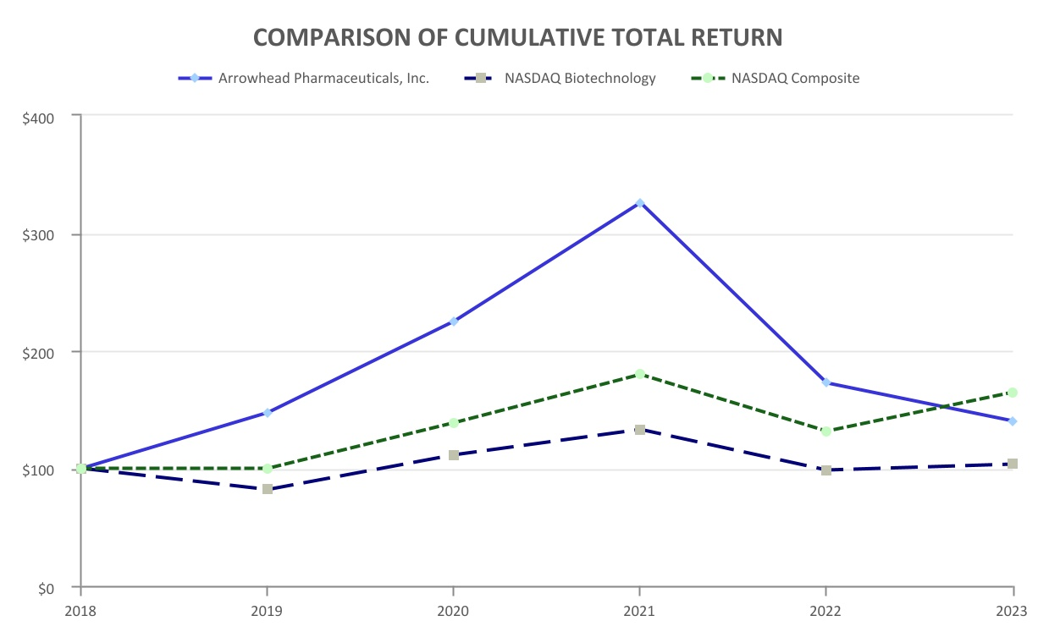
$100 investment in stock or index |  |  |  |  |  | Ticker |  |  |  |  |  | 2018 |  |  |  |  |  | 2019 |  |  |  |  |  | 2020 |  |  |  |  |  | 2021 |  |  |  |  |  | 2022 |  |  |  |  |  | 2023
Arrowhead Pharmaceuticals, Inc. |  |  |  |  |  | ARWR |  |  |  |  |  | $ | 100.00 |  |  |  |  | $ | 147.00 |  |  |  |  | $ | 224.62 |  |  |  |  | $ | 325.67 |  |  |  |  | $ | 172.40 |  |  |  |  | $ | 140.17
NASDAQ Biotechnology Index |  |  |  |  |  | ^NBI |  |  |  |  |  | $ | 100.00 |  |  |  |  | $ | 81.55 |  |  |  |  | $ | 110.98 |  |  |  |  | $ | 132.58 |  |  |  |  | $ | 98.23 |  |  |  |  | $ | 103.08
NASDAQ Composite Index |  |  |  |  |  | ^IXIC |  |  |  |  |  | $ | 100.00 |  |  |  |  | $ | 99.42 |  |  |  |  | $ | 138.79 |  |  |  |  | $ | 179.57 |  |  |  |  | $ | 131.43 |  |  |  |  | $ | 164.29

ITEM 6. RESERVED

58

ITEM 7.MANAGEMENT’S DISCUSSION AND ANALYSIS OF FINANCIAL CONDITION AND RESULTS OF OPERATIONS

OVERVIEW
The Company develops medicines that treat intractable diseases by silencing the genes that cause them. Using a broad portfolio of RNA chemistries and efficient modes of delivery, the Company’s therapies trigger the RNAi interference mechanism to induce rapid, deep and durable knockdown of target genes. RNAi is a mechanism present in living cells that inhibits the expression of a specific gene, thereby affecting the production of a specific protein. RNAi-based therapeutics may leverage this natural pathway of gene silencing to target and shut down specific disease-causing genes.
The Company has focused its resources on therapeutics that exclusively utilize its high levels of pharmacologic activity in multiple animal models spanning several therapeutic areas. The Company believes that TRiMTM enabled therapeutics offer several potential advantages over prior generation and competing technologies, including: simplified manufacturing and reduced costs; multiple routes of administration including subcutaneous injection and inhaled administration; the ability to target multiple tissue types including liver, lung, CNS, muscle, and adipose tissue; and the potential for improved safety and reduced risk of intracellular buildup, because there are fewer metabolites from smaller, simpler molecules.
The Company’s pipeline includes:
•Hypertriglyceridemia - Plozasiran (formerly ARO-APOC3)
•Dyslipidemia - Zodasiran (formerly ARO-ANG3)
•Cardiovascular disease - olpasiran (formerly AMG 890 or ARO-LPA, out-licensed to Amgen)
•Muco-obstructive or inflammatory pulmonary conditions - ARO-MUC5AC and ARO-RAGE
•Idiopathic pulmonary fibrosis - ARO-MMP7
•Non-alcoholic steatohepatitis (NASH) - GSK-4532990 (formerly ARO-HSD, out-licensed to GSK)
•Alpha-1 antitrypsin deficiency (AATD) - fazirsiran (formerly ARO-AAT, a collaboration with Takeda)
•Chronic hepatitis B virus - JNJ-3989 (formerly ARO-HBV, out-licensed to Janssen(1))
•Uncontrolled gout - HZN-457 (formerly ARO-XDH, out-licensed to Horizon(2))
•Complement mediated diseases - ARO-C3
•Non-alcoholic steatohepatitis (NASH) - ARO-PNPLA3 (formerly JNJ-75220795 or ARO-JNJ1)
•Facioscapulohumeral muscular dystrophy - ARO-DUX4
•Amyotrophic lateral sclerosis “ALS” (CNS) - ARO-SOD1
(1) On October 30, 2023, the Company entered into an Assignment and Consent Agreement with Janssen, whereby, the Company consented to the assignment of the Janssen License Agreement to GSK, which assignment shall be effective upon the receipt of certain anti-trust approvals.
(2) On October 6, 2023, Amgen announced that it has completed its acquisition of Horizon.
The Company operates lab facilities in San Diego, California and Madison, Wisconsin, where its research and development activities, including the development of RNAi therapeutics, take place. The Company’s principal executive offices are located in Pasadena, California.
The Company continues to develop other clinical candidates for future clinical trials. Clinical candidates are tested internally and through GLP toxicology studies at outside laboratories. Drug materials for such studies and clinical trials are either manufactured internally or contracted to third-party manufacturers. The Company engages third-party contract research organizations to manage clinical trials and works cooperatively with such organizations on all aspects of clinical trial management, including plan design, patient recruiting, and follow up. These outside costs, relating to the preparation for and administration of clinical trials, are referred to as “candidate costs.” As clinical candidates progress through clinical development, candidate costs will increase.
2023 Business Highlights
During fiscal year 2023, the Company continued to develop and advance its pipeline and partnered candidates and expanded its facilities to support its growing programs. The bullets below highlight some of these key developments; however, this list is not all-inclusive and is meant to be read in conjunction with the entirety of management’s discussion and analysis, the Company’s Consolidated Financial Statements and notes thereto, and all other items contained within this Annual Report on Form 10-K.
•presented data on Company’s pulmonary pipeline at the European Respiratory Society (ERS) International Congress 2023 in Milan, Italy in September 2023, which included:
59

◦in an ongoing Phase 1/2 clinical trial, ARO-RAGE achieved mean target gene knockdown of up to 90% with a maximum of 95% after a single inhaled administration;
◦the TRiM™ platform can achieve compelling results across multiple additional gene targets in the lung, including MUC5AC, MMP7, and the Company’s newest program against thymic stromal lymphopoietin (TSLP), a clinically well validated target;
•filed an application for clearance to initiate a Phase 1/2 clinical trial of ARO-DUX4 in July 2023, which is being developed as a potential treatment for patients with facioscapulohumeral muscular dystrophy (FSHD);
•hosted a Research & Development (“R&D”) Day on June 1, 2023 to discuss progress of the Company’s pipeline of RNAi Therapeutics, at which the following updates were discussed:
◦ARO-RAGE showed continued dose response with single inhaled dose of 184 mg achieving mean knockdown of 90% and max of 95%;
◦adipose delivery platform achieved single dose target gene silencing of greater than 90% with six months of duration in non-human primates;
◦improved hepatic dimer platform achieved equivalent or better knockdown of two target genes with longer duration than monomer mixture in non-human primates;
◦TRiM™ platform now has potential to address multiple cell types including liver, solid tumors, lung, central nervous system, skeletal muscle, and adipose;
◦announced progress towards the Company's “20 in 25” goal to grow its pipeline of RNAi therapeutics that leverage the proprietary Targeted RNAi Molecule (TRiM™) platform to a total of 20 clinical stage or marketed products in the year 2025;
•presented updated data from the Phase 2 SEQUOIA study of investigational RNAi therapy fazirsiran in patients with alpha-1 antitrypsin deficiency liver disease which included:
◦fazirsiran reduced serum Z-AAT concentration in a dose-dependent manner;
◦fazirsiran significantly reduced liver Z-AAT; median reductions of 94% of Z-AAT accumulation in the liver;
◦fazirsiran consistently reduced hepatic globule burden; mean reductions of 68% in histologic globule burden were observed;
◦fazirsiran treatment reduced histological signs of hepatic inflammation;
◦50% of the pooled fazirsiran treated patients showed at least a one-point improvement in METAVIR liver fibrosis versus 38% in the placebo group;
◦fazirsiran has been well tolerated to date; treatment emergent adverse events were generally well balanced between fazirsiran and placebo group;
◦pulmonary function test results (FEV1 and DLCO) for both fazirsiran and placebo were stable over time with no apparent dose-dependent effects;
◦updated Phase 2 clinical data were presented at the European Association for the Study of the Liver (EASL) Congress 2023 in an oral presentation titled, “Fazirsiran reduces liver Z-alpha-1 antitrypsin synthesis, decreases globule burden and improves histological measures of liver disease in adults with alpha-1 antitrypsin deficiency: a randomized placebo-controlled phase 2 study”;
◦results were consistent with AROAAT-2002 open-label study previously published in The New England Journal of Medicine;
•presented interim data from the ongoing Phase 2 GATEWAY clinical study of ARO-ANG3 which included:
◦mean reduction in LDL-C of 48.1% (200mg) and 44.0% (300mg);
◦ANPTL3 inhibition with ARO-ANG3 also reduced HDL-C, non-HDL-C, and triglycerides, consistent with published human genetic data;
◦safety and tolerability;
•completed enrollment of the Phase 3 PALISADE clinical trial evaluating ARO-APOC3 for treatment of familial chylomicronemia syndrome;
•announced interim results from ARO-RAGE administration in Part 1 of the ongoing Phase 1/2 study in normal healthy volunteers which included:
◦reductions in soluble RAGE (sRAGE) as measured in serum after two doses on Day 1 and Day 29;
60

◦duration of pharmacologic effect persisted for at least 6 weeks after the second administration of the 92 mg does with further follow up ongoing;
◦reduction in sRAGE as measured in bronchoalveolar lavage fluid (BALF) at Day 31 after a single dose;
◦reduction in in serum sRAGE was observed after a single dose;
◦the pooled placebo groups experienced a mean sRAGE increase of 8% in BALF and a mean decrease of 1% serum;
◦safety and tolerability;
•expanded TRiMTM platform to include an optimized intrathecal administration for CNS delivery with distribution throughout the brain and in all relevant brain cell types. The first development candidate to utilize this new delivery platform is ARO-SOD1. In June 2023, the Company filed a CTA for approval to initiate a Phase 1 clinical study. In preclinical studies, ARO-SOD1 achieved 95% spinal cord tissue mRNA knockdown after a single intrathecal dose in human SOD1 transgenic rats and maintained greater than 80% spinal cord tissue mRNA knockdown three months after a single intrathecal dose in non-human primates;
•dosed the first patient in Takeda’s Phase 3 REDWOOD clinical study of fazirsiran for the treatment of alpha-1 antitrypsin deficiency associated liver diseases, triggering a $40.0 million milestone payment to the Company which was paid in the third quarter of fiscal 2023;
•dosed the first patient in GSK’s Phase 2b trial of GSK4532990, an investigational RNAi therapeutic for the treatment of patients with non-alcoholic steatohepatitis (NASH), triggering a $30.0 million milestone payment to the Company which was paid in the third quarter of fiscal 2023;
•announced that the FDA has granted Fast Track designation to ARO-APOC3 for reducing triglycerides in adult patients with familial chylomicronemia syndrome (FCS). ARO-APOC3 was previously granted Orphan Drug designation by the FDA and the European Union;
•announced interim results from Part 1 of AROC3-1001, an ongoing Phase 1/2 clinical study of ARO-C3, which included:
◦a dose-dependent reduction in serum C3, with 88% mean reduction at highest dose tested;
◦a dose-dependent reduction in AH50, a marker of alternative complement pathway hemolytic activity, with 91% mean reduction at highest dose tested;
◦duration of pharmacologic effect supportive of quarterly or less frequent subcutaneous dose administration;
◦safety and tolerability;
•initiated dosing in ARO-MMP7-1001 (NCT05537025), a Phase 1/2a single ascending dose and multiple ascending dose clinical study to evaluate the safety, tolerability, pharmacokinetics, and pharmacodynamics of ARO-MMP7, an investigational RNAi therapeutic designed to reduce expression of matrix metalloproteinase 7 (MMP7) as a potential treatment for idiopathic pulmonary fibrosis (IPF), in up to 56 healthy volunteers and in up to 21 patients with IPF;
•enrolled the first subject in a Phase 1 randomized, placebo-controlled trial to assess the safety tolerability, pharmacokinetics and pharmacodynamics of a development-stage medicine, HZN-457, which is out-licensed to Horizon, triggering a $15.0 million milestone payment to the Company which was paid in the second quarter of fiscal 2023;
•enrolled the first subject in Amgen’s Phase 3 trial of olpasiran, which triggered a $25.0 million milestone payment to the Company, which was paid in the second quarter of fiscal 2023;
•entered into the Royalty Pharma Agreement on November 9, 2022, pursuant to which Royalty Pharma paid $250.0 million upfront (See Note 11 — Liability Related to the Sale of Future Royalties of Notes to Consolidated Financial Statements of Part I, “Item 1. Financial Statements.”)
2023 Financial Performance Summary
Net loss attributable to Arrowhead Pharmaceuticals, Inc. was $205.3 million for the year ended September 30, 2023 as compared to $176.1 million for the year ended September 30, 2022. Net loss per share – diluted was $1.92 for the year ended September 30, 2023 as compared to $1.67 for the year ended September 30, 2022. The change in net loss for the
61

year ended September 30, 2023 reflected an increase in research and development expenses, which have continued to increase as the Company’s pipeline of candidates has expanded and progressed through clinical trial phases.
The Company had $110.9 million of cash, cash equivalents and restricted cash, $292.7 million in available-for-sale securities and $765.6 million of total assets as of September 30, 2023, as compared to $108.0 million of cash, cash equivalents and restricted cash, $374.3 million in held-to-maturities debt securities, and $691.9 million of total assets as of September 30, 2022. Based upon the Company’s current cash and investment resources and operating plan, the Company expects to have sufficient liquidity to fund operations for at least the next twelve months.
Critical Accounting Estimates
Management makes certain judgments and uses certain estimates and assumptions when applying U.S. generally accepted accounting principles (“GAAP”) in the preparation of the Company’s Consolidated Financial Statements. On an ongoing basis, the Company evaluates its estimates, judgments and assumptions. The Company bases its estimates on historical experience and on various other assumptions that it believes are reasonable, the results of which form the basis for making judgments about the carrying values of assets, liabilities and equity and the amount of revenue and expense. Actual results may vary from what the Company anticipates and different assumptions or estimates about the future could change its reported results. The Company believes the following accounting policies are the most critical to it, in that they require its most difficult, subjective or complex judgments in the preparation of the Company’s Consolidated Financial Statements. For further information, see Note 1, Organization and Significant Accounting Policies of the Notes to the Company’s Consolidated Financial Statements in Part IV, “Item 15. Exhibits and Financial Statement Schedules.”
Revenue Recognition—The Company has adopted Financial Accounting Standards Board (“FASB”) Topic 606 – Revenue for Contracts from Customers. The Company has not yet achieved commercial sales of its drug candidates to date, however, this standard is applicable to its licensing and collaboration agreements. This is discussed further in Note 2, Collaboration and License Agreements of the Notes to the Company’s Consolidated Financial Statements in Part IV, “Item 15. Exhibits and Financial Statement Schedules.”
At contract inception, the Company assesses whether the goods or services promised within each contract are distinct and, therefore, represent a separate performance obligation, or whether they are not distinct and are combined with other goods and services until a distinct bundle is identified. The Company then determines the transaction price, which typically includes upfront payments and any variable consideration that it determines is probable to not cause a significant reversal in the amount of cumulative revenue recognized when the uncertainty associated with the variable consideration is resolved. The Company then allocates the transaction price to each performance obligation and recognizes the associated revenue when (or as) each performance obligation is satisfied.
The Company recognizes the transaction price allocated to upfront license payments as revenue upon delivery of the license to the customer and resulting ability of the customer to use and benefit from the license, if the license is determined to be distinct from the other performance obligations identified in the contract. These other performance obligations are typically to perform research and development services for the customer, often times relating to the candidate that the customer is licensing. If the license is not considered to be distinct from other performance obligations, the Company assesses the nature of the combined performance obligation to determine whether the combined performance obligation is satisfied at a point in time or over time. If the performance obligation is satisfied over time, the Company then determines the appropriate method of measuring progress for purposes of recognizing revenue from license payments. The Company evaluates the measure of progress each reporting period and, if necessary, adjusts the related revenue recognition.
Typically, the Company’s collaboration agreements entitle it to additional payments upon the achievement of milestones or royalties on sales. The milestones are generally categorized into three types: development milestones, generally based on the initiation of toxicity studies or clinical trials; regulatory milestones, generally based on the submission, filing or approval of regulatory applications such as a CTA or a NDA in the United States; and sales-based milestones, generally based on meeting specific thresholds of sales in certain geographic areas. The Company evaluates whether it is probable that the consideration associated with each milestone or royalty will not be subject to a significant reversal in the cumulative amount of revenue recognized. Amounts that meet this threshold are included in the transaction price using the most-likely-amount method, whereas amounts that do not meet this threshold are excluded from the transaction price until they meet this threshold. At the end of each subsequent reporting period, the Company re-evaluates the probability of a significant reversal of the cumulative revenue recognized for its milestones and royalties, and, if necessary, adjusts its estimate of the overall transaction price. Any such adjustments are recorded on a cumulative catch-up basis, which would affect revenues and net income in the Company’s consolidated statements of operations and comprehensive loss. Typically, milestone payments and royalties are achieved after the Company’s performance obligations associated with the collaboration agreements have been completed and after the customer has assumed responsibility for the respective clinical or preclinical program. Milestones or royalties achieved after the Company’s
62

performance obligations have been completed are recognized as revenue in the period the milestone or royalty was achieved. If a milestone payment is achieved during the performance period, the milestone payment would be recognized as revenue to the extent performance had been completed at that point, and the remaining balance would be recorded as deferred revenue.
The revenue standard requires the Company to assess whether a significant financing component exists in determining the transaction price. The Company performs this assessment at the onset of its licensing or collaboration agreements. Typically, a significant financing component does not exist because the customer is paying for a license or services in advance with an upfront payment. Additionally, future royalty payments are not substantially within the control of the Company or the customer.
The revenue standard requires the Company to allocate the arrangement consideration on a relative standalone selling price basis for each performance obligation after determining the transaction price of the contract and identifying the performance obligations to which that amount should be allocated. The relative standalone selling price is defined in the revenue standard as the price at which an entity would sell a promised good or service separately to a customer. If other observable transactions in which the Company has sold the same performance obligation separately are not available, the Company estimates the standalone selling price of each performance obligation. Key assumptions to determine the standalone selling price may include forecasted revenues, development timelines, reimbursement rates for personnel costs, discount rates and probabilities of technical and regulatory success.
Whenever we determine that goods or services promised in a contract should be accounted for as a combined performance obligation over time, the Company determines the period over which the performance obligations will be performed and revenue will be recognized. Revenue is recognized using the input method. Labor hours, costs incurred or patient visits in clinical trials are typically used as the measure of performance. Significant management judgment is required in determining the level of effort required under an arrangement and the period over which the Company is expected to complete its performance obligations. If the Company determines that the performance obligation is satisfied over time, any upfront payment received is initially recorded as deferred revenue on the Company’s consolidated balance sheets.
Collaborative Arrangements—The Company analyzes its collaborative arrangements to assess whether such arrangements involve joint operating activities performed by parties that are both active participants in the activities and exposed to significant risks and rewards, and therefore an appropriate recognition method is determined and applied consistently, either by analogy to appropriate accounting literature or by applying a reasonable accounting policy election. For collaborative arrangements that are within the scope of FASB Topic 808—Collaborative Arrangements, the Company evaluates the income statement classification for presentation of amounts due to or owed from other participants associated with multiple units of account in a collaborative arrangement based on the nature of each activity. Payments or reimbursements that are the result of a collaborative relationship instead of a customer relationship, such as co-development and co-commercialization activities, are recorded as increases or decreases to research and development expense or general and administrative expense, as appropriate.
Leases—The Company classifies each of its leases as operating or financing considering factors such as the length of the lease term, the present value of the lease payments, the nature of the asset being leased, and the potential for ownership of the asset to transfer during the lease term. Leases with terms greater than one-year are recognized on the Company’s consolidated balance sheets as right-of-use assets that represent its right to use an underlying asset for the lease term, and lease liabilities that represent its obligation to make lease payments arising from the lease. Lease assets and liabilities are recognized at the lease commencement date based on the estimated present value of lease payments over the expected lease term.
The interest rate implicit in lease contracts is typically not readily determinable. As such, the Company utilizes the appropriate incremental borrowing rate, which is the rate incurred to borrow on a collateralized basis an amount equal to the lease payments over a similar term and in a similar economic environment. The Company records expense to recognize fixed lease payments on a straight-line basis over the expected lease term. Costs determined to be variable and not based on an index or rate are not included in the measurement of the lease liability and are expensed as incurred.

63

RESULTS OF OPERATIONS
The following data summarizes the Company’s results of operations for the following periods indicated:
 |  |  |  |  |  | Year Ended September 30,
 |  |  |  |  |  | 2023 |  |  |  |  |  | 2022 |  |  |  |  |  | 2021
 |  |  |  |  |  | (in thousands, except per share amounts)
Revenue |  |  |  |  |  | $ | 240,735 |  |  |  |  | $ | 243,231 |  |  |  |  | $ | 138,287
Operating loss |  |  |  |  |  | $ | (205,002) |  |  |  |  | $ | (178,507) |  |  |  |  | $ | (149,036)
Net loss attributable to Arrowhead Pharmaceuticals, Inc. |  |  |  |  |  | $ | (205,275) |  |  |  |  | $ | (176,063) |  |  |  |  | $ | (140,848)
Net loss per share (diluted) attributable to Arrowhead Pharmaceuticals, Inc. |  |  |  |  |  | $ | (1.92) |  |  |  |  | $ | (1.67) |  |  |  |  | $ | (1.36)

Year Ended September 30, 2023 Compared to Year Ended September 30, 2022
Revenue
Total revenue for the year ended September 30, 2023 decreased slightly to $240.7 million, 1.0% from the same period of 2022. The revenue is mainly associated with GSK, Horizon, Takeda and Amgen license agreements, as discussed below. The Company has evaluated each agreement in accordance with FASB Topic 808–Collaborative Arrangements and Topic 606-Revenue for Contracts from Customers. See Note 2 — Collaboration and License Agreements of the Notes to Consolidated Financial Statements of Part IV, “Item 15. Exhibits and Financial Statement Schedules.”
GSK
At the inception of the GSK License Agreement, the Company identified one distinct performance obligation. The Company determined that the key deliverables included the license and certain R&D services, including the Company’s responsibility to complete the Phase 1/2 study (the “GSK R&D Services”). Due to the specialized and unique nature of the GSK R&D Services and their direct relationship with the license, the Company determined that these deliverables represented one distinct bundle and, thus, one performance obligation.
The Company determined the initial transaction price totaled $120.0 million, including the upfront payment, which was collected in January 2022. The Company has excluded any future estimated milestones or royalties from this transaction price to date. The Company has allocated the total $120.0 million initial transaction price to its one distinct performance obligation for the GSK-4532990 license and the associated GSK R&D Services. As the Company has completed its performance obligation related to this agreement, the upfront payment of $120.0 million was fully recognized in the year ended September 30, 2022. Further, GSK dosed the first patient in a Phase 2b trial in March 2023, triggering a $30.0 million milestone payment to the Company which was paid in the third quarter of fiscal 2023.
The Company has also performed certain development and manufacturing activities, including drug substance and drug product manufacture under GMP conditions, for GSK pursuant to the GSK License Agreement, for which the Company has been reimbursed for its costs. The Company recognized $0.3 million and $4.8 million in connection with these efforts for the years ended September 30, 2023 and 2022, respectively.
Horizon
At the inception of the Horizon License Agreement, the Company identified one distinct performance obligation. The Company determined that the key deliverables included the license and certain R&D services, including the Company’s responsibilities to conduct all activities through the preclinical stages of development of HZN-457 (the “Horizon R&D Services”). Due to the specialized and unique nature of these Horizon R&D Services and their direct relationship with the license, the Company determined that these deliverables represented one distinct bundle and, thus, one performance obligation.
The Company determined the initial transaction price totaled $40.0 million, including the upfront payment, which was collected in July 2021. The Company has excluded any future estimated milestones or royalties from this transaction price to date. The Company allocated the total $40.0 million initial transaction price to its one distinct performance obligation for the HZN-457 license and the associated Horizon R&D Services. Further, Horizon enrolled the first subject in December 2022 in a Phase 1 randomized, placebo-controlled trial to assess the safety, tolerability, pharmacokinetics and
64

pharmacodynamics of HZN-457, triggering a $15.0 million milestone payment to the Company which was paid in the second quarter of fiscal 2023.
The Company has performed certain development and manufacturing activities, including drug substance and drug product manufacture under GMP conditions, for Horizon pursuant to the Horizon License Agreement. The Company recognized $1.5 million and $2.5 million in connection with these efforts for the years ended September 30, 2023 and 2022, respectively.
Takeda
At the inception of the Takeda License Agreement, the Company identified one distinct performance obligation. The Company determined that the key deliverables included the license and certain R&D services including the Company’s responsibilities to complete the initial portion of the SEQUOIA study, to complete the ongoing Phase 2 AROAAT2002 study and to ensure certain manufacturing of fazirsiran drug product is completed and delivered to Takeda (the “Takeda R&D Services”). Due to the specialized and unique nature of these Takeda R&D Services and their direct relationship with the license, the Company determined that these deliverables represent one distinct bundle and, thus, one performance obligation. Beyond the Takeda R&D Services, which are the responsibility of the Company, Takeda will be responsible for managing future clinical development and commercialization outside the United States. Within the United States, the Company will also participate in co-development and co-commercialization efforts and will co-fund these efforts with Takeda as part of the 50/50 profit sharing structure within the United States. The Company considers the collaborative activities, including the co-development and co-commercialization, to be a separate unit of account within Topic 808, and as such, these co-funding amounts are recorded as research and development expenses or general and administrative expenses, as appropriate.
Under the terms of the Takeda License Agreement, the Company received $300.0 million as an upfront payment in January 2021 and an additional $40.0 million upon Takeda’s initiation of a Phase 3 REDWOOD clinical study of fazirsiran in March 2023.
The Company has allocated the total $300.0 million initial transaction price to its one distinct performance obligation for the fazirsiran license and the associated Takeda R&D Services. Revenue is recognized using the input method (based on actual patient visits completed versus total estimated visits completed for the ongoing SEQUOIA and AROAAT2002 clinical studies). The Company previously expected these clinical trials to extend to September 2025 in order to demonstrate long term safety and efficacy in the open label extension (OLE) part of the studies; however, in August 2023, Takeda initiated a Phase 3 OLE study available to patients participating in these Phase 2 studies. Based on this new information, patients enrolled in the SEQUOIA and AROAAT2002 studies are expected to complete their Phase 2 study visits between June 2023 and December 2023, shortening the Company’s performance obligation. As a result, effective the second quarter of fiscal 2023, the Company changed its estimates of the revenue recognition to better reflect this newly estimated performance period. The effect of these changes in estimates resulted in accelerated revenue by $70.5 million, or $0.66 per share (diluted) for the year ended September 30, 2023.
Amgen
Under the Olpasiran Agreement, the Company has received $35.0 million in upfront payments and $21.5 million in the form of an equity investment by Amgen in the Company’s common stock. Further, the Company received an additional $55.0 million in milestone payments; $10.0 million upon Amgen’s initiation of a Phase 1 study in September 2018, $20.0 million upon its initiation of a Phase 2 clinical study in July 2020, and $25.0 million upon its first subject enrollment in a Phase 3 trial in December 2022. The Company has substantially completed its performance obligations under the Olpasiran Agreement.
In November 2022, Royalty Pharma and the Company entered into the Royalty Pharma Agreement. In consideration for the payments under the Royalty Pharma Agreement, Royalty Pharma is entitled to receive all royalties otherwise payable by Amgen to the Company under the Olpasiran Agreement. The Company remains eligible to receive up to an additional $535.0 million in remaining development, regulatory and sales milestone payments payable from Amgen and Royalty Pharma. See Note 13 — Liability Related to the Sale of Future Royalties of Notes to Consolidated Financial Statements of Part IV, “Item 15. Exhibits and Financial Statement Schedules.”

65

Operating Expenses
The analysis below details the operating expenses and discusses the expenditures of the Company within the major expense categories. For purposes of comparison, the amounts for the years ended September 30, 2023 and 2022 are shown in the tables below.
Research and Development (R&D) Expenses
R&D expenses are related to the Company’s research and development discovery efforts and related candidate costs, which are comprised primarily of outsourced costs related to the manufacturing of clinical supplies, toxicity/efficacy studies and clinical trial expenses. Internal costs primarily relate to discovery operations at the Company’s research facilities in San Diego, California and Madison, Wisconsin, including facility costs and laboratory-related expenses. The Company does not separately track R&D expenses by individual research and development projects, or by individual drug candidates. The Company operates in a cross-functional manner across projects and does not separately allocate facilities-related costs, candidate costs, discovery costs, compensation expenses, depreciation and amortization expenses, and other expenses related to research and development activities.
The following table provides details of research and development expenses:
(in thousands) |  |  | Twelve  Months  Ended  September 30, 2023 |  |  |  |  |  | % of  Expense  Category |  |  |  |  |  | Twelve  Months  Ended  September 30, 2022 |  |  |  |  |  | % of  Expense  Category |  |  |  |  |  | Increase (Decrease)
 |  |  |  |  |  |  |  |  |  |  |  |  |  |  |  |  |  |  |  |  |  |  |  |  |  |  | $ |  |  |  |  |  | %
Candidate costs |  |  | $ | 141,436 |  |  |  |  | 40 |  | % |  |  |  | $ | 136,904 |  |  |  |  | 46 |  | % |  |  |  | $ | 4,532 |  |  |  |  | 3 |  | %
R&D discovery costs |  |  | 76,609 |  |  |  |  |  | 22 |  | % |  |  |  | 54,346 |  |  |  |  |  | 18 |  | % |  |  |  | 22,263 |  |  |  |  |  | 41 |  | %
Salaries |  |  | 73,668 |  |  |  |  |  | 21 |  | % |  |  |  | 51,931 |  |  |  |  |  | 17 |  | % |  |  |  | 21,737 |  |  |  |  |  | 42 |  | %
Facilities related |  |  | 16,267 |  |  |  |  |  | 5 |  | % |  |  |  | 12,948 |  |  |  |  |  | 4 |  | % |  |  |  | 3,319 |  |  |  |  |  | 26 |  | %
Total research and development expense, excluding non-cash expense |  |  | $ | 307,980 |  |  |  |  | 87 |  | % |  |  |  | $ | 256,129 |  |  |  |  | 86 |  | % |  |  |  | $ | 51,851 |  |  |  |  | 20 |  | %
Stock compensation |  |  | 34,332 |  |  |  |  |  | 10 |  | % |  |  |  | 32,371 |  |  |  |  |  | 11 |  | % |  |  |  | 1,961 |  |  |  |  |  | 6 |  | %
Depreciation and amortization |  |  | 10,876 |  |  |  |  |  | 3 |  | % |  |  |  | 8,807 |  |  |  |  |  | 3 |  | % |  |  |  | 2,069 |  |  |  |  |  | 23 |  | %
Total research and development expense |  |  | $ | 353,188 |  |  |  |  | 100 |  | % |  |  |  | $ | 297,307 |  |  |  |  | 100 |  | % |  |  |  | $ | 55,881 |  |  |  |  | 19 |  | %
Candidate costs increased $4.5 million, or 3%, for the year ended September 30, 2023 compared to the same period of 2022. This increase was primarily due to the additional progression of the Company’s pipeline of candidates into and through clinical trials, which resulted in higher outsourced clinical trial, toxicity study and manufacturing costs.
R&D discovery costs increased $22.3 million, or 41%, for the year ended September 30, 2023 compared to the same period of 2022. This increase was due to the growth of the Company’s discovery efforts and continued advancement into novel therapeutic areas and tissue types.
Salaries and stock compensation expense consist of salary, bonuses, payroll taxes, related benefits and stock compensation for the Company’s R&D personnel. The increases in salaries and stock comp expenses for 2023 were primarily due to an increase in R&D headcount that has occurred as the Company has expanded its pipeline of candidates, in addition to annual salary increases. Stock compensation expense was based upon the valuation of stock options and restricted stock units granted to employees.
Facilities-related expense primarily includes lease costs for the Company’s research and development facilities in San Diego, California and Madison, Wisconsin. Facilities-related costs increased $3.3 million, or 26%, for the year ended September 30, 2023 compared to the same period of 2022. This increase was mainly due to the additional lease expense as the Company expands discovery efforts to identify new drug candidates.
Depreciation and amortization expense, a non-cash expense, relates to depreciation on lab equipment and leasehold improvements at the facilities.
The Company anticipates these R&D expenses to continue to increase as its pipeline of candidates grows and progresses to later phase clinical trials, in addition to inflationary pressure on goods and services and the labor market.
General & Administrative Expenses
The following table provides details of general and administrative expenses:
66

(in thousands) |  |  | Twelve  Months  Ended  September 30, 2023 |  |  |  |  |  | % of  Expense  Category |  |  |  |  |  | Twelve  Months  Ended  September 30, 2022 |  |  |  |  |  | % of  Expense  Category |  |  |  |  |  | Increase (Decrease)
 |  |  |  |  |  |  |  |  |  |  |  |  |  |  |  |  |  |  |  |  |  |  |  |  |  |  | $ |  |  |  |  |  | %
Salaries |  |  | $ | 22,999 |  |  |  |  | 25 |  | % |  |  |  | $ | 16,646 |  |  |  |  | 13 |  | % |  |  |  | $ | 6,353 |  |  |  |  | 38 |  | %
Professional, outside services, and other |  |  | 20,720 |  |  |  |  |  | 22 |  | % |  |  |  | 14,738 |  |  |  |  |  | 12 |  | % |  |  |  | 5,982 |  |  |  |  |  | 41 |  | %
Facilities related |  |  | 3,415 |  |  |  |  |  | 4 |  | % |  |  |  | 2,912 |  |  |  |  |  | 2 |  | % |  |  |  | 503 |  |  |  |  |  | 17 |  | %
Total general & administrative expense, excluding non-cash expense |  |  | $ | 47,134 |  |  |  |  | 51 |  | % |  |  |  | $ | 34,296 |  |  |  |  | 28 |  | % |  |  |  | $ | 12,838 |  |  |  |  | 37 |  | %
Stock compensation |  |  | 43,798 |  |  |  |  |  | 47 |  | % |  |  |  | 88,521 |  |  |  |  |  | 71 |  | % |  |  |  | (44,723) |  |  |  |  |  | (51) |  | %
Depreciation/amortization |  |  | 1,617 |  |  |  |  |  | 2 |  | % |  |  |  | 1,614 |  |  |  |  |  | 1 |  | % |  |  |  | 3 |  |  |  |  |  | — |  | %
Total general & administrative expense |  |  | $ | 92,549 |  |  |  |  | 100 |  | % |  |  |  | $ | 124,431 |  |  |  |  | 100 |  | % |  |  |  | $ | (31,882) |  |  |  |  | (26) |  | %
Salaries expense increased $6.4 million, or 38%, for the year ended September 30, 2023 compared to the same period of 2022. The increase was driven by the combination of annual salary increases and increased headcount required to support the Company’s growth.
Professional, outside services, and other expense includes legal, consulting, patent expenses, business insurance expenses, other outside services, travel, and communication and technology expenses. This expense increased $6.0 million, or 41%, for the year ended September 30, 2023 compared to the same period of 2022. The increase was mainly due to the cost associated with consulting services focused on the preparation of commercialization activities.
Facilities related expense primarily includes rental costs and other facilities-related costs for the Company’s corporate headquarters in Pasadena, California.
Stock compensation expense, a non-cash expense, decreased by $44.7 million, or 51%, for the year ended September 30, 2023 compared to the same period of 2022. The decrease was mainly due to the lower amount of recognized compensation costs and the reversal of recognized compensation costs related to a performance award where the minimum performance goal was not met. The fair value of market condition-based awards was expensed ratably over the service period and was not adjusted for actual achievement.
Depreciation and amortization expense, a noncash expense, was primarily related to amortization of leasehold improvements for the Company’s corporate headquarters.
Other than with respect to the stock compensation costs described above, the Company anticipates these general and administrative expenses to continue to increase as its pipeline of candidates grows and progresses to later phase clinical trials, in addition to inflationary pressure on goods and services and the labor market.
Other Income (Expense)
Other income (expense) is primarily related to interest income and expense. Other expense was $1.5 million for the year ended September 30, 2023 compared to other income of $5.8 million for the year ended September 30, 2022. The change was primarily due to the interest expense on the liability related to the sale of future royalties, partially offset by higher yields on investments due to increased interest rates.
Year Ended September 30, 2022 Compared to Year Ended September 30, 2021
See “Item 7. Management’s Discussion and Analysis of Financial Condition and Results of Operations” of the Company’s Form 10-K for the year ended September 30, 2022 for a discussion of changes in its results of operations from the year ended September 30, 2022 to the year ended September 30, 2021.

67

LIQUIDITY AND CAPITAL RESOURCES
The Company has historically financed its operations through the sale of its equity securities, revenue from its licensing and collaboration agreements, and the sale of certain future royalties. Research and development activities have required significant capital investment since the Company’s inception and are expected to continue to require significant cash expenditure as the Company’s pipeline continues to expand and matures into later stage clinical trials. Additionally, the Company expanded its facilities in Verona, Wisconsin and commenced the lease agreement for additional facilities in San Diego, California. These expansions are designed to increase the Company’s internal manufacturing and discovery capabilities, and the ongoing expansion in Verona, Wisconsin continues to require capital investment. For further information on our capital needs, see the section titled “Risks Related to Our Financial Condition” in “Item 1A. Risk Factors” of this Annual Report on Form 10-K.
The Company’s cash, cash equivalents and restricted cash slightly increased to $110.9 million at September 30, 2023 compared to $108.0 million at September 30, 2022. Cash invested in available-for-sale debt securities was $292.7 million at September 30, 2023 compared to held-to-maturity debt securities of $374.3 million at September 30, 2022. In April 2022, the Company sold all of its investments in mutual funds for $122.3 million.
On September 30, 2023, the Company changed the classification of its investment securities from held-to-maturity to available-for-sale. This change enables the Company to sell securities to diversify its portfolio, reduce exposure to market risks, and provide flexibility to meet cash flow needs and new investment opportunities.
On December 2, 2022, the Company entered into the Open Market Sale Agreement (See Note 6 — Stockholders’ Equity to Consolidated Financial Statements of Part I, “Item 1. Financial Statements”), pursuant to which the Company may, from time to time, sell up to $250.0 million in shares of the Company’s common stock through Jefferies LLC, acting as the sales agent and/or principal, in an at-the-market offering. As of September 30, 2023, no shares have been issued under the Open Market Sale Agreement. The Company believes its current financial resources are sufficient to fund its operations through at least the next twelve months.
The following table presents a summary of cash flows:
 |  |  | Year Ended September 30,
 |  |  | 2023 |  |  |  |  |  | 2022 |  |  |  |  |  | 2021
 |  |  | (in thousands)
Cash Flow from:
Operating activities |  |  | $ | (153,890) |  |  |  |  | $ | (136,131) |  |  |  |  | $ | 171,312
Investing activities |  |  | (96,155) |  |  |  |  |  | (5,417) |  |  |  |  |  | (141,678)
Financing activities |  |  | 253,053 |  |  |  |  |  | 65,186 |  |  |  |  |  | 11,305
Net increase (decrease) in cash, cash equivalents and restricted cash |  |  | $ | 3,008 |  |  |  |  | $ | (76,362) |  |  |  |  | $ | 40,939
Cash, cash equivalents and restricted cash at end of period |  |  | $ | 110,891 |  |  |  |  | $ | 108,005 |  |  |  |  | $ | 184,434
During the year ended September 30, 2023, cash flow used by operating activities was $153.9 million, which was primarily due to the ongoing expenses related to the Company’s research and development programs and general and administrative expenses, partially offset by the receipt of the $110.0 million from collaboration and license agreements (See Note 2 — Collaboration and License Agreements of Notes to Consolidated Financial Statements of Part IV, “Item 15. Exhibits and Financial Statement Schedules.”). Cash used in investing activities was $96.2 million, which was primarily related to the purchase of property and equipment of $176.7 million, offset by net proceeds of $80.6 million from maturities of securities. Cash provided by financing activities of $253.1 million was primarily related to the $250.0 million payment from Royalty Pharma as well as cash received from stock option exercises (See Note 13 — Liability Related to the Sale of Future Royalties of Notes to Consolidated Financial Statements of Part IV, “Item 15. Exhibits and Financial Statement Schedules.”).
During the year ended September 30, 2022, cash flow used by operating activities was $136.1 million, which was primarily due to the ongoing expenses related to the Company’s research and development programs and general and administrative expenses, partially offset by the receipt of the $120.0 million upfront payment from GSK. Cash used in investing activities was $5.4 million, which was primarily related to the purchase of property and equipment of $52.8 million, offset by net proceeds from maturities of investments of $47.4 million. Cash provided by financing activities of
68

$65.2 million was primarily related to the formation of the Company’s joint venture, Visirna, as well as cash received from stock option exercises.
On December 20, 2021, the Company completed a purchase of 13 acres of land in the Verona Technology Park in Verona, Wisconsin, which is being developed into an approximately 160,000 square foot drug manufacturing facility and an approximately 140,000 square foot laboratory and office facility which will support the Company’s process development and analytical activities. The Company is now occupying the laboratory and office facility, but construction of the manufacturing facility is still ongoing. As of September 30, 2023, the Company has incurred $166.2 million and intends to spend an additional $120.0 million to $130.0 million to complete the build out of the facilities.
As part of this land acquisition, the Company entered into a development agreement with the City of Verona to construct certain infrastructure improvements within the tax increment district and will be reimbursed up to $16.0 million by the City of Verona by future tax increment revenue generated from the developed property. The total amount of funding that City of Verona will pay under the Tax Increment Financing program is not guaranteed and will depend on future tax revenues generated from the developed property. The Company also became eligible to receive up to $2.5 million in refundable Wisconsin state income tax credits from the Wisconsin Economic Development Corporation (WEDC) as incentives for investing in the local community and creating new job opportunities. As of September 30, 2023, the Company has collected $1.5 million of these credits.
See “Item 7. Management’s Discussion and Analysis of Financial Condition and Results of Operations” of the Company’s Form 10-K for the year ended September 30, 2022 for a discussion of cash flows from the year ended September 30, 2021.

Contractual Obligations
For information related to the Company’s future commitments for its facility-related obligations and collaboration and licensing agreements, see Notes 8 and 2, respectively, of Notes to the Company’s Consolidated Financial Statements of Part IV, “Item 15. Exhibits and Financial Statement Schedules.” Commitments related to the Company’s clinical, manufacturing and business operation related agreements are $579.7 million as of September 30, 2023, but many of these agreements are cancellable.

ITEM 7A.QUANTITATIVE AND QUALITATIVE DISCLOSURES ABOUT MARKET RISK
The Company is subject to market risk exposures primarily due to its investing activities. The primary market risk exposure is change in interest rates. Adverse changes to rates may occur due to changes in the liquidity of a market or to changes in market perceptions of creditworthiness and risk tolerance.
The Company does not hold any instruments for trading purposes and investment criteria are governed by its Investment Policy. As of September 30, 2023 and 2022, the Company had cash, cash equivalents, and restricted cash of $110.9 million and $108.0 million, respectively, and investments of $292.7 million and $374.3 million, respectively. The Company has invested its cash reserves in corporate bonds typically with maturities of less than 3 years and historically classified these investments as held-to-maturity. On September 30, 2023, the Company changed the classification of its investment securities from held-to-maturity to available-for-sale. This change enables the Company to sell securities to diversify its portfolio, reduce exposure to market risks, and provide flexibility to meet cash flow needs and new investment opportunities. Due to the relatively short-term nature of the investments that the Company holds, it does not believe that the results of operations or cash flows would be affected to any significant degree by a sudden change in market interest rates relative to its investment portfolio.

ITEM 8.FINANCIAL STATEMENTS AND SUPPLEMENTARY DATA
The information required by this item is included in Item 15 of this Annual Report on Form 10-K.

ITEM 9.CHANGES IN AND DISAGREEMENTS WITH ACCOUNTANTS ON ACCOUNTING AND FINANCIAL DISCLOSURE
None.

69

ITEM 9A.CONTROLS AND PROCEDURES
Evaluation of Disclosure Controls and Procedures
The Company maintains disclosure controls and procedures designed to ensure that information required to be disclosed in its reports filed under the Exchange Act is recorded, processed, summarized, and reported within the time periods specified in the SEC rules and forms, and that such information is accumulated and communicated to its management, including its Chief Executive Officer and Chief Financial Officer, as appropriate, to allow for timely decisions regarding required disclosure. In designing and evaluating the disclosure controls and procedures, management recognizes that any controls and procedures, no matter how well designed and operated, can provide only reasonable assurance of achieving the desired control objectives, and management necessarily was required to apply its judgment in evaluating the cost benefit relationship of possible controls and procedures.
As required by Rule 13a-15(b) of the Exchange Act, the Company carried out an evaluation, under the supervision and with the participation of its management, including its Chief Executive Officer and Chief Financial Officer, of the effectiveness of the design and operation of the Company’s disclosure controls and procedures as of the end of the period covered by this Annual Report on Form 10-K. Based on the foregoing, the Company’s Chief Executive Officer and Chief Financial Officer concluded that the Company’s disclosure controls and procedures were effective at the reasonable assurance level.
Management’s Annual Report on Internal Control over Financial Reporting
The Company’s management is responsible for establishing and maintaining adequate internal control over financial reporting as defined in Rules 13a-15(f) and 15d-15(f) of the Exchange Act. The Company’s internal control over financial reporting is designed to provide reasonable assurance regarding the reliability of financial reporting and the preparation of its Consolidated Financial Statements for external purposes in accordance with GAAP.
This process includes those policies and procedures that:
(i) pertain to the maintenance of records that, in reasonable detail, accurately and fairly reflect the transactions and dispositions of the Company’s assets;
(ii) provide reasonable assurance that transactions are recorded as necessary to permit preparation of financial statements in accordance with GAAP, and that receipts and expenditures are being made only in accordance with authorizations of the Company’s management and directors; and
(iii) provide reasonable assurance regarding prevention or timely detection of unauthorized acquisition, use or disposition of the Company’s assets that could have a material effect on the Company’s financial statements.
Because of its inherent limitations, internal control over financial reporting may not prevent or detect misstatements. Also, projections of any evaluation of the internal control over financial reporting to future periods are subject to risk that controls may become inadequate because either conditions change or the degree of compliance with policies or procedures may deteriorate.
Management has assessed the effectiveness of the Company’s internal control over financial reporting as of September 30, 2023. In making this assessment, the Company used the criteria set forth by the Committee of Sponsoring Organizations of the Treadway Commission (COSO) in Internal Control-Integrated Framework (2013). Based on this assessment, management concluded that the Company’s internal control over financial reporting was effective as of September 30, 2023.
Rose, Snyder and Jacobs LLP, the independent registered public accounting firm that audited the Consolidated Financial Statements included in this 2023 Annual Report on Form 10-K, has issued an audit report on the effectiveness of the Company’s internal control over financial reporting as of September 30, 2023, which is included herein.
Changes in Internal Control Over Financial Reporting
There has been no change in the Company’s internal control over financial reporting during the Company’s most recent fiscal quarter that has materially affected, or is reasonably likely to materially affect, the Company’s internal control over financial reporting. The Company’s process for evaluating controls and procedures is continuous and encompasses consistent improvement of the design and effectiveness of established controls and procedures and the remediation of any deficiencies which may be identified during this process.

70

ITEM 9B.OTHER INFORMATION
(b) Trading Plans
During the quarter ended September 30, 2023, the following directors and officers (as defined in Exchange Act Rule 16a-1(f)) adopted certain trading plans intended to satisfy Rule 10b5-1(c):
Name |  |  |  |  |  | Title |  |  |  |  |  | Adoption or Termination Date |  |  |  |  |  | Plan Start Date |  |  |  |  |  | Plan End Date |  |  |  |  |  | Shares Vesting and Subject to Sell-To-Cover (1) |  |  |  |  |  | Other Shares Being Sold (Subject to Certain Conditions)
Mauro Ferrari |  |  |  |  |  | Board Member |  |  |  |  |  | 09/28/2023 |  |  |  |  |  | 01/11/2024 |  |  |  |  |  | 01/31/2024 |  |  |  |  |  | n/a |  |  |  |  |  | 3,147
Douglass Given |  |  |  |  |  | Board Member |  |  |  |  |  | 09/26/2023 |  |  |  |  |  | 01/11/2024 |  |  |  |  |  | 01/31/2024 |  |  |  |  |  | n/a |  |  |  |  |  | 2,911
James Hamilton (2) |  |  |  |  |  | Chief Discovery and Translational Medicine |  |  |  |  |  | 08/15/2023 |  |  |  |  |  | 01/03/2024 |  |  |  |  |  | 01/31/2024 |  |  |  |  |  | 52,500 |  |  |  |  |  | n/a
James Hamilton |  |  |  |  |  | Chief Discovery and Translational Medicine |  |  |  |  |  | 08/22/2023 |  |  |  |  |  | 12/01/2023 |  |  |  |  |  | 11/29/2024 |  |  |  |  |  | n/a |  |  |  |  |  | 35,000
Ken Myszkowski |  |  |  |  |  | Chief Financial Officer |  |  |  |  |  | 09/07/2023 |  |  |  |  |  | 01/05/2024 |  |  |  |  |  | 01/31/2024 |  |  |  |  |  | 30,000 |  |  |  |  |  | n/a
Patrick O’Brien |  |  |  |  |  | Chief Operating Officer and General Counsel |  |  |  |  |  | 09/03/2023 |  |  |  |  |  | 01/03/2024 |  |  |  |  |  | 01/05/2024 |  |  |  |  |  | n/a |  |  |  |  |  | 4,000
Tracie Oliver |  |  |  |  |  | Chief Commercial Officer |  |  |  |  |  | 08/28/2023 |  |  |  |  |  | 01/05/2024 |  |  |  |  |  | 07/31/2024 |  |  |  |  |  | 17,625 |  |  |  |  |  | n/a
Victoria Vakiener |  |  |  |  |  | Board Member |  |  |  |  |  | 09/28/2023 |  |  |  |  |  | 01/11/2024 |  |  |  |  |  | 05/31/2024 |  |  |  |  |  | n/a |  |  |  |  |  | 6,519
William Waddill |  |  |  |  |  | Board Member |  |  |  |  |  | 08/29/2023 |  |  |  |  |  | 01/11/2024 |  |  |  |  |  | 01/31/2024 |  |  |  |  |  | n/a |  |  |  |  |  | 3,934
(1) This column indicates the total number of shares vesting, but the 10b5-1 Plan provides for the sale of only those shares necessary to satisfy payment of applicable withholding taxes.
(2) Termination of a trading plan that was intended to satisfy Rule 10b5-1(c).

ITEM 9C.DISCLOSURE REGARDING FOREIGN JURISDICTIONS THAT PREVENT INSPECTIONS
Not applicable.

PART III

ITEM 10.DIRECTORS, EXECUTIVE OFFICERS AND CORPORATE GOVERNANCE
The information called for by this Item will be incorporated by reference from the Company’s Definitive Proxy Statement, under the headings Proposal One — Election of Directors, Equity Compensation Plan Information, Corporate Governance, Environmental and Social Commitment, and, if applicable, Delinquent Section 16(a) Reports, to be filed for the Company’s 2024 Annual Meeting of Stockholders, which proxy statement will be filed no later than January 26, 2024 (the “Definitive Proxy Statement”).

ITEM 11.EXECUTIVE COMPENSATION
The information called for by this Item will be incorporated by reference from the Definitive Proxy Statement, under the heading Executive Compensation.

ITEM 12.SECURITY OWNERSHIP OF CERTAIN BENEFICIAL OWNERS AND MANAGEMENT AND RELATED STOCKHOLDER MATTERS
The information called for by this Item will be incorporated by reference from the Definitive Proxy Statement, under the heading Voting Securities of Principal Stockholders and Management.

ITEM 13.CERTAIN RELATIONSHIPS, RELATED TRANSACTIONS AND DIRECTOR INDEPENDENCE
The information called for by this Item will be incorporated by reference from the Definitive Proxy Statement, under the headings Review and Approval of Related-Party Transactions and Certain Relationships and Related Transactions, and Director Independence.

71

ITEM 14.PRINCIPAL ACCOUNTANT FEES AND SERVICES
The information called for by this Item will be incorporated by reference from the Definitive Proxy Statement, under the heading Audit Fees.

PART IV

ITEM 15.EXHIBITS AND FINANCIAL STATEMENT SCHEDULES
The following documents are filed as part of this Annual Report on Form 10-K:
(1)Financial Statements.
See Index to Financial Statements and Schedule on page F-1.
(2)Financial Statement Schedules.
See Index to Financial Statements and Schedule on page F-1. All other schedules are omitted as the required information is not present or is not present in amounts sufficient to require submission of the schedule, or because the information required is included in the Consolidated Financial Statements or notes thereto.
(3)Exhibits.
The following exhibits are filed (or incorporated by reference herein) as part of this Annual Report on Form 10-K:
 |  |  |  |  |  |  |  |  |  |  |  | Incorporated by Reference Herein
Exhibit  Number |  |  |  |  |  | Description |  |  |  |  |  | Form |  |  |  |  |  | Date
1.1 |  |  |  |  |  | Open Market Sale Agreement, dated as of December 2, 2022, by and between Arrowhead Pharmaceuticals, Inc. and Jefferies LLC |  |  |  |  |  | Current Report on Form 8-K as Exhibit 1.1 |  |  |  |  |  | December 2, 2022
2.1† |  |  |  |  |  | Stock and Asset Purchase Agreement between Arrowhead Research Corporation and Roche entities, dated October 21, 2011 |  |  |  |  |  | Annual Report on Form 10-K as Exhibit 2.1 |  |  |  |  |  | December 20, 2011
2.2† |  |  |  |  |  | Asset Purchase and Exclusive License Agreement between Arrowhead Research Corporation and Novartis Institutes for BioMedical Research, Inc., dated March 3, 2015 |  |  |  |  |  | Quarterly Report on Form 10-Q, as Exhibit 2.1 |  |  |  |  |  | May 11, 2015
3.1 |  |  |  |  |  | Amended and Restated Certificate of Incorporation (incorporated by reference from Exhibit 3.3 of the Company’s Form 8-K filed on April 6, 2016) |  |  |  |  |  | Current Report on Form 8-K as Exhibit 3.3 |  |  |  |  |  | April 6, 2016
3.2 |  |  |  |  |  | Certificate of Amendment to the Amended and Restated Certificate of Incorporation of Arrowhead Pharmaceuticals, Inc. (incorporated by reference from Exhibit 3.2 of the Company’s Form 10-Q filed on May 2, 2023) |  |  |  |  |  | Quarterly Report on Form 10-Q, as Exhibit 3.2 |  |  |  |  |  | May 2, 2023
3.3 |  |  |  |  |  | Second Amended and Restated Bylaws (incorporated by reference from Exhibit 3.1 of the Company’s Form 8-K filed on January 30, 2023) |  |  |  |  |  | Current Report on Form 8-K as Exhibit 3.2 |  |  |  |  |  | January 30, 2023
4.1 |  |  |  |  |  | Form of Common Stock Certificate of Arrowhead Pharmaceuticals, Inc. |  |  |  |  |  | Current Report on Form 8-K, as Exhibit 4.1 |  |  |  |  |  | April 6, 2016
4.2 |  |  |  |  |  | Form of Indenture |  |  |  |  |  | Registration Statement on Form S-3, as Exhibit 4.2 |  |  |  |  |  | December 2, 2019
4.3 |  |  |  |  |  | Rights Agreement dated as of March 21, 2017, between the Company and Computershare Trust Company, N.A., as rights agent, which includes as Exhibit B the Form of Rights Certificate |  |  |  |  |  | Current Report on Form 8-K, as Exhibit 4.1 |  |  |  |  |  | March 23, 2017
4.4 |  |  |  |  |  | Description of Registrant’s Securities |  |  |  |  |  | Annual Report on Form 10-K, as Exhibit 4.4 |  |  |  |  |  | November 25, 2019
4.5 |  |  |  |  |  | Registration Rights Agreement by and between Arrowhead Pharmaceuticals, Inc. and Johnson & Johnson Innovation-JJDC, Inc., dated October 3, 2018 |  |  |  |  |  | Quarterly Report on Form 10-Q, as Exhibit 10.4 |  |  |  |  |  | February 7, 2019
72

 |  |  |  |  |  |  |  |  |  |  |  | Incorporated by Reference Herein
Exhibit  Number |  |  |  |  |  | Description |  |  |  |  |  | Form |  |  |  |  |  | Date
10.1** |  |  |  |  |  | Arrowhead Research Corporation 2004 Equity Incentive Plan, as amended |  |  |  |  |  | Schedule 14C, as Annex B |  |  |  |  |  | January 12, 2012
10.2** |  |  |  |  |  | Arrowhead Research Corporation 2013 Incentive Plan |  |  |  |  |  | Schedule 14C, as Annex A |  |  |  |  |  | December 20, 2013
10.3** |  |  |  |  |  | Form of Stock Option Agreement for use with the 2013 Incentive Plan |  |  |  |  |  | Current Report on Form 8-K, as Exhibit 10.1 |  |  |  |  |  | February 12, 2014
10.4** |  |  |  |  |  | Form of Restricted Stock Unit Agreement for use with the 2013 Incentive Plan |  |  |  |  |  | Current Report on Form 8-K, as Exhibit 10.2 |  |  |  |  |  | February 12, 2014
10.5** |  |  |  |  |  | Arrowhead Pharmaceuticals, Inc. 2021 Incentive Plan |  |  |  |  |  | Schedule 14A, Exhibit A |  |  |  |  |  | January 28, 2021
10.6** |  |  |  |  |  | Form of RSU Agreement for Officers and Certain Other Employees (Arrowhead Pharmaceuticals, Inc. 2021 Incentive Plan- Inducement Award) |  |  |  |  |  | Registration Statement on Form S-8, Exhibit 99.1 |  |  |  |  |  | December 22, 2021
10.7*, ** |  |  |  |  |  | Form of RSU Agreement for Officers and Certain Other Employees (Arrowhead Pharmaceuticals, Inc. 2021 Incentive Plan)
10.8** |  |  |  |  |  | Form of RSU Agreement for Employees (Arrowhead Pharmaceuticals, Inc. 2021 Incentive Plan- Inducement Award) |  |  |  |  |  | Registration Statement on Form S-8, Exhibit 99.2 |  |  |  |  |  | December 22, 2021
10.9*, ** |  |  |  |  |  | Form of RSU Agreement for Employees (Arrowhead Pharmaceuticals, Inc. 2021 Incentive Plan)
10.10** |  |  |  |  |  | Form of Stock Option Grant (Arrowhead Pharmaceuticals, Inc. 2021 Incentive Plan- Inducement Award) |  |  |  |  |  | Registration Statement on Form S-8, Exhibit 99.3 |  |  |  |  |  | December 22, 2021
10.11*, ** |  |  |  |  |  | Form of Stock Option Grant (Arrowhead Pharmaceuticals, Inc. 2021 Incentive Plan)
10.12** |  |  |  |  |  | Executive Incentive Plan, adopted December 12, 2006 |  |  |  |  |  | Annual Report on Form 10-K, as Exhibit 10.11 |  |  |  |  |  | December 14, 2006
10.13** |  |  |  |  |  | Employment Agreement between Arrowhead and Dr. Christopher Anzalone, dated June 11, 2008 |  |  |  |  |  | Current Report on Form 8-K, as Exhibit 10.1 |  |  |  |  |  | June 13, 2008
10.14** |  |  |  |  |  | Amendment to Employment Agreement between Arrowhead and Dr. Christopher Anzalone, effective May 12, 2009 |  |  |  |  |  | Annual Report on Form 10-K, as Exhibit 10.8 |  |  |  |  |  | December 22, 2009
10.15† |  |  |  |  |  | Collaboration Agreement by and among Alnylam Pharmaceuticals, Inc. and F. Hoffmann-La Roche Ltd and Hoffman-La Roche Inc., dated October 29, 2009 † |  |  |  |  |  | Annual Report on Form 10-K, as Exhibit 10.36 |  |  |  |  |  | December 20, 2011
10.16† |  |  |  |  |  | Non-Exclusive License Agreement between Arrowhead Research Corporation and Roche entities, dated October 21, 2011† |  |  |  |  |  | Annual Report on Form 10-K, as Exhibit 10.33 |  |  |  |  |  | December 20, 2011
10.16† |  |  |  |  |  | License Agreement by and between Alnylam Pharmaceuticals, Inc., Arrowhead Research Corporation and Arrowhead Madison, Inc.† |  |  |  |  |  | Quarterly Report on Form 10-Q, as Exhibit 10.1 |  |  |  |  |  | August 12, 2014
10.17† |  |  |  |  |  | Second Collaboration and Licensing Agreement between Arrowhead Pharmaceuticals, Inc. and Amgen Inc., dated September 28, 2016† |  |  |  |  |  | Annual Report on Form 10-K, as Exhibit 10.19 |  |  |  |  |  | December 14, 2016
10.18 |  |  |  |  |  | Common Stock Purchase Agreement between the Company and Amgen Inc., dated September 28, 2016 |  |  |  |  |  | Amendment No. 1 to the Registration Statement on Form S-3, as Exhibit 10.1) |  |  |  |  |  | November 25, 2016
10.19† |  |  |  |  |  | License Agreement by and between Arrowhead Pharmaceuticals, Inc. and Janssen Pharmaceuticals, Inc., dated October 3, 2018† |  |  |  |  |  | Quarterly Report on Form 10-Q, as Exhibit 10.1 |  |  |  |  |  | February 7, 2019
73

 |  |  |  |  |  |  |  |  |  |  |  | Incorporated by Reference Herein
Exhibit  Number |  |  |  |  |  | Description |  |  |  |  |  | Form |  |  |  |  |  | Date
10.20† |  |  |  |  |  | Amendment No. 1 to License Agreement by and between Arrowhead Pharmaceuticals, Inc. and Janssen Pharmaceuticals, Inc., dated December 18, 2018† |  |  |  |  |  | Annual Report on Form 10-K, as Exhibit 10.19 |  |  |  |  |  | November 25, 2019
10.21† |  |  |  |  |  | Amendment No. 2 to License Agreement by and between Arrowhead Pharmaceuticals, Inc. and Janssen Pharmaceuticals, Inc., dated February 4, 2019† |  |  |  |  |  | Annual Report on Form 10-K, as Exhibit 10.20 |  |  |  |  |  | November 25, 2019
10.22 |  |  |  |  |  | Stock Purchase Agreement by and between Johnson & Johnson Innovation-JJDC, Inc. and Arrowhead Pharmaceuticals, Inc., dated October 3, 2018 |  |  |  |  |  | Quarterly Report on Form 10-Q, as Exhibit 10.3 |  |  |  |  |  | February 7, 2019
10.23† |  |  |  |  |  | Exclusive License and Co-Funding Agreement by and between Arrowhead Pharmaceuticals, Inc. and Takeda Pharmaceuticals U.S.A., Inc., dated October 7, 2020† |  |  |  |  |  | Quarterly Report on Form 10-Q, as Exhibit 10.1 |  |  |  |  |  | February 4, 2021
10.24 |  |  |  |  |  | First Amendment to Exclusive License and Co-Funding Agreement by and between Arrowhead Pharmaceuticals, Inc. and Takeda Pharmaceuticals U.S.A., Inc. dated March 15, 2022 |  |  |  |  |  | Quarterly Report on Form 10-Q, as Exhibit 10.1 |  |  |  |  |  | May 10, 2022
10.25† |  |  |  |  |  | Collaboration and License Agreement by and between Arrowhead Pharmaceuticals, Inc. and Horizon Therapeutics Ireland DAC, dated June 18, 2021† |  |  |  |  |  | Quarterly Report on Form 10-Q, as Exhibit 10.4 |  |  |  |  |  | August 5, 2021
10.26 |  |  |  |  |  | Collaboration and License Agreement by and between Arrowhead Pharmaceuticals, Inc. and Glaxosmithkline Intellectual Property, dated November 22, 2021 |  |  |  |  |  | Quarterly Report on Form 10-Q, as Exhibit 10.1 |  |  |  |  |  | February 2, 2022
10.27 |  |  |  |  |  | Royalty Purchase Agreement, dated as of November 9, 2022, by and between Arrowhead Pharmaceuticals, Inc. and Royalty Pharma Investments 2019 ICAV |  |  |  |  |  | Quarterly Report on Form 10-Q, as Exhibit 10.1 |  |  |  |  |  | February 6, 2023
10.28 |  |  |  |  |  | Lease Agreement between University Research Park, Incorporated and Arrowhead Madison, Inc., dated January 8, 2016 |  |  |  |  |  | Quarterly Report on Form 10-Q, as Exhibit 10.1 |  |  |  |  |  | February 9. 2016
10.29 |  |  |  |  |  | Amendment No. 1 to Lease Agreement between Arrowhead Pharmaceuticals, Inc. and University Research Park, Incorporated, dated October 22, 2018 |  |  |  |  |  | Annual Report on Form 10-K, as Exhibit 10.23 |  |  |  |  |  | November 23, 2020
10.30 |  |  |  |  |  | Amendment No. 2 to Lease Agreement between Arrowhead Pharmaceuticals, Inc. and University Research Park, Incorporated, dated January 10, 2019 |  |  |  |  |  | Annual Report on Form 10-K, as Exhibit 10.24 |  |  |  |  |  | November 23, 2020
10.31 |  |  |  |  |  | Amendment No. 3 to Lease Agreement between Arrowhead Pharmaceuticals, Inc. and University Research Park, Incorporated, dated January 11, 2019 |  |  |  |  |  | Annual Report on Form 10-K, as Exhibit 10.25 |  |  |  |  |  | November 23, 2020
10.32 |  |  |  |  |  | Amendment No. 4 to Lease Agreement between Arrowhead Pharmaceuticals, Inc. and University Research Park, Incorporated, dated September 19, 2019 |  |  |  |  |  | Annual report on Form 10-K, as Exhibit 10.26 |  |  |  |  |  | November 23, 2020
10.33 |  |  |  |  |  | Amendment No. 5 to Lease Agreement between Arrowhead Pharmaceuticals, Inc. and University Research Park, Incorporated, dated May 14, 2020 |  |  |  |  |  | Annual report on Form 10-K, as Exhibit 10.27 |  |  |  |  |  | November 23, 2020
10.34 |  |  |  |  |  | Amendment No. 6 to Lease Agreement by and between Arrowhead Pharmaceuticals, Inc. and University Research Park, dated November 23, 2020 |  |  |  |  |  | Quarterly Report on Form 10-Q, as Exhibit 10.3 |  |  |  |  |  | February 4, 2021
10.35 |  |  |  |  |  | Amendment No. 7 to Lease Agreement by and between Arrowhead Pharmaceuticals, Inc. and University Research Park, dated December 9, 2020 |  |  |  |  |  | Quarterly Report on Form 10-Q, as Exhibit 10.4 |  |  |  |  |  | February 4, 2021
10.36 |  |  |  |  |  | Office Lease by and between 177 Colorado Owner LLC and Arrowhead Pharmaceuticals, Inc., dated April 17, 2019 |  |  |  |  |  | Quarterly Report on Form 10-Q, as Exhibit 10.1 |  |  |  |  |  | August 5, 2019
74

 |  |  |  |  |  |  |  |  |  |  |  | Incorporated by Reference Herein
Exhibit  Number |  |  |  |  |  | Description |  |  |  |  |  | Form |  |  |  |  |  | Date
10.37 |  |  |  |  |  | First Amendment to Office Lease by and between Arrowhead Pharmaceuticals, Inc. and 177 Colorado Owner LLC., dated October 23, 2020 |  |  |  |  |  | Quarterly Report on Form 10-Q, as Exhibit 10.2 |  |  |  |  |  | February 4, 2021
10.38 |  |  |  |  |  | Lease Agreement by and between Arrowhead Pharmaceuticals, Inc. and ARE-SD Region No. 72, LLC, dated November 19, 2021 |  |  |  |  |  | Quarterly Report on Form 10-Q, as Exhibit 10.2 |  |  |  |  |  | February 2, 2022
10.39* |  |  |  |  |  | First Amendment to Lease Agreement by and between Arrowhead Pharmaceuticals, Inc. and ARE-SD Region No. 72, LLC, dated September 26, 2023
21.1* |  |  |  |  |  | List of Subsidiaries
23.1* |  |  |  |  |  | Consent of Independent Public Registered Accounting Firm
31.1* |  |  |  |  |  | Certification of Chief Executive Officer pursuant to Section 302 of the Sarbanes-Oxley Act of 2002
31.2* |  |  |  |  |  | Certification of Chief Financial Officer pursuant to Section 302 of the Sarbanes-Oxley Act of 2002
32.1*** |  |  |  |  |  | Certification by Chief Executive Officer pursuant to Section 906 of the Sarbanes-Oxley Act of 2002
32.2*** |  |  |  |  |  | Certification by Chief Financial Officer pursuant to Section 906 of the Sarbanes-Oxley Act of 2002
97*, ** |  |  |  |  |  | Arrowhead Pharmaceuticals, Inc. Compensation Recoupment (Clawback) Policy, dated November 20, 2023
101.INS* |  |  |  |  |  | Inline XBRL Taxonomy Extension Instance Document
101.SCH* |  |  |  |  |  | Inline XBRL Taxonomy Extension Schema Document
101.CAL* |  |  |  |  |  | Inline XBRL Taxonomy Extension Calculation Linkbase Document
101.LAB* |  |  |  |  |  | Inline XBRL Taxonomy Extension Label Linkbase Document
101.PRE* |  |  |  |  |  | Inline XBRL Taxonomy Extension Presentation Linkbase Document
101.DEF* |  |  |  |  |  | Inline XBRL Taxonomy Extension Definition Linkbase Document
104* |  |  |  |  |  | The cover page from the Company’s Annual Report on Form 10-K for the year ended September 30, 2023, formatted in Inline XBRL (included as Exhibit 101)
* Filed herewith
** Indicates compensation plan, contract or arrangement.
*** Furnished herewith
† Certain portions of this exhibit were redacted by means of marking such portions with asterisks because the identified portions are (i) not material and (ii) treated as private or confidential by the Company.

ITEM 16.FORM 10-K SUMMARY
None.

75

SIGNATURE
Pursuant to the requirements of Section 13 or 15(d) of the Securities Exchange Act of 1934, the Registrant has duly caused this report on Form 10-K to be signed on its behalf by the undersigned, thereunto duly authorized.
Dated: November 29, 2023
 |  |  | ARROWHEAD PHARMACEUTICALS, INC.
 |  |  | By: |  |  | /s/ Christopher Anzalone
 |  |  |  |  |  | Christopher Anzalone
 |  |  |  |  |  | Chief Executive Officer
Pursuant to the requirements of the Securities Exchange Act of 1934, this report on Form 10-K has been signed below by the following persons on behalf of the Registrant and in the capacities and on the dates indicated:
Signature |  |  |  |  |  | Title |  |  |  |  |  | Date
/s/ Christopher Anzalone |  |  |  |  |  | Chief Executive Officer, President and Director (Principal Executive Officer) |  |  |  |  |  | November 29, 2023
Christopher Anzalone
/s/ Kenneth A. Myszkowski |  |  |  |  |  | Chief Financial Officer (Principal Financial and Accounting Officer) |  |  |  |  |  | November 29, 2023
Kenneth A. Myszkowski
/s/ Douglass Given |  |  |  |  |  | Director, Chairman of the Board of Directors |  |  |  |  |  | November 29, 2023
Douglass Given
/s/ Mauro Ferrari |  |  |  |  |  | Director |  |  |  |  |  | November 29, 2023
Mauro Ferrari
/s/ Michael S. Perry |  |  |  |  |  | Director |  |  |  |  |  | November 29, 2023
Michael S. Perry
/s/ William Waddill |  |  |  |  |  | Director |  |  |  |  |  | November 29, 2023
William Waddill
/s/ Adeoye Olukotun |  |  |  |  |  | Director |  |  |  |  |  | November 29, 2023
Adeoye Olukotun
/s/ Victoria Vakiener |  |  |  |  |  | Director |  |  |  |  |  | November 29, 2023
Victoria Vakiener

76

INDEX TO FINANCIAL STATEMENTS AND SCHEDULE
Reports of Independent Registered Public Accounting Firm (PCAOB ID: 468) |  |  | F-2
Consolidated Balance Sheets as of September 30, 2023 and 2022 |  |  | F-5
Consolidated Statements of Operations and Comprehensive Loss for the years ended September 30, 2023, 2022 and 2021 |  |  | F-6
Consolidated Statements of Stockholders’ Equity for the years ended September 30, 2023, 2022 and 2021 |  |  | F-7
Consolidated Statements of Cash Flows for the years ended September 30, 2023, 2022 and 2021 |  |  | F-8
Notes to Consolidated Financial Statements |  |  | F-9

F-1

REPORT OF INDEPENDENT REGISTERED PUBLIC ACCOUNTING FIRM
To the Board of Directors and
Stockholders of Arrowhead Pharmaceuticals, Inc.
Opinion on the Financial Statements
We have audited the accompanying consolidated balance sheets of Arrowhead Pharmaceuticals, Inc. and Subsidiaries (the Company) as of September 30, 2023 and 2022, and the related consolidated statements of operations and comprehensive income (loss), stockholders’ equity, and cash flows for each of the years in the three-year period ended September 30, 2023, and the related notes (collectively referred to as the financial statements). In our opinion, the consolidated financial statements present fairly, in all material respects, the financial position of the Company as of September 30, 2023 and 2022, and the results of its operations and its cash flows for each of the years in the three-year period ended September 30, 2023, in conformity with accounting principles generally accepted in the United States of America.
We also have audited, in accordance with the standards of the Public Company Accounting Oversight Board (United States) (PCAOB), the Company’s internal control over financial reporting as of September 30, 2023, based on criteria established in Internal Control—Integrated Framework (2013) issued by the Committee of Sponsoring Organizations of the Treadway Commission (COSO), and our report dated November 29, 2023, expressed an unqualified opinion.
Basis for Opinion
These consolidated financial statements are the responsibility of the Company’s management. Our responsibility is to express an opinion on the Company’s consolidated financial statements based on our audits. We are a public accounting firm registered with the PCAOB and are required to be independent with respect to the Company in accordance with the U.S. federal securities laws and the applicable rules and regulations of the Securities and Exchange Commission and the PCAOB.
We conducted our audits in accordance with the standards of the PCAOB. Those standards require that we plan and perform the audit to obtain reasonable assurance about whether the financial statements are free of material misstatement, whether due to error or fraud. Our audits included performing procedures to assess the risks of material misstatement of the financial statements, whether due to error or fraud, and performing procedures that respond to those risks. Such procedures included examining, on a test basis, evidence regarding the amounts and disclosures in the financial statements. Our audits also included evaluating the accounting principles used and significant estimates made by management, as well as evaluating the overall presentation of the financial statements. We believe that our audits provide a reasonable basis for our opinion.
Critical Audit Matters
The critical audit matters communicated below are matters arising from the current period audit of the financial statements that were communicated or required to be communicated to the audit committee and that: (1) relate to accounts or disclosures that are material to the financial statements and (2) involved our especially challenging, subjective, or complex judgments. The communication of critical audit matters does not alter in any way our opinion on the financial statements, taken as a whole, and we are not, by communicating the critical audit matters below, providing separate opinions on the critical audit matters or on the accounts or disclosures to which they relate.
Revenue Recognition – Revenue Recognized Over Time
Description of the Matter
As discussed in Note 1 and Note 2 to the Consolidated Financial Statements, the Company earns its revenue through license and collaboration agreements. For performance obligations related to services that are required to be recognized over time, the Company measures its progress to completion using various measures, including an input measure of total labor costs incurred divided by total labor costs expected to be incurred, time elapsed, and an output measure of total patient visits divided by total patient visits expected. The selection of measurement criteria is based on the nature and phase of trials being conducted.
F-2

Auditing revenue recognition is complex and highly judgmental due to the variability and uncertainty associated with the Company’s assessment of measure of progress. Changes in these estimates would have a significant effect on the amount of revenue recognized.
How We Addressed the Matter in Our Audit
We obtained an understanding, evaluated the design, and tested the operating effectiveness of controls that address the risk of material misstatement of license and collaboration agreement revenue including those associated with cost to complete estimates. We tested controls over management’s process to collect, review, and approve the data used in assessing revenue recognized over time.
To test the measures of progress used for performance obligations related to services that are required to be recognized over time, our audit procedures included, among others, evaluating the appropriateness of the Company’s accounting policy for each type of arrangement, testing the identified measure of performance by reading contracts with customers, including all amendments, and reviewing the contract analyses prepared by management. We evaluated whether the selected measures of progress towards satisfaction of performance obligations were applied consistently. We also tested the completeness and accuracy of the underlying data used for the measure of progress by testing and or analyzing the underlying data.
Rose, Snyder & Jacobs LLP
We have served as the Company’s auditor since 2004.
Encino, California
November 29, 2023
F-3

REPORT OF INDEPENDENT REGISTERED PUBLIC ACCOUNTING FIRM
To the Board of Directors and
Stockholders of Arrowhead Pharmaceuticals, Inc.
Opinion on Internal Control over Financial Reporting
We have audited Arrowhead Pharmaceuticals, Inc. and its Subsidiaries (the Company’s) internal control over financial reporting as of September 30, 2023, based on criteria established in Internal Control—Integrated Framework (2013) issued by the Committee of Sponsoring Organizations of the Treadway Commission (COSO). In our opinion, the Company maintained, in all material respects, effective internal control over financial reporting as of September 30, 2023, based on criteria established in Internal Control—Integrated Framework (2013) issued by COSO.
We also have audited, in accordance with the standards of the Public Company Accounting Oversight Board (United States) (PCAOB), the consolidated balance sheets as of September 30, 2023 and 2022 and the related consolidated statements of operations and comprehensive income (loss), stockholders’ equity, and cash flows for each of the three years in the period ended September 30, 2023 and related notes, and our report dated November 29, 2023 expressed an unqualified opinion thereon.
Basis for Opinion
The Company’s management is responsible for maintaining effective internal control over financial reporting, and for its assessment of the effectiveness of internal control over financial reporting, included in the accompanying Management Report on Internal Control over Financial Reporting. Our responsibility is to express an opinion on the Company’s internal control over financial reporting based on our audit. We are a public accounting firm registered with the PCAOB and are required to be independent with respect to the Company in accordance with the U.S. federal securities laws and the applicable rules and regulations of the Securities and Exchange Commission and the PCAOB.
We conducted our audit in accordance with the standards of the PCAOB. Those standards require that we plan and perform the audit to obtain reasonable assurance about whether effective internal control over financial reporting was maintained in all material respects. Our audit of internal control over financial reporting included obtaining an understanding of internal control over financial reporting, assessing the risk that a material weakness exists, and testing and evaluating the design and operating effectiveness of internal control based on the assessed risk. Our audit also included performing such other procedures as we considered necessary in the circumstances. We believe that our audit provides a reasonable basis for our opinion.
Definition and Limitations of Internal Control over Financial Reporting
A company’s internal control over financial reporting is a process designed to provide reasonable assurance regarding the reliability of financial reporting and the preparation of financial statements for external purposes in accordance with generally accepted accounting principles. A company’s internal control over financial reporting includes those policies and procedures that (1) pertain to the maintenance of records that, in reasonable detail, accurately and fairly reflect the transactions and dispositions of the assets of the company; (2) provide reasonable assurance that transactions are recorded as necessary to permit preparation of financial statements in accordance with generally accepted accounting principles, and that receipts and expenditures of the company are being made only in accordance with authorizations of management and directors of the company; and (3) provide reasonable assurance regarding prevention or timely detection of unauthorized acquisition, use, or disposition of the company’s assets that could have a material effect on the financial statements.
Because of its inherent limitations, internal control over financial reporting may not prevent or detect misstatements. Also, projections of any evaluation of effectiveness to future periods are subject to the risk that controls may become inadequate because of changes in conditions, or that the degree of compliance with the policies or procedures may deteriorate.

Rose, Snyder & Jacobs LLP
Encino, CA
November 29, 2023

F-4

Arrowhead Pharmaceuticals, Inc.
Consolidated Balance Sheets
(in thousands, except per share amounts)
 |  |  | September 30,
 |  |  | 2023 |  |  |  |  |  | 2022
ASSETS
Current assets:
Cash, cash equivalents and restricted cash |  |  | $ | 110,891 |  |  |  |  | $ | 108,005
Accounts receivable |  |  | — |  |  |  |  |  | 1,410
Available-for-sale securities, at fair value |  |  | 292,735 |  |  |  |  |  | —
Held-to-maturity securities, at amortized cost |  |  | — |  |  |  |  |  | 268,391
Prepaid expenses |  |  | 8,813 |  |  |  |  |  | 7,289
Other current assets |  |  | 7,082 |  |  |  |  |  | 20,204
Total current assets |  |  | 419,521 |  |  |  |  |  | 405,299
Property and equipment, net |  |  | 290,262 |  |  |  |  |  | 110,297
Intangible assets, net |  |  | 10,262 |  |  |  |  |  | 11,962
Held-to-maturity securities, at amortized cost |  |  | — |  |  |  |  |  | 105,872
Right-of-use assets |  |  | 45,297 |  |  |  |  |  | 58,291
Other assets |  |  | 210 |  |  |  |  |  | 218
Total Assets |  |  | $ | 765,552 |  |  |  |  | $ | 691,939
LIABILITIES, NONCONTROLLING INTEREST AND STOCKHOLDERS’ EQUITY
Current liabilities:
Accounts payable |  |  | $ | 35,866 |  |  |  |  | $ | 2,868
Accrued expenses |  |  | 39,763 |  |  |  |  |  | 46,856
Accrued payroll and benefits |  |  | 17,963 |  |  |  |  |  | 12,251
Lease liabilities |  |  | 10,563 |  |  |  |  |  | 2,776
Deferred revenue |  |  | 866 |  |  |  |  |  | 74,099
Other liabilities |  |  | 435 |  |  |  |  |  | —
Total current liabilities |  |  | 105,456 |  |  |  |  |  | 138,850
Long-term liabilities:
Lease liabilities, net of current portion |  |  | 104,608 |  |  |  |  |  | 78,800
Deferred revenue, net of current portion |  |  | — |  |  |  |  |  | 55,950
Liability related to the sale of future royalties |  |  | 268,326 |  |  |  |  |  | —
Total long-term liabilities |  |  | 372,934 |  |  |  |  |  | 134,750
Commitments and contingencies (Note 7)
Noncontrolling interest and stockholders' equity:
Common stock, $0.001 par value:  Authorized 290,000 shares; issued and outstanding 107,312 and 105,960 shares |  |  | 200 |  |  |  |  |  | 198
Additional paid-in capital |  |  | 1,300,395 |  |  |  |  |  | 1,219,213
Accumulated other comprehensive loss |  |  | (3,222) |  |  |  |  |  | (136)
Accumulated deficit |  |  | (1,026,030) |  |  |  |  |  | (820,755)
Total Arrowhead Pharmaceuticals, Inc. stockholders' equity |  |  | 271,343 |  |  |  |  |  | 398,520
Noncontrolling interest |  |  | 15,819 |  |  |  |  |  | 19,819
Total noncontrolling interest and stockholders' equity |  |  | 287,162 |  |  |  |  |  | 418,339
Total Liabilities, Noncontrolling Interest and Stockholders' Equity |  |  | $ | 765,552 |  |  |  |  | $ | 691,939
The accompanying notes are an integral part of these consolidated financial statements.

F-5

Arrowhead Pharmaceuticals, Inc.
Consolidated Statements of Operations and Comprehensive Loss
(in thousands, except per share amounts)
 |  |  | Year Ended September 30,
 |  |  | 2023 |  |  |  |  |  | 2022 |  |  |  |  |  | 2021
Revenue |  |  | $ | 240,735 |  |  |  |  | $ | 243,231 |  |  |  |  | $ | 138,287
Operating expenses:
Research and development |  |  | 353,188 |  |  |  |  |  | 297,307 |  |  |  |  |  | 206,342
General and administrative |  |  | 92,549 |  |  |  |  |  | 124,431 |  |  |  |  |  | 80,981
Total operating expenses |  |  | 445,737 |  |  |  |  |  | 421,738 |  |  |  |  |  | 287,323
Operating loss |  |  | (205,002) |  |  |  |  |  | (178,507) |  |  |  |  |  | (149,036)
Other income (expense):
Interest income |  |  | 15,299 |  |  |  |  |  | 5,033 |  |  |  |  |  | 6,120
Interest expense |  |  | (18,326) |  |  |  |  |  | — |  |  |  |  |  | —
Other, net |  |  | 1,538 |  |  |  |  |  | 765 |  |  |  |  |  | 2,070
Total other (expense) income |  |  | (1,489) |  |  |  |  |  | 5,798 |  |  |  |  |  | 8,190
Loss before income tax expense and noncontrolling interest |  |  | (206,491) |  |  |  |  |  | (172,709) |  |  |  |  |  | (140,846)
Income tax expense |  |  | 2,784 |  |  |  |  |  | 3,785 |  |  |  |  |  | 2
Net loss including noncontrolling interest |  |  | (209,275) |  |  |  |  |  | (176,494) |  |  |  |  |  | (140,848)
Net loss attributable to noncontrolling interest, net of tax |  |  | (4,000) |  |  |  |  |  | (431) |  |  |  |  |  | —
Net loss attributable to Arrowhead Pharmaceuticals, Inc. |  |  | $ | (205,275) |  |  |  |  | $ | (176,063) |  |  |  |  | $ | (140,848)
Net loss per share attributable to Arrowhead Pharmaceuticals, Inc.:
Basic |  |  | $ | (1.92) |  |  |  |  | $ | (1.67) |  |  |  |  | $ | (1.36)
Diluted |  |  | $ | (1.92) |  |  |  |  | $ | (1.67) |  |  |  |  | $ | (1.36)
Weighted-average shares used in calculating
Basic |  |  | 106,750 |  |  |  |  |  | 105,426 |  |  |  |  |  | 103,745
Diluted |  |  | 106,750 |  |  |  |  |  | 105,426 |  |  |  |  |  | 103,745
Other comprehensive loss, net of tax:
Unrealized losses on available-for-sale securities |  |  | (2,964) |  |  |  |  |  | — |  |  |  |  |  | —
Foreign currency translation adjustments |  |  | (122) |  |  |  |  |  | (67) |  |  |  |  |  | (87)
Comprehensive loss |  |  | $ | (212,361) |  |  |  |  | $ | (176,561) |  |  |  |  | $ | (140,935)
The accompanying notes are an integral part of these consolidated financial statements.

F-6

Arrowhead Pharmaceuticals, Inc.
Consolidated Statements of Stockholders’ Equity
(in thousands)
 |  |  | Common  Stock |  |  |  |  |  | Amount ($) |  |  |  |  |  | Additional  Paid-In  Capital |  |  |  |  |  | Accumulated  Other  Comprehensive  Income (Loss) |  |  |  |  |  | Accumulated  Deficit |  |  |  |  |  | Non-  controlling  Interest |  |  |  |  |  | Totals
Balance at September 30, 2020 |  |  | 102,376 |  |  |  |  |  | $ | 195 |  |  |  |  | $ | 965,410 |  |  |  |  | $ | 18 |  |  |  |  | $ | (503,844) |  |  |  |  | $ | — |  |  |  |  | $ | 461,779
Stock-based compensation |  |  | — |  |  |  |  |  | — |  |  |  |  |  | 76,673 |  |  |  |  |  | — |  |  |  |  |  | — |  |  |  |  |  | — |  |  |  |  |  | 76,673
Exercise of stock options |  |  | 1,052 |  |  |  |  |  | 1 |  |  |  |  |  | 11,304 |  |  |  |  |  | — |  |  |  |  |  | — |  |  |  |  |  | — |  |  |  |  |  | 11,305
Common stock - restricted stock units vesting |  |  | 899 |  |  |  |  |  | 1 |  |  |  |  |  | (1) |  |  |  |  |  | — |  |  |  |  |  | — |  |  |  |  |  | — |  |  |  |  |  | —
Foreign currency translation adjustments |  |  | — |  |  |  |  |  | — |  |  |  |  |  | — |  |  |  |  |  | (87) |  |  |  |  |  | — |  |  |  |  |  | — |  |  |  |  |  | (87)
Net loss |  |  | — |  |  |  |  |  | — |  |  |  |  |  | — |  |  |  |  |  | — |  |  |  |  |  | (140,848) |  |  |  |  |  | — |  |  |  |  |  | (140,848)
Balance at September 30, 2021 |  |  | 104,327 |  |  |  |  |  | $ | 197 |  |  |  |  | $ | 1,053,386 |  |  |  |  | $ | (69) |  |  |  |  | $ | (644,692) |  |  |  |  | $ | — |  |  |  |  | $ | 408,822
 |  |  | Common  Stock |  |  |  |  |  | Amount ($) |  |  |  |  |  | Additional  Paid-In  Capital |  |  |  |  |  | Accumulated  Other  Comprehensive  Income (Loss) |  |  |  |  |  | Accumulated  Deficit |  |  |  |  |  | Non-  controlling  Interest |  |  |  |  |  | Totals
Balance at September 30, 2021 |  |  | 104,327 |  |  |  |  |  | $ | 197 |  |  |  |  | $ | 1,053,386 |  |  |  |  | $ | (69) |  |  |  |  | $ | (644,692) |  |  |  |  | $ | — |  |  |  |  | $ | 408,822
Stock-based compensation |  |  | — |  |  |  |  |  | — |  |  |  |  |  | 120,893 |  |  |  |  |  | — |  |  |  |  |  | — |  |  |  |  |  | — |  |  |  |  |  | 120,893
Exercise of stock options |  |  | 606 |  |  |  |  |  | — |  |  |  |  |  | 5,185 |  |  |  |  |  | — |  |  |  |  |  | — |  |  |  |  |  | — |  |  |  |  |  | 5,185
Common stock - restricted stock units vesting |  |  | 1,027 |  |  |  |  |  | 1 |  |  |  |  |  | (1) |  |  |  |  |  | — |  |  |  |  |  | — |  |  |  |  |  | — |  |  |  |  |  | —
Foreign currency translation adjustments |  |  | — |  |  |  |  |  | — |  |  |  |  |  | — |  |  |  |  |  | (67) |  |  |  |  |  | — |  |  |  |  |  | — |  |  |  |  |  | (67)
Interest in joint venture |  |  | — |  |  |  |  |  | — |  |  |  |  |  | 39,750 |  |  |  |  |  | — |  |  |  |  |  | — |  |  |  |  |  | 20,250 |  |  |  |  |  | 60,000
Net loss |  |  | — |  |  |  |  |  | — |  |  |  |  |  | — |  |  |  |  |  | — |  |  |  |  |  | (176,063) |  |  |  |  |  | (431) |  |  |  |  |  | (176,494)
Balance at September 30, 2022 |  |  | 105,960 |  |  |  |  |  | $ | 198 |  |  |  |  | $ | 1,219,213 |  |  |  |  | $ | (136) |  |  |  |  | $ | (820,755) |  |  |  |  | $ | 19,819 |  |  |  |  | $ | 418,339
 |  |  | Common  Stock |  |  |  |  |  | Amount ($) |  |  |  |  |  | Additional  Paid-In  Capital |  |  |  |  |  | Accumulated  Other  Comprehensive  Income (Loss) |  |  |  |  |  | Accumulated  Deficit |  |  |  |  |  | Non-  controlling  Interest |  |  |  |  |  | Totals
Balance at September 30, 2022 |  |  | 105,960 |  |  |  |  |  | $ | 198 |  |  |  |  | $ | 1,219,213 |  |  |  |  | $ | (136) |  |  |  |  | $ | (820,755) |  |  |  |  | $ | 19,819 |  |  |  |  | $ | 418,339
Stock-based compensation |  |  | — |  |  |  |  |  | — |  |  |  |  |  | 78,130 |  |  |  |  |  | — |  |  |  |  |  | — |  |  |  |  |  | — |  |  |  |  |  | 78,130
Exercise of stock options |  |  | 439 |  |  |  |  |  | 1 |  |  |  |  |  | 3,053 |  |  |  |  |  | — |  |  |  |  |  | — |  |  |  |  |  | — |  |  |  |  |  | 3,054
Common stock - restricted stock units vesting |  |  | 913 |  |  |  |  |  | 1 |  |  |  |  |  | (1) |  |  |  |  |  | — |  |  |  |  |  | — |  |  |  |  |  | — |  |  |  |  |  | —
Unrealized losses on available-for-sale securities |  |  | — |  |  |  |  |  | — |  |  |  |  |  | — |  |  |  |  |  | (2,964) |  |  |  |  |  | — |  |  |  |  |  | — |  |  |  |  |  | (2,964)
Foreign currency translation adjustments |  |  | — |  |  |  |  |  | — |  |  |  |  |  | — |  |  |  |  |  | (122) |  |  |  |  |  | — |  |  |  |  |  | — |  |  |  |  |  | (122)
Net loss |  |  | — |  |  |  |  |  | — |  |  |  |  |  | — |  |  |  |  |  | — |  |  |  |  |  | (205,275) |  |  |  |  |  | (4,000) |  |  |  |  |  | (209,275)
Balance at September 30, 2023 |  |  | 107,312 |  |  |  |  |  | $ | 200 |  |  |  |  | $ | 1,300,395 |  |  |  |  | $ | (3,222) |  |  |  |  | $ | (1,026,030) |  |  |  |  | $ | 15,819 |  |  |  |  | $ | 287,162
The accompanying notes are an integral part of these consolidated financial statements.

F-7

Arrowhead Pharmaceuticals, Inc.
Consolidated Statements of Cash Flows
(in thousands)
 |  |  | Year Ended September 30,
 |  |  | 2023 |  |  |  |  |  | 2022 |  |  |  |  |  | 2021
CASH FLOWS FROM OPERATING ACTIVITIES:
Net loss |  |  | $ | (209,275) |  |  |  |  | $ | (176,494) |  |  |  |  | $ | (140,848)
Adjustments to reconcile net loss to net cash flow from operating activities:
Stock-based compensation |  |  | 78,130 |  |  |  |  |  | 120,893 |  |  |  |  |  | 76,673
Depreciation and amortization |  |  | 12,493 |  |  |  |  |  | 10,421 |  |  |  |  |  | 8,267
(Accretion) amortization of note premiums/discounts |  |  | (2,017) |  |  |  |  |  | 2,910 |  |  |  |  |  | 266
Non-cash interest expense on liability related to the sale of future royalties |  |  | 18,326 |  |  |  |  |  | — |  |  |  |  |  | —
Net loss (gain) from investments |  |  | — |  |  |  |  |  | 4,432 |  |  |  |  |  | (1,708)
Changes in operating assets and liabilities:
Accounts receivable |  |  | 1,410 |  |  |  |  |  | 8,845 |  |  |  |  |  | (9,409)
Prepaid expenses and other current assets |  |  | 11,603 |  |  |  |  |  | (19,291) |  |  |  |  |  | (360)
Accounts payable |  |  | 32,998 |  |  |  |  |  | (6,589) |  |  |  |  |  | 2,628
Accrued expenses |  |  | (14,965) |  |  |  |  |  | 17,750 |  |  |  |  |  | 9,522
Deferred revenue |  |  | (129,183) |  |  |  |  |  | (112,501) |  |  |  |  |  | 223,258
Operating lease, net |  |  | 46,590 |  |  |  |  |  | 13,428 |  |  |  |  |  | 3,192
Other |  |  | — |  |  |  |  |  | 65 |  |  |  |  |  | (169)
Net cash provided by (used in) operating activities |  |  | (153,890) |  |  |  |  |  | (136,131) |  |  |  |  |  | 171,312
CASH FLOWS FROM INVESTING ACTIVITIES:
Purchases of property and equipment |  |  | (176,737) |  |  |  |  |  | (52,777) |  |  |  |  |  | (23,567)
Purchases of investments |  |  | (246,141) |  |  |  |  |  | (223,391) |  |  |  |  |  | (240,703)
Proceeds from sales and maturities of investments |  |  | 326,723 |  |  |  |  |  | 270,751 |  |  |  |  |  | 122,592
Net cash used in investing activities |  |  | (96,155) |  |  |  |  |  | (5,417) |  |  |  |  |  | (141,678)
CASH FLOWS FROM FINANCING ACTIVITIES:
Proceeds from the exercises of stock options |  |  | 3,053 |  |  |  |  |  | 5,186 |  |  |  |  |  | 11,305
Proceeds from the sale of future royalties |  |  | 250,000 |  |  |  |  |  | — |  |  |  |  |  | —
Proceeds from investment in joint venture |  |  | — |  |  |  |  |  | 60,000 |  |  |  |  |  | —
Net cash provided by financing activities |  |  | 253,053 |  |  |  |  |  | 65,186 |  |  |  |  |  | 11,305
Net increase (decrease) in cash, cash equivalents and restricted cash |  |  | 3,008 |  |  |  |  |  | (76,362) |  |  |  |  |  | 40,939
Effect of exchange rate on cash, cash equivalents and restricted cash |  |  | (122) |  |  |  |  |  | (67) |  |  |  |  |  | (88)
CASH, CASH EQUIVALENTS AND RESTRICTED CASH:
BEGINNING OR PERIOD |  |  | 108,005 |  |  |  |  |  | 184,434 |  |  |  |  |  | 143,583
END OF PERIOD |  |  | $ | 110,891 |  |  |  |  | $ | 108,005 |  |  |  |  | $ | 184,434
Supplementary disclosures:
Interest paid |  |  | $ | — |  |  |  |  | $ | — |  |  |  |  | $ | —
Income Taxes Paid |  |  | $ | — |  |  |  |  | $ | (2) |  |  |  |  | $ | (2)
The accompanying notes are an integral part of these consolidated financial statements.

F-8

Arrowhead Pharmaceuticals, Inc.
Notes to Consolidated Financial Statements

NOTE 1. ORGANIZATION AND SIGNIFICANT ACCOUNTING POLICIES
General
Arrowhead Pharmaceuticals, Inc. and its subsidiaries (referred to herein collectively as the “Company”) are primarily engaged in developing medicines that treat intractable diseases by silencing the genes that cause them. Using a broad portfolio of RNA chemistries and efficient modes of delivery, the Company’s therapies trigger the RNA interference mechanism to induce rapid, deep and durable knockdown of target genes. RNA interference (“RNAi”) is a mechanism present in living cells that inhibits the expression of a specific gene, thereby affecting the production of a specific protein. The Company’s RNAi-based therapeutics may leverage this natural pathway of gene silencing to target and shut down specific disease-causing genes.
The following table presents the Company’s current pipeline:
Therapeutic Area |  |  | Name |  |  | Stage |  |  | Product Rights
Cardiometabolic |  |  | Plozasiran (ARO-APOC3) |  |  | Two Phase 2b and one Phase 3 |  |  | Arrowhead
 |  |  | Zodasiran (ARO-ANG3) |  |  | Two Phase 2b |  |  | Arrowhead
 |  |  | Olpasiran |  |  | Phase 3 |  |  | Amgen
Pulmonary |  |  | ARO-RAGE |  |  | Phase 1/2a |  |  | Arrowhead
 |  |  | ARO-MUC5AC |  |  | Phase 1/2a |  |  | Arrowhead
 |  |  | ARO-MMP7 |  |  | Phase 1/2a |  |  | Arrowhead
Liver |  |  | GSK-4532990 |  |  | Phase 2b |  |  | GSK
 |  |  | Fazirsiran |  |  | Phase 3 |  |  | Takeda and Arrowhead
 |  |  | JNJ-3989 |  |  | Phase 2 |  |  | Janssen(1)
 |  |  | HZN-457 |  |  | Phase 1 |  |  | Horizon(2)
 |  |  | ARO-C3 |  |  | Phase 1/2a |  |  | Arrowhead
 |  |  | ARO-PNPLA3 |  |  | Phase 1 |  |  | Arrowhead
Muscle |  |  | ARO-DUX4 |  |  | Pre-Clinical |  |  | Arrowhead
Central Nervous System (CNS) |  |  | ARO-SOD1 |  |  | Pre-Clinical |  |  | Arrowhead
(1) On October 30, 2023, the Company entered into an Assignment and Consent Agreement with Janssen. See Note 15.
(2) On October 6, 2023, Amgen announced that it has completed its acquisition of Horizon.
The Company operates lab facilities in San Diego, California and Madison, Wisconsin, where its research and development activities, including the development of RNAi therapeutics, take place. The Company’s principal executive offices are located in Pasadena, California.
Consolidation and Basis of Presentation
The Consolidated Financial Statements include the accounts of Arrowhead Pharmaceuticals, Inc. and its subsidiaries (wholly-owned subsidiaries and a variable interest entity for which the Company is the primary beneficiary). Subsidiaries refer to Arrowhead Madison, Inc., Visirna Therapeutics, Inc. (“Visirna”), and Arrowhead Australia Pty Ltd. For subsidiaries in which the Company owns or is exposed to less than 100% of the economics, the Company records net loss attributable to noncontrolling interests in its consolidated statements of operations equal to the percentage of the economic or ownership interests retained in such entity by the respective noncontrolling party.
The Consolidated Financial Statements have been prepared in conformity with U.S. generally accepted accounting principles (“GAAP”). All intercompany transactions and balances have been eliminated. Certain prior period amounts have been reclassified to conform with the current period presentation.
Liquidity
The Company’s primary sources of financing have been through the sale of its securities, revenue from its licensing and collaboration agreements and the sale of certain future royalties. Research and development activities have required significant capital investment since the Company’s inception and are expected to continue to require significant cash expenditure in the future, particularly as the Company’s pipeline of drug candidates and its headcount have both expanded
F-9

significantly. Additionally, significant capital investment will be required as the Company’s pipeline matures into later stage clinical trials and as the Company plans to increase its internal manufacturing capabilities.
At September 30, 2023, the Company had $110.9 million in cash, cash equivalents and restricted cash ($7.9 million in restricted cash) and $292.7 million in available-for-sale debt securities to fund operations. During the year ended September 30, 2023, the Company’s cash, cash equivalents and restricted cash and investments balance decreased by $78.6 million which was primarily due to cash used to fund its operations, offset by the $250.0 million upfront payment received from Royalty Pharma (Note 13) and $110.0 million in milestone payments from the Company’s collaboration and license agreements (Note 2).
In total, the Company is eligible to receive up to $2.8 billion in developmental, regulatory and sales milestones, and may receive various royalties on net sales from its licensing and collaboration agreements, subject to the terms and conditions of those agreements. The revenue recognition for these collaboration agreements is discussed further in Note 2.
Summary of Significant Accounting Policies
Use of Estimates
The preparation of financial statements in conformity with U.S. generally accepted accounting principles (“GAAP”) requires management to make estimates and assumptions that affect the reported amounts of assets and liabilities and disclosure of contingent assets and liabilities at the date of the financial statements, and the reported amounts of revenues and expenses during the reporting period. On an ongoing basis, the Company evaluates its estimates, judgments and assumptions. The Company bases its estimates on historical experience and on various other assumptions that it believes are reasonable, the results of which form the basis for making judgments about the carrying values of assets, liabilities and equity and the amount of revenue and expense. Actual results could materially differ from those estimates.
Variable Interest Entity (“VIE”)
A VIE is an entity that, by design, either (i) lacks sufficient equity to permit the entity to finance its activities without additional subordinated financial support from other parties; or (ii) has equity investors that do not have the ability to make significant decisions relating to the entity’s operations through voting rights, or do not have the obligation to absorb the expected losses, or do not have the right to receive the residual returns of the entity. The primary beneficiary of a VIE is required to consolidate the assets and liabilities of the VIE. The primary beneficiary is the party that has both (i) the power to direct the activities of the VIE that most significantly impact the VIE’s economic performance, and (ii) the obligation to absorb losses or the right to receive benefits from the VIE that could potentially be significant to the VIE through its interest in the VIE.
On April 25, 2022, the Company entered into a license agreement with Visirna (Note 2) and consolidated Visirna’s financial statements in which the Company has a direct controlling financial interest based on the VIE model.
The Company considers all the facts and circumstances, including its role in establishing Visirna and its ongoing rights and responsibilities to assess whether the Company has the power to direct the activities of Visirna. In general, the parties that make the most significant decisions affecting a VIE and have the right to unilaterally remove those decision-makers are deemed to have the power to direct the activities of a VIE.
The Company also considers all of its economic interests to assess whether the Company has the obligation to absorb losses of Visirna or the right to receive benefits from it that could potentially be significant to Visirna. This assessment requires the Company to apply judgment in determining whether these interests, in the aggregate, are considered potentially significant to Visirna. Factors considered in assessing the significance include: the design of the Visirna, including its capitalization structure, subordination of interests, payment priority, and the reasons why the interests are held by the Company.
At Visirna’s inception, the Company determined whether it was the primary beneficiary and if Visirna should be consolidated based on the facts and circumstances. The Company performs ongoing reassessments of the VIE based on reconsideration events and reevaluates whether a change to the consolidation is required. As of September 30, 2023, there were no events to be reconsidered in the consolidation.
Cash, Cash Equivalents and Restricted Cash
All highly liquid interest-bearing investments are classified as cash equivalents. These investments mainly include commercial paper with maturities of three months or less when purchased. The carrying value of these cash equivalents approximate fair value.
There was $7.9 million and $7.3 million restricted cash at September 30, 2023 and 2022, respectively, that is primarily held as collateral associated with letters of credit for the Company’s facility leases.
F-10

Concentration of Credit Risk
Financial instruments that potentially expose the Company to concentration of credit risk primarily consist of cash, cash equivalents and restricted cash and investments. As of September 30, 2023 and 2022, the Company’s investments were primarily invested in money market funds, certificates of deposit, commercial paper, and corporate debt securities through highly rated financial institutions. The Company also maintains several bank accounts primarily at three financial institutions for its operations. These accounts are insured by the Federal Deposit Insurance Corporation (FDIC) for up to $250,000 per institution. Management believes the Company is not exposed to significant credit risk due to the financial position of the depository institutions in which these deposits are held.
Investments
Investment securities are mainly held-to-maturity investments, available-for-sale, and marketable securities.
These held-to-maturity investments may consist of investment-grade interest bearing instruments, primarily money market accounts, government-sponsored enterprise securities, corporate bonds and/or commercial paper, which are stated at amortized cost. The Company does not intend to sell these investment securities and the contractual maturities are not greater than 36 months. Those with maturities less than twelve months are included in short-term investments on the Company’s consolidated balance sheets, while those with remaining maturities in excess of twelve months are included in long-term investments on its consolidated balance sheets. Discounts and premiums to par value of the debt securities are amortized to interest income/expense over the term of the security, and no gains or losses on held-to-maturity investment are realized until they are sold. The Company reassesses the classification of held-to-maturity at each reporting period.
The available-for-sale investments may consist of investment-grade interest bearing instruments, primarily money market accounts, government-sponsored enterprise securities, corporate bonds and/or commercial paper, which are accounted for at fair value. Changes in fair values are reported as unrealized gains or losses and are recorded in the Company’s consolidated statement of operations and comprehensive loss. On September 30, 2023, the Company changed the classification of debt securities to available-for-sale from held-to-maturity. As a result, these debt securities are carried at fair value.
The Company’s marketable debt securities consisted of mutual funds that primarily invest in U.S. government bonds, U.S. government agency bonds, and corporate bonds. Dividends from these funds were automatically re-invested. These securities were recorded at fair value, and all unrealized gains/losses were recorded in the Company’s consolidated statement of operations and comprehensive loss. In April 2022, the Company sold all of its investments in mutual funds for $122.3 million.
The Company monitors its investments closely. If an unrealized loss is determined to be other-than-temporary, it is written off as a realized loss through the consolidated statements of operations and comprehensive loss. The Company’s methodology of assessing other-than-temporary impairments is based on security-specific analysis as of the balance sheet date and considers various factors, including the length of time to maturity and the extent to which the fair value has been less than the cost, recoverability of future cash flows as compared to carrying value of the security, the financial condition and the near-term prospects of the issuer, and the Company’s ability and intent to hold the security. If a decline in fair value of investments is determined to be other-than-temporary, the securities are written down to fair value as the new cost basis and the amount of the write down is accounted for as realized losses. The Company did not recognize any other-than-temporary impairments of its investment for the years ended September 30, 2023, 2022, and 2021.
Property and Equipment
Property and equipment are recorded at cost. Depreciation of property and equipment is recorded using the straight-line method over the respective useful lives of the assets ranging from three to seven years. Leasehold improvements are amortized over the lesser of the expected useful life or the remaining lease term.
The Company periodically assesses long-lived assets or asset groups, including property and equipment, for recoverability when events or changes in circumstances indicate that their carrying amounts may not be recoverable. If the Company identifies an indicator of impairment, the Company assesses recoverability by comparing the carrying amount of the asset to the sum of the undiscounted cash flows expected to result from the use and the eventual disposal of the asset.
F-11

An impairment loss is recognized when the carrying amount is not recoverable and is measured as the excess of carrying value over fair value. There were no impairment charges during the years ended September 30, 2023, 2022, and 2021.
Intangible Assets Subject to Amortization
Intangible assets subject to amortization include certain patents and license agreements. The Company qualitatively evaluates intangible assets for impairment annually or whenever events or changes in circumstances indicate that it is more likely than not that the carrying amount of intangible assets may exceed their implied fair values. As of September 30, 2023 and 2022, intangible impairment assessments indicated that there was no impairment.
Leases
The Company determines whether a contract is, or contains, a lease at inception. All of the Company’s leases are classified as operating leases. Leases with terms greater than one-year are recognized on the Company’s consolidated balance sheets as right-of-use assets that represent the Company’s right to use an underlying asset for the lease term, and lease liabilities that represent its obligation to make lease payments arising from the lease. Lease assets and liabilities are recognized at the lease commencement date based on the estimated present value of lease payments over the expected lease term.
The interest rate implicit in lease contracts is typically not readily determinable. As such, the Company utilizes the appropriate incremental borrowing rate, which is the rate incurred to borrow on a collateralized basis an amount equal to the lease payments over a similar term and in a similar economic environment. The Company records expense to recognize lease payments on a straight-line basis over the expected lease term. Costs determined to be variable and not based on an index or rate are not included in the measurement of the lease liability and are expensed as incurred.
Revenue Recognition
The revenue standard provides a five-step framework for recognizing revenue as control of promised goods or services is transferred to a customer at an amount that reflects the consideration to which the entity expects to be entitled in exchange for those goods or services. To determine revenue recognition for arrangements that it determines are within the scope of the revenue standard, the Company performs the following five steps: (i) identify the contract; (ii) identify the performance obligations; (iii) determine the transaction price; (iv) allocate the transaction price to the performance obligations in the contract; and (v) recognize revenue when (or as) the Company satisfies a performance obligation. At contract inception, the Company assesses whether the goods or services promised within each contract are distinct and, therefore, represent a separate performance obligation, or whether they are not distinct and are combined with other goods and services until a distinct bundle is identified. The Company then determines the transaction price, which typically includes upfront payments and any variable consideration that it determines is probable to not cause a significant reversal in the amount of cumulative revenue recognized when the uncertainty associated with the variable consideration is resolved. The Company then allocates the transaction price to each performance obligation and recognizes the associated revenue when (or as) each performance obligation is satisfied.
The Company recognizes the transaction price allocated to upfront license payments as revenue upon delivery of the license to the customer and resulting ability of the customer to use and benefit from the license, if the license is determined to be distinct from the other performance obligations identified in the contract. These other performance obligations are typically to perform research and development services for the customer, often times relating to the candidate that the customer is licensing. If the license is not considered to be distinct from other performance obligations, the Company assesses the nature of the combined performance obligation to determine whether the combined performance obligation is satisfied at a point in time or over time. If the performance obligation is satisfied over time, the Company then determines the appropriate method of measuring progress for purposes of recognizing revenue from license payments. The Company evaluates the measure of progress each reporting period and, if necessary, adjusts the related revenue recognition.
F-12

Typically, the Company’s collaboration agreements entitle it to additional payments upon the achievement of milestones or royalties on sales. The milestones are generally categorized into three types: development milestones, generally based on the initiation of toxicity studies or clinical trials; regulatory milestones, generally based on the submission, filing or approval of regulatory applications such as a Clinical Trial Application (“CTA”) or a New Drug Application (“NDA”) in the United States; and sales-based milestones, generally based on meeting specific thresholds of sales in certain geographic areas. The Company evaluates whether it is probable that the consideration associated with each milestone or royalty will not be subject to a significant reversal in the cumulative amount of revenue recognized. Amounts that meet this threshold are included in the transaction price using the most likely amount method, whereas amounts that do not meet this threshold are excluded from the transaction price until they meet this threshold. At the end of each subsequent reporting period, the Company re-evaluates the probability of a significant reversal of the cumulative revenue recognized for its milestones and royalties, and, if necessary, adjusts its estimate of the overall transaction price. Any such adjustments are recorded on a cumulative catch-up basis, which would affect revenues and net income in the Company’s consolidated statements of operation and comprehensive loss. Typically, milestone payments and royalties are achieved after the Company’s performance obligations associated with the collaboration agreements have been completed and after the customer has assumed responsibility for the respective clinical or preclinical program. Milestones or royalties achieved after the Company’s performance obligations have been completed are recognized as revenue in the period the milestone or royalty was achieved. If a milestone payment is achieved during the performance period, the milestone payment would be recognized as revenue to the extent performance had been completed at that point, and the remaining balance would be recorded as deferred revenue.
The revenue standard requires the Company to assess whether a significant financing component exists in determining the transaction price. The Company performs this assessment at the onset of its licensing or collaboration agreements. Typically, a significant financing component does not exist because the customer is paying for a license or services in advance with an upfront payment. Additionally, future royalty payments are not substantially within the control of the Company or the customer.
Further, the revenue standard requires the Company to allocate the arrangement consideration on a relative standalone selling price basis for each performance obligation after determining the transaction price of the contract and identifying the performance obligations to which that amount should be allocated. The relative standalone selling price is defined in the revenue standard as the price at which an entity would sell a promised good or service separately to a customer. If other observable transactions in which the Company has sold the same performance obligation separately are not available, the Company estimates the standalone selling price of each performance obligation. Key assumptions to determine the standalone selling price may include forecasted revenues, development timelines, reimbursement rates for personnel costs, discount rates and probabilities of technical and regulatory success.
Whenever the Company determines that goods or services promised in a contract should be accounted for as a combined performance obligation over time, the Company determines the period over which the performance obligations will be performed and revenue will be recognized. Revenue is recognized using the input method; Labor hours, costs incurred or patient visits in clinical trials are typically used as the measure of performance. Significant management judgment is required in determining the level of effort required under an arrangement and the period over which the Company is expected to complete its performance obligations. If the Company determines that the performance obligation is satisfied over time, any upfront payment received is initially recorded as deferred revenue on its consolidated balance sheets.
Certain judgments affect the application of the Company’s revenue recognition policy. For example, the Company records short-term (less than one year) and long-term (over one year) deferred revenue based on its best estimate of when such revenue will be recognized. This estimate is based on the Company’s current operating plan and, the Company may recognize a different amount of deferred revenue over the next 12-month period if its plan changes in the future.
Collaborative Arrangements
The Company analyzes its collaborative arrangements to assess whether such arrangements involve joint operating activities performed by parties that are both active participants in the activities and exposed to significant risks and rewards, and therefore are within the scope of Financial Accounting Standards Board (“FASB”) Topic 808 - Collaborative Arrangements. For collaborative arrangements that contain multiple elements, the Company determines which units of account are deemed to be within the scope of Topic 808 and which units of account are more reflective of a vendor-customer relationship, and therefore are within the scope of Topic 606. For units of account that are accounted for pursuant to Topic 808, an appropriate recognition method is determined and applied consistently, either by analogy to appropriate accounting literature or by applying a reasonable accounting policy election. For collaborative arrangements that are within the scope of Topic 808, the Company evaluates the income statement classification for presentation of amounts due to or owed from other participants associated with multiple units of account in a collaborative arrangement based on the nature
F-13

of each activity. Payments or reimbursements that are the result of a collaborative relationship instead of a customer relationship, such as co-development and co-commercialization activities, are recorded as increases or decreases to research and development expense or general and administrative expense, as appropriate.
Research and Development
Costs and expenses that can be clearly identified as research and development are charged to expense as incurred. Included in research and development costs are operating costs, facilities, supplies, external services, clinical trial and manufacturing costs, overhead directly related to the Company’s research and development operations, and costs to acquire technology licenses.
Stock-Based Compensation
Share-based compensation expenses for all stock grants are based on their estimated grant-date fair value. The fair value of stock option awards is estimated using the Black-Scholes option valuation model which requires the input of subjective assumptions to calculate the value of stock options. For restricted stock units, the value of the award is based on the Company’s stock price at the grant date. For performance-based restricted stock unit awards, the value of the award is based on the Company’s stock price at the grant date, with consideration given to the probability of the performance condition being achieved. The Company uses historical data and other information to estimate the expected price volatility and the expected forfeiture rate for stock option awards. Expense is recognized over the vesting period for all awards and commences at the grant date for time-based awards and upon the Company’s determination that the achievement of such performance conditions is probable for performance-based awards. This determination requires significant judgment by management.
Income Taxes
Deferred tax assets and liabilities are recognized for the estimated future tax consequences attributable to differences between the financial reporting basis and the respective tax basis of the Company’s assets and liabilities, and expected benefits of utilizing net operating loss, capital loss, and tax-credit carryforwards. The Company assesses the likelihood that its deferred tax assets will be realized and, to the extent management does not believe these assets are more likely than not to be realized, a valuation allowance is established. Deferred tax assets and liabilities are measured using enacted tax rates expected to apply to taxable income in the years in which those temporary differences are expected to be recovered or settled. The effect on deferred tax assets and liabilities of a change in tax rates or laws is recognized in earnings in the period that includes the enactment date.
Earnings per Share
Basic earnings per share is computed using the weighted-average number of common shares outstanding during the period. Diluted earnings per share is computed using the weighted-average number of common shares and dilutive potential common shares outstanding during the period. Dilutive potential common shares primarily consist of stock options and restricted stock units outstanding.
During the years ended September 30, 2023, 2022 and 2021, the calculation of the effect of dilutive stock options and restricted stock units excluded all stock options and restricted stock units outstanding during the period due to their anti-dilutive effect.
Foreign currency translation adjustments
One of the Company’s wholly-owned subsidiaries’ functional currencies are not the United States dollar, which is the Company’s reporting currency. Assets and liabilities are translated at the exchange rate in effect at the balance sheet date. Revenues and expenses are translated at the average rate of exchange prevailing during the reporting period. Translation adjustments arising from the use of different exchange rates from period to period are included in the accumulated other comprehensive loss.
Recent Accounting Pronouncements
There have been no recent accounting pronouncements that have significantly impacted this Annual Report on Form 10-K.

F-14

NOTE 2. COLLABORATION AND LICENSE AGREEMENTS
The following table provides a summary of revenue recognized:
 |  |  |  |  |  | Year Ended September 30,
 |  |  |  |  |  | 2023 |  |  |  |  |  | 2022 |  |  |  |  |  | 2021
 |  |  |  |  |  | (in thousands)
GSK |  |  |  |  |  | $ | 29,657 |  |  |  |  | $ | 124,764 |  |  |  |  | $ | —
Horizon |  |  |  |  |  | 23,206 |  |  |  |  |  | 29,181 |  |  |  |  |  | 6,816
Takeda |  |  |  |  |  | 162,516 |  |  |  |  |  | 85,834 |  |  |  |  |  | 90,784
Janssen |  |  |  |  |  | 356 |  |  |  |  |  | 3,452 |  |  |  |  |  | 40,687
Amgen |  |  |  |  |  | 25,000 |  |  |  |  |  | — |  |  |  |  |  | —
Total |  |  |  |  |  | $ | 240,735 |  |  |  |  | $ | 243,231 |  |  |  |  | $ | 138,287
The following table summarizes the balance of receivables and contract liabilities related to the Company’s collaboration and license agreements:
 |  |  |  |  |  | September 30,
 |  |  |  |  |  | 2023 |  |  |  |  |  | 2022
 |  |  |  |  |  | (in thousands)
Receivables included in accounts receivable |  |  |  |  |  | $ | — |  |  |  |  | $ | 1,410
Contract liabilities included in deferred revenue |  |  |  |  |  | $ | 866 |  |  |  |  | $ | 130,049
Glaxosmithkline Intellectual Property (No. 3) Limited (“GSK”)
On November 22, 2021, GSK and the Company entered into an Exclusive License Agreement (the “GSK License Agreement”). Under the GSK License Agreement, GSK has received an exclusive license for GSK-4532990 (formerly ARO-HSD). The exclusive license is worldwide with the exception of greater China. GSK is wholly responsible for all clinical development and commercialization of GSK-4532990 in its territory.
At the inception of the GSK License Agreement, the Company identified one distinct performance obligation. The Company determined that the key deliverables included the license and certain R&D services, including the Company’s responsibility to complete the Phase 1/2 study (the “GSK R&D Services”). Due to the specialized and unique nature of the GSK R&D Services and their direct relationship with the license, the Company determined that these deliverables represented one distinct bundle and, thus, one performance obligation.
The Company determined the initial transaction price totaled $120.0 million, including the upfront payment, which was collected in January 2022. The Company has excluded any future estimated milestones or royalties from this transaction price to date. The Company has allocated the total $120.0 million initial transaction price to its one distinct performance obligation for the GSK-4532990 license and the associated GSK R&D Services. As the Company has completed its performance obligation related to this agreement, the upfront payment of $120.0 million was fully recognized in the year ended September 30, 2022. Further, GSK dosed the first patient in a Phase 2b trial in March 2023, triggering a $30.0 million milestone payment to the Company which was paid in the third quarter of fiscal 2023.
The Company is also eligible for an additional payment of $100.0 million upon achieving the first patient dosed in a Phase 3 trial. Furthermore, should the Phase 3 trial read out positively, and the potential new medicine receives regulatory approval in major markets, the deal provides for commercial milestone payments to the Company of up to $190.0 million at first commercial sale, and up to $590.0 million in sales-related milestone payments. The Company is further eligible to receive tiered royalties on net product sales in a range of mid-teens to twenty percent.
The Company has also performed certain development and manufacturing activities, including the manufacture of drug substance and drug product under GMP conditions, for GSK pursuant to the GSK License Agreement, for which the Company has been reimbursed for its costs. The Company recognized $0.3 million and $4.8 million in connection with these efforts for the years ended September 30, 2023 and 2022, respectively.
Horizon Therapeutics Ireland DAC (“Horizon”)
On June 18, 2021, Horizon and the Company entered into a collaboration and license agreement (the “Horizon License Agreement”). Under the terms of the Horizon License Agreement, Horizon received a worldwide exclusive license for HZN-457, a clinical-stage medicine being developed by Horizon as a potential treatment for people with uncontrolled
F-15

gout. Horizon is wholly responsible for clinical development and commercialization of HZN-457. On October 6, 2023, Amgen completed its acquisition of Horizon.
At the inception of the Horizon License Agreement, the Company identified one distinct performance obligation. The Company determined that the key deliverables included the license and certain R&D services, including the Company’s responsibilities to conduct all activities through the preclinical stages of development of HZN-457 (the “Horizon R&D Services”). Due to the specialized and unique nature of these Horizon R&D Services and their direct relationship with the license, the Company determined that these deliverables represented one distinct bundle and, thus, one performance obligation. Beyond the Horizon R&D Services, which are the responsibility of the Company, Horizon will be responsible for managing future clinical development and commercialization of HZN-457. The Company conducted all activities through the preclinical stages of development of HZN-457.
Under the terms of the agreement, the Company received an upfront payment of $40.0 million in July 2021. The Company determined the initial transaction price totaled $40.0 million and has excluded any future estimated milestones or royalties from this transaction price to date. The Company allocated the total $40.0 million initial transaction price to its one distinct performance obligation for the HZN-457 license and the associated Horizon R&D Services. Revenue was recognized on a straight-line basis over the timeframe for completing the Horizon R&D Services. The Company determined that the straight-line basis was appropriate as its efforts were expended evenly over the course of completing its performance obligation. Further, Horizon enrolled the first subject in December 2022 in a Phase 1 randomized, placebo-controlled trial to assess the safety, tolerability, pharmacokinetics and pharmacodynamics of HZN-457, triggering a $15.0 million milestone payment to the Company which was paid in the second quarter of fiscal 2023.
On November 21, 2023, the Company received notice from Horizon that it has elected to terminate the Horizon License Agreement. Horizon exercised its right to terminate the Horizon License Agreement for convenience. The termination will take effect on December 21, 2023.
In addition, the Company has performed certain development and manufacturing activities, including drug substance and drug product manufacture under GMP conditions, for Horizon pursuant to the Horizon License Agreement. The Company recognized $1.5 million and $2.5 million in connection with these efforts for the years ended September 30, 2023 and 2022, respectively.
Takeda Pharmaceutical Company Limited (“Takeda”)
On October 7, 2020, Takeda and the Company entered into an Exclusive License and Co-Funding Agreement (the “Takeda License Agreement”). Under the Takeda License Agreement, Takeda and the Company will co-develop the Company’s Fazirsiran program (formerly TAK-999 and ARO-AAT), the Company’s second-generation subcutaneously administered RNAi therapeutic candidate being developed as a treatment for liver disease associated with alpha-1 antitrypsin deficiency. Within the United States, fazirsiran, if approved, will be co-commercialized under a 50/50 profit sharing structure. Outside the United States, Takeda received an exclusive license to commercialize fazirsiran and will lead the global commercialization strategy, while the Company will be eligible to receive tiered royalties of 20% to 25% on net sales.
At the inception of the Takeda License Agreement, the Company identified one distinct performance obligation. The Company determined that the key deliverables included the license and certain R&D services including the Company’s responsibilities to complete the initial portion of the SEQUOIA study, to complete the ongoing Phase 2 AROAAT2002 study and to ensure certain manufacturing of fazirsiran drug product is completed and delivered to Takeda (the “Takeda R&D Services”). Due to the specialized and unique nature of these Takeda R&D Services and their direct relationship with the license, the Company determined that these deliverables represent one distinct bundle and, thus, one performance obligation. Beyond the Takeda R&D Services, which are the responsibility of the Company, Takeda will be responsible for managing future clinical development and commercialization outside the United States. Within the United States, the Company will also participate in co-development and co-commercialization efforts and will co-fund these efforts with Takeda as part of the 50/50 profit sharing structure within the United States. The Company considers the collaborative activities, including the co-development and co-commercialization, to be a separate unit of account within Topic 808, and as such, these co-funding amounts are recorded as research and development expenses or general and administrative expenses, as appropriate.
Under the terms of the Takeda License Agreement, the Company received $300.0 million as an upfront payment in January 2021 and an additional $40.0 million upon Takeda’s initiation of a Phase 3 REDWOOD clinical study of fazirsiran in March 2023, and is eligible to receive up to $527.5 million in additional potential development, regulatory and commercial milestones.
F-16

The Company has allocated the total $300.0 million initial transaction price to its one distinct performance obligation for the fazirsiran license and the associated Takeda R&D Services. Revenue is recognized using the input method (based on actual patient visits completed versus total estimated visits completed for the ongoing SEQUOIA and AROAAT2002 clinical studies). The Company previously expected these clinical trials to extend to September 2025 in order to demonstrate long term safety and efficacy in the open label extension (OLE) part of the studies; however, in August 2023, Takeda initiated a Phase 3 OLE study available to patients participating in these Phase 2 studies. Based on this new information, patients enrolled in the SEQUOIA and AROAAT2002 studies are expected to complete their Phase 2 study visits between June 2023 and December 2023, shortening the Company’s performance obligation. As a result, effective the second quarter of fiscal 2023, the Company changed its estimates of the revenue recognition to better reflect this newly estimated performance period. The effect of these changes in estimates resulted in accelerated revenue by $70.5 million, or $0.66 per share (diluted) for the year ended September 30, 2023. There were $0.9 million of contract liabilities recorded as current deferred revenue as of September 30, 2023.
The Company also recorded $4.5 million as accrued expenses as of September 30, 2023 that was primarily driven by co-development and co-commercialization activities.
Janssen Pharmaceuticals, Inc. (“Janssen”)
On October 3, 2018, Janssen, part of the Janssen Pharmaceutical Companies of Johnson & Johnson, and the Company entered into a License Agreement (the “Janssen License Agreement”). The Company also entered into a stock purchase agreement with JJDC, Inc. (“JJDC”), Johnson & Johnson’s venture capital arm (the “JJDC Stock Purchase Agreement”). Under the Janssen License Agreement, Janssen received a worldwide, exclusive license to the Company’s JNJ-3989 (formerly ARO-HBV) program, the Company’s third-generation subcutaneously administered RNAi therapeutic candidate being developed as a potential therapy for patients with chronic hepatitis B virus infection. Beyond the Company’s Phase 1/2 study of JNJ-3989, which the Company was responsible for completing, Janssen is wholly responsible for clinical development and commercialization of JNJ-3989.
Under the terms of the Janssen License Agreement, the Company received $175.0 million as an upfront payment, $75.0 million in the form of an equity investment by JJDC in the Company’s common stock under the JJDC Stock Purchase Agreement, and milestone and option payments totaling $73.0 million, and the Company may receive up to $825.0 million in development and sales milestone payments for the Janssen License Agreement. The Company is further eligible to receive tiered royalties on product sales up to mid-teens under the Janssen License Agreement.
At the inception of the Janssen License Agreement, the Company determined that the key deliverables included the license and certain R&D services including the Company’s responsibility to complete the Phase 1/2 study of JNJ-3989 and the Company’s responsibility to ensure certain manufacturing of JNJ-3989 drug product is completed and delivered to Janssen (the “Janssen R&D Services”). Due to the specialized and unique nature of these Janssen R&D Services and their direct relationship with the license, the Company determined that these deliverables represent one distinct bundle and, thus, one performance obligation.
The Company determined the transaction price totaled approximately $252.7 million, which includes the upfront payment, the premium paid by JJDC for its equity investment in the Company, two $25.0 million milestone payments related to JNJ-3989, and estimated payments for reimbursable Janssen R&D Services to be performed. The Company has allocated the total $252.7 million initial transaction price to its one distinct performance obligation for the JNJ-3989 license and the associated Janssen R&D Services. The Company recognized this transaction price in its entirety as of September 30, 2021, as its performance obligations were substantially completed. There were no contract assets and liabilities recorded as of September 30, 2023.
On April 7, 2023, Janssen voluntarily terminated its collaboration agreement with the Company, dated October 3, 2018. Upon termination of the collaboration agreement, the Company regained full rights to ARO-PNPLA3, formerly called JNJ-75220795. ARO-PNPLA3 is in Phase 1 clinical trials that are now being developed by the Company.
Amgen Inc. (“Amgen”)
On September 28, 2016, Amgen and the Company entered into two collaboration and license agreements and a common stock purchase agreement. Under the Second Collaboration and License Agreement (the “Olpasiran Agreement”), Amgen received a worldwide, exclusive license to the Company’s novel RNAi olpasiran (previously referred to as AMG- 890 or ARO-LPA) program. These RNAi molecules are designed to reduce elevated lipoprotein(a), which is a genetically validated, independent risk factor for atherosclerotic cardiovascular disease. Under the Olpasiran Agreement, Amgen is wholly responsible for clinical development and commercialization.
Under the Olpasiran Agreement, the Company has received $35.0 million in upfront payments and $21.5 million in the form of an equity investment by Amgen in the Company’s common stock. Further, the Company received additional an
F-17

$55.0 million in milestone payments; $10.0 million upon Amgen’s initiation of a Phase 1 study in September 2018, $20.0 million upon its initiation of a Phase 2 clinical study in July 2020, and $25.0 million upon its first subject enrollment in a Phase 3 trial in December 2022. The Company has substantially completed its performance obligations under the Olpasiran Agreement. There were no contract assets and liabilities recorded as of September 30, 2023.
In November 2022, Royalty Pharma Investments 2019 ICAV (“Royalty Pharma”) and the Company entered into a Royalty Purchase Agreement (the “Royalty Pharma Agreement”). In consideration for the payments under the Royalty Pharma Agreement, Royalty Pharma is entitled to receive all royalties otherwise payable by Amgen to the Company under the Olpasiran Agreement. The Company remains eligible to receive up to an additional $535.0 million in remaining development, regulatory and sales milestone payments payable from Amgen and Royalty Pharma. See Note 13.
Joint Venture and License Agreement with Visirna Therapeutics, Inc. (“Visirna”)
On April 25, 2022, the Company entered into a License Agreement with Visirna (the “Visirna License Agreement”), pursuant to which Visirna received an exclusive license to develop, manufacture and commercialize four of the Company’s RNAi-based investigational cardiometabolic medicines in Greater China (including the People’s Republic of China, Hong Kong, Macau and Taiwan). Pursuant to a Share Purchase Agreement entered into simultaneously with the Visirna License Agreement (the “Visirna SPA”), the Company acquired a majority stake in Visirna (after accounting for shares reserved for Visirna’s employee stock ownership plan) as partial consideration for the Visirna License Agreement. Under the Visirna SPA, entities affiliated with Vivo Capital also acquired a minority stake in Visirna in exchange for $60.0 million in upfront capital to support the operations of Visirna. As further consideration under the Visirna License Agreement, the Company is also eligible to receive potential royalties on commercial sales.

NOTE 3. PROPERTY AND EQUIPMENT
The following table summarizes the Company’s major classes of property and equipment:
 |  |  | September 30,
 |  |  | 2023 |  |  |  |  |  | 2022
 |  |  | (in thousands)
Computers, software, office equipment and furniture |  |  | $ | 2,240 |  |  |  |  | $ | 2,182
Land |  |  | 2,996 |  |  |  |  |  | 2,996
Research equipment |  |  | 56,509 |  |  |  |  |  | 38,283
Leasehold improvements |  |  | 103,813 |  |  |  |  |  | 42,017
Construction in progress |  |  | 166,655 |  |  |  |  |  | 56,373
 |  |  | 332,213 |  |  |  |  |  | 141,851
Less: Accumulated depreciation and amortization |  |  | (41,951) |  |  |  |  |  | (31,554)
Property and equipment, net |  |  | $ | 290,262 |  |  |  |  | $ | 110,297
Depreciation and amortization expense for property and equipment for the years ended September 30, 2023, 2022, and 2021 was $10.7 million, $8.7 million and $6.6 million respectively.
The increase in the construction in progress during 2023 was mainly due to the continuing developments of manufacturing, laboratory and office facilities in Verona, Wisconsin. In May 2023, the Company completed the development of the San Diego facility, which resulted in the reclassification of related construction in progress to leasehold improvements as of September 30, 2023.

F-18

NOTE 4. INVESTMENTS
The Company’s investments consisted of the following:
 |  |  | As of September 30, 2023
 |  |  | (in thousands)
 |  |  | Adjusted Basis |  |  |  |  |  | Gross  Unrealized Gains |  |  |  |  |  | Gross  Unrealized Losses |  |  |  |  |  | Fair Value
Available-for-sale debt securities |  |  | $ | 295,699 |  |  |  |  | $ | — |  |  |  |  | $ | (2,964) |  |  |  |  | $ | 292,735
Total current investments |  |  | $ | 295,699 |  |  |  |  | $ | — |  |  |  |  | $ | (2,964) |  |  |  |  | $ | 292,735
On September 30, 2023, the Company changed the classification of its investment securities from held-to-maturity to available-for-sale. This change enables the Company’s need to be able to respond to market and liquidity risks in managing its portfolio. Such investments are carried at fair value with any unrealized gains and losses reported as a component of other accumulated comprehensive loss. At the date of the transfer, the carrying value of the Company’s held-to-maturity securities was $295.7 million, and net unrealized losses of $3.0 million were recognized in accumulated other comprehensive loss. The Company does not believe that the available-for-sale debt securities that were in an unrealized loss position have any credit loss impairment as of September 30, 2023.
 |  |  | As of September 30, 2022
 |  |  | (in thousands)
 |  |  | Adjusted Basis |  |  |  |  |  | Gross  Unrealized Gains |  |  |  |  |  | Gross  Unrealized Losses |  |  |  |  |  | Fair Value
Short-term investments (due within one year)
Held-to-maturity debt securities |  |  | $ | 218,391 |  |  |  |  | $ | — |  |  |  |  | $ | (3,661) |  |  |  |  | $ | 214,730
Held-to-maturity certificate of deposit |  |  | 50,000 |  |  |  |  |  | — |  |  |  |  |  | — |  |  |  |  |  | 50,000
Total current investments |  |  | $ | 268,391 |  |  |  |  | $ | — |  |  |  |  | $ | (3,661) |  |  |  |  | $ | 264,730
Long-term investments (Due within one through three years)
Held-to-maturity debt securities |  |  | $ | 105,872 |  |  |  |  | $ | — |  |  |  |  | $ | (5,569) |  |  |  |  | $ | 100,303
Total long-term investments |  |  | $ | 105,872 |  |  |  |  | $ | — |  |  |  |  | $ | (5,569) |  |  |  |  | $ | 100,303

F-19

NOTE 5. INTANGIBLE ASSETS
Intangible assets subject to amortization include patents and a license agreement capitalized as part of the Novartis RNAi asset acquisition in March 2015. The following table presents the components of intangible assets:
 |  |  | Gross Carrying Amount |  |  |  |  |  | Accumulated Amortization |  |  |  |  |  | Impairment |  |  |  |  |  | Net Carrying Amount |  |  |  |  |  | Useful Lives
 |  |  | (in thousands) |  |  |  |  |  |  |  |  |  |  |  |  |  |  |  |  |  |  |  |  |  |  |  | (in years)
As of September 30, 2023
Patents |  |  | $ | 21,728 |  |  |  |  | $ | 13,321 |  |  |  |  | $ | — |  |  |  |  | $ | 8,407 |  |  |  |  | 14
License |  |  | 3,129 |  |  |  |  |  | 1,274 |  |  |  |  |  | — |  |  |  |  |  | 1,855 |  |  |  |  |  | 21
Total intangible assets, net |  |  | $ | 24,857 |  |  |  |  | $ | 14,595 |  |  |  |  | $ | — |  |  |  |  | $ | 10,262
As of September 30, 2022
Patents |  |  | $ | 21,728 |  |  |  |  | $ | 11,770 |  |  |  |  | $ | — |  |  |  |  | $ | 9,958 |  |  |  |  | 14
License |  |  | 3,129 |  |  |  |  |  | 1,125 |  |  |  |  |  | — |  |  |  |  |  | 2,004 |  |  |  |  |  | 21
Total intangible assets, net |  |  | $ | 24,857 |  |  |  |  | $ | 12,895 |  |  |  |  | $ | — |  |  |  |  | $ | 11,962
Intangible assets are reviewed annually for impairment and more frequently if potential impairment indicators exist. No impairment indicators were identified during 2023 and 2022.
Intangible assets with definite useful lives are amortized on a straight-line basis over their useful lives. Intangible assets amortization expense in each of 2023, 2022, and 2021 was $1.7 million. None of the intangible assets with definite useful lives are anticipated to have a residual value.
The following table presents the estimated future amortization expense related to intangible assets as of September 30, 2023:
 |  |  |  |  |  | Amortization Expense
Year Ending September 30, |  |  |  |  |  | (in thousands)
2024 |  |  |  |  |  | $ | 1,700
2025 |  |  |  |  |  | 1,700
2026 |  |  |  |  |  | 1,700
2027 |  |  |  |  |  | 1,700
2028 |  |  |  |  |  | 1,700
Thereafter |  |  |  |  |  | 1,762
Total |  |  |  |  |  | $ | 10,262

NOTE 6. STOCKHOLDERS’ EQUITY
The following table summarizes the Company’s shares of common stock and preferred stock:
F-20

 |  |  |  |  |  |  |  |  | Shares
 |  |  | Par Value |  |  |  |  |  | Authorized |  |  | Issued |  |  | Outstanding
 |  |  |  |  |  |  |  |  | (in thousands)
As of September 30, 2023
Common stock |  |  | $ | 0.001 |  |  |  |  | 290,000 |  |  | 107,312 |  |  | 107,312
Preferred stock |  |  | $ | 0.001 |  |  |  |  | 5,000 |  |  | — |  |  | —
As of September 30, 2022
Common stock |  |  | $ | 0.001 |  |  |  |  | 145,000 |  |  | 105,960 |  |  | 105,960
Preferred stock |  |  | $ | 0.001 |  |  |  |  | 5,000 |  |  | — |  |  | —
On March 16, 2023, the Company’s stockholders approved an increase in authorized common shares, par value $0.001 per share, from 145,000,000 to 290,000,000. The amendment to the Amended and Restated Certificate of Incorporation was filed on April 27, 2023.
As of September 30, 2023 and 2022, respectively, 12,709,837 and 14,000,392 shares of common stock were reserved for issuance upon exercise of options and vesting of restricted stock units granted or available for grant under the Company’s 2004 Equity Incentive Plan, 2013 Incentive Plan, and 2021 Incentive Plan, as well as for inducement grants made to new employees under Rule 5635(c)(4) of the Nasdaq Listing Rules.
On December 2, 2022, the Company entered into an open market sale agreement (the “Open Market Sale Agreement”), pursuant to which the Company may, from time to time, sell up to $250,000,000 in shares of the Company’s common stock through Jefferies LLC, acting as the sales agent and/or principal, in an at-the-market offering (“ATM Offering”). The Company is not required to sell shares under the Open Market Sale Agreement. The Company will pay Jefferies LLC a commission of up to 3.0% of the aggregate gross proceeds received from all sales of the common stock under the Open Market Sale Agreement. Unless otherwise terminated, the ATM Offering shall terminate upon the earlier of (i) the sale of all shares of common stock subject to the Sales Agreement and (ii) the termination of the Sales Agreement as permitted therein. The Company and Jefferies may each terminate the Open Market Sale Agreement at any time upon prior notice. As of September 30, 2023, no shares have been issued under the Open Market Sale Agreement.

NOTE 7. COMMITMENTS AND CONTINGENCIES
Litigation
From time to time, the Company may be subject to various claims and legal proceedings in the ordinary course of business. If the potential loss from any claim, asserted or unasserted, or legal proceeding is considered probable and the amount is reasonably estimable, the Company will accrue a liability for the estimated loss. There were no contingent liabilities recorded as of September 30, 2023 and 2022.
Commitments
On December 20, 2021, the Company completed a purchase of 13 acres of land in the Verona Technology Park in Verona, Wisconsin, which is being developed into an approximately 160,000 square foot drug manufacturing facility and an approximately 140,000 square foot laboratory and office facility which will support the Company’s process development and analytical activities. As of September 30, 2023, the Company has incurred $166.2 million and intends to spend an additional $120.0 million to $130.0 million to complete the build out of the facilities.
As part of this land acquisition, the Company entered into a development agreement with the City of Verona to construct certain infrastructure improvements within the tax increment district and will be reimbursed up to $16.0 million by the City of Verona by future tax increment revenue generated from the developed property. The total amount of funding that City of Verona will pay under the Tax Increment Financing program is not guaranteed and will depend on future tax revenues generated from the developed property. The Company also became eligible to receive up to $2.5 million in refundable Wisconsin state income tax credits from the Wisconsin Economic Development Corporation (WEDC) as incentives for investing in the local community and creating new job opportunities. As of September 30, 2023, the Company has collected $1.5 million of these credits.
Technology License Commitments
The Company has licensed from third parties the rights to use certain technologies for its research and development activities, as well as in any products it may develop using these licensed technologies. These agreements and other similar agreements often require the Company to make milestone and royalty payments. Milestone payments, for example, may be
F-21

required as the research and development process progresses through various stages of development, such as when clinical candidates enter or progress through clinical trials, upon NDA and/or certain sales level milestones. The Company did not reach any milestones during the years of 2023 and 2022. During 2021, the Company triggered the milestone related to the progression of the ARO-ENaC and ARO-HIF2 candidates and made milestone payments of $2.4 million.

NOTE 8. LEASES
On November 19, 2021, the Company entered into a 15-year lease for approximately 144,000 square feet of office and research and development laboratory space in San Diego, California, for which the rent commencement date began on April 19, 2023. This new facility accommodates increased personnel for its expanding pipeline of current and future drug candidates. Pursuant to the lease, within twelve months of the expiration of the initial 15-year term, the Company has the option to extend the lease for up to one additional ten-year term, with certain annual increases in base rent.
The lease agreement grants the Company the right to receive an Additional Tenant Improvement Allowance (“ATIA”) funded by the lessor, with a maximum amount of $7.2 million, subject to a 7% interest per annum over the base term. Further, on September 25, 2023, the Company executed the first amendment to the lease, which grants a second ATIA with a maximum amount of $23.6 million, bearing interest at a rate of 9% per annum over the base term. The Company has received $27.8 million ATIA from the lessor as of September 30, 2023. As a result, the Company remeasured its lease liability and right-of-use assets to reflect these additional allowances and the related increase lease payments. The Company has further concluded that these ATIAs have no effects on the classification of the lease.
Other Significant Leases
Pasadena, California: The Company leases 49,000 square feet of office space located at 177 East Colorado Blvd. for its corporate headquarters from 177 Colorado Owner, LLC, which lease expires on April 30, 2027. The lease contains an option to renew for one term of five years.
San Diego, California: The Company subleased space from Halozyme, Inc. for additional research and development space in San Diego, California. The term of this sublease commenced on April 1, 2020 and ended on January 14, 2023. On December 23, 2022, the Company entered into a new six-month lease agreement with 11404 & 11408 Sorrento Valley Owner (DE) LLC, effective January 15, 2023. The lease ended on July 15, 2023.
Madison, Wisconsin: The Company leases space for office and laboratory facilities, which expires on September 30, 2031. The lease contains options to renew for two terms of five years. After accounting for additional rental square feet added pursuant to amendments to the lease agreement in 2019 and 2020, the Company currently leases a total of 115,000 square feet.
The components of lease assets and liabilities along with their classification on the Company’s consolidated balance sheets were as follows:
 |  |  |  |  |  |  |  |  | September 30,
Lease Assets and Liabilities |  |  | Classification |  |  |  |  |  | 2023 |  |  |  |  |  | 2022
 |  |  |  |  |  |  |  |  | (in thousands)
Operating lease assets |  |  | Right-of-use assets |  |  |  |  |  | $ | 45,297 |  |  |  |  | $ | 58,291
Current operating lease liabilities |  |  | Lease liabilities |  |  |  |  |  | 10,563 |  |  |  |  |  | 2,776
Non-current operating lease liabilities |  |  | Lease liabilities, net of current portion |  |  |  |  |  | 104,608 |  |  |  |  |  | 78,800
The components of lease cost along with its classification on the Company’s consolidated statements of operations were as follows:
F-22

 |  |  |  |  |  |  |  |  | Year Ended September 30,
Lease Cost |  |  | Classification |  |  |  |  |  | 2023 |  |  |  |  |  | 2022 |  |  |  |  |  | 2021
 |  |  |  |  |  |  |  |  | (in thousands)
Operating lease cost |  |  | Research and development |  |  |  |  |  | $ | 10,350 |  |  |  |  | $ | 7,278 |  |  |  |  | $ | 3,649
 |  |  | General and administrative expense |  |  |  |  |  | 1,730 |  |  |  |  |  | 1,757 |  |  |  |  |  | 1,498
Variable lease cost(1) |  |  | Research and development |  |  |  |  |  | 1,179 |  |  |  |  |  | 728 |  |  |  |  |  | 814
 |  |  | General and administrative expense |  |  |  |  |  | — |  |  |  |  |  | — |  |  |  |  |  | 1
Total |  |  |  |  |  |  |  |  | $ | 13,259 |  |  |  |  | $ | 9,763 |  |  |  |  | $ | 5,962
(1) Variable lease cost is primarily related to operating expenses associated with the Company’s operating leases.
There was $1.4 million, $0.3 million and $0 short-term lease cost during the years ended September 30, 2023, 2022, and 2021, respectively.
The following table presents maturities of operating lease liabilities on an undiscounted basis as of September 30, 2023:
Year |  |  | Amounts
 |  |  | (in thousands)
2024 |  |  | $ | 10,735
2025 |  |  | 15,000
2026 |  |  | 15,341
2027 |  |  | 14,514
2028 |  |  | 13,156
2029 and thereafter |  |  | 124,951
Total |  |  | $ | 193,697
Less imputed interest |  |  | (78,526)
Total operating lease liabilities |  |  | $ | 115,171
Supplemental cash flow and other information related to leases was as follows:
 |  |  |  |  |  | Year Ended September 30,
 |  |  |  |  |  | 2023 |  |  |  |  |  | 2022 |  |  |  |  |  | 2021
 |  |  |  |  |  | (in thousands)
Cash received for amounts included in the measurement of lease liabilities:
Operating cash flows from operating leases |  |  |  |  |  | $ | 48,391 |  |  |  |  | $ | — |  |  |  |  | $ | —
Right-of-use assets obtained in exchange for amended operating lease liabilities |  |  |  |  |  | $ | 17,071 |  |  |  |  | $ | — |  |  |  |  | $ | —
Cash paid for amounts included in the measurement of lease liabilities:
Operating cash flows from operating leases |  |  |  |  |  | $ | 5,204 |  |  |  |  | $ | 4,500 |  |  |  |  | $ | 3,100
Weighted-average remaining lease term (in years) |  |  |  |  |  | 13.5 |  |  |  |  |  | 7 |  |  |  |  |  | 8
Weighted-average discount rate |  |  |  |  |  | 8.0 |  | % |  |  |  | 8.5 |  | % |  |  |  | 8.5 |  | %

F-23

NOTE 9. STOCK-BASED COMPENSATION
The Company has three plans that provide for equity-based compensation. Under the 2004 Equity Incentive Plan (the “2004 Plan”) and the 2013 Incentive Plan (the “2013 Plan”), 0 and 3,408,707 shares, respectively, of the Company’s common stock are reserved for the grant of stock options and restricted stock awards to employees and directors of the Company as of September 30, 2023.
On March 18, 2021, the Company’s Board of Directors approved the Arrowhead Pharmaceuticals, Inc. 2021 Incentive Plan (the “2021 Plan”), which authorized 8,000,000 shares (subject to certain adjustments) available for grants of stock options, stock appreciation rights, restricted and unrestricted stock, performance awards, cash awards and other awards convertible into or otherwise based on shares of the Company’s common stock. The maximum number of shares authorized under the 2021 Plan will be (i) reduced by any shares subject to awards made under the 2013 Plan after January 1, 2021, and (ii) increased by any shares subject to outstanding awards under the 2013 Plan as of January 1, 2021 that, after January 1, 2021, are canceled, expired, forfeited or otherwise not issued under such awards (other than as a result of being tendered or withheld to pay the exercise price or withholding taxes in connection with any such awards) or settled in cash. As of September 30, 2023, the total number of shares reserved for issuance was 6,204,720 shares, which includes 217,922 shares that were forfeited under the 2013 Plan, and 1,979,364 shares have been granted under the 2021 Plan.
In addition, there were 707,432 shares reserved for options and 683,825 shares reserved for restricted stock units issued as inducement grants to new employees granted outside of the Company’s equity-based compensation plans under Rule 5635(c)(4) of the Nasdaq Listing Rules.
The following table presents a summary of awards outstanding:
 |  |  | As of September 30, 2023
 |  |  | 2004 Plan |  |  |  |  |  | 2013 Plan |  |  |  |  |  | 2021 Plan |  |  |  |  |  | Inducement Awards |  |  |  |  |  | Total
Granted and outstanding awards:
Options |  |  | — |  |  |  |  |  | 1,522,207 |  |  |  |  |  | 33,838 |  |  |  |  |  | 707,432 |  |  |  |  |  | 2,263,477
Restricted stock units |  |  | — |  |  |  |  |  | 1,886,500 |  |  |  |  |  | 1,671,315 |  |  |  |  |  | 683,825 |  |  |  |  |  | 4,241,640
Total |  |  | — |  |  |  |  |  | 3,408,707 |  |  |  |  |  | 1,705,153 |  |  |  |  |  | 1,391,257 |  |  |  |  |  | 6,505,117
Stock Option Awards
The following table presents a summary of the stock option activity for the year ended September 30, 2023:
 |  |  | Shares |  |  |  |  |  | Weighted-  Average  Exercise  Price  Per Share |  |  |  |  |  | Weighted-  Average  Remaining  Contractual  Term (Years) |  |  |  |  |  | Aggregate  Intrinsic  Value
Outstanding at September 30, 2022 |  |  | 2,721,384 |  |  |  |  |  | $ | 20.73
Granted |  |  | 32,151 |  |  |  |  |  | 33.03
Cancelled or expired |  |  | (50,708) |  |  |  |  |  | 60.72
Exercised |  |  | (439,350) |  |  |  |  |  | 6.94
Outstanding at September 30, 2023 |  |  | 2,263,477 |  |  |  |  |  | $ | 22.68 |  |  |  |  | 4.3 |  |  |  |  |  | $ | 26,795,879
Exercisable at September 30, 2023 |  |  | 2,141,592 |  |  |  |  |  | $ | 21.45 |  |  |  |  | 4.2 |  |  |  |  |  | $ | 26,786,757
The aggregate intrinsic values represent the amount by which the market price of the underlying stock exceeds the exercise price of the option. The total intrinsic value of the options exercised during the years ended September 30, 2023, 2022, and 2021 was $12.2 million, $27.6 million and $66.9 million, respectively.
Stock-based compensation expense related to stock options outstanding for the years ended September 30, 2023, 2022, and 2021 was $8.4 million, $10.8 million and $12.4 million, respectively.
As of September 30, 2023, the pre-tax compensation expense for all outstanding unvested stock options in the amount of $2.9 million will be recognized in the Company’s results of operations over a weighted average period of 0.4 years.
The fair value of each stock option award is estimated on the date of grant using the Black-Scholes option pricing model. The Black-Scholes option valuation model was developed for use in estimating the fair value of traded options, which do not have vesting restrictions and are fully transferable. The determination of the fair value of each stock option is affected by the Company’s stock price on the date of grant, as well as assumptions regarding a number of highly complex and
F-24

subjective variables. Because the Company’s employee stock options have characteristics significantly different from those of traded options, and because changes in the subjective input assumptions can materially affect the fair value estimate, the existing models do not necessarily provide a reliable single measure of the fair value of its employee stock options.
The following table provides the assumptions used in the calculation of grant-date fair values of these stock options based on the Black-Scholes option pricing model:
 |  |  | Year Ended September 30,
 |  |  | 2023 |  |  |  |  |  | 2022(5) |  |  |  |  |  | 2021
Expected dividend yield(1) |  |  | — |  |  |  |  |  | — |  |  |  |  |  | —
Risk-free interest rate(2) |  |  | 3.69 – 4.57% |  |  |  |  |  | N/A |  |  |  |  |  | 0.40 – 1.1%
Expected volatility(3) |  |  | 86.4 |  |  |  |  |  | N/A |  |  |  |  |  | 86.2 – 90.4%
Expected term (in years)(4) |  |  | 6.25 |  |  |  |  |  | N/A |  |  |  |  |  | 6.25
Weighted-average grant date fair value per share |  |  | 25.61 |  |  |  |  |  | N/A |  |  |  |  |  | 48.64
(1) The dividend yield is zero as the Company currently does not pay a dividend.
(2) The risk-free interest rate is based on that of the U.S. Treasury yields with equivalent terms in effect at the time of the grant..
(3) Volatility is estimated based on volatility average of the Company’s common stock price.
(4) The expected term represents the period of time that stock options granted are expected to be outstanding, by using historical exercise patterns and post-vesting termination behavior.
(5) No options were granted during the year ended September 30, 2022.
Restricted Stock Units
Restricted stock units (“RSUs”), including market-based, time-based and performance-based awards, have been granted under the Company’s 2013 and 2021 Plans and as inducements grants granted outside of the Company’s equity-based compensation plans. At vesting, each outstanding RSU will be exchanged for one share of the Company’s common stock. RSU awards generally vest subject to the satisfaction of service requirements or the satisfaction of both service requirements and achievement of certain performance targets.
The following table summarizes the activity of the Company’s RSUs:
 |  |  | Number of  RSUs |  |  |  |  |  | Weighted-  Average  Grant  Date  Fair Value
Outstanding as of September 30, 2022 |  |  | 4,069,931 |  |  |  |  |  | $ | 64.39
Granted |  |  | 1,243,644 |  |  |  |  |  | 34.32
Vested |  |  | (913,146) |  |  |  |  |  | 52.99
Forfeited |  |  | (158,789) |  |  |  |  |  | 53.80
Outstanding as of September 30, 2023 |  |  | 4,241,640 |  |  |  |  |  | $ | 58.43
The fair value of RSUs was determined based on the closing price of the Company’s common stock on the grant date, with consideration given to the probability of achieving service and/or performance conditions for awards.
On July 8, 2022, the Company revised the equity award made to its Chief Executive Officer on January 1, 2022 consisting of 800,000 shares, equal in value to $38.4 million, that was a 100% market-based award. The revised awards consist of 99,521 RSUs and 149,282 performance-based RSUs. No incremental expense resulted from the modification. The fair values of these awards were estimated on the date of grant using a closed-form valuation model (Monte-Carlo).
For the years ended September 30, 2023, 2022 and 2021, the Company recorded stock-based compensation expense of $69.7 million, $113.6 million and $64.2 million, respectively, related to shares of RSUs. As of September 30, 2023, there was $94.4 million of total unrecognized compensation cost related to RSUs that is expected to be recognized over a weighted-average period of 1.6 years.

F-25

NOTE 10. FAIR VALUE MEASUREMENTS
The Company employs a fair value hierarchy that prioritizes the inputs to valuation techniques used to measure fair value. The fair value of a financial instrument is the amount that would be received to sell an asset or paid to transfer a liability in an orderly transaction between market participants at the measurement date using the exit price. Accordingly, when market observable data are not readily available, the Company’s own assumptions are used to reflect those that market participants would be presumed to use in pricing the asset or liability at the measurement date.
Assets and liabilities recorded at fair value on the consolidated balance sheets are categorized based on the level of judgment associated with inputs used to measure their fair values and the level of market price observability, as follows:

Level 1 Unadjusted quoted prices are available in active markets for identical assets or liabilities as of the reporting date.
Level 2 Pricing inputs are other than quoted prices in active markets, which are based on the following:
• Quoted prices for similar assets or liabilities in active markets;
• Quoted prices for identical or similar assets or liabilities in non-active markets; or
• Either directly or indirectly observable inputs as of the reporting date.
Level 3 Pricing inputs are unobservable and significant to the overall fair value measurement, and the determination of fair value requires significant management judgment or estimation.
In certain cases, inputs used to measure fair value may fall into different levels of the fair value hierarchy. In such cases, the level in the fair value hierarchy within which the fair value measurement in its entirety falls has been determined based on the lowest level input that is significant to the fair value measurement in its entirety. Thus, a Level 3 fair value measurement may include inputs that are observable (Level 1 or Level 2) and unobservable (Level 3). The Company’s assessment of the significance of a particular input to the fair value measurement in its entirety requires judgment and consideration of factors specific to the asset or liability.
The Company uses prices and inputs that are current as of the measurement date, including during periods of market disruption. In periods of market disruption, the ability to observe prices and inputs may be reduced for many instruments. This condition could cause an instrument to be reclassified from Level 1 to Level 2, or from Level 2 to Level 3. The Company recognizes transfers between levels at either the actual date of the event or a change in circumstances that caused the transfer. At September 30, 2023 and 2022, the Company did not have any financial assets or financial liabilities based on Level 3 measurements
The following table presents information about the Company’s assets and liabilities measured at fair value on a recurring basis, and indicate the fair value hierarchy of the valuation techniques utilized by the Company:
F-26

 |  |  | September 30, 2023
 |  |  | Level 1 |  |  |  |  |  | Level 2 |  |  |  |  |  | Level 3 |  |  |  |  |  | Total
 |  |  | (in thousands)
Available-for-sale debt securities
U.S. government bonds |  |  | $ | 31,553 |  |  |  |  | $ | — |  |  |  |  | $ | — |  |  |  |  | $ | 31,553
Municipal securities |  |  | — |  |  |  |  |  | 7,093 |  |  |  |  |  | — |  |  |  |  |  | 7,093
Commercial notes |  |  | — |  |  |  |  |  | 22,205 |  |  |  |  |  | — |  |  |  |  |  | 22,205
Corporate debt securities |  |  | — |  |  |  |  |  | 231,884 |  |  |  |  |  | — |  |  |  |  |  | 231,884
Total available-for-sale debt securities |  |  | 31,553 |  |  |  |  |  | 261,182 |  |  |  |  |  | — |  |  |  |  |  | 292,735
Money market instruments |  |  | 347 |  |  |  |  |  | — |  |  |  |  |  | — |  |  |  |  |  | 347
Total financial assets |  |  | $ | 31,900 |  |  |  |  | $ | 261,182 |  |  |  |  | $ | — |  |  |  |  | $ | 293,082
 |  |  | September 30, 2022
 |  |  | Level 1 |  |  |  |  |  | Level 2 |  |  |  |  |  | Level 3 |  |  |  |  |  | Total
 |  |  | (in thousands)
Held-to-maturity debt securities
U.S. government bonds |  |  | $ | 1,973 |  |  |  |  | $ | — |  |  |  |  | $ | — |  |  |  |  | $ | 1,973
Municipal securities |  |  | — |  |  |  |  |  | — |  |  |  |  |  | — |  |  |  |  |  | —
Commercial notes |  |  | — |  |  |  |  |  | 41,727 |  |  |  |  |  | — |  |  |  |  |  | 41,727
Corporate debt securities |  |  | — |  |  |  |  |  | 271,333 |  |  |  |  |  | — |  |  |  |  |  | 271,333
Certificate of deposits |  |  | 50,000 |  |  |  |  |  | — |  |  |  |  |  | — |  |  |  |  |  | 50,000
Total held-to-maturity debt securities |  |  | 51,973 |  |  |  |  |  | 313,060 |  |  |  |  |  | — |  |  |  |  |  | 365,033
Money market instruments |  |  | 39,262 |  |  |  |  |  | — |  |  |  |  |  | — |  |  |  |  |  | 39,262
Total financial assets |  |  | $ | 91,235 |  |  |  |  | $ | 313,060 |  |  |  |  | $ | — |  |  |  |  | $ | 404,295
Debt securities were reclassified from held-to-maturity to available-for-sale recorded at fair value on a recurring basis. The fair value of debt securities are priced using model pricing based on the securities’ relationship to other benchmark quoted prices as provided by an independent third party, and under GAAP are considered a Level 2 input.
There were no transfers between Levels 1, 2, and 3 of the fair value hierarchy during the years ended September 30, 2023 and 2022.
The carrying amounts of cash and cash equivalents, accounts receivable, accounts payable, and accrued expenses of the Company approximate fair value based on the short maturities of these instruments. At September 30, 2023, the Company did not have any nonrecurring fair value measurements of nonfinancial assets or nonfinancial liabilities.

NOTE 11. INCOME TAXES
Income Tax Provision
The components of the loss before income taxes are as follows:
 |  |  | Year Ended September 30,
 |  |  | 2023 |  |  |  |  |  | 2022 |  |  |  |  |  | 2021
 |  |  | (in thousands)
Domestic |  |  | $ | (194,639) |  |  |  |  | $ | (170,570) |  |  |  |  | $ | (140,846)
Foreign |  |  | (7,852) |  |  |  |  |  | (1,708) |  |  |  |  |  | —
Total |  |  | $ | (202,491) |  |  |  |  | $ | (172,278) |  |  |  |  | $ | (140,846)
The provision for income taxes consisted of the following components:

F-27

 |  |  | Year Ended September 30,
 |  |  | 2023 |  |  |  |  |  | 2022 |  |  |  |  |  | 2021
 |  |  | (in thousands)
Current:
Federal |  |  | $ | 1,074 |  |  |  |  | $ | — |  |  |  |  | $ | —
State |  |  | 1,710 |  |  |  |  |  | 304 |  |  |  |  |  | 2
Foreign |  |  | — |  |  |  |  |  | 3,481 |  |  |  |  |  | —
Total current tax |  |  | $ | 2,784 |  |  |  |  | $ | 3,785 |  |  |  |  | $ | 2
Deferred:
Federal |  |  | $ | — |  |  |  |  | $ | — |  |  |  |  | $ | —
State |  |  | — |  |  |  |  |  | — |  |  |  |  |  | —
Foreign |  |  | — |  |  |  |  |  | — |  |  |  |  |  | —
Total deferred tax |  |  | $ | — |  |  |  |  | $ | — |  |  |  |  | $ | —
Income tax provision |  |  | $ | 2,784 |  |  |  |  | $ | 3,785 |  |  |  |  | $ | 2
The following table presents a reconciliation of the tax expense based on the statutory rate to the Company’s actual tax expense in the consolidated statements of operations. A notional 21% tax rate was applied as follows:
 |  |  | September 30,
 |  |  | 2023 |  |  |  |  |  | 2022 |  |  |  |  |  | 2021
U.S. federal statutory income tax |  |  | 21.0 |  | % |  |  |  | 21.0 |  | % |  |  |  | 21.0 |  | %
State income taxes, net of federal tax benefit |  |  | 0.4 |  | % |  |  |  | 8.6 |  | % |  |  |  | 7.0 |  | %
Tax credits |  |  | 6.8 |  | % |  |  |  | — |  | % |  |  |  | — |  | %
Permanent and other items |  |  | -4.6 |  | % |  |  |  | -1.7 |  | % |  |  |  | — |  | %
Non-deductible compensation |  |  | -4.6 |  | % |  |  |  | — |  | % |  |  |  | — |  | %
Foreign-derived intangible income deduction |  |  | 1.2 |  | % |  |  |  | — |  | % |  |  |  | — |  | %
Stock compensation |  |  | -1.1 |  | % |  |  |  | -1.7 |  | % |  |  |  | 1.3 |  | %
Valuation allowance |  |  | -20.5 |  | % |  |  |  | -28.4 |  | % |  |  |  | -29.3 |  | %
Effective income tax rate |  |  | -1.4 |  | % |  |  |  | -2.2 |  | % |  |  |  | — |  | %
Deferred Income Taxes
The following table presents the significant components of the Company’s net deferred tax assets and liabilities:
F-28

 |  |  | September 30,
 |  |  | 2023 |  |  |  |  |  | 2022
 |  |  | (in thousands)
Deferred tax assets:
Net operating loss carryforwards |  |  | $ | 60,495 |  |  |  |  | $ | 171,319
Capitalized research and development |  |  | 75,208 |  |  |  |  |  | 324
Tax credits |  |  | 66,407 |  |  |  |  |  | —
Deferred revenue |  |  | 59,441 |  |  |  |  |  | 38,810
Lease liabilities |  |  | 25,382 |  |  |  |  |  | 2,844
Stock compensation |  |  | 10,296 |  |  |  |  |  | 41,479
Accrued compensation |  |  | 3,082 |  |  |  |  |  | 2,961
Intangible assets |  |  | 1,523 |  |  |  |  |  | 2,973
Other |  |  | 2,636 |  |  |  |  |  | 2,162
Total gross deferred tax assets |  |  | $ | 304,470 |  |  |  |  | $ | 262,872
Valuation allowance |  |  | $ | (284,626) |  |  |  |  | $ | (242,394)
Deferred tax liabilities:
Fixed assets |  |  | $ | (9,878) |  |  |  |  | $ | (1,088)
Right-of-use assets |  |  | (9,966) |  |  |  |  |  | —
State taxes |  |  | — |  |  |  |  |  | (19,390)
Total gross deferred tax liability |  |  | $ | (19,844) |  |  |  |  | $ | (20,478)
Net deferred tax assets (liabilities) |  |  | $ | — |  |  |  |  | $ | —
A valuation allowance is recorded to reduce deferred tax assets to the amount that is more likely than not to be realized based on an assessment of positive and negative evidence, including estimates of future taxable income necessary to realize future deductible amounts. A significant piece of objective negative evidence evaluated was the cumulative loss incurred over the three-year period ended September 30, 2023. Such objective evidence limits the ability to consider other subjective evidence such as its projections for future growth. On the basis of this evaluation at September 30, 2023 and 2022, a valuation allowance of $284.6 million and $242.4 million, respectively, has been recorded.
As of September 30, 2023, the Company had accumulated federal and state net operating loss (“NOL”) carry forwards of $134.3 million and $491.5 million, respectively. Of the $134.3 million of federal NOL carryforwards, $34.0 million was generated before January 1, 2018 and is subject to the 20-year carryforward period (“pre-Tax Act losses”). The remaining $100.3 million (“post-Tax Act losses”) can be carried forward indefinitely but is subject to the 80% taxable income limitation. Of the $491.5 million of state NOL carryforwards $2.9 million can be carried forward indefinitely. The pre-Tax Act U.S. federal and state net operating loss carryforwards will expire at various dates through 2041.
Pursuant to the Internal Revenue Code of 1986, as amended (the “Code”) Sections 382 and 383, annual use of an entity’s NOL and research and development credit carryforwards may be limited if there is a cumulative change in ownership of greater than 50% within a three-year period. The amount of the annual limitation is determined based on the value of the entity immediately prior to the ownership change. Subsequent ownership changes may further affect the limitation in future years. If limited, the related tax asset would be removed from the deferred tax asset schedule with a corresponding reduction in the valuation allowance. To date, the Company has not completed an analysis pursuant to Sections 382 and 383. Future changes in ownership may occur which could limit the Company’s ability to utilize attributes.
Uncertainty in Income Taxes
The Company has adopted guidance issued by the FASB that clarifies the accounting for uncertainty in income taxes recognized in an enterprise’s financial statements and prescribes a recognition threshold of more-likely-than not and a measurement process for financial statement recognition and measurement of a tax position taken or expected to be taken in a tax return. In making this assessment, a company must determine whether it is more-likely-than not that a tax position will be sustained upon examination, based solely on the technical merits of the position and must assume that the tax position will be examined by taxing authorities.
The following table summarizes the Company’s gross unrecognized tax benefits:
F-29

 |  |  | Year Ended September 30,
 |  |  | 2023 |  |  |  |  |  | 2022 |  |  |  |  |  | 2021
 |  |  | (in thousands)
Beginning balance of unrecognized tax benefits |  |  | $ | 3,481 |  |  |  |  | $ | — |  |  |  |  | $ | —
Gross increase for prior period tax positions |  |  | 9,495 |  |  |  |  |  | 3,481 |  |  |  |  |  | —
Gross decrease for prior period tax positions |  |  | (1,489) |  |  |  |  |  | — |  |  |  |  |  | —
Gross increase for current period tax positions |  |  | 3,049 |  |  |  |  |  | — |  |  |  |  |  | —
Ending balance of unrecognized tax benefits |  |  | $ | 14,536 |  |  |  |  | $ | 3,481 |  |  |  |  | $ | —
For the years ended September 30, 2023, 2022 and 2021, the Company has recorded income tax expense of $0, $3.5 million and $0 respectively, related to uncertain tax positions. The Company’s policy is to recognize potential interest and penalties related to unrecognized tax benefits associated with uncertain tax positions, if any, in the income tax provision. As of September 30, 2023, the Company has accrued interest and penalties of $0.6 million and $0.9 million, respectively.
If the unrecognized tax benefit at September 30, 2023 are ultimately recognized, excluding the impact of U.S. Tax benefits netted against deferred taxes that are subject to a valuation allowance, approximately $3.5 million would result in a reduction in the Company’s income tax expense and effective tax rate. The Company expects that $3.5 million of its unrecognized tax benefits to change over the next 12 months.
The Company is subject to taxation in the U.S. and various states along with other foreign countries. Due to the presence of NOL carryforwards, all of the income tax years remain open for examination domestically. The Company has not been notified that it is under audit by the Internal Revenue Service or foreign taxing authorities; however, the Company has been notified of an income tax examination by the state of California. There are no other audits in any other jurisdictions.

NOTE 12. EMPLOYEE BENEFIT PLANS
The Company sponsors a defined contribution retirement plan which is under Section 401(k) of the Internal Revenue Code and is designed to adhere to ERISA Fiduciary standards. Substantially all of the Company’s employees are eligible to participate this plan. Under the terms of the plan, an eligible employee may elect to contribute a portion of their salary on a pre-tax basis, subject to federal statutory limitations. The plan allows for a discretionary match in an amount up to 100% of each participant’s first 3% of compensation contributed plus 50% of each participant’s next 2% of compensation contributed.
For the years ended September 30, 2023, 2022, and 2021, the Company recorded expenses for the matching contributions under this plan of $2.2 million, $1.7 million and $1.3 million, respectively.
The Company also provides certain employee benefit plans, including those which provide health and life insurance benefits to employees.

NOTE 13. LIABILITY RELATED TO THE SALE OF FUTURE ROYALTIES
On November 9, 2022, the Company and Royalty Pharma entered into the Royalty Pharma Agreement, pursuant to which Royalty Pharma agreed to pay up to $410.0 million in cash to the Company in consideration for the Company’s future royalty interest in olpasiran, a small interfering RNA (siRNA) originally developed by the Company and licensed to Amgen in 2016 under the Olpasiran Agreement.
Pursuant to the Royalty Pharma Agreement, Royalty Pharma paid $250.0 million upfront and agreed to pay up to an additional $160.0 million in aggregate one-time milestone payments due if and when the following milestone events occur: (i) $50.0 million on completion of enrollment in the OCEAN Phase 3 clinical trial for olpasiran, (ii) $50.0 million upon receipt of FDA approval of olpasiran for an approved indication (reduction in the risk of myocardial infarction, urgent coronary revascularization, or coronary heart disease death in adults with established cardiovascular disease and elevated Lp(a)), and (iii) $60.0 million upon Royalty Pharma’s receipt of at least $70.0 million of royalty payments under the Royalty Pharma Agreement in any single calendar year.
In consideration for the payment of the foregoing amounts under the Royalty Pharma Agreement, Royalty Pharma is entitled to receive all royalties otherwise payable by Amgen to the Company under the Olpasiran Agreement. The Company remains eligible to receive any milestone payments potentially payable by Amgen under the Olpasiran Agreement.
F-30

The Company has evaluated the terms of the Royalty Pharma Agreement and concluded in accordance with the relevant accounting guidance that the Company accounted for the transaction as debt and the funding of $250.0 million from Royalty Pharma was recorded as a liability related to the sale of future royalties on its consolidated balance sheets. The Company is not obligated to repay this upfront funding received under the Royalty Pharma Agreement. This liability is amortized over the expected repayment term using an effective interest rate method. The effective interest rate is calculated based on the rate that would enable the debt to be repaid in full over the anticipated life of the arrangement. The interest rate may vary during the term of the agreement depending on a number of factors, including the amount and timing of forecasted net revenues which affects the repayment timing and ultimate amount of repayment. The Company will evaluate the effective interest rate periodically based on its current revenue forecasts utilizing the prospective method. For 2023, the Company recognized non-cash interest expense of $18.3 million, on the consolidated statements of operations and comprehensive loss.

NOTE 14. EARNINGS PER SHARE
The following table presents the computation of basic and diluted earnings per share for the years ended September 30, 2023, 2022 and 2021.
 |  |  |  |  |  | Year Ended September 30,
 |  |  |  |  |  | 2023 |  |  |  |  |  | 2022 |  |  |  |  |  | 2021
 |  |  |  |  |  | (in thousands, except per share amounts)
Numerator:
Net loss attributable to Arrowhead Pharmaceuticals, Inc. |  |  |  |  |  | $ | (205,275) |  |  |  |  | $ | (176,063) |  |  |  |  | $ | (140,848)
Denominator:
Weighted-average basic shares outstanding |  |  |  |  |  | 106,750 |  |  |  |  |  | 105,426 |  |  |  |  |  | 103,745
Effect of dilutive securities |  |  |  |  |  | — |  |  |  |  |  | — |  |  |  |  |  | —
Weighted-average diluted shares outstanding |  |  |  |  |  | 106,750 |  |  |  |  |  | 105,426 |  |  |  |  |  | 103,745
Basic earnings per share |  |  |  |  |  | $ | (1.92) |  |  |  |  | $ | (1.67) |  |  |  |  | $ | (1.36)
Diluted earnings per share |  |  |  |  |  | $ | (1.92) |  |  |  |  | $ | (1.67) |  |  |  |  | $ | (1.36)
Potentially dilutive securities representing approximately 4,053,000, 3,885,000 and 2,063,000 shares of common stock were excluded from the computation of diluted earnings per share for the years ended September 30, 2023, 2022 and 2021, respectively, because their effect would have been anti-dilutive.

NOTE 15. SUBSEQUENT EVENTS
On October 30, 2023, the Company entered into an Assignment and Consent Agreement with Janssen, whereby, the Company consented to the assignment of the Janssen License Agreement to GSK, which assignment shall be effective upon the receipt of certain anti-trust approvals.
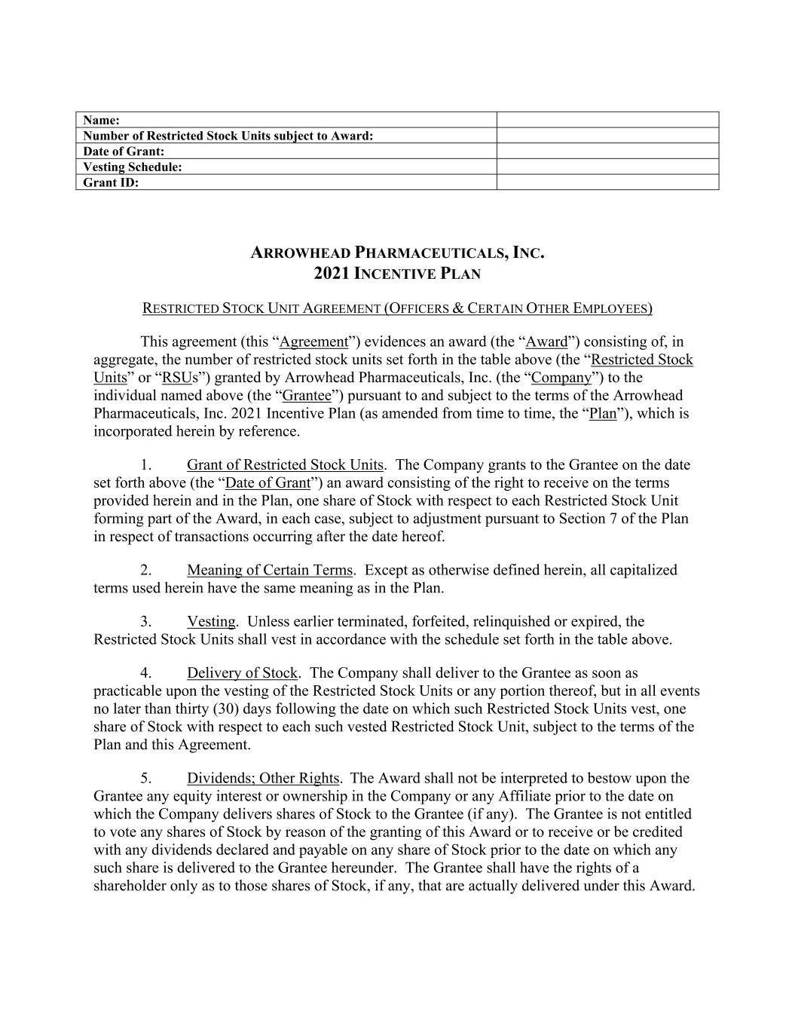
F-31
Name: Number of Restricted Stock Units subject to Award: Date of Grant: Vesting Schedule: Grant ID: ARROWHEAD PHARMACEUTICALS, INC. 2021 INCENTIVE PLAN RESTRICTED STOCK UNIT AGREEMENT (OFFICERS & CERTAIN OTHER EMPLOYEES) This agreement (this “Agreement”) evidences an award (the “Award”) consisting of, in aggregate, the number of restricted stock units set forth in the table above (the “Restricted Stock Units” or “RSUs”) granted by Arrowhead Pharmaceuticals, Inc. (the “Company”) to the individual named above (the “Grantee”) pursuant to and subject to the terms of the Arrowhead Pharmaceuticals, Inc. 2021 Incentive Plan (as amended from time to time, the “Plan”), which is incorporated herein by reference. 1. Grant of Restricted Stock Units. The Company grants to the Grantee on the date set forth above (the “Date of Grant”) an award consisting of the right to receive on the terms provided herein and in the Plan, one share of Stock with respect to each Restricted Stock Unit forming part of the Award, in each case, subject to adjustment pursuant to Section 7 of the Plan in respect of transactions occurring after the date hereof. 2. Meaning of Certain Terms. Except as otherwise defined herein, all capitalized terms used herein have the same meaning as in the Plan. 3. Vesting. Unless earlier terminated, forfeited, relinquished or expired, the Restricted Stock Units shall vest in accordance with the schedule set forth in the table above. 4. Delivery of Stock. The Company shall deliver to the Grantee as soon as practicable upon the vesting of the Restricted Stock Units or any portion thereof, but in all events no later than thirty (30) days following the date on which such Restricted Stock Units vest, one share of Stock with respect to each such vested Restricted Stock Unit, subject to the terms of the Plan and this Agreement. 5. Dividends; Other Rights. The Award shall not be interpreted to bestow upon the Grantee any equity interest or ownership in the Company or any Affiliate prior to the date on which the Company delivers shares of Stock to the Grantee (if any). The Grantee is not entitled to vote any shares of Stock by reason of the granting of this Award or to receive or be credited with any dividends declared and payable on any share of Stock prior to the date on which any such share is delivered to the Grantee hereunder. The Grantee shall have the rights of a shareholder only as to those shares of Stock, if any, that are actually delivered under this Award.

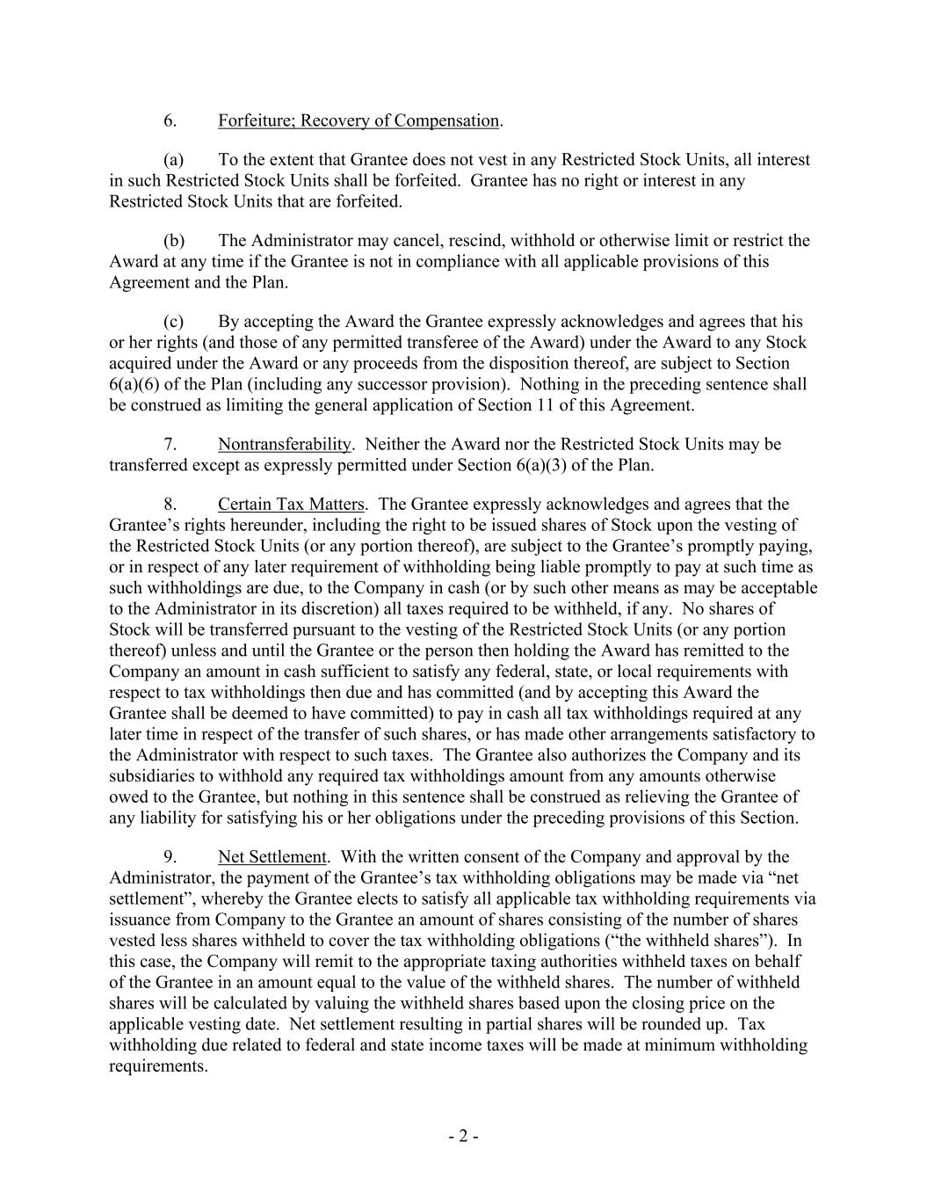
- 2 - 6. Forfeiture; Recovery of Compensation. (a) To the extent that Grantee does not vest in any Restricted Stock Units, all interest in such Restricted Stock Units shall be forfeited. Grantee has no right or interest in any Restricted Stock Units that are forfeited. (b) The Administrator may cancel, rescind, withhold or otherwise limit or restrict the Award at any time if the Grantee is not in compliance with all applicable provisions of this Agreement and the Plan. (c) By accepting the Award the Grantee expressly acknowledges and agrees that his or her rights (and those of any permitted transferee of the Award) under the Award to any Stock acquired under the Award or any proceeds from the disposition thereof, are subject to Section 6(a)(6) of the Plan (including any successor provision). Nothing in the preceding sentence shall be construed as limiting the general application of Section 11 of this Agreement. 7. Nontransferability. Neither the Award nor the Restricted Stock Units may be transferred except as expressly permitted under Section 6(a)(3) of the Plan. 8. Certain Tax Matters. The Grantee expressly acknowledges and agrees that the Grantee’s rights hereunder, including the right to be issued shares of Stock upon the vesting of the Restricted Stock Units (or any portion thereof), are subject to the Grantee’s promptly paying, or in respect of any later requirement of withholding being liable promptly to pay at such time as such withholdings are due, to the Company in cash (or by such other means as may be acceptable to the Administrator in its discretion) all taxes required to be withheld, if any. No shares of Stock will be transferred pursuant to the vesting of the Restricted Stock Units (or any portion thereof) unless and until the Grantee or the person then holding the Award has remitted to the Company an amount in cash sufficient to satisfy any federal, state, or local requirements with respect to tax withholdings then due and has committed (and by accepting this Award the Grantee shall be deemed to have committed) to pay in cash all tax withholdings required at any later time in respect of the transfer of such shares, or has made other arrangements satisfactory to the Administrator with respect to such taxes. The Grantee also authorizes the Company and its subsidiaries to withhold any required tax withholdings amount from any amounts otherwise owed to the Grantee, but nothing in this sentence shall be construed as relieving the Grantee of any liability for satisfying his or her obligations under the preceding provisions of this Section. 9. Net Settlement. With the written consent of the Company and approval by the Administrator, the payment of the Grantee’s tax withholding obligations may be made via “net settlement”, whereby the Grantee elects to satisfy all applicable tax withholding requirements via issuance from Company to the Grantee an amount of shares consisting of the number of shares vested less shares withheld to cover the tax withholding obligations (“the withheld shares”). In this case, the Company will remit to the appropriate taxing authorities withheld taxes on behalf of the Grantee in an amount equal to the value of the withheld shares. The number of withheld shares will be calculated by valuing the withheld shares based upon the closing price on the applicable vesting date. Net settlement resulting in partial shares will be rounded up. Tax withholding due related to federal and state income taxes will be made at minimum withholding requirements.

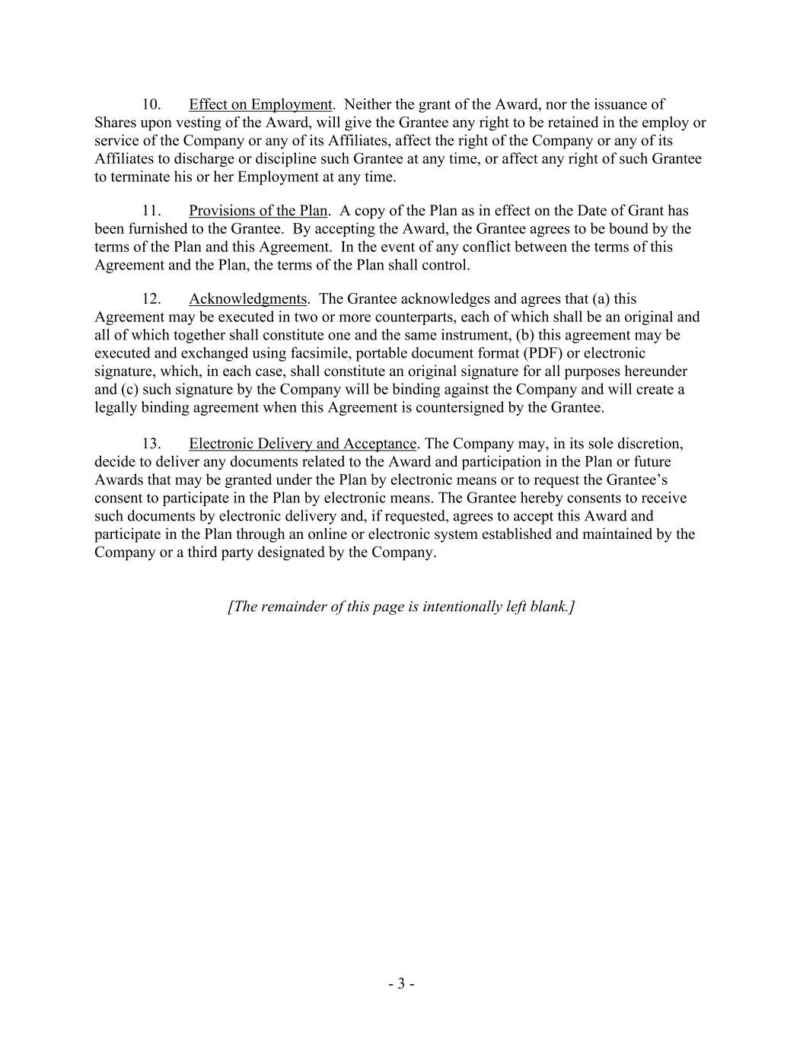
- 3 - 10. Effect on Employment. Neither the grant of the Award, nor the issuance of Shares upon vesting of the Award, will give the Grantee any right to be retained in the employ or service of the Company or any of its Affiliates, affect the right of the Company or any of its Affiliates to discharge or discipline such Grantee at any time, or affect any right of such Grantee to terminate his or her Employment at any time. 11. Provisions of the Plan. A copy of the Plan as in effect on the Date of Grant has been furnished to the Grantee. By accepting the Award, the Grantee agrees to be bound by the terms of the Plan and this Agreement. In the event of any conflict between the terms of this Agreement and the Plan, the terms of the Plan shall control. 12. Acknowledgments. The Grantee acknowledges and agrees that (a) this Agreement may be executed in two or more counterparts, each of which shall be an original and all of which together shall constitute one and the same instrument, (b) this agreement may be executed and exchanged using facsimile, portable document format (PDF) or electronic signature, which, in each case, shall constitute an original signature for all purposes hereunder and (c) such signature by the Company will be binding against the Company and will create a legally binding agreement when this Agreement is countersigned by the Grantee. 13. Electronic Delivery and Acceptance. The Company may, in its sole discretion, decide to deliver any documents related to the Award and participation in the Plan or future Awards that may be granted under the Plan by electronic means or to request the Grantee’s consent to participate in the Plan by electronic means. The Grantee hereby consents to receive such documents by electronic delivery and, if requested, agrees to accept this Award and participate in the Plan through an online or electronic system established and maintained by the Company or a third party designated by the Company. [The remainder of this page is intentionally left blank.]

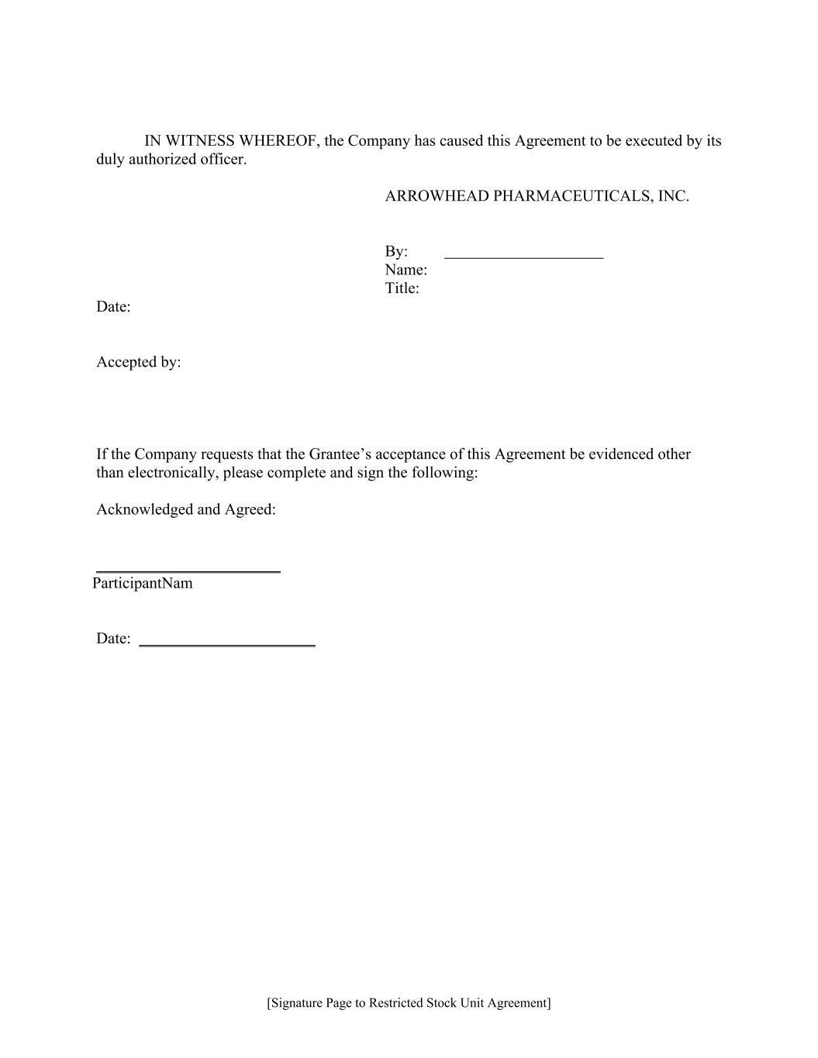
[Signature Page to Restricted Stock Unit Agreement] IN WITNESS WHEREOF, the Company has caused this Agreement to be executed by its duly authorized officer. ARROWHEAD PHARMACEUTICALS, INC. By: Name: Title: Date: Accepted by: If the Company requests that the Grantee’s acceptance of this Agreement be evidenced other than electronically, please complete and sign the following: Acknowledged and Agreed: _______________________ ParticipantNam Date: ______________________

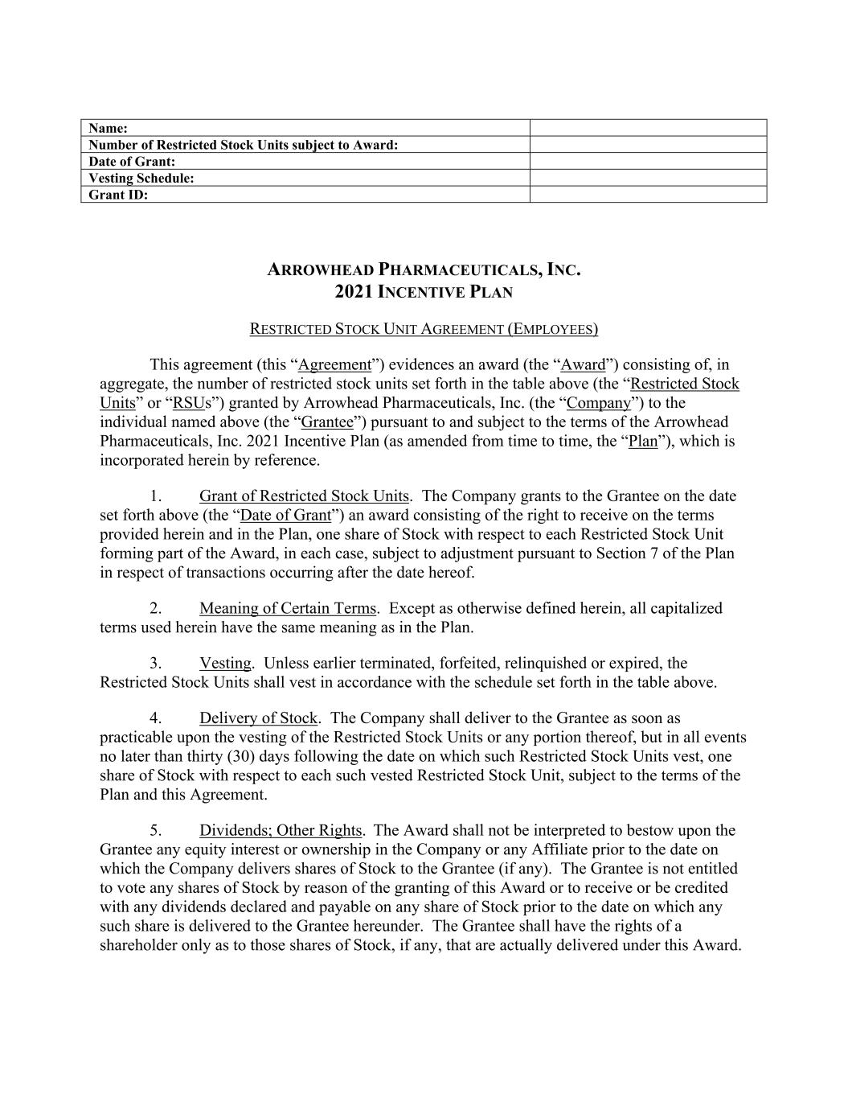
Name: Number of Restricted Stock Units subject to Award: Date of Grant: Vesting Schedule: Grant ID: ARROWHEAD PHARMACEUTICALS, INC. 2021 INCENTIVE PLAN RESTRICTED STOCK UNIT AGREEMENT (EMPLOYEES) This agreement (this “Agreement”) evidences an award (the “Award”) consisting of, in aggregate, the number of restricted stock units set forth in the table above (the “Restricted Stock Units” or “RSUs”) granted by Arrowhead Pharmaceuticals, Inc. (the “Company”) to the individual named above (the “Grantee”) pursuant to and subject to the terms of the Arrowhead Pharmaceuticals, Inc. 2021 Incentive Plan (as amended from time to time, the “Plan”), which is incorporated herein by reference. 1. Grant of Restricted Stock Units. The Company grants to the Grantee on the date set forth above (the “Date of Grant”) an award consisting of the right to receive on the terms provided herein and in the Plan, one share of Stock with respect to each Restricted Stock Unit forming part of the Award, in each case, subject to adjustment pursuant to Section 7 of the Plan in respect of transactions occurring after the date hereof. 2. Meaning of Certain Terms. Except as otherwise defined herein, all capitalized terms used herein have the same meaning as in the Plan. 3. Vesting. Unless earlier terminated, forfeited, relinquished or expired, the Restricted Stock Units shall vest in accordance with the schedule set forth in the table above. 4. Delivery of Stock. The Company shall deliver to the Grantee as soon as practicable upon the vesting of the Restricted Stock Units or any portion thereof, but in all events no later than thirty (30) days following the date on which such Restricted Stock Units vest, one share of Stock with respect to each such vested Restricted Stock Unit, subject to the terms of the Plan and this Agreement. 5. Dividends; Other Rights. The Award shall not be interpreted to bestow upon the Grantee any equity interest or ownership in the Company or any Affiliate prior to the date on which the Company delivers shares of Stock to the Grantee (if any). The Grantee is not entitled to vote any shares of Stock by reason of the granting of this Award or to receive or be credited with any dividends declared and payable on any share of Stock prior to the date on which any such share is delivered to the Grantee hereunder. The Grantee shall have the rights of a shareholder only as to those shares of Stock, if any, that are actually delivered under this Award.

- 2 - 6. Forfeiture; Recovery of Compensation. (a) To the extent that Grantee does not vest in any Restricted Stock Units, all interest in such Restricted Stock Units shall be forfeited. Grantee has no right or interest in any Restricted Stock Units that are forfeited. (b) The Administrator may cancel, rescind, withhold or otherwise limit or restrict the Award at any time if the Grantee is not in compliance with all applicable provisions of this Agreement and the Plan. (c) By accepting the Award the Grantee expressly acknowledges and agrees that his or her rights (and those of any permitted transferee of the Award) under the Award to any Stock acquired under the Award or any proceeds from the disposition thereof, are subject to Section 6(a)(6) of the Plan (including any successor provision). Nothing in the preceding sentence shall be construed as limiting the general application of Section 11 of this Agreement. 7. Nontransferability. Neither the Award nor the Restricted Stock Units may be transferred except as expressly permitted under Section 6(a)(3) of the Plan. 8. Certain Tax Matters. The Grantee expressly acknowledges and agrees that the Grantee’s rights hereunder, including the right to be issued shares of Stock upon the vesting of the Restricted Stock Units (or any portion thereof), are subject to the Grantee’s promptly paying, or in respect of any later requirement of withholding being liable promptly to pay at such time as such withholdings are due, to the Company in cash (or by such other means as may be acceptable to the Administrator in its discretion) all taxes required to be withheld, if any. No shares of Stock will be transferred pursuant to the vesting of the Restricted Stock Units (or any portion thereof) unless and until the Grantee or the person then holding the Award has remitted to the Company an amount in cash sufficient to satisfy any federal, state, or local requirements with respect to tax withholdings then due and has committed (and by accepting this Award the Grantee shall be deemed to have committed) to pay in cash all tax withholdings required at any later time in respect of the transfer of such shares, or has made other arrangements satisfactory to the Administrator with respect to such taxes. The Grantee also authorizes the Company and its subsidiaries to withhold any required tax withholdings amount from any amounts otherwise owed to the Grantee, but nothing in this sentence shall be construed as relieving the Grantee of any liability for satisfying his or her obligations under the preceding provisions of this Section. 9. Net Settlement. With the written consent of the Company and approval by the Administrator, the payment of the Grantee’s tax withholding obligations may be made via “net settlement”, whereby the Grantee elects to satisfy all applicable tax withholding requirements via issuance from Company to the Grantee an amount of shares consisting of the number of shares vested less shares withheld to cover the tax withholding obligations (“the withheld shares”). In this case, the Company will remit to the appropriate taxing authorities withheld taxes on behalf of the Grantee in an amount equal to the value of the withheld shares. The number of withheld shares will be calculated by valuing the withheld shares based upon the closing price on the applicable vesting date. Net settlement resulting in partial shares will be rounded up. Tax withholding due related to federal and state income taxes will be made at minimum withholding requirements.

- 3 - 10. Effect on Employment. Neither the grant of the Award, nor the issuance of Shares upon vesting of the Award, will give the Grantee any right to be retained in the employ or service of the Company or any of its Affiliates, affect the right of the Company or any of its Affiliates to discharge or discipline such Grantee at any time, or affect any right of such Grantee to terminate his or her Employment at any time. 11. Provisions of the Plan. A copy of the Plan as in effect on the Date of Grant has been furnished to the Grantee. By accepting the Award, the Grantee agrees to be bound by the terms of the Plan and this Agreement. In the event of any conflict between the terms of this Agreement and the Plan, the terms of the Plan shall control. 12. Acknowledgments. The Grantee acknowledges and agrees that (a) this Agreement may be executed in two or more counterparts, each of which shall be an original and all of which together shall constitute one and the same instrument, (b) this agreement may be executed and exchanged using facsimile, portable document format (PDF) or electronic signature, which, in each case, shall constitute an original signature for all purposes hereunder and (c) such signature by the Company will be binding against the Company and will create a legally binding agreement when this Agreement is countersigned by the Grantee. 13. Electronic Delivery and Acceptance. The Company may, in its sole discretion, decide to deliver any documents related to the Award and participation in the Plan or future Awards that may be granted under the Plan by electronic means or to request the Grantee’s consent to participate in the Plan by electronic means. The Grantee hereby consents to receive such documents by electronic delivery and, if requested, agrees to accept this Award and participate in the Plan through an online or electronic system established and maintained by the Company or a third party designated by the Company. [The remainder of this page is intentionally left blank.]

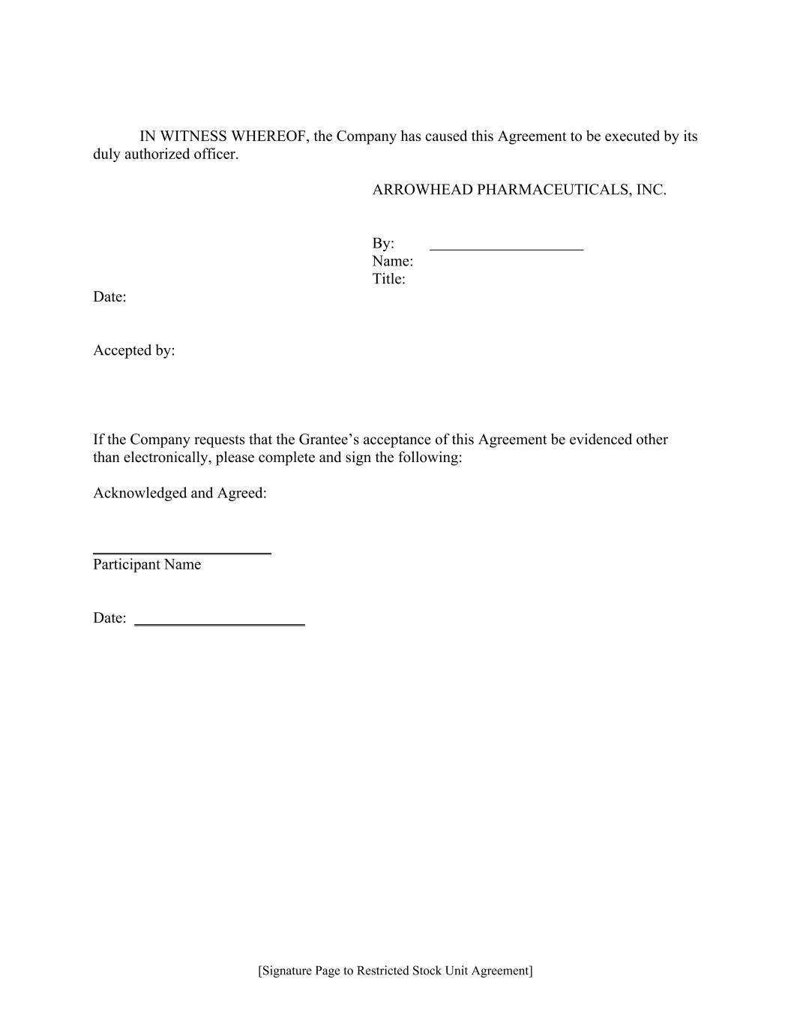
[Signature Page to Restricted Stock Unit Agreement] IN WITNESS WHEREOF, the Company has caused this Agreement to be executed by its duly authorized officer. ARROWHEAD PHARMACEUTICALS, INC. By: Name: Title: Date: Accepted by: If the Company requests that the Grantee’s acceptance of this Agreement be evidenced other than electronically, please complete and sign the following: Acknowledged and Agreed: _______________________ Participant Name Date: ______________________

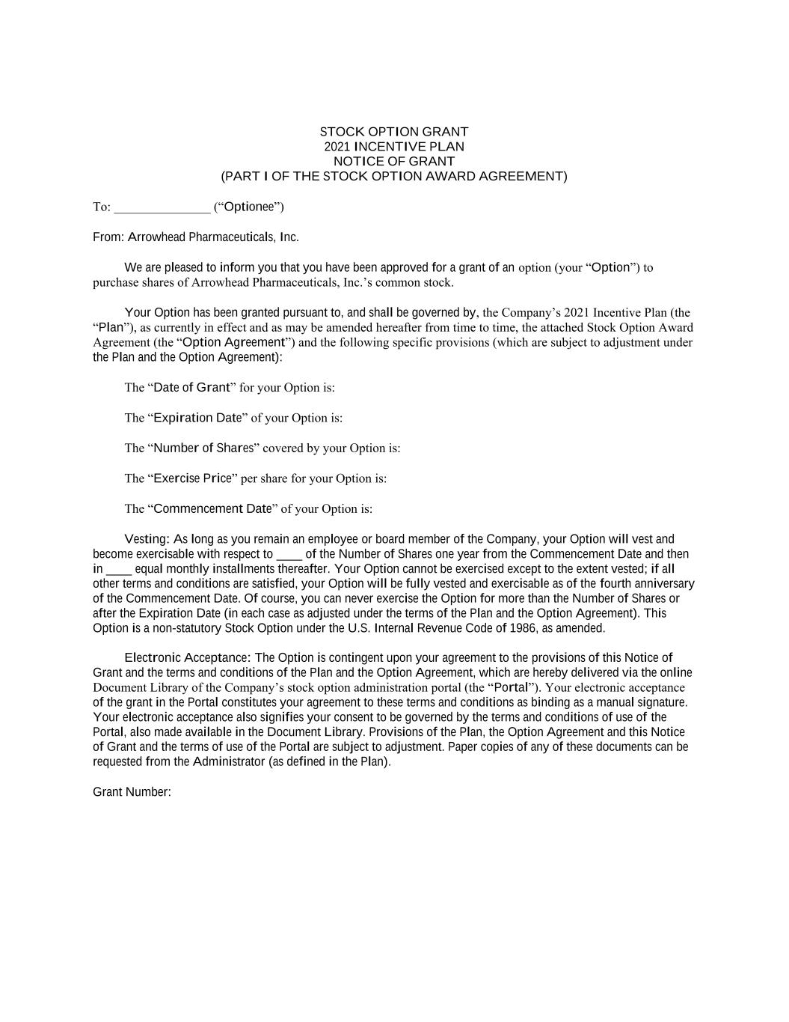
STOCK OPTION GRANT 2021 INCENTIVE PLAN NOTICE OF GRANT (PART I OF THE STOCK OPTION AWARD AGREEMENT) To: _______________ (“Optionee”) From: Arrowhead Pharmaceuticals, Inc. We are pleased to inform you that you have been approved for a grant of an option (your “Option”) to purchase shares of Arrowhead Pharmaceuticals, Inc.’s common stock. Your Option has been granted pursuant to, and shall be governed by, the Company’s 2021 Incentive Plan (the “Plan”), as currently in effect and as may be amended hereafter from time to time, the attached Stock Option Award Agreement (the “Option Agreement”) and the following specific provisions (which are subject to adjustment under the Plan and the Option Agreement): The “Date of Grant” for your Option is: The “Expiration Date” of your Option is: The “Number of Shares” covered by your Option is: The “Exercise Price” per share for your Option is: The “Commencement Date” of your Option is: Vesting: As long as you remain an employee or board member of the Company, your Option will vest and become exercisable with respect to ____ of the Number of Shares one year from the Commencement Date and then in ____ equal monthly installments thereafter. Your Option cannot be exercised except to the extent vested; if all other terms and conditions are satisfied, your Option will be fully vested and exercisable as of the fourth anniversary of the Commencement Date. Of course, you can never exercise the Option for more than the Number of Shares or after the Expiration Date (in each case as adjusted under the terms of the Plan and the Option Agreement). This Option is a non-statutory Stock Option under the U.S. Internal Revenue Code of 1986, as amended. Electronic Acceptance: The Option is contingent upon your agreement to the provisions of this Notice of Grant and the terms and conditions of the Plan and the Option Agreement, which are hereby delivered via the online Document Library of the Company’s stock option administration portal (the “Portal”). Your electronic acceptance of the grant in the Portal constitutes your agreement to these terms and conditions as binding as a manual signature. Your electronic acceptance also signifies your consent to be governed by the terms and conditions of use of the Portal, also made available in the Document Library. Provisions of the Plan, the Option Agreement and this Notice of Grant and the terms of use of the Portal are subject to adjustment. Paper copies of any of these documents can be requested from the Administrator (as defined in the Plan). Grant Number:

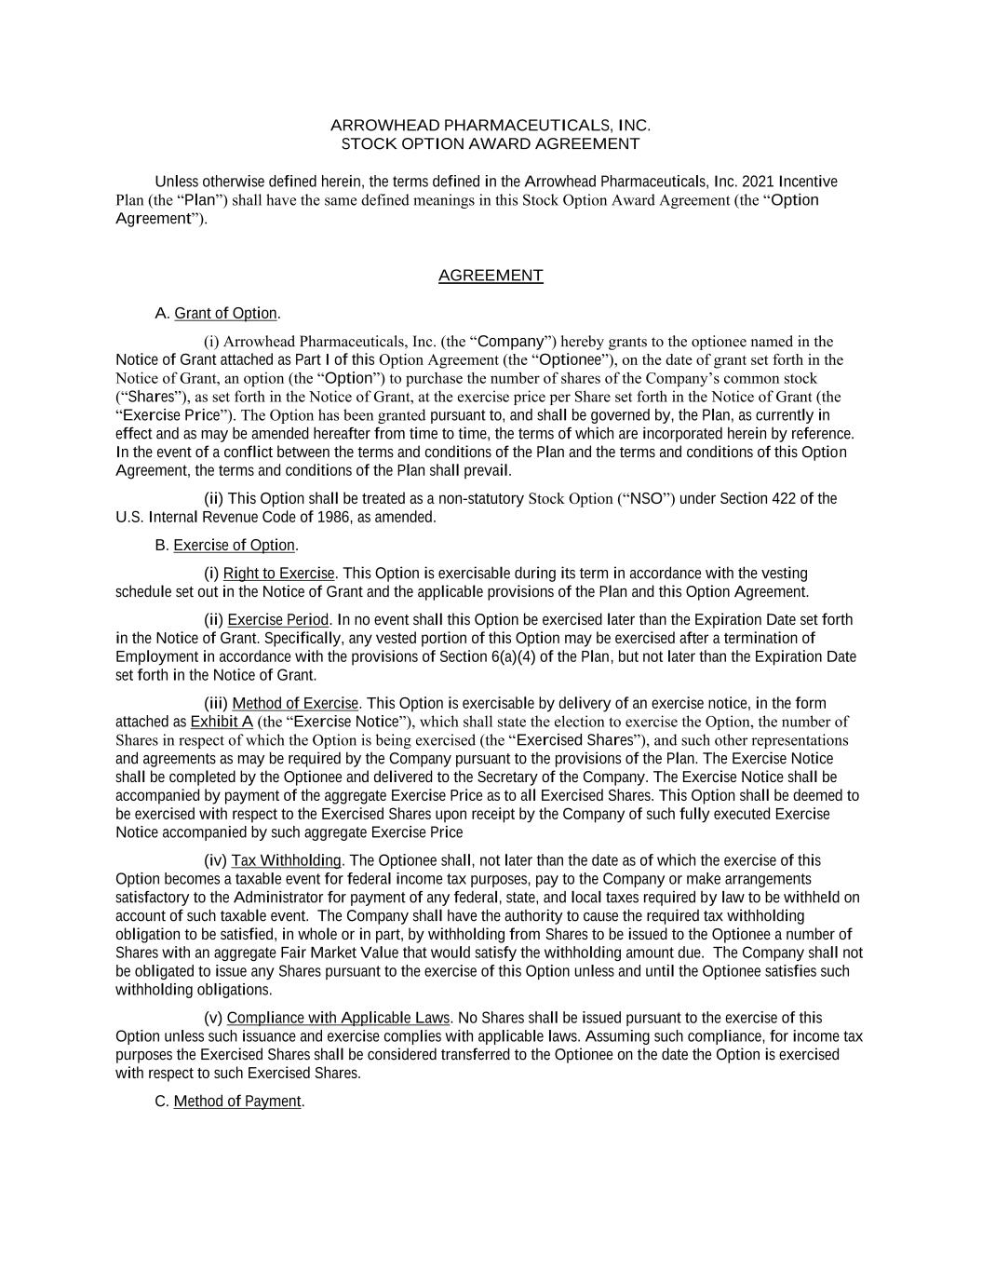
ARROWHEAD PHARMACEUTICALS, INC. STOCK OPTION AWARD AGREEMENT Unless otherwise defined herein, the terms defined in the Arrowhead Pharmaceuticals, Inc. 2021 Incentive Plan (the “Plan”) shall have the same defined meanings in this Stock Option Award Agreement (the “Option Agreement”). AGREEMENT A. Grant of Option. (i) Arrowhead Pharmaceuticals, Inc. (the “Company”) hereby grants to the optionee named in the Notice of Grant attached as Part I of this Option Agreement (the “Optionee”), on the date of grant set forth in the Notice of Grant, an option (the “Option”) to purchase the number of shares of the Company’s common stock (“Shares”), as set forth in the Notice of Grant, at the exercise price per Share set forth in the Notice of Grant (the “Exercise Price”). The Option has been granted pursuant to, and shall be governed by, the Plan, as currently in effect and as may be amended hereafter from time to time, the terms of which are incorporated herein by reference. In the event of a conflict between the terms and conditions of the Plan and the terms and conditions of this Option Agreement, the terms and conditions of the Plan shall prevail. (ii) This Option shall be treated as a non-statutory Stock Option (“NSO”) under Section 422 of the U.S. Internal Revenue Code of 1986, as amended. B. Exercise of Option. (i) Right to Exercise. This Option is exercisable during its term in accordance with the vesting schedule set out in the Notice of Grant and the applicable provisions of the Plan and this Option Agreement. (ii) Exercise Period. In no event shall this Option be exercised later than the Expiration Date set forth in the Notice of Grant. Specifically, any vested portion of this Option may be exercised after a termination of Employment in accordance with the provisions of Section 6(a)(4) of the Plan, but not later than the Expiration Date set forth in the Notice of Grant. (iii) Method of Exercise. This Option is exercisable by delivery of an exercise notice, in the form attached as Exhibit A (the “Exercise Notice”), which shall state the election to exercise the Option, the number of Shares in respect of which the Option is being exercised (the “Exercised Shares”), and such other representations and agreements as may be required by the Company pursuant to the provisions of the Plan. The Exercise Notice shall be completed by the Optionee and delivered to the Secretary of the Company. The Exercise Notice shall be accompanied by payment of the aggregate Exercise Price as to all Exercised Shares. This Option shall be deemed to be exercised with respect to the Exercised Shares upon receipt by the Company of such fully executed Exercise Notice accompanied by such aggregate Exercise Price (iv) Tax Withholding. The Optionee shall, not later than the date as of which the exercise of this Option becomes a taxable event for federal income tax purposes, pay to the Company or make arrangements satisfactory to the Administrator for payment of any federal, state, and local taxes required by law to be withheld on account of such taxable event. The Company shall have the authority to cause the required tax withholding obligation to be satisfied, in whole or in part, by withholding from Shares to be issued to the Optionee a number of Shares with an aggregate Fair Market Value that would satisfy the withholding amount due. The Company shall not be obligated to issue any Shares pursuant to the exercise of this Option unless and until the Optionee satisfies such withholding obligations. (v) Compliance with Applicable Laws. No Shares shall be issued pursuant to the exercise of this Option unless such issuance and exercise complies with applicable laws. Assuming such compliance, for income tax purposes the Exercised Shares shall be considered transferred to the Optionee on the date the Option is exercised with respect to such Exercised Shares. C. Method of Payment.

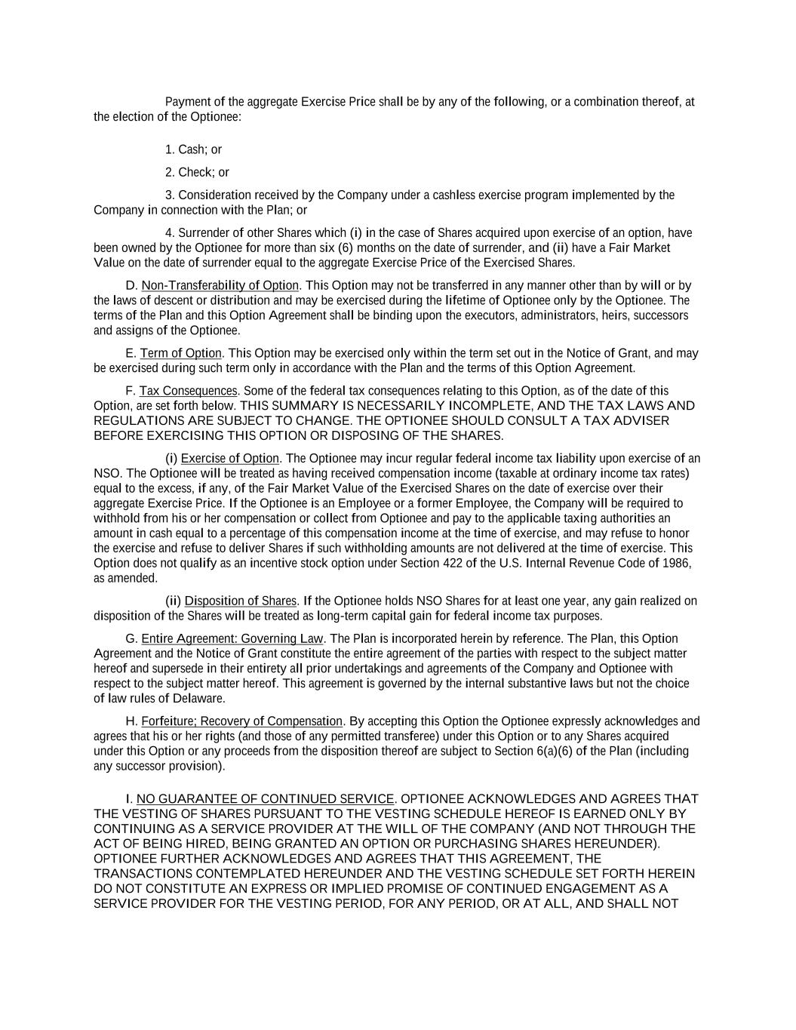
Payment of the aggregate Exercise Price shall be by any of the following, or a combination thereof, at the election of the Optionee: 1. Cash; or 2. Check; or 3. Consideration received by the Company under a cashless exercise program implemented by the Company in connection with the Plan; or 4. Surrender of other Shares which (i) in the case of Shares acquired upon exercise of an option, have been owned by the Optionee for more than six (6) months on the date of surrender, and (ii) have a Fair Market Value on the date of surrender equal to the aggregate Exercise Price of the Exercised Shares. D. Non-Transferability of Option. This Option may not be transferred in any manner other than by will or by the laws of descent or distribution and may be exercised during the lifetime of Optionee only by the Optionee. The terms of the Plan and this Option Agreement shall be binding upon the executors, administrators, heirs, successors and assigns of the Optionee. E. Term of Option. This Option may be exercised only within the term set out in the Notice of Grant, and may be exercised during such term only in accordance with the Plan and the terms of this Option Agreement. F. Tax Consequences. Some of the federal tax consequences relating to this Option, as of the date of this Option, are set forth below. THIS SUMMARY IS NECESSARILY INCOMPLETE, AND THE TAX LAWS AND REGULATIONS ARE SUBJECT TO CHANGE. THE OPTIONEE SHOULD CONSULT A TAX ADVISER BEFORE EXERCISING THIS OPTION OR DISPOSING OF THE SHARES. (i) Exercise of Option. The Optionee may incur regular federal income tax liability upon exercise of an NSO. The Optionee will be treated as having received compensation income (taxable at ordinary income tax rates) equal to the excess, if any, of the Fair Market Value of the Exercised Shares on the date of exercise over their aggregate Exercise Price. If the Optionee is an Employee or a former Employee, the Company will be required to withhold from his or her compensation or collect from Optionee and pay to the applicable taxing authorities an amount in cash equal to a percentage of this compensation income at the time of exercise, and may refuse to honor the exercise and refuse to deliver Shares if such withholding amounts are not delivered at the time of exercise. This Option does not qualify as an incentive stock option under Section 422 of the U.S. Internal Revenue Code of 1986, as amended. (ii) Disposition of Shares. If the Optionee holds NSO Shares for at least one year, any gain realized on disposition of the Shares will be treated as long-term capital gain for federal income tax purposes. G. Entire Agreement: Governing Law. The Plan is incorporated herein by reference. The Plan, this Option Agreement and the Notice of Grant constitute the entire agreement of the parties with respect to the subject matter hereof and supersede in their entirety all prior undertakings and agreements of the Company and Optionee with respect to the subject matter hereof. This agreement is governed by the internal substantive laws but not the choice of law rules of Delaware. H. Forfeiture; Recovery of Compensation. By accepting this Option the Optionee expressly acknowledges and agrees that his or her rights (and those of any permitted transferee) under this Option or to any Shares acquired under this Option or any proceeds from the disposition thereof are subject to Section 6(a)(6) of the Plan (including any successor provision). I. NO GUARANTEE OF CONTINUED SERVICE. OPTIONEE ACKNOWLEDGES AND AGREES THAT THE VESTING OF SHARES PURSUANT TO THE VESTING SCHEDULE HEREOF IS EARNED ONLY BY CONTINUING AS A SERVICE PROVIDER AT THE WILL OF THE COMPANY (AND NOT THROUGH THE ACT OF BEING HIRED, BEING GRANTED AN OPTION OR PURCHASING SHARES HEREUNDER). OPTIONEE FURTHER ACKNOWLEDGES AND AGREES THAT THIS AGREEMENT, THE TRANSACTIONS CONTEMPLATED HEREUNDER AND THE VESTING SCHEDULE SET FORTH HEREIN DO NOT CONSTITUTE AN EXPRESS OR IMPLIED PROMISE OF CONTINUED ENGAGEMENT AS A SERVICE PROVIDER FOR THE VESTING PERIOD, FOR ANY PERIOD, OR AT ALL, AND SHALL NOT


INTERFERE WITH OPTIONEE’S RIGHT OR THE COMPANY’S RIGHT TO TERMINATE OPTIONEE’S RELATIONSHIP AS A SERVICE PROVIDER AT ANY TIME, WITH OR WITHOUT CAUSE. J. Electronic Delivery and Acceptance. The Company may, in its sole discretion, decide to deliver any documents related to this Award or future Awards by electronic means or to request the Optionee’s consent to participate in the Plan by electronic means. The Optionee hereby consents to receive such documents by electronic delivery and, if requested, agrees to accept this Award and participate in the Plan through an online or electronic system established and maintained by the Company or a third party designated by the Company.

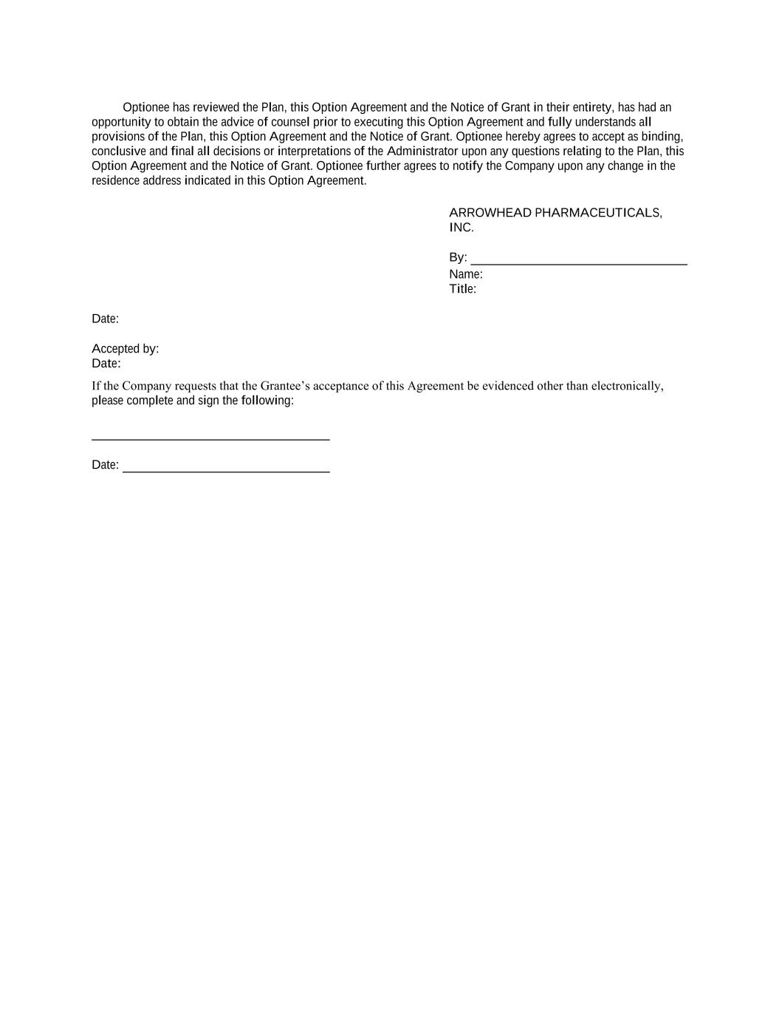
Optionee has reviewed the Plan, this Option Agreement and the Notice of Grant in their entirety, has had an opportunity to obtain the advice of counsel prior to executing this Option Agreement and fully understands all provisions of the Plan, this Option Agreement and the Notice of Grant. Optionee hereby agrees to accept as binding, conclusive and final all decisions or interpretations of the Administrator upon any questions relating to the Plan, this Option Agreement and the Notice of Grant. Optionee further agrees to notify the Company upon any change in the residence address indicated in this Option Agreement. ARROWHEAD PHARMACEUTICALS, INC. By: Name: Title: Date: Accepted by: Date: If the Company requests that the Grantee’s acceptance of this Agreement be evidenced other than electronically, please complete and sign the following: Date:

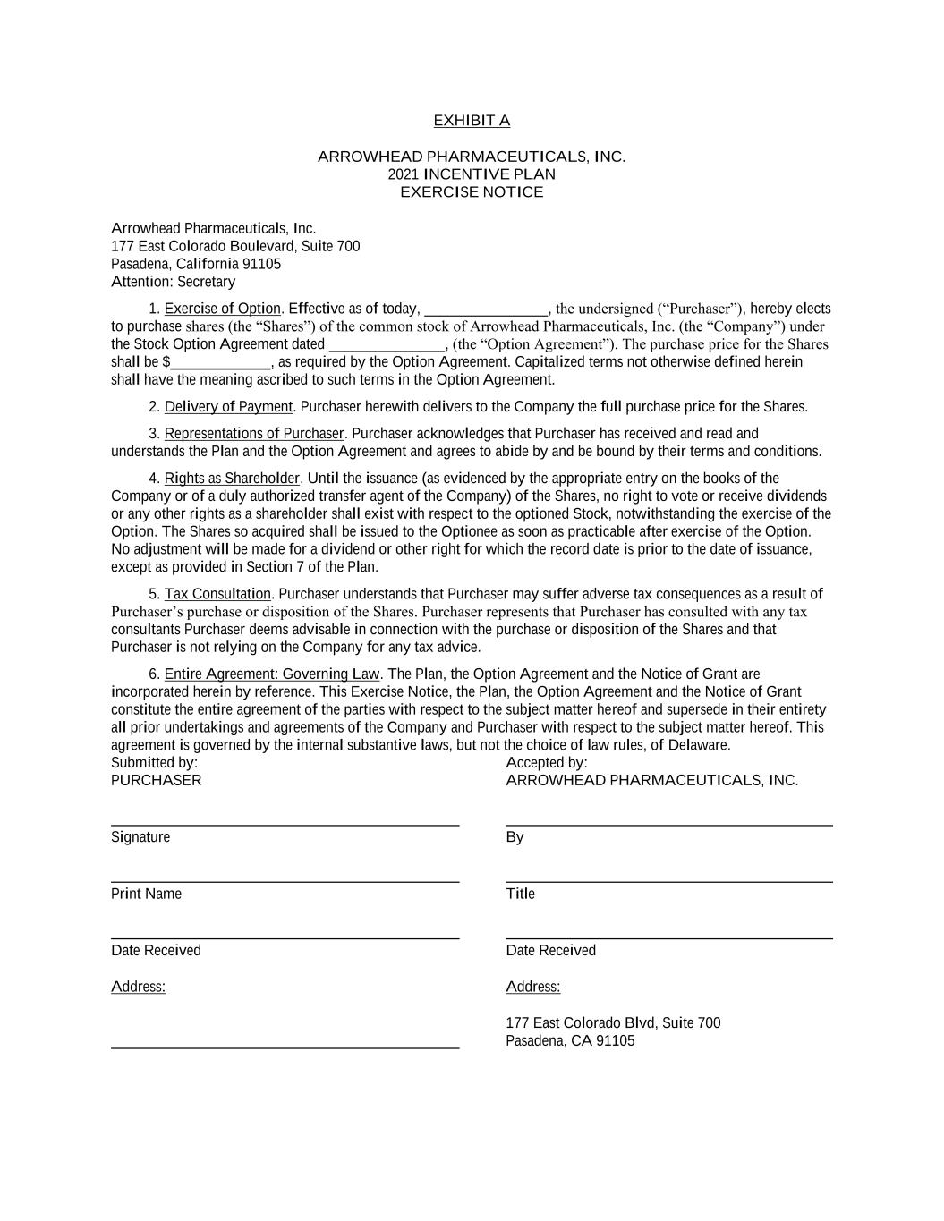
EXHIBIT A ARROWHEAD PHARMACEUTICALS, INC. 2021 INCENTIVE PLAN EXERCISE NOTICE Arrowhead Pharmaceuticals, Inc. 177 East Colorado Boulevard, Suite 700 Pasadena, California 91105 Attention: Secretary 1. Exercise of Option. Effective as of today, ________________, the undersigned (“Purchaser”), hereby elects to purchase shares (the “Shares”) of the common stock of Arrowhead Pharmaceuticals, Inc. (the “Company”) under the Stock Option Agreement dated _______________, (the “Option Agreement”). The purchase price for the Shares shall be $_____________, as required by the Option Agreement. Capitalized terms not otherwise defined herein shall have the meaning ascribed to such terms in the Option Agreement. 2. Delivery of Payment. Purchaser herewith delivers to the Company the full purchase price for the Shares. 3. Representations of Purchaser. Purchaser acknowledges that Purchaser has received and read and understands the Plan and the Option Agreement and agrees to abide by and be bound by their terms and conditions. 4. Rights as Shareholder. Until the issuance (as evidenced by the appropriate entry on the books of the Company or of a duly authorized transfer agent of the Company) of the Shares, no right to vote or receive dividends or any other rights as a shareholder shall exist with respect to the optioned Stock, notwithstanding the exercise of the Option. The Shares so acquired shall be issued to the Optionee as soon as practicable after exercise of the Option. No adjustment will be made for a dividend or other right for which the record date is prior to the date of issuance, except as provided in Section 7 of the Plan. 5. Tax Consultation. Purchaser understands that Purchaser may suffer adverse tax consequences as a result of Purchaser’s purchase or disposition of the Shares. Purchaser represents that Purchaser has consulted with any tax consultants Purchaser deems advisable in connection with the purchase or disposition of the Shares and that Purchaser is not relying on the Company for any tax advice. 6. Entire Agreement: Governing Law. The Plan, the Option Agreement and the Notice of Grant are incorporated herein by reference. This Exercise Notice, the Plan, the Option Agreement and the Notice of Grant constitute the entire agreement of the parties with respect to the subject matter hereof and supersede in their entirety all prior undertakings and agreements of the Company and Purchaser with respect to the subject matter hereof. This agreement is governed by the internal substantive laws, but not the choice of law rules, of Delaware. Submitted by: Accepted by: PURCHASER ARROWHEAD PHARMACEUTICALS, INC. Signature By Print Name Title Date Received Date Received Address: Address: 177 East Colorado Blvd, Suite 700 Pasadena, CA 91105

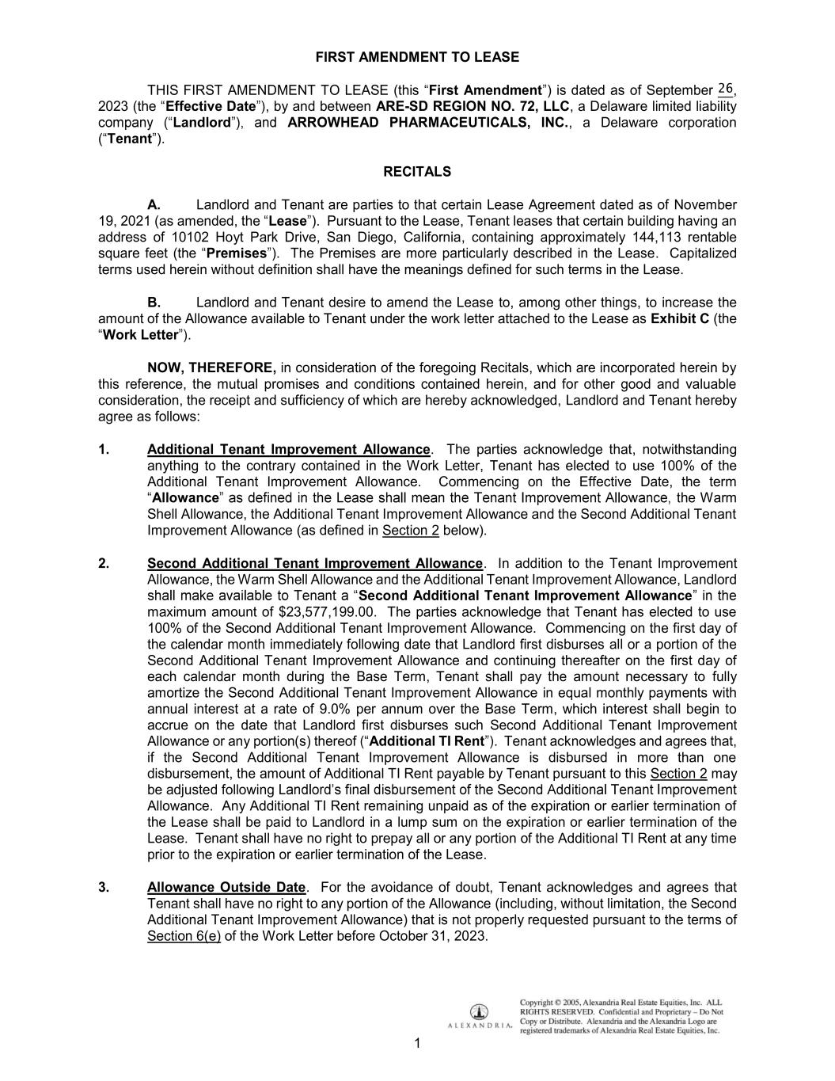
1 FIRST AMENDMENT TO LEASE THIS FIRST AMENDMENT TO LEASE (this First Amendment ) is dated as of September __, 2023 (the Effective Date , by and between ARE-SD REGION NO. 72, LLC, a Delaware limited liability Landlord ARROWHEAD PHARMACEUTICALS, INC., a Delaware corporation ( Tenant ). RECITALS A. Landlord and Tenant are parties to that certain Lease Agreement dated as of November 19, 2021 (as amended, the Lease ). Pursuant to the Lease, Tenant leases that certain building having an address of 10102 Hoyt Park Drive, San Diego, California, containing approximately 144,113 rentable square feet (the Premises ). The Premises are more particularly described in the Lease. Capitalized terms used herein without definition shall have the meanings defined for such terms in the Lease. B. Landlord and Tenant desire to amend the Lease to, among other things, to increase the amount of the Allowance available to Tenant under the work letter attached to the Lease as Exhibit C (the Work Letter . NOW, THEREFORE, in consideration of the foregoing Recitals, which are incorporated herein by this reference, the mutual promises and conditions contained herein, and for other good and valuable consideration, the receipt and sufficiency of which are hereby acknowledged, Landlord and Tenant hereby agree as follows: 1. Additional Tenant Improvement Allowance. The parties acknowledge that, notwithstanding anything to the contrary contained in the Work Letter, Tenant has elected to use 100% of the Additional Tenant Improvement Allowance. Commencing on the Effective Date, the term Allowance the Warm Shell Allowance, the Additional Tenant Improvement Allowance and the Second Additional Tenant Improvement Allowance (as defined in Section 2 below). 2. Second Additional Tenant Improvement Allowance. In addition to the Tenant Improvement Allowance, the Warm Shell Allowance and the Additional Tenant Improvement Allowance, Landlord Second Additional Tenant Improvement Allowance maximum amount of $23,577,199.00. The parties acknowledge that Tenant has elected to use 100% of the Second Additional Tenant Improvement Allowance. Commencing on the first day of the calendar month immediately following date that Landlord first disburses all or a portion of the Second Additional Tenant Improvement Allowance and continuing thereafter on the first day of each calendar month during the Base Term, Tenant shall pay the amount necessary to fully amortize the Second Additional Tenant Improvement Allowance in equal monthly payments with annual interest at a rate of 9.0% per annum over the Base Term, which interest shall begin to accrue on the date that Landlord first disburses such Second Additional Tenant Improvement Allowance or any portion(s) thereof Additional TI Rent . Tenant acknowledges and agrees that, if the Second Additional Tenant Improvement Allowance is disbursed in more than one disbursement, the amount of Additional TI Rent payable by Tenant pursuant to this Section 2 may be adjusted following Allowance. Any Additional TI Rent remaining unpaid as of the expiration or earlier termination of the Lease shall be paid to Landlord in a lump sum on the expiration or earlier termination of the Lease. Tenant shall have no right to prepay all or any portion of the Additional TI Rent at any time prior to the expiration or earlier termination of the Lease. 3. Allowance Outside Date. For the avoidance of doubt, Tenant acknowledges and agrees that Tenant shall have no right to any portion of the Allowance (including, without limitation, the Second Additional Tenant Improvement Allowance) that is not properly requested pursuant to the terms of Section 6(e) of the Work Letter before October 31, 2023.

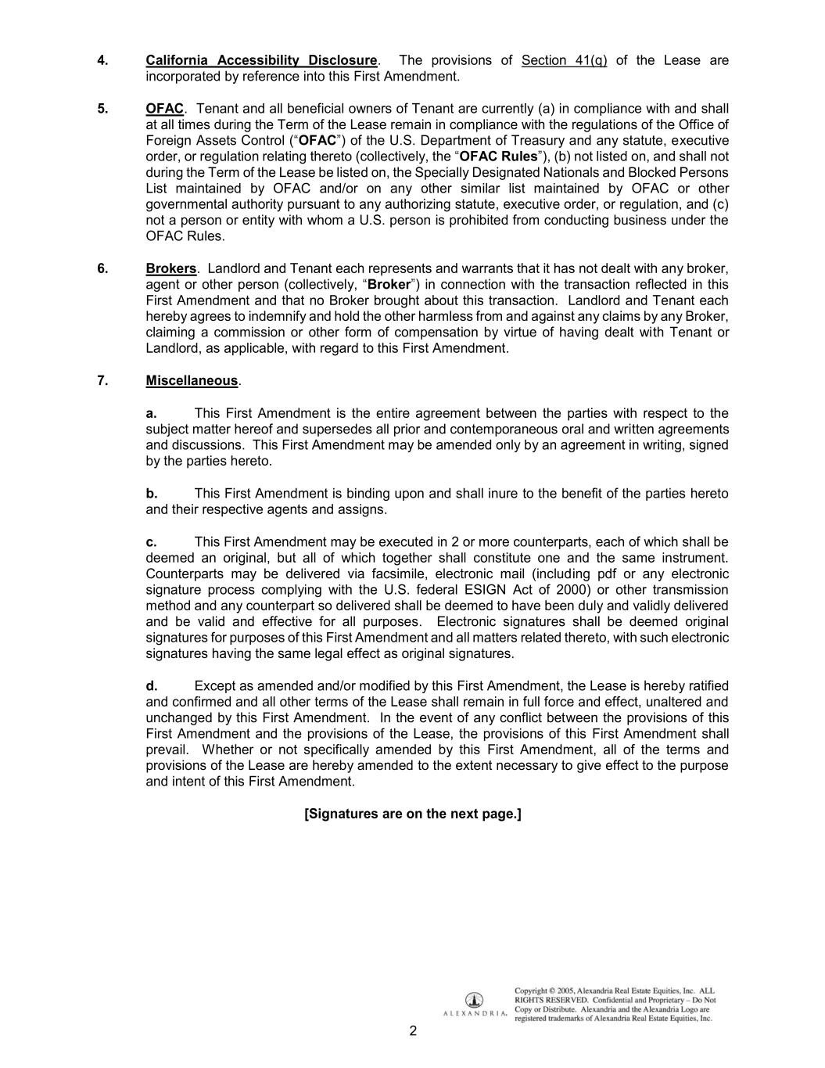
2 4. California Accessibility Disclosure. The provisions of Section 41(q) of the Lease are incorporated by reference into this First Amendment. 5. OFAC. Tenant and all beneficial owners of Tenant are currently (a) in compliance with and shall at all times during the Term of the Lease remain in compliance with the regulations of the Office of Foreign Assets Control ( OFAC ) of the U.S. Department of Treasury and any statute, executive order, or regulation relating thereto (collectively, the OFAC Rules ), (b) not listed on, and shall not during the Term of the Lease be listed on, the Specially Designated Nationals and Blocked Persons List maintained by OFAC and/or on any other similar list maintained by OFAC or other governmental authority pursuant to any authorizing statute, executive order, or regulation, and (c) not a person or entity with whom a U.S. person is prohibited from conducting business under the OFAC Rules. 6. Brokers. Landlord and Tenant each represents and warrants that it has not dealt with any broker, agent or other person (collectively, Broker ) in connection with the transaction reflected in this First Amendment and that no Broker brought about this transaction. Landlord and Tenant each hereby agrees to indemnify and hold the other harmless from and against any claims by any Broker, claiming a commission or other form of compensation by virtue of having dealt with Tenant or Landlord, as applicable, with regard to this First Amendment. 7. Miscellaneous. a. This First Amendment is the entire agreement between the parties with respect to the subject matter hereof and supersedes all prior and contemporaneous oral and written agreements and discussions. This First Amendment may be amended only by an agreement in writing, signed by the parties hereto. b. This First Amendment is binding upon and shall inure to the benefit of the parties hereto and their respective agents and assigns. c. This First Amendment may be executed in 2 or more counterparts, each of which shall be deemed an original, but all of which together shall constitute one and the same instrument. Counterparts may be delivered via facsimile, electronic mail (including pdf or any electronic signature process complying with the U.S. federal ESIGN Act of 2000) or other transmission method and any counterpart so delivered shall be deemed to have been duly and validly delivered and be valid and effective for all purposes. Electronic signatures shall be deemed original signatures for purposes of this First Amendment and all matters related thereto, with such electronic signatures having the same legal effect as original signatures. d. Except as amended and/or modified by this First Amendment, the Lease is hereby ratified and confirmed and all other terms of the Lease shall remain in full force and effect, unaltered and unchanged by this First Amendment. In the event of any conflict between the provisions of this First Amendment and the provisions of the Lease, the provisions of this First Amendment shall prevail. Whether or not specifically amended by this First Amendment, all of the terms and provisions of the Lease are hereby amended to the extent necessary to give effect to the purpose and intent of this First Amendment. [Signatures are on the next page.]

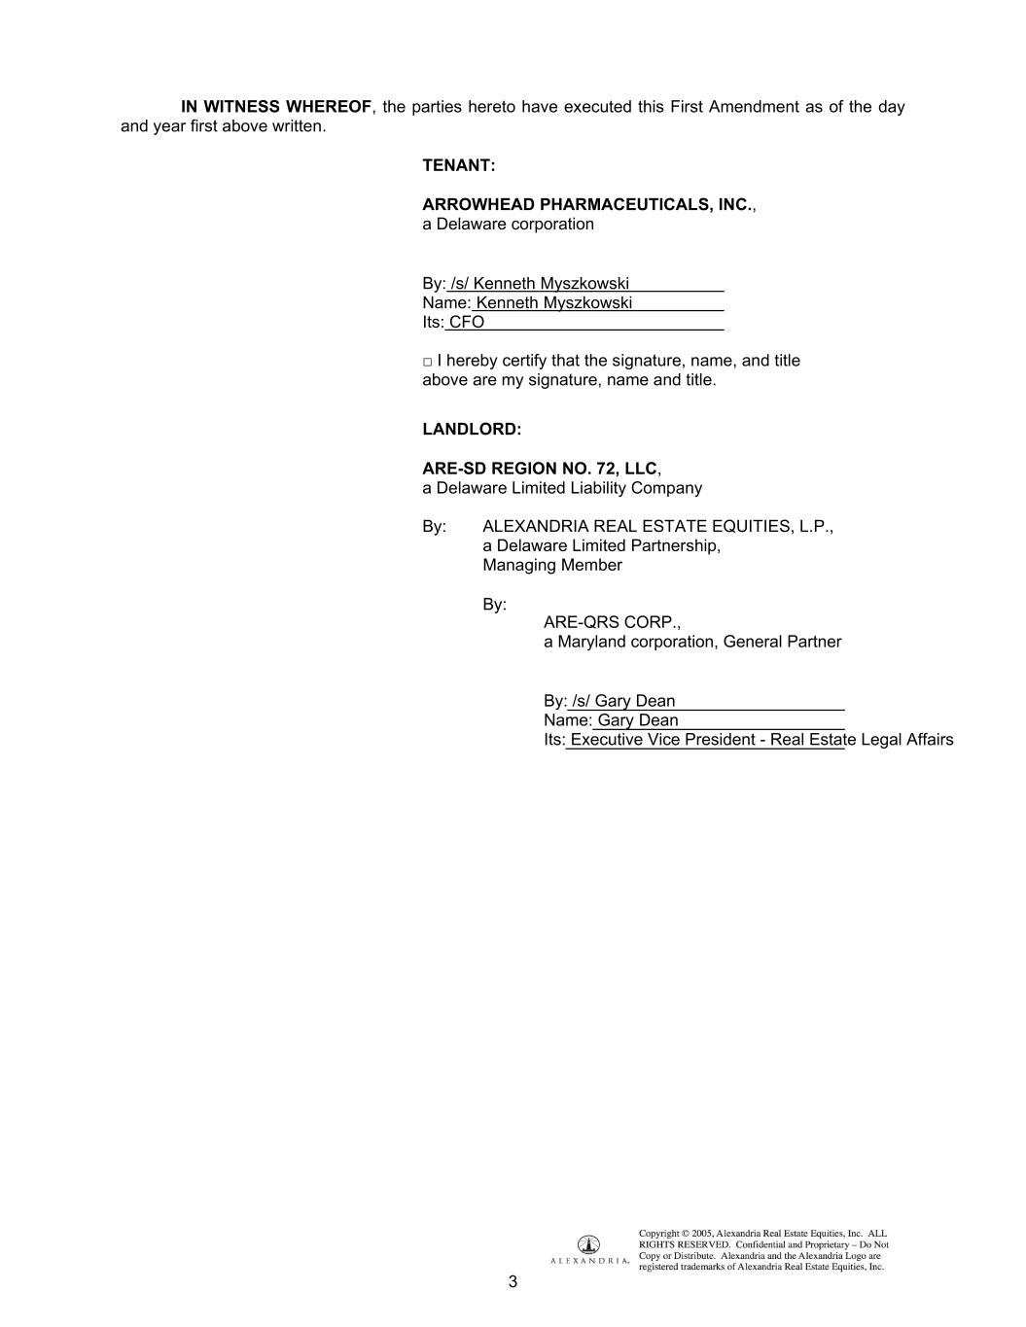
3 IN WITNESS WHEREOF, the parties hereto have executed this First Amendment as of the day and year first above written. TENANT: ARROWHEAD PHARMACEUTICALS, INC., a Delaware corporation By: /s/ Kenneth Myszkowski Name: Kenneth Myszkowski Its: CFO □ I hereby certify that the signature, name, and title above are my signature, name and title. LANDLORD: ARE-SD REGION NO. 72, LLC, a Delaware Limited Liability Company By: ALEXANDRIA REAL ESTATE EQUITIES, L.P., a Delaware Limited Partnership, Managing Member By: ARE-QRS CORP., a Maryland corporation, General Partner By: /s/ Gary Dean Name: Gary Dean Its: Executive Vice President - Real Estate Legal Affairs

Exhibit 23.1
CONSENT OF INDEPENDENT REGISTERED PUBLIC ACCOUNTING FIRM

We hereby consent to the incorporation by reference in the Registration Statements on Forms S-1 (Nos. 333-164039 and 333-161344), Forms S-3 (Nos. 333-268665, 333-228598, 333-214315, 333-214311, 333-213484, 333-202737, 333-191922, 333-188718, 333-178532, 333-178073, 333-178072, 333-144109, 333-137329, 333-132310, 333-124065, and 333-113065), and Forms S-8 (Nos. 333-270779, 333-261847, 333-256255, 333-238616, 333-230621, 333-223836, 333-210117, 333-202741, 333-198920, 333-194596, 333-190970, 333-180692, 333-170252, 333-136225, 333-124066, and 333-120072) of Arrowhead Pharmaceuticals, Inc. of our report dated November 29, 2023, with respect to the consolidated balance sheets of Arrowhead Pharmaceuticals, Inc. and Subsidiaries as of September 30, 2023 and September 30, 2022, and the related consolidated statements of operations and comprehensive loss, stockholders’ equity and cash flows for each of the years in the three-year period ended September 30, 2023, and the effectiveness of internal control over financial reporting as of September 30, 2023, which reports appear in the September 30, 2023 annual report on Form 10-K of Arrowhead Pharmaceuticals, Inc.

Rose, Snyder & Jacobs LLP

Encino, California

November 29, 2023
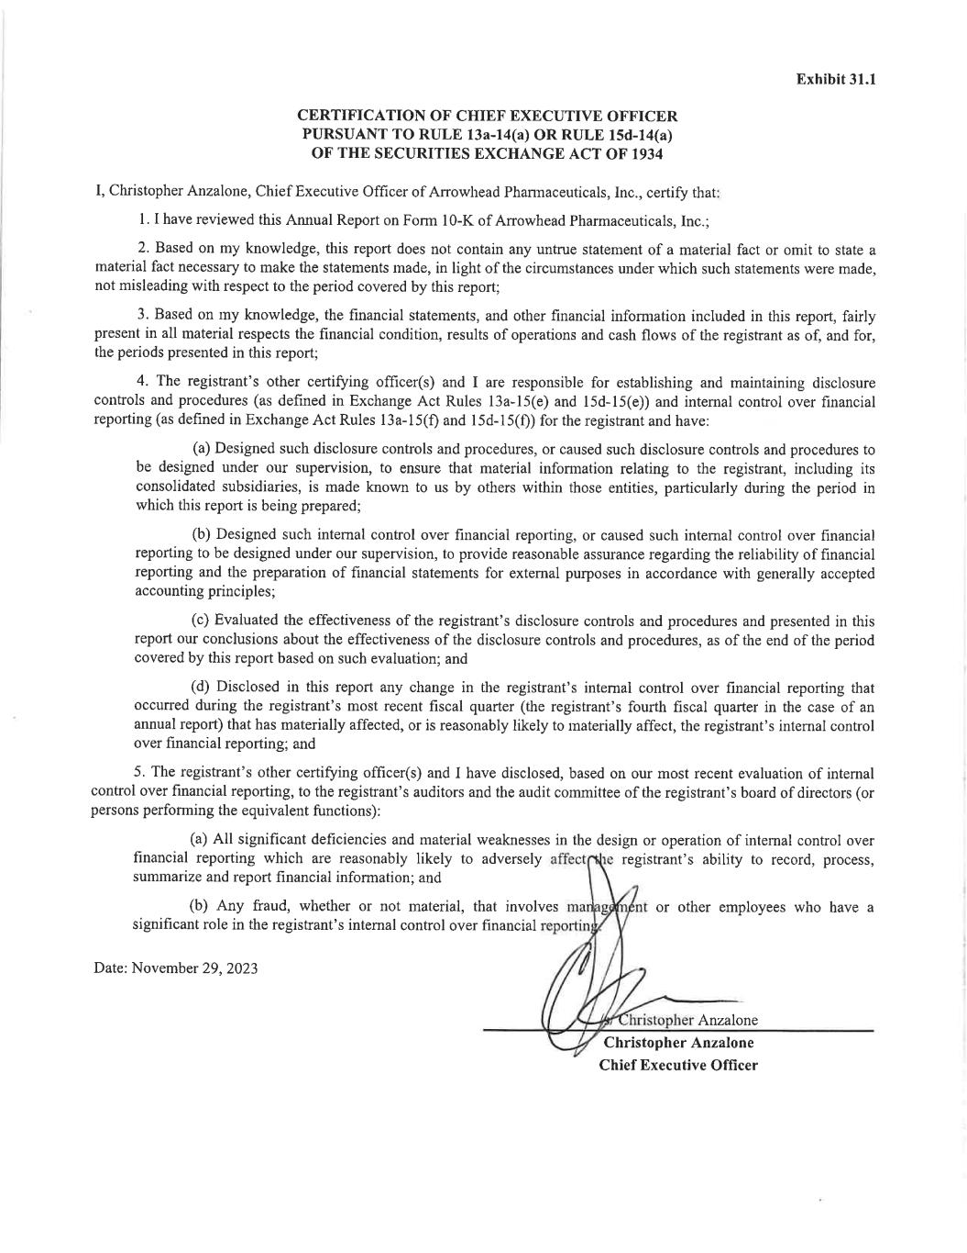

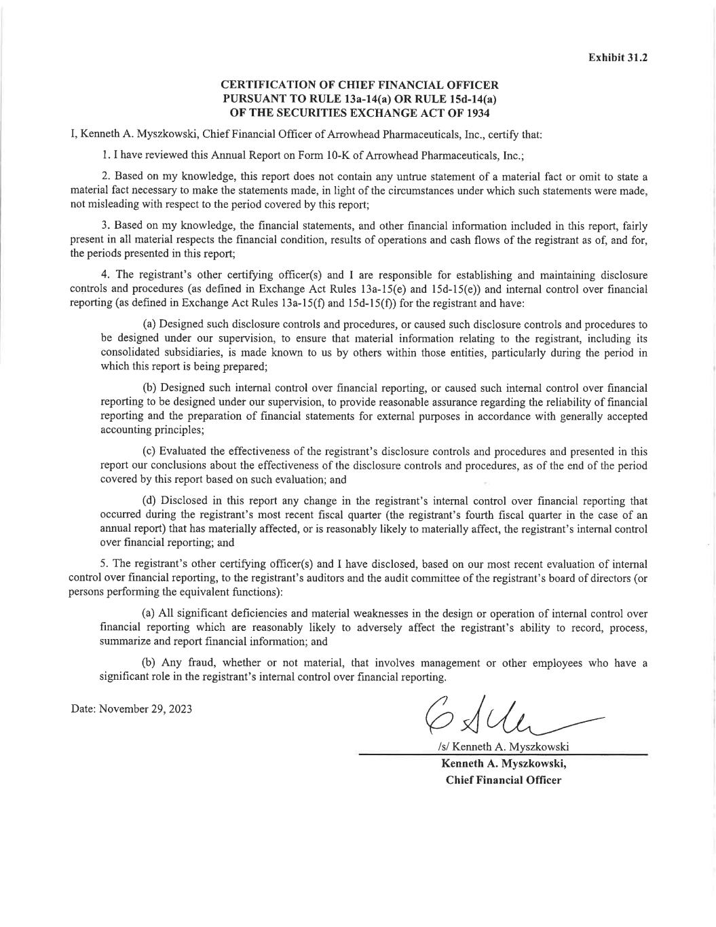

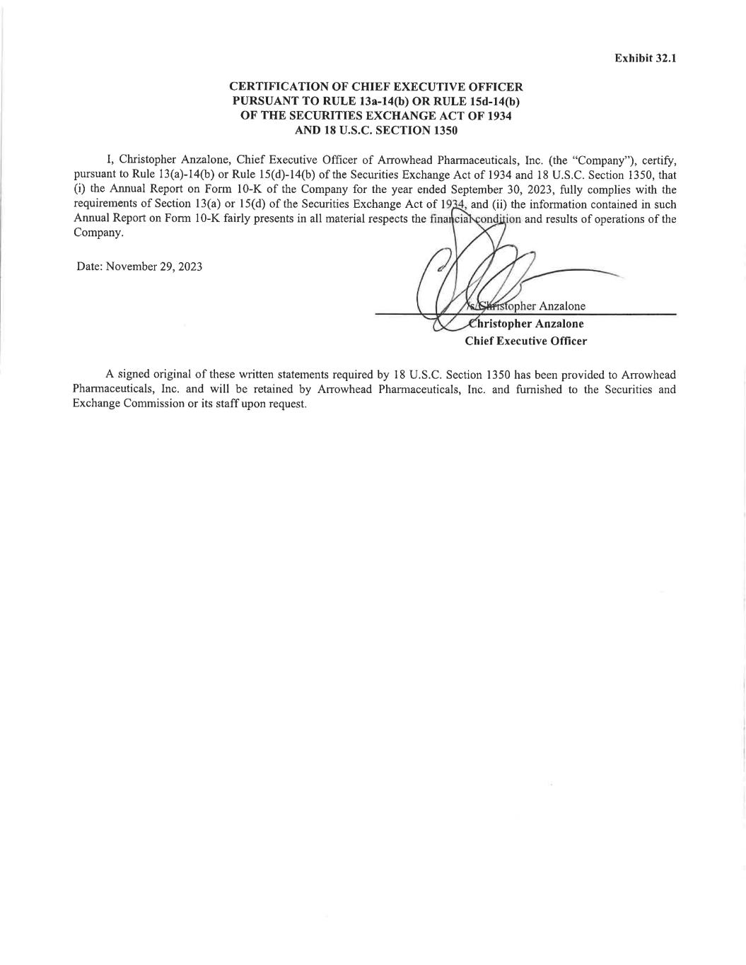

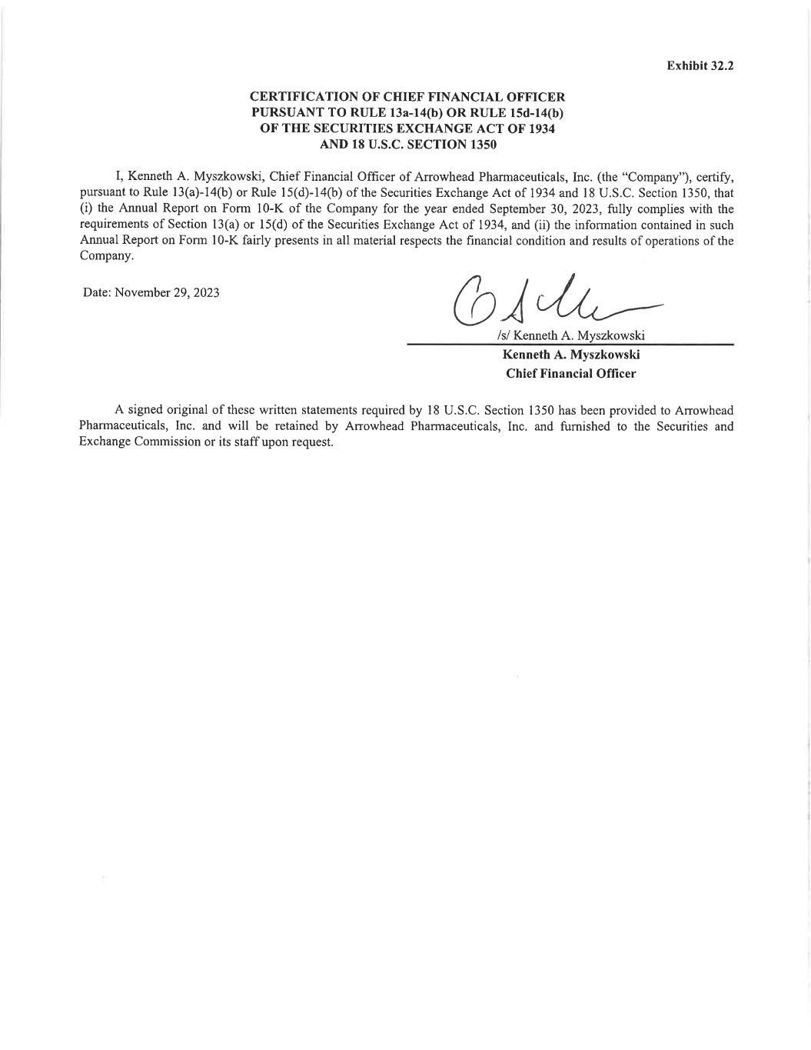

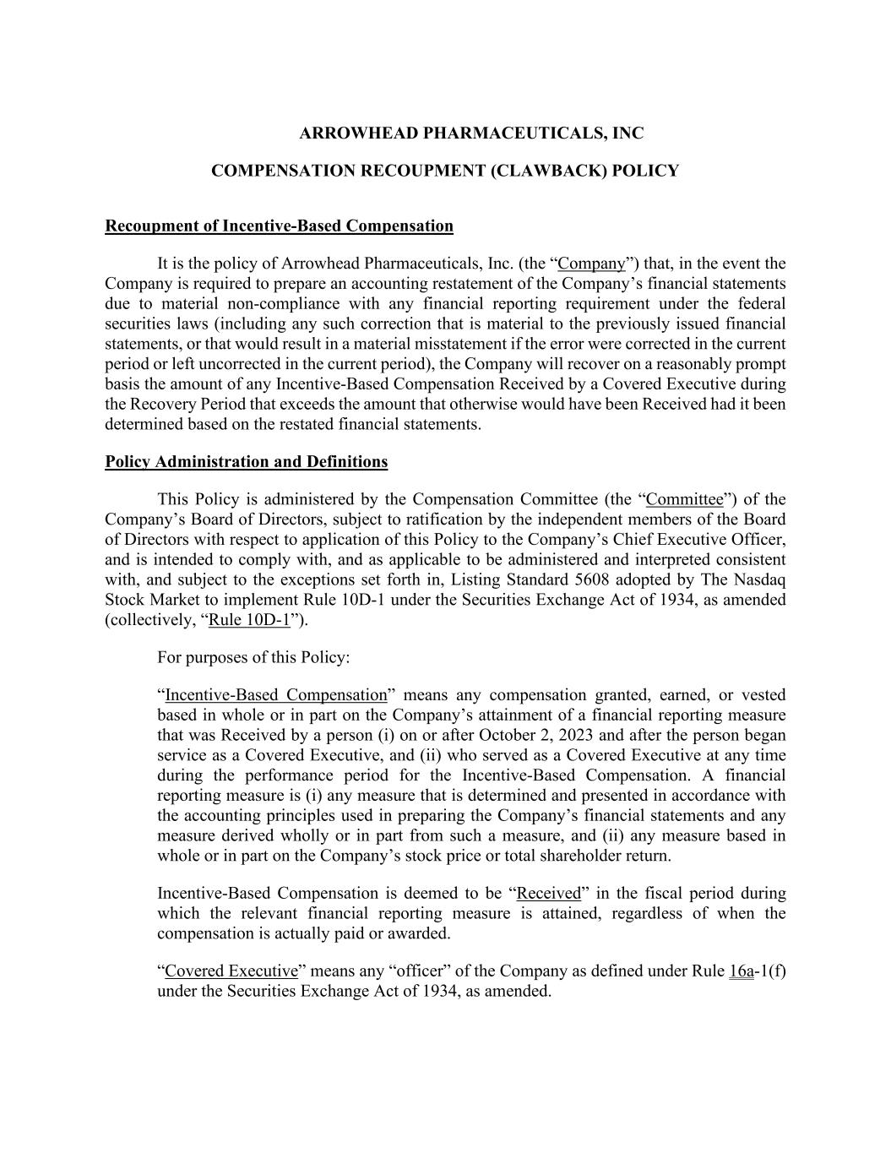
ARROWHEAD PHARMACEUTICALS, INC COMPENSATION RECOUPMENT (CLAWBACK) POLICY Recoupment of Incentive-Based Compensation It is the policy of Arrowhead Pharmaceuticals, Inc. (the “Company”) that, in the event the Company is required to prepare an accounting restatement of the Company’s financial statements due to material non-compliance with any financial reporting requirement under the federal securities laws (including any such correction that is material to the previously issued financial statements, or that would result in a material misstatement if the error were corrected in the current period or left uncorrected in the current period), the Company will recover on a reasonably prompt basis the amount of any Incentive-Based Compensation Received by a Covered Executive during the Recovery Period that exceeds the amount that otherwise would have been Received had it been determined based on the restated financial statements. Policy Administration and Definitions This Policy is administered by the Compensation Committee (the “Committee”) of the Company’s Board of Directors, subject to ratification by the independent members of the Board of Directors with respect to application of this Policy to the Company’s Chief Executive Officer, and is intended to comply with, and as applicable to be administered and interpreted consistent with, and subject to the exceptions set forth in, Listing Standard 5608 adopted by The Nasdaq Stock Market to implement Rule 10D-1 under the Securities Exchange Act of 1934, as amended (collectively, “Rule 10D-1”). For purposes of this Policy: “Incentive-Based Compensation” means any compensation granted, earned, or vested based in whole or in part on the Company’s attainment of a financial reporting measure that was Received by a person (i) on or after October 2, 2023 and after the person began service as a Covered Executive, and (ii) who served as a Covered Executive at any time during the performance period for the Incentive-Based Compensation. A financial reporting measure is (i) any measure that is determined and presented in accordance with the accounting principles used in preparing the Company’s financial statements and any measure derived wholly or in part from such a measure, and (ii) any measure based in whole or in part on the Company’s stock price or total shareholder return. Incentive-Based Compensation is deemed to be “Received” in the fiscal period during which the relevant financial reporting measure is attained, regardless of when the compensation is actually paid or awarded. “Covered Executive” means any “officer” of the Company as defined under Rule 16a-1(f) under the Securities Exchange Act of 1934, as amended.

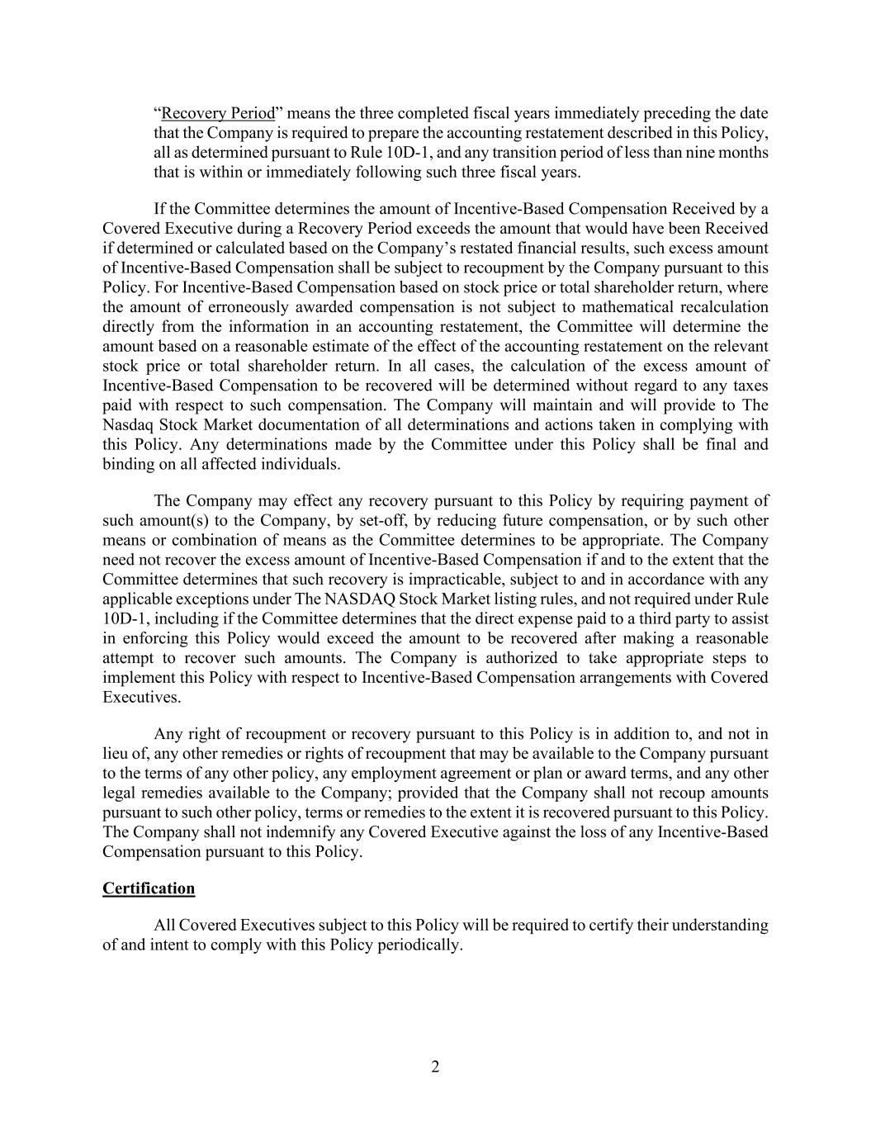
2 “Recovery Period” means the three completed fiscal years immediately preceding the date that the Company is required to prepare the accounting restatement described in this Policy, all as determined pursuant to Rule 10D-1, and any transition period of less than nine months that is within or immediately following such three fiscal years. If the Committee determines the amount of Incentive-Based Compensation Received by a Covered Executive during a Recovery Period exceeds the amount that would have been Received if determined or calculated based on the Company’s restated financial results, such excess amount of Incentive-Based Compensation shall be subject to recoupment by the Company pursuant to this Policy. For Incentive-Based Compensation based on stock price or total shareholder return, where the amount of erroneously awarded compensation is not subject to mathematical recalculation directly from the information in an accounting restatement, the Committee will determine the amount based on a reasonable estimate of the effect of the accounting restatement on the relevant stock price or total shareholder return. In all cases, the calculation of the excess amount of Incentive-Based Compensation to be recovered will be determined without regard to any taxes paid with respect to such compensation. The Company will maintain and will provide to The Nasdaq Stock Market documentation of all determinations and actions taken in complying with this Policy. Any determinations made by the Committee under this Policy shall be final and binding on all affected individuals. The Company may effect any recovery pursuant to this Policy by requiring payment of such amount(s) to the Company, by set-off, by reducing future compensation, or by such other means or combination of means as the Committee determines to be appropriate. The Company need not recover the excess amount of Incentive-Based Compensation if and to the extent that the Committee determines that such recovery is impracticable, subject to and in accordance with any applicable exceptions under The NASDAQ Stock Market listing rules, and not required under Rule 10D-1, including if the Committee determines that the direct expense paid to a third party to assist in enforcing this Policy would exceed the amount to be recovered after making a reasonable attempt to recover such amounts. The Company is authorized to take appropriate steps to implement this Policy with respect to Incentive-Based Compensation arrangements with Covered Executives. Any right of recoupment or recovery pursuant to this Policy is in addition to, and not in lieu of, any other remedies or rights of recoupment that may be available to the Company pursuant to the terms of any other policy, any employment agreement or plan or award terms, and any other legal remedies available to the Company; provided that the Company shall not recoup amounts pursuant to such other policy, terms or remedies to the extent it is recovered pursuant to this Policy. The Company shall not indemnify any Covered Executive against the loss of any Incentive-Based Compensation pursuant to this Policy. Certification All Covered Executives subject to this Policy will be required to certify their understanding of and intent to comply with this Policy periodically.


[ACKNOWLEDGMENT AND CERTIFICATION] ACKNOWLEDGMENT AND CERTIFICATION By signing below, the undersigned covered executive (the “Covered Executive”) acknowledges and confirms that the Covered Executive has received and reviewed a copy of the Arrowhead Pharmaceuticals, Inc. (the “Company”) Incentive Compensation Clawback Policy (the “Policy”), and in addition, the Covered Executive acknowledges and agrees that, for good and valid consideration, including continuing participation in the Company’s incentive compensation programs, the receipt and sufficiency of which the Covered Executive hereby acknowledges, the Covered Executive will be bound by and abide by the Policy as follows: (a) the Covered Executive is and will continue to be subject to the Policy and the Policy will apply both during and after the Covered Executive’s employment with the Company; (b) to the extent necessary to comply with the Policy, the Company hereby amends any employment agreement, equity award agreement or similar agreement that the Covered Executive is a party to with the Company; (c) the Covered Executive shall abide by the terms of the Policy, including, without limitation, by returning any compensation to the Company to the extent required by, and in a manner permitted by, the Policy, and understands and agrees that the Company is not permitted to, and will not, indemnify the Covered Executive for the loss of any compensation that is subject to recovery by the Company; (d) any amounts payable to the Covered Executive shall be subject to the Policy as may be in effect and interpreted or modified from time to time in the sole discretion of the Compensation Committee of the Company’s Board of Directors (the “Committee”) or as required by applicable law or the requirements of any securities exchange on which the Company’s securities are listed, and that such interpretation or modification will be covered by this acknowledgment; (e) the Company may recover compensation paid to the Covered Executive through any method of recovery the Committee or its delegate deems appropriate, including without limitation by reducing any amount that is or may become payable to the Covered Executive, and the Covered Executive agrees to comply with any request or demand for repayment by the Company in order to comply with the Policy; and (f) the Company is not responsible for and shall not make the Covered Executive whole for any effect under any tax law or regulation of the recovery of any compensation pursuant to the Policy, or for any taxes paid by the Covered Executive on compensation that is subject to recovery or is recovered pursuant to the Policy. Signature Print Name Date

