UNITED STATES
SECURITIES AND EXCHANGE COMMISSION
Washington, DC 20549
_____________________________________
FORM 10-Q
_____________________________________
(Mark One)
x |  |  | QUARTERLY REPORT PURSUANT TO SECTION 13 OR 15(d) OF THE SECURITIES EXCHANGE ACT OF 1934
For the quarterly period ended March 31, 2024
o |  |  | TRANSITION REPORT PURSUANT TO SECTION 13 OR 15(d) OF THE SECURITIES EXCHANGE ACT OF 1934
For the transition period from to
Commission file number 001-38042
_____________________________________
ARROWHEAD PHARMACEUTICALS, INC.
(Exact name of registrant as specified in its charter)
_____________________________________
Delaware |  |  |  |  |  | 46-0408024
(State or other jurisdiction of incorporation or organization) |  |  |  |  |  | (I.R.S. Employer Identification No.)
177 E. Colorado Blvd, Suite 700
Pasadena, California 91105
(626) 304-3400
(Address and telephone number of principal executive offices)
Former name, former address, and former fiscal year, if changed since last report: N/A
_____________________________________
Securities registered pursuant to Section 12(b) of the Exchange Act:
Title of each class |  |  |  |  |  | Trading Symbol(s) |  |  |  |  |  | Name of each exchange on which registered
Common Stock, par value $0.001 per share |  |  |  |  |  | ARWR |  |  |  |  |  | The Nasdaq Global Select Market
Indicate by check mark whether the registrant (1) has filed all reports required to be filed by Section 13 or 15(d) of the Securities Exchange Act of 1934 during the preceding 12 months (or for such shorter period that the registrant was required to file such reports), and (2) has been subject to such filing requirements for the past 90 days. Yes x No o
Indicate by check mark whether the registrant has submitted electronically every Interactive Data File required to be submitted pursuant to Rule 405 of Regulation S-T (§ 232.405 of this chapter) during the preceding 12 months (or for such shorter period that the registrant was required to submit such files). Yes x No o
Indicate by check mark whether the registrant is a large accelerated filer, an accelerated filer, a non-accelerated filer, a smaller reporting company, or an emerging growth company. See the definitions of “large accelerated filer,” “accelerated filer,” “smaller reporting company” and “emerging growth company” in Rule 12b-2 of the Exchange Act.
Large Accelerated Filer |  |  | x |  |  | Accelerated Filer |  |  | o
Non-Accelerated Filer |  |  | o |  |  | Smaller Reporting Company |  |  | o
Emerging Growth Company |  |  | o
If an emerging growth company, indicate by check mark if the registrant has elected not to use the extended transition period for complying with any new or revised financial accounting standards provided pursuant to Section 13(a) of the Exchange Act. o
Indicate by check mark whether the registrant is a shell company (as defined in Rule 12b-2 of the Exchange Act). Yes o No x
The number of shares of the registrant’s common stock outstanding as of May 1, 2024 was 124,200,230.

 |  |  | Page(s)
PART I — FINANCIAL INFORMATION
ITEM 1. FINANCIAL STATEMENTS |  |  | 1
Consolidated Balance Sheets |  |  | 1
Consolidated Statements of Operations and Comprehensive (Loss) Income |  |  | 2
Consolidated Statements of Stockholders’ Equity |  |  | 3
Consolidated Statements of Cash Flows |  |  | 4
Notes to Consolidated Financial Statements |  |  | 5
ITEM 2. MANAGEMENT’S DISCUSSION AND ANALYSIS OF FINANCIAL CONDITION AND RESULTS OF OPERATIONS |  |  | 21
ITEM 3. QUANTITATIVE AND QUALITATIVE DISCLOSURES ABOUT MARKET RISK |  |  | 27
ITEM 4. CONTROLS AND PROCEDURES |  |  | 27
PART II — OTHER INFORMATION |  |  | 29
ITEM 1. LEGAL PROCEEDINGS |  |  | 29
ITEM 1A. RISK FACTORS |  |  | 29
ITEM 2. UNREGISTERED SALES OF EQUITY SECURITIES AND USE OF PROCEEDS |  |  | 29
ITEM 3. DEFAULTS UPON SENIOR SECURITIES |  |  | 29
ITEM 4. MINE SAFETY DISCLOSURES |  |  | 29
ITEM 5. OTHER INFORMATION |  |  | 29
ITEM 6. EXHIBITS |  |  | 30
SIGNATURE |  |  | 31

PART I. FINANCIAL INFORMATION

ITEM 1. FINANCIAL STATEMENTS

Arrowhead Pharmaceuticals, Inc.
Consolidated Balance Sheets
(In thousands, except per share amounts)
 |  |  | March 31, 2024 |  |  |  |  |  | September 30, 2023
 |  |  | (unaudited)
ASSETS
Current assets:
Cash, cash equivalents and restricted cash |  |  | $ | 127,704 |  |  |  |  | $ | 110,891
Available-for-sale securities, at fair value |  |  | 395,410 |  |  |  |  |  | 292,735
Prepaid expenses |  |  | 11,022 |  |  |  |  |  | 8,813
Other current assets |  |  | 7,514 |  |  |  |  |  | 7,082
Total current assets |  |  | 541,650 |  |  |  |  |  | 419,521
Property, plant and equipment, net |  |  | 359,252 |  |  |  |  |  | 290,262
Intangible assets, net |  |  | 9,412 |  |  |  |  |  | 10,262
Right-of-use assets |  |  | 44,626 |  |  |  |  |  | 45,297
Other assets |  |  | 210 |  |  |  |  |  | 210
Total Assets |  |  | $ | 955,150 |  |  |  |  | $ | 765,552
LIABILITIES, NONCONTROLLING INTEREST AND STOCKHOLDERS’ EQUITY
Current liabilities:
Accounts payable |  |  | $ | 8,521 |  |  |  |  | $ | 35,866
Accrued expenses |  |  | 37,055 |  |  |  |  |  | 39,763
Accrued payroll and benefits |  |  | 13,741 |  |  |  |  |  | 17,963
Lease liabilities |  |  | 5,285 |  |  |  |  |  | 10,563
Deferred revenue |  |  | — |  |  |  |  |  | 866
Other liabilities |  |  | 573 |  |  |  |  |  | 435
Total current liabilities |  |  | 65,175 |  |  |  |  |  | 105,456
Long-term liabilities:
Lease liabilities, net of current portion |  |  | 113,632 |  |  |  |  |  | 104,608
Liability related to the sale of future royalties |  |  | 280,938 |  |  |  |  |  | 268,326
Total long-term liabilities |  |  | 394,570 |  |  |  |  |  | 372,934
Commitments and contingencies (Note 7)
Noncontrolling interest and stockholders’ equity:
Common stock, $0.001 par value:  Authorized 290,000 shares; issued and outstanding 124,133 and 107,312 shares |  |  | 217 |  |  |  |  |  | 200
Additional paid-in capital |  |  | 1,768,866 |  |  |  |  |  | 1,300,395
Accumulated other comprehensive loss |  |  | (1,095) |  |  |  |  |  | (3,222)
Accumulated deficit |  |  | (1,284,194) |  |  |  |  |  | (1,026,030)
Total Arrowhead Pharmaceuticals, Inc. stockholders’ equity |  |  | 483,794 |  |  |  |  |  | 271,343
Noncontrolling interest |  |  | 11,611 |  |  |  |  |  | 15,819
Total noncontrolling interest and stockholders’ equity |  |  | 495,405 |  |  |  |  |  | 287,162
Total Liabilities, Noncontrolling Interest and Stockholders’ Equity |  |  | $ | 955,150 |  |  |  |  | $ | 765,552
The accompanying notes are an integral part of these unaudited consolidated financial statements.

1

Arrowhead Pharmaceuticals, Inc.
Consolidated Statements of Operations and Comprehensive (Loss) Income
(In thousands, except per share amounts)
(unaudited)
 |  |  | Three Months Ended March 31, |  |  |  |  |  |  |  |  |  |  |  | Six Months Ended March 31,
 |  |  | 2024 |  |  |  |  |  | 2023 |  |  |  |  |  | 2024 |  |  |  |  |  | 2023
Revenue |  |  | $ | — |  |  |  |  | $ | 146,267 |  |  |  |  | $ | 3,551 |  |  |  |  | $ | 208,813
Operating expenses:
Research and development |  |  | 101,122 |  |  |  |  |  | 74,881 |  |  |  |  |  | 217,613 |  |  |  |  |  | 158,576
General and administrative |  |  | 25,069 |  |  |  |  |  | 23,221 |  |  |  |  |  | 48,674 |  |  |  |  |  | 44,206
Total operating expenses |  |  | 126,191 |  |  |  |  |  | 98,102 |  |  |  |  |  | 266,287 |  |  |  |  |  | 202,782
Operating (loss) income |  |  | (126,191) |  |  |  |  |  | 48,165 |  |  |  |  |  | (262,736) |  |  |  |  |  | 6,031
Other income (expense):
Interest income |  |  | 6,250 |  |  |  |  |  | 4,560 |  |  |  |  |  | 9,052 |  |  |  |  |  | 7,242
Interest expense |  |  | (7,244) |  |  |  |  |  | (5,057) |  |  |  |  |  | (12,611) |  |  |  |  |  | (7,906)
Other, net |  |  | 189 |  |  |  |  |  | 8 |  |  |  |  |  | 610 |  |  |  |  |  | 515
Total other expense |  |  | (805) |  |  |  |  |  | (489) |  |  |  |  |  | (2,949) |  |  |  |  |  | (149)
(Loss) income before income tax (benefit) expense and noncontrolling interest |  |  | (126,996) |  |  |  |  |  | 47,676 |  |  |  |  |  | (265,685) |  |  |  |  |  | 5,882
Income tax (benefit) expense |  |  | — |  |  |  |  |  | — |  |  |  |  |  | (3,313) |  |  |  |  |  | 17
Net (loss) income including noncontrolling interest |  |  | (126,996) |  |  |  |  |  | 47,676 |  |  |  |  |  | $ | (262,372) |  |  |  |  | $ | 5,865
Net loss attributable to noncontrolling interest, net of tax |  |  | (1,696) |  |  |  |  |  | (999) |  |  |  |  |  | (4,208) |  |  |  |  |  | (1,485)
Net (loss) income attributable to Arrowhead Pharmaceuticals, Inc. |  |  | $ | (125,300) |  |  |  |  | $ | 48,675 |  |  |  |  | $ | (258,164) |  |  |  |  | $ | 7,350
Net (loss) income per share attributable to Arrowhead Pharmaceuticals, Inc.:
Basic |  |  | $ | (1.02) |  |  |  |  | $ | 0.46 |  |  |  |  | $ | (2.24) |  |  |  |  | $ | 0.07
Diluted |  |  | $ | (1.02) |  |  |  |  | $ | 0.45 |  |  |  |  | $ | (2.24) |  |  |  |  | $ | 0.07
Weighted-average shares used in calculating
Basic |  |  | 123,285 |  |  |  |  |  | 106,757 |  |  |  |  |  | 115,307 |  |  |  |  |  | 106,394
Diluted |  |  | 123,285 |  |  |  |  |  | 108,143 |  |  |  |  |  | 115,307 |  |  |  |  |  | 107,893
Other comprehensive (loss) income, net of tax:
Change in unrealized losses on available-for-sale securities |  |  | 216 |  |  |  |  |  | — |  |  |  |  |  | 2,125 |  |  |  |  |  | —
Foreign currency translation adjustments |  |  | (56) |  |  |  |  |  | (74) |  |  |  |  |  | 2 |  |  |  |  |  | (196)
Comprehensive (loss) income |  |  | $ | (126,836) |  |  |  |  | $ | 47,602 |  |  |  |  | $ | (260,245) |  |  |  |  | $ | 5,669
The accompanying notes are an integral part of these unaudited consolidated financial statements.

2

Arrowhead Pharmaceuticals, Inc.
Consolidated Statements of Stockholders’ Equity
(in thousands)
(unaudited)
 |  |  | Common  Stock |  |  |  |  |  | Amount ($) |  |  |  |  |  | Additional  Paid-In  Capital |  |  |  |  |  | Accumulated  Other  Comprehensive  Loss |  |  |  |  |  | Accumulated  Deficit |  |  |  |  |  | Non-  controlling Interest |  |  |  |  |  | Totals
Balance at September 30, 2023 |  |  | 107,312 |  |  |  |  |  | $ | 200 |  |  |  |  | $ | 1,300,395 |  |  |  |  | $ | (3,222) |  |  |  |  | $ | (1,026,030) |  |  |  |  | $ | 15,819 |  |  |  |  | $ | 287,162
Stock-based compensation |  |  | — |  |  |  |  |  | — |  |  |  |  |  | 19,694 |  |  |  |  |  | — |  |  |  |  |  | — |  |  |  |  |  | — |  |  |  |  |  | 19,694
Exercise of stock options |  |  | 34 |  |  |  |  |  | — |  |  |  |  |  | 267 |  |  |  |  |  | — |  |  |  |  |  | — |  |  |  |  |  | — |  |  |  |  |  | 267
Common stock - restricted stock units vesting |  |  | 154 |  |  |  |  |  | — |  |  |  |  |  | — |  |  |  |  |  | — |  |  |  |  |  | — |  |  |  |  |  | — |  |  |  |  |  | —
Foreign currency translation adjustments |  |  | — |  |  |  |  |  | — |  |  |  |  |  | — |  |  |  |  |  | 58 |  |  |  |  |  | — |  |  |  |  |  | — |  |  |  |  |  | 58
Change in unrealized losses on available-for-sale securities |  |  | — |  |  |  |  |  | — |  |  |  |  |  | — |  |  |  |  |  | 1,909 |  |  |  |  |  | — |  |  |  |  |  | — |  |  |  |  |  | 1,909
Net loss |  |  | — |  |  |  |  |  | — |  |  |  |  |  | — |  |  |  |  |  | — |  |  |  |  |  | (132,864) |  |  |  |  |  | (2,512) |  |  |  |  |  | (135,376)
Balance at December 31, 2023 |  |  | 107,500 |  |  |  |  |  | $ | 200 |  |  |  |  | $ | 1,320,356 |  |  |  |  | $ | (1,255) |  |  |  |  | $ | (1,158,894) |  |  |  |  | $ | 13,307 |  |  |  |  | $ | 173,714
Stock-based compensation |  |  | — |  |  |  |  |  | — |  |  |  |  |  | 17,750 |  |  |  |  |  | — |  |  |  |  |  | — |  |  |  |  |  | — |  |  |  |  |  | 17,750
Exercise of stock options |  |  | 120 |  |  |  |  |  | — |  |  |  |  |  | 1,512 |  |  |  |  |  | — |  |  |  |  |  | — |  |  |  |  |  | — |  |  |  |  |  | 1,512
Common stock - restricted stock units vesting |  |  | 723 |  |  |  |  |  | 1 |  |  |  |  |  | (1) |  |  |  |  |  | — |  |  |  |  |  | — |  |  |  |  |  | — |  |  |  |  |  | —
Common stock issued, net of offering costs |  |  | 15,790 |  |  |  |  |  | 16 |  |  |  |  |  | 429,249 |  |  |  |  |  | — |  |  |  |  |  | — |  |  |  |  |  | — |  |  |  |  |  | 429,265
Foreign currency translation adjustments |  |  | — |  |  |  |  |  | — |  |  |  |  |  | — |  |  |  |  |  | (56) |  |  |  |  |  | — |  |  |  |  |  | — |  |  |  |  |  | (56)
Change in unrealized losses on available-for-sale securities |  |  | — |  |  |  |  |  | — |  |  |  |  |  | — |  |  |  |  |  | 216 |  |  |  |  |  | — |  |  |  |  |  | — |  |  |  |  |  | 216
Net loss |  |  | — |  |  |  |  |  | — |  |  |  |  |  | — |  |  |  |  |  | — |  |  |  |  |  | (125,300) |  |  |  |  |  | (1,696) |  |  |  |  |  | (126,996)
Balance at March 31, 2024 |  |  | 124,133 |  |  |  |  |  | $ | 217 |  |  |  |  | $ | 1,768,866 |  |  |  |  | $ | (1,095) |  |  |  |  | $ | (1,284,194) |  |  |  |  | $ | 11,611 |  |  |  |  | $ | 495,405

 |  |  | Common  Stock |  |  |  |  |  | Amount ($) |  |  |  |  |  | Additional  Paid-In  Capital |  |  |  |  |  | Accumulated  Other  Comprehensive  Loss |  |  |  |  |  | Accumulated  Deficit |  |  |  |  |  | Non-  controlling Interest |  |  |  |  |  | Totals
Balance at September 30, 2022 |  |  | 105,960 |  |  |  |  |  | $ | 198 |  |  |  |  | $ | 1,219,213 |  |  |  |  | $ | (136) |  |  |  |  | $ | (820,755) |  |  |  |  | $ | 19,819 |  |  |  |  | $ | 418,339
Stock-based compensation |  |  | — |  |  |  |  |  | — |  |  |  |  |  | 19,390 |  |  |  |  |  | — |  |  |  |  |  | — |  |  |  |  |  | — |  |  |  |  |  | 19,390
Exercise of stock options |  |  | 82 |  |  |  |  |  | — |  |  |  |  |  | 576 |  |  |  |  |  | — |  |  |  |  |  | — |  |  |  |  |  | — |  |  |  |  |  | 576
Common stock - restricted stock units vesting |  |  | 98 |  |  |  |  |  | 1 |  |  |  |  |  | (1) |  |  |  |  |  | — |  |  |  |  |  | — |  |  |  |  |  | — |  |  |  |  |  | —
Foreign currency translation adjustments |  |  | — |  |  |  |  |  | — |  |  |  |  |  | — |  |  |  |  |  | (122) |  |  |  |  |  | — |  |  |  |  |  | — |  |  |  |  |  | (122)
Net loss |  |  | — |  |  |  |  |  | — |  |  |  |  |  | — |  |  |  |  |  | — |  |  |  |  |  | (41,325) |  |  |  |  |  | (486) |  |  |  |  |  | (41,811)
Balance at December 31, 2022 |  |  | 106,140 |  |  |  |  |  | $ | 199 |  |  |  |  | $ | 1,239,178 |  |  |  |  | $ | (258) |  |  |  |  | $ | (862,080) |  |  |  |  | $ | 19,333 |  |  |  |  | $ | 396,372
Stock-based compensation |  |  | — |  |  |  |  |  | — |  |  |  |  |  | 20,612 |  |  |  |  |  | — |  |  |  |  |  | — |  |  |  |  |  | — |  |  |  |  |  | 20,612
Exercise of stock options |  |  | 64 |  |  |  |  |  | — |  |  |  |  |  | 520 |  |  |  |  |  | — |  |  |  |  |  | — |  |  |  |  |  | — |  |  |  |  |  | 520
Common stock - restricted stock units vesting |  |  | 665 |  |  |  |  |  | — |  |  |  |  |  | — |  |  |  |  |  | — |  |  |  |  |  | — |  |  |  |  |  | — |  |  |  |  |  | —
Foreign currency translation adjustments |  |  | — |  |  |  |  |  | — |  |  |  |  |  | — |  |  |  |  |  | (74) |  |  |  |  |  | — |  |  |  |  |  | — |  |  |  |  |  | (74)
Net income |  |  | — |  |  |  |  |  | — |  |  |  |  |  | — |  |  |  |  |  | — |  |  |  |  |  | 48,675 |  |  |  |  |  | (999) |  |  |  |  |  | 47,676
Balance at March 31, 2023 |  |  | 106,869 |  |  |  |  |  | $ | 199 |  |  |  |  | $ | 1,260,310 |  |  |  |  | $ | (332) |  |  |  |  | $ | (813,405) |  |  |  |  | $ | 18,334 |  |  |  |  | $ | 465,106
The accompanying notes are an integral part of these unaudited consolidated financial statements.

3

Arrowhead Pharmaceuticals, Inc.
Consolidated Statements of Cash Flows
(in thousands)
(unaudited)
 |  |  | Six Months Ended March 31,
 |  |  | 2024 |  |  |  |  |  | 2023
CASH FLOWS FROM OPERATING ACTIVITIES:
Net (loss) income |  |  | $ | (262,372) |  |  |  |  | $ | 5,865
Adjustments to reconcile net loss to net cash flow from operating activities
Stock-based compensation |  |  | 37,444 |  |  |  |  |  | 40,002
Depreciation and amortization |  |  | 8,788 |  |  |  |  |  | 5,358
Amortization (accretion) of note premiums/discounts |  |  | 896 |  |  |  |  |  | (82)
Realized gain on investments |  |  | (80) |  |  |  |  |  | —
Non-cash interest expense on liability related to the sale of future royalties |  |  | 12,612 |  |  |  |  |  | 7,906
Changes in operating assets and liabilities:
Accounts receivable |  |  | — |  |  |  |  |  | (68,024)
Prepaid expenses and other current assets |  |  | (2,643) |  |  |  |  |  | 20,309
Accounts payable |  |  | (8,402) |  |  |  |  |  | 6,688
Accrued expenses |  |  | (11) |  |  |  |  |  | (27,279)
Deferred revenue |  |  | (866) |  |  |  |  |  | (99,135)
Operating lease, net |  |  | 4,417 |  |  |  |  |  | 1,205
Net cash used in operating activities |  |  | (210,217) |  |  |  |  |  | (107,187)
CASH FLOWS FROM INVESTING ACTIVITIES:
Purchases of property and equipment |  |  | (102,731) |  |  |  |  |  | (66,225)
Purchases of investments |  |  | (309,982) |  |  |  |  |  | (192,528)
Proceeds from sales and maturities of investments |  |  | 208,615 |  |  |  |  |  | 141,994
Net cash used in investing activities |  |  | (204,098) |  |  |  |  |  | (116,759)
CASH FLOWS FROM FINANCING ACTIVITIES:
Proceeds from the exercises of stock options |  |  | 1,779 |  |  |  |  |  | 1,096
Proceeds from the issuance of common stock, net of offering costs |  |  | 429,265 |  |  |  |  |  | —
Proceeds from the sale of future royalties |  |  | — |  |  |  |  |  | 250,000
Net cash provided by financing activities |  |  | 431,044 |  |  |  |  |  | 251,096
Net increase in cash, cash equivalents and restricted cash |  |  | 16,729 |  |  |  |  |  | 27,150
Effect of exchange rate on cash, cash equivalents and restricted cash |  |  | 84 |  |  |  |  |  | (196)
CASH, CASH EQUIVALENTS AND RESTRICTED CASH:
BEGINNING OF PERIOD |  |  | 110,891 |  |  |  |  |  | 108,005
END OF PERIOD |  |  | $ | 127,704 |  |  |  |  | $ | 134,959
Supplementary disclosure of cash flows:
Income taxes paid |  |  | $ | (3,014) |  |  |  |  | $ | —
Supplemental disclosure of noncash investing activities:
Capital expenditures included in accrued expenses |  |  | $ | 7,265 |  |  |  |  | $ | 12,831
The accompanying notes are an integral part of these unaudited consolidated financial statements.

4

Arrowhead Pharmaceuticals, Inc.
Notes to Consolidated Financial Statements
(unaudited)

NOTE 1. ORGANIZATION AND SIGNIFICANT ACCOUNTING POLICIES
General and Recent Developments
Arrowhead Pharmaceuticals, Inc. and its subsidiaries (referred to herein collectively as the “Company”) are primarily engaged in developing medicines that treat intractable diseases by silencing the genes that cause them. Using a broad portfolio of RNA chemistries and efficient modes of delivery, the Company’s therapies trigger the RNA interference mechanism to induce rapid, deep and durable knockdown of target genes. RNA interference (“RNAi”) is a mechanism present in living cells that inhibits the expression of a specific gene, thereby affecting the production of a specific protein. The Company’s RNAi-based therapeutics may leverage this natural pathway of gene silencing to target and shut down specific disease-causing genes.
The following table presents the Company’s current pipeline:
Therapeutic Area |  |  | Name |  |  | Stage |  |  | Product Rights
Cardiometabolic |  |  | plozasiran (ARO-APOC3) |  |  | Phase 3 |  |  | Arrowhead
 |  |  | zodasiran (ARO-ANG3) |  |  | Phase 2b |  |  | Arrowhead
 |  |  | olpasiran |  |  | Phase 3 |  |  | Amgen
Pulmonary |  |  | ARO-RAGE |  |  | Phase 1/2a |  |  | Arrowhead
 |  |  | ARO-MUC5AC |  |  | Phase 1/2a |  |  | Arrowhead
 |  |  | ARO-MMP7 |  |  | Phase 1/2a |  |  | Arrowhead
Liver |  |  | GSK-4532990 |  |  | Phase 2b |  |  | GSK
 |  |  | fazirsiran |  |  | Phase 3 |  |  | Takeda and Arrowhead
 |  |  | JNJ-3989 |  |  | Phase 2 |  |  | GSK
 |  |  | ARO-C3 |  |  | Phase 1/2a |  |  | Arrowhead
 |  |  | ARO-PNPLA3 |  |  | Phase 1 |  |  | Arrowhead
 |  |  | ARO-CFB |  |  | Phase 1/2a |  |  | Arrowhead
Muscle |  |  | ARO-DUX4 |  |  | Phase 1/2a |  |  | Arrowhead
 |  |  | ARO-DM1 |  |  | Phase 1/2a |  |  | Arrowhead
Central Nervous System (CNS) |  |  | Various |  |  | Pre-Clinical |  |  | Arrowhead
The Company operates lab facilities in California and Wisconsin, where its research and development activities, including the development of RNAi therapeutics, take place. The Company’s principal executive offices are located in Pasadena, California.
Thus far in fiscal 2024, the Company has continued to develop and advance its pipeline and partnered candidates. Several key recent developments include:
•Completed enrollment in Amgen’s Phase 3 OCEAN(a) - outcome trial of olpasiran, triggering a $50.0 million milestone payment to the Company, which was paid in the third quarter of fiscal 2024;
•Presented final data from the double-blind treatment period of the Company’s Phase 2 SHASTA-2 study of investigational plozasiran in patients with severe Hypertriglyceridemia. Results from the SHASTA-2 study showed dramatic, consistent, and sustained reductions in Apolipoprotein C-III (APOC3) and triglycerides and improvement in multiple atherogenic lipoprotein levels;
•Announced an Expanded Access Program (EAP) to make investigational plozasiran available outside of a clinical trial for qualifying patients with familial chylomicronemia syndrome (FCS);
•Initiated a Phase 1/2a clinical trial of ARO-DM1, being developed as a potential treatment for type 1 myotonic dystrophy (DM1), the most common adult-onset muscular dystrophy;
•Filed an application for clearance to initiate a Phase 1/2a clinical trial of ARO-CFB, being developed as a potential treatment for complement mediated renal disease;
5

•Entered into an Amended and Restated License Agreement with GSK, pursuant to which GSK received a worldwide, exclusive license to develop and commercialize JNJ-3989 (formerly ARO-HBV). JNJ-3989 had previously been licensed to Janssen Pharmaceuticals, Inc. See Note 2.
Consolidation and Basis of Presentation
The interim Consolidated Financial Statements include the accounts of Arrowhead Pharmaceuticals, Inc. and its subsidiaries (wholly-owned subsidiaries and a variable interest entity for which the Company is the primary beneficiary). Subsidiaries refer to Arrowhead Madison, Inc., Visirna Therapeutics, Inc. (“Visirna”), and Arrowhead Australia Pty Ltd. For subsidiaries in which the Company owns or is exposed to less than 100% of the economics, the Company records net loss attributable to noncontrolling interests in its consolidated statements of operations equal to the percentage of the economic or ownership interests retained in such entity by the respective noncontrolling party.
The interim Consolidated Financial Statements have been prepared in conformity with U.S. generally accepted accounting principles (“GAAP”). The financial data of the Company included herein are unaudited. In the opinion of management, all material adjustments of a normal recurring nature have been made to present fairly the Company’s financial position at March 31, 2024 and the results of operations and cash flows for the periods presented. All intercompany transactions and balances have been eliminated.
Certain financial information that is normally included in annual financial statements prepared in accordance with GAAP, but that is not required for interim reporting purposes, has been omitted from the accompanying interim consolidated financial statements and related notes. Readers are urged to review the Company’s Annual Report on Form 10-K for the year ended September 30, 2023 for more complete descriptions and discussions. Operating results and cash flows for the six months ended March 31, 2024 are not necessarily indicative of the results that may be expected for the fiscal year ending September 30, 2024.
Liquidity
The Company’s primary sources of financing have been through the sale of its equity securities, revenue from its licensing and collaboration agreements and the sale of certain future royalties. Research and development activities have required significant capital investment since the Company’s inception and are expected to continue to require significant cash expenditure in the future, particularly as the Company’s pipeline of drug candidates and its headcount have both expanded. Additionally, significant capital investment will be required as the Company’s pipeline matures into later stage clinical trials.
As of March 31, 2024, the Company had $127.7 million in cash, cash equivalents and restricted cash ($2.2 million in restricted cash) and $395.4 million in available-for-sale securities to fund operations. During the six months ended March 31, 2024, the Company’s cash, cash equivalents and restricted cash and investments balance increased by $119.5 million which was primarily due to the net proceeds of $429.3 million from the underwritten offering in January 2024 discussed below, offset by ongoing expenses related to the Company’s research and development programs, general and administrative expenses and capital expenditures.
On January 2, 2024, the Company entered into an underwriting agreement with Jefferies LLC, BofA Securities, Inc., and Cowen and Company, LLC, as representatives of the several underwriters. The Company issued 15,790,000 shares of common stock at a price of $28.50 per share. The aggregate purchase price paid by investors was $450.0 million and the Company received net proceeds of $429.3 million after deducting advisory fees and offering expenses.
In total, the Company is eligible to receive up to $2.8 billion in developmental, regulatory and sales milestones, and may receive various royalties on net sales from its licensing and collaboration agreements, subject to the terms and conditions of those agreements. The revenue recognition for these collaboration agreements is discussed further in Note 2.
Summary of Significant Accounting Policies
There have been no changes to the significant accounting policies disclosed in the Company’s most recent Annual Report on Form 10-K for the fiscal year ended September 30, 2023.
Uncertainty in Income Taxes
The Company recorded an income tax benefit of $3.3 million and $0 for the six months ended March 31, 2024 and 2023, respectively. The income tax benefit is primarily due to the discrete change in the Company’s uncertain tax positions related to the statute of limitation expiration.
6

Recent Accounting Pronouncements
In December 2023, the Financial Accounting Standards Board (“FASB”) issued ASU 2023-09, Income Taxes (Topic 740): Improvements to Income Tax Disclosures, to improve its income tax disclosure requirements. Under the ASU, entities must annually (1) disclose specific categories in the rate reconciliation and (2) provide additional information for reconciling items that meet a quantitative threshold. This ASU will become effective for the Company beginning on October 1, 2025. The Company does not expect any material impact on its consolidated financial statements and related disclosures resulting from applying this ASU.

NOTE 2. COLLABORATION AND LICENSE AGREEMENTS
The following table provides a summary of revenue recognized:
 |  |  |  |  |  | Three Months Ended March 31, |  |  |  |  |  |  |  |  |  |  |  | Six Months Ended March 31,
 |  |  |  |  |  | 2024 |  |  |  |  |  | 2023 |  |  |  |  |  | 2024 |  |  |  |  |  | 2023
 |  |  |  |  |  | (in thousands)
GSK |  |  |  |  |  | $ | — |  |  |  |  | $ | 30,000 |  |  |  |  | $ | 2,685 |  |  |  |  | $ | 29,323
Horizon |  |  |  |  |  | — |  |  |  |  |  | — |  |  |  |  |  | — |  |  |  |  |  | 21,667
Takeda |  |  |  |  |  | — |  |  |  |  |  | 116,156 |  |  |  |  |  | 866 |  |  |  |  |  | 132,468
Janssen |  |  |  |  |  | — |  |  |  |  |  | 111 |  |  |  |  |  | — |  |  |  |  |  | 355
Amgen |  |  |  |  |  | — |  |  |  |  |  | — |  |  |  |  |  | — |  |  |  |  |  | 25,000
Total |  |  |  |  |  | $ | — |  |  |  |  | $ | 146,267 |  |  |  |  | $ | 3,551 |  |  |  |  | $ | 208,813
The following table summarizes the balance of receivables and contract liabilities related to the Company’s collaboration and license agreements:
 |  |  |  |  |  | March 31, 2024 |  |  |  |  |  | September 30, 2023
 |  |  |  |  |  | (in thousands)
Receivables included in accounts receivable |  |  |  |  |  | $ | — |  |  |  |  | $ | —
Contract liabilities included in deferred revenue |  |  |  |  |  | $ | — |  |  |  |  | $ | 866
Glaxosmithkline Intellectual Property (No. 3) Limited (“GSK”)
GSK License Agreement
On November 22, 2021, GSK and the Company entered into an Exclusive License Agreement (the “GSK License Agreement”). Under the GSK License Agreement, GSK has received an exclusive license for GSK-4532990 (formerly ARO-HSD). The exclusive license is worldwide with the exception of greater China. GSK is wholly responsible for all clinical development and commercialization of GSK-4532990 in its territory. GSK dosed the first patient in a Phase 2b trial in March 2023 and paid a $30.0 million milestone payment to the Company in the third quarter of fiscal 2023.
The Company is eligible for an additional payment of $100.0 million upon achieving the first patient dosed in a Phase 3 trial. Furthermore, should the Phase 3 trial read out positively, and the potential new medicine receives regulatory approval in major markets, the deal provides for commercial milestone payments to the Company of up to $190.0 million at first commercial sale, and up to $590.0 million in sales-related milestone payments. The Company is further eligible to receive tiered royalties on net product sales in a range of mid-teens to twenty percent.
GSK-HBV Agreement
On December 11, 2023, the Company entered into an Amended and Restated License Agreement with GSK (the “GSK-HBV Agreement”) pursuant to which GSK received a worldwide, exclusive license to develop and commercialize JNJ-3989 (formerly ARO-HBV), the Company’s third-generation subcutaneously administered RNAi therapeutic candidate being developed as a potential therapy for patients with chronic hepatitis B virus infection. JNJ-3989 had previously been licensed to Janssen in October 2018.
Under the terms of the GSK-HBV Agreement, the Company received $2.7 million in December 2023, upon signing the amended GSK-HBV Agreement. The Company is eligible to receive up to $832.5 million in development and sales milestone payments under the GSK-HBV Agreement.
There were no contract assets and liabilities recorded as of March 31, 2024.
7

Horizon Therapeutics Ireland DAC (“Horizon”)
In June 2021, Horizon and the Company entered into a collaboration and license agreement (the “Horizon License Agreement”). Under the terms of the Horizon License Agreement, Horizon received a worldwide exclusive license for HZN-457, a clinical-stage medicine being developed by Horizon as a potential treatment for people with uncontrolled gout.
At the inception of the Horizon License Agreement, the Company identified one distinct performance obligation. The Company determined that the key deliverables included the license and certain R&D services, including the Company’s responsibilities to conduct all activities through the preclinical stages of development of HZN-457 (the “Horizon R&D Services”). The Company received a $40.0 million upfront payment in July 2021. Revenue was recognized on a straight-line basis over the timeframe for completing the Horizon R&D Services, concluding in the first quarter of 2023. Further, the Company received an additional $15.0 million upon Horizon’s initiation of a Phase 1 clinical trial in January 2023.
On October 6, 2023, Amgen completed its acquisition of Horizon and subsequently notified the Company of Amgen’s intent to terminate the HZN-457 license. Horizon exercised its right to terminate the Horizon License Agreement for convenience, which took effect on December 21, 2023.
Takeda Pharmaceutical Company Limited (“Takeda”)
In October 2020, Takeda and the Company entered into an Exclusive License and Co-Funding Agreement (the “Takeda License Agreement”). Under the Takeda License Agreement, Takeda and the Company will co-develop the Company’s fazirsiran program (formerly TAK-999 and ARO-AAT), the Company’s second-generation subcutaneously administered RNAi therapeutic candidate being developed as a treatment for liver disease associated with alpha-1 antitrypsin deficiency. Within the United States, fazirsiran, if approved, will be co-commercialized under a 50/50 profit sharing structure. Outside the United States, Takeda received an exclusive license to commercialize fazirsiran and will lead the global commercialization strategy, while the Company will be eligible to receive tiered royalties of 20% to 25% on net sales.
At the inception of the Takeda License Agreement, the Company identified one distinct performance obligation. The Company determined that the key deliverables included the license and certain R&D services including the Company’s responsibilities to complete the initial portion of the SEQUOIA study, to complete the ongoing Phase 2 AROAAT2002 study and to ensure certain manufacturing of fazirsiran drug product is completed and delivered to Takeda (the “Takeda R&D Services”). Due to the specialized and unique nature of these Takeda R&D Services and their direct relationship with the license, the Company determined that these deliverables represent one distinct bundle and, thus, one performance obligation. Beyond the Takeda R&D Services, which are the responsibility of the Company, Takeda will be responsible for managing future clinical development and commercialization outside the United States. Within the United States, the Company will also participate in co-development and co-commercialization efforts and will co-fund these efforts with Takeda as part of the 50/50 profit sharing structure within the United States. The Company considers the collaborative activities, including the co-development and co-commercialization, to be a separate unit of account within Topic 808, and as such, these co-funding amounts are recorded as research and development expenses or general and administrative expenses, as appropriate.
Under the terms of the Takeda License Agreement, the Company received $300.0 million as an upfront payment in January 2021 and an additional $40.0 million upon Takeda’s initiation of a Phase 3 REDWOOD clinical study of fazirsiran in March 2023, and is eligible to receive up to $527.5 million in additional potential development, regulatory and commercial milestones.
The Company has allocated the total $300.0 million initial transaction price to its one distinct performance obligation for the fazirsiran license and the associated Takeda R&D Services. Revenue was recognized using the input method (based on actual patient visits completed versus total estimated visits completed for the ongoing SEQUOIA and AROAAT2002 clinical studies). The Phase 2 study visits for patients in the SEQUOIA and AROAAT2002 studies concluded by December 31, 2023, and the Company has substantially completed its performance obligation under the Takeda license agreement. As such, all revenue has been fully recognized as of December 31, 2023. There were no further deferred revenue and contract liabilities as of March 31, 2024.
The Company has recorded $13.8 million as accrued expenses as of March 31, 2024 that was primarily driven by co-development and co-commercialization activities.
Janssen Pharmaceuticals, Inc. (“Janssen”)
On April 7, 2023, Janssen voluntarily terminated its collaboration agreement with the Company and the Company regained full rights to ARO-PNPLA3, formerly called JNJ-75220795. ARO-PNPLA3 is in Phase 1 clinical trials, which are
8

now being developed by the Company.
Further, on December 11, 2023, the Company entered into the GSK-HBV Agreement, as discussed above, pursuant to which GSK received an exclusive license for JNJ-3989 (formerly ARO-HBV). JNJ-3989 had previously been licensed to Janssen in October 2018.
Amgen Inc. (“Amgen”)
In September 2016, Amgen and the Company entered into two collaboration and license agreements and a common stock purchase agreement. Under the Second Collaboration and License Agreement (the “Olpasiran Agreement”), Amgen received a worldwide, exclusive license to the Company’s novel RNAi olpasiran (previously referred to as AMG- 890 or ARO-LPA) program. These RNAi molecules are designed to reduce elevated lipoprotein(a), which is a genetically validated, independent risk factor for atherosclerotic cardiovascular disease. Under the Olpasiran Agreement, Amgen is wholly responsible for clinical development and commercialization.
Under the Olpasiran Agreement, the Company has received $35.0 million in upfront payments and $21.5 million in the form of an equity investment by Amgen in the Company’s common stock. Further, the Company received additional an $55.0 million in milestone payments; $10.0 million upon Amgen’s initiation of a Phase 1 study in September 2018, $20.0 million upon its initiation of a Phase 2 clinical study in July 2020, and $25.0 million upon its first subject enrollment in a Phase 3 trial in December 2022. The Company has substantially completed its performance obligations under the Olpasiran Agreement. There were no contract assets and liabilities recorded as of March 31, 2024.
In November 2022, Royalty Pharma Investments 2019 ICAV (“Royalty Pharma”) and the Company entered into the Royalty Pharma Agreement. In consideration for the payments under the Royalty Pharma Agreement, Royalty Pharma is entitled to receive all royalties otherwise payable by Amgen to the Company under the Olpasiran Agreement. The Company remains eligible to receive up to an additional $535.0 million in remaining development, regulatory and sales milestone payments payable from Amgen and Royalty Pharma. See Note 11.
Visirna Therapeutics, Inc. (“Visirna”)
In April 2022, the Company and Visirna, its subsidiary, entered into a License Agreement (the “Visirna License Agreement”), pursuant to which Visirna received an exclusive license to develop, manufacture and commercialize four of the Company’s RNAi-based investigational cardiometabolic medicines in Greater China (including the People’s Republic of China, Hong Kong, Macau and Taiwan).
The Company also performs manufacturing and development work pursuant to a Clinical Supply Agreement between the parties contemplated by the Visirna License Agreement. The Company received $0.1 million and $0.9 million as consideration for this manufacturing and development work for the six months ended March 31, 2024 and 2023, respectively. There were no contract assets and liabilities recorded as of March 31, 2024.

9

NOTE 3. BALANCE SHEET ACCOUNTS
Property, Plant and Equipment
The following table summarizes the Company’s major classes of property, plant and equipment:
 |  |  | March 31, 2024 |  |  |  |  |  | September 30, 2023
 |  |  | (in thousands)
Land |  |  | $ | 2,996 |  |  |  |  | $ | 2,996
Building |  |  | 75,262 |  |  |  |  |  | —
Research equipment |  |  | 62,926 |  |  |  |  |  | 56,509
Furniture |  |  | 4,150 |  |  |  |  |  | 1,540
Computers and software |  |  | 923 |  |  |  |  |  | 700
Leasehold improvements |  |  | 104,723 |  |  |  |  |  | 103,813
Construction in progress |  |  | 158,243 |  |  |  |  |  | 166,655
 |  |  | 409,223 |  |  |  |  |  | 332,213
Less: Accumulated depreciation and amortization |  |  | (49,971) |  |  |  |  |  | (41,951)
Property, plant and equipment, net |  |  | $ | 359,252 |  |  |  |  | $ | 290,262
Depreciation and amortization expense for property, plant and equipment for the three months ended March 31, 2024 and 2023 was $4.1 million and $2.2 million, respectively. Depreciation and amortization expense for property and equipment for the six months ended March 31, 2024 and 2023 was $7.9 million and $4.5 million, respectively.
During the first quarter of fiscal 2024, the Company completed the build out of one of its laboratory and office facilities in Verona, Wisconsin, which resulted in the reclassification of $75.3 million from construction in progress to building as of March 31, 2024. Further, the Company commenced depreciation on the newly completed facility over a 39-year period.
Accrued Expenses
Accrued expenses consist of the following:
 |  |  | March 31, 2024 |  |  |  |  |  | September 30, 2023
 |  |  | (in thousands)
Accrued R&D expenses |  |  | $ | 14,443 |  |  |  |  | $ | 16,125
Accrued R&D expenses; co-development |  |  | 13,751 |  |  |  |  |  | 5,895
Accrued capital expenditures |  |  | 7,265 |  |  |  |  |  | 14,044
Other |  |  | 1,596 |  |  |  |  |  | 3,699
Total accrued expense |  |  | $ | 37,055 |  |  |  |  | $ | 39,763

10

NOTE 4. INVESTMENTS
The Company’s investments consisted of the following:
 |  |  | As of March 31, 2024
 |  |  | (in thousands)
 |  |  | Adjusted Basis |  |  |  |  |  | Gross  Unrealized Gains |  |  |  |  |  | Gross  Unrealized Losses |  |  |  |  |  | Fair Value
Available-for-sale securities |  |  | $ | 396,249 |  |  |  |  | $ | 11 |  |  |  |  | $ | (850) |  |  |  |  | $ | 395,410
Total current investments |  |  | $ | 396,249 |  |  |  |  | $ | 11 |  |  |  |  | $ | (850) |  |  |  |  | $ | 395,410
 |  |  | As of September 30, 2023
 |  |  | (in thousands)
 |  |  | Adjusted Basis |  |  |  |  |  | Gross  Unrealized Gains |  |  |  |  |  | Gross  Unrealized Losses |  |  |  |  |  | Fair Value
Available-for-sale securities |  |  | $ | 295,699 |  |  |  |  | $ | 3 |  |  |  |  | $ | (2,967) |  |  |  |  | $ | 292,735
Total current investments |  |  | $ | 295,699 |  |  |  |  | $ | 3 |  |  |  |  | $ | (2,967) |  |  |  |  | $ | 292,735
The Company has determined that the available-for-sale securities that were in an unrealized loss position did not have any credit loss impairment as of March 31, 2024 and 2023.

11

NOTE 5. INTANGIBLE ASSETS
Intangible assets subject to amortization include patents and a license agreement capitalized as part of the Novartis RNAi asset acquisition in March 2015. The following table presents the components of intangible assets:
 |  |  | Gross Carrying Amount |  |  |  |  |  | Accumulated Amortization |  |  |  |  |  | Impairment |  |  |  |  |  | Net Carrying Amount |  |  |  |  |  | Useful Lives
 |  |  | (in thousands) |  |  |  |  |  |  |  |  |  |  |  |  |  |  |  |  |  |  |  |  |  |  |  | (in years)
As of March 31, 2024
Patents |  |  | $ | 21,728 |  |  |  |  | $ | 14,097 |  |  |  |  | $ | — |  |  |  |  | $ | 7,631 |  |  |  |  | 14
License |  |  | 3,129 |  |  |  |  |  | 1,348 |  |  |  |  |  | — |  |  |  |  |  | 1,781 |  |  |  |  |  | 21
Total intangible assets, net |  |  | $ | 24,857 |  |  |  |  | $ | 15,445 |  |  |  |  | $ | — |  |  |  |  | $ | 9,412
As of September 30, 2023
Patents |  |  | $ | 21,728 |  |  |  |  | $ | 13,321 |  |  |  |  | $ | — |  |  |  |  | $ | 8,407 |  |  |  |  | 14
License |  |  | 3,129 |  |  |  |  |  | 1,274 |  |  |  |  |  | — |  |  |  |  |  | 1,855 |  |  |  |  |  | 21
Total intangible assets, net |  |  | $ | 24,857 |  |  |  |  | $ | 14,595 |  |  |  |  | $ | — |  |  |  |  | $ | 10,262
Intangible assets are reviewed annually for impairment and more frequently if potential impairment indicators exist. No impairment indicators were identified during the six months ended March 31, 2024 and 2023.
Intangible assets with definite useful lives are amortized on a straight-line basis over their useful lives. Intangible assets amortization expense was $0.4 million for each of the three months ended March 31, 2024 and 2023, and $0.9 million for each of six months ended March 31, 2024 and 2023. None of the intangible assets with definite useful lives are anticipated to have a residual value.
The following table presents the estimated future amortization expense related to intangible assets as of March 31, 2024:
 |  |  |  |  |  | Amortization Expense
Year Ending September 30, |  |  |  |  |  | (in thousands)
2024 (remainder) |  |  |  |  |  | $ | 850
2025 |  |  |  |  |  | 1,700
2026 |  |  |  |  |  | 1,700
2027 |  |  |  |  |  | 1,700
2028 |  |  |  |  |  | 1,700
Thereafter |  |  |  |  |  | 1,762
Total |  |  |  |  |  | $ | 9,412

12

NOTE 6. STOCKHOLDERS’ EQUITY
The following table summarizes the Company’s shares of common stock and preferred stock:
 |  |  |  |  |  | Shares
 |  |  | Par Value |  |  | Authorized |  |  | Issued |  |  | Outstanding
 |  |  |  |  |  | (in thousands)
As of March 31, 2024
Common stock |  |  | $ | 0.001 |  | 290,000 |  |  | 124,133 |  |  | 124,133
Preferred stock |  |  | $ | 0.001 |  | 5,000 |  |  | — |  |  | —
As of September 30, 2023
Common stock |  |  | $ | 0.001 |  | 290,000 |  |  | 107,312 |  |  | 107,312
Preferred stock |  |  | $ | 0.001 |  | 5,000 |  |  | — |  |  | —
As of March 31, 2024 and September 30, 2023, respectively, 11,723,683 and 12,709,837 shares of common stock were reserved for issuance upon exercise of options and vesting of restricted stock units granted or available for grant under the Company’s 2004 Equity Incentive Plan, 2013 Incentive Plan, 2021 Incentive Plan, as well as for other inducement grants made to new employees under Rule 5635(c)(4) of the Nasdaq Listing Rules.
On January 2, 2024, the Company entered into an underwriting agreement with Jefferies LLC, BofA Securities, Inc., and Cowen and Company, LLC, as representatives of the several underwriters. The Company issued 15,790,000 shares of common stock at an offering price of $28.50 per share. The aggregate purchase price paid by investors was $450.0 million and the Company received net proceeds of $429.3 million after deducting advisory fees and offering expenses.
On December 2, 2022, the Company entered into an open market sale agreement (the “Open Market Sale Agreement”), pursuant to which the Company may, from time to time, sell up to $250,000,000 in shares of the Company’s common stock through Jefferies LLC, acting as the sales agent and/or principal, in an at-the-market offering (“ATM Offering”). The Company is not required to sell shares under the Open Market Sale Agreement. The Company will pay Jefferies LLC a commission of up to 3.0% of the aggregate gross proceeds received from all sales of the common stock under the Open Market Sale Agreement. Unless otherwise terminated, the ATM Offering shall terminate upon the earlier of (i) the sale of all shares of common stock subject to the Sales Agreement and (ii) the termination of the Sales Agreement as permitted therein. The Company and Jefferies may each terminate the Open Market Sale Agreement at any time upon prior notice. As of March 31, 2024, no shares have been issued under the Open Market Sale Agreement.

NOTE 7. COMMITMENTS AND CONTINGENCIES
Litigation
From time to time, the Company may be subject to various claims and legal proceedings in the ordinary course of business. If the potential loss from any claim, asserted or unasserted, or legal proceeding is considered probable and the amount is reasonably estimable, the Company will accrue a liability for the estimated loss. There were no contingent liabilities recorded as of March 31, 2024.
Commitments
The Company owns land in the Verona Technology Park in Verona, Wisconsin, which is being developed into an approximately 160,000 square foot drug manufacturing facility and an approximately 140,000 square foot laboratory and office facility which will support the Company’s manufacturing process development and analytical activities. During the first quarter of fiscal 2024, the Company completed the build out of one of its laboratory and office facilities.
As of March 31, 2024, the Company has incurred $247.0 million and intends to spend an additional $37.0 million to $51.0 million to complete the build out of the facilities.

NOTE 8. LEASES
Pasadena, California: The Company leases 49,000 square feet of office space located at 177 East Colorado Blvd. for its corporate headquarters from 177 Colorado Owner, LLC, which lease expires on April 30, 2027. The lease contains an option to renew for one additional five-year term.
San Diego, California: The Company leases 144,000 square feet of office and research and development laboratory space located at 10102 Hoyt Park, San Diego, California, which lease expires on April 30, 2038. Pursuant to the lease, within
13

twelve months of the expiration of the initial 15-year term, the Company has the option to extend the lease for up to one additional ten-year term, with certain annual increases in base rent.
The lease agreement grants the Company the right to receive an Additional Tenant Improvement Allowance (“ATIA”) funded by the lessor, with a maximum amount of $7.2 million, subject to a 7% interest per annum over the base term. Further, on September 25, 2023, the Company executed the first amendment to the lease, which grants a second ATIA with a maximum amount of $23.6 million, bearing interest at a rate of 9% per annum over the base term. The Company received $30.8 million ATIA from the lessor during the first quarter of fiscal 2024. As a result, the Company remeasured its lease liability and right-of-use assets to reflect these additional allowances and the related increased lease payments. The Company has further concluded that these ATIAs have no effects on the classification of the lease.
The Company previously subleased additional research and development space in San Diego, California, which subleases ended during the fiscal year of 2023.
Madison, Wisconsin: The Company leases space for office and laboratory facilities, which expires on September 30, 2031. The lease contains options to renew for two terms of five years. After accounting for additional rental square feet added pursuant to amendments to the lease agreement in 2019 and 2020, the Company currently leases a total of 115,000 square feet.
The components of lease assets and liabilities along with their classification on the Company’s consolidated balance sheets were as follows:
Lease Assets and Liabilities |  |  | Classification |  |  |  |  |  | March 31, 2024 |  |  |  |  |  | September 30, 2023
 |  |  |  |  |  |  |  |  | (in thousands)
Operating lease assets |  |  | Right-of-use assets |  |  |  |  |  | $ | 44,626 |  |  |  |  | $ | 45,297
Current operating lease liabilities |  |  | Lease liabilities |  |  |  |  |  | 5,285 |  |  |  |  |  | 10,563
Non-current operating lease liabilities |  |  | Lease liabilities, net of current portion |  |  |  |  |  | 113,632 |  |  |  |  |  | 104,608
 |  |  |  |  |  |  |  |  | Three Months Ended March 31, |  |  |  |  |  |  |  |  |  |  |  | Six Months Ended March 31,
Lease Cost |  |  | Classification |  |  |  |  |  | 2024 |  |  |  |  |  | 2023 |  |  |  |  |  | 2024 |  |  |  |  |  | 2023
 |  |  |  |  |  | (in thousands)
Operating lease cost |  |  | Research and development |  |  |  |  |  | $ | 2,572 |  |  |  |  | $ | 2,343 |  |  |  |  | $ | 5,566 |  |  |  |  | $ | 4,412
 |  |  | General and administrative expense |  |  |  |  |  | 491 |  |  |  |  |  | 500 |  |  |  |  |  | 967 |  |  |  |  |  | 1,033
Variable lease cost (1) |  |  | Research and development |  |  |  |  |  | 836 |  |  |  |  |  | 160 |  |  |  |  |  | 1,615 |  |  |  |  |  | 370
 |  |  | General and administrative expense |  |  |  |  |  | — |  |  |  |  |  | — |  |  |  |  |  | — |  |  |  |  |  | —
Total |  |  |  |  |  |  |  |  | $ | 3,899 |  |  |  |  | $ | 3,003 |  |  |  |  | $ | 8,148 |  |  |  |  | $ | 5,815
(1) Variable lease cost is primarily related to operating expenses associated with the Company’s operating leases.
There was no short-term lease cost during the first half of fiscal 2024. There was $0.4 million and $0.7 million short-term lease cost during the three and six months ended March 31, 2023, respectively.
The following table presents maturities of operating lease liabilities on an undiscounted basis as of March 31, 2024:
Year |  |  | Amounts
 |  |  | (in thousands)
2024 (remainder of fiscal year) |  |  | $ | 6,997
2025 |  |  | 15,356
2026 |  |  | 15,696
2027 |  |  | 14,869
2028 |  |  | 13,511
2029 and thereafter |  |  | 128,356
Total |  |  | $ | 194,785
Less imputed interest |  |  | $ | (75,868)
Total operating lease liabilities (includes current portion) |  |  | $ | 118,917
14

Supplemental cash flow and other information related to leases was as follows:
 |  |  |  |  |  | Three Months Ended March 31, |  |  |  |  |  |  |  |  |  |  |  | Six Months Ended March 31,
 |  |  |  |  |  | 2024 |  |  |  |  |  | 2023 |  |  |  |  |  | 2024 |  |  |  |  |  | 2023
 |  |  |  |  |  | (in thousands)
Cash received for amounts included in the measurement of lease liabilities:
Operating cash flows from operating leases |  |  |  |  |  | $ | — |  |  |  |  | $ | 8,918 |  |  |  |  | $ | 3,099 |  |  |  |  | $ | 17,929
Right-of-use assets obtained in exchanged for amended operating lease liabilities |  |  |  |  |  | $ | — |  |  |  |  | $ | — |  |  |  |  | $ | 64 |  |  |  |  | $ | 22,582
Cash paid for amounts included in the measurement of lease liabilities:
Operating cash flows from operating leases |  |  |  |  |  | $ | 2,046 |  |  |  |  | $ | 1,098 |  |  |  |  | $ | 4,016 |  |  |  |  | $ | 2,196
 |  |  |  |  |  |  |  |  |  |  |  |  |  |  |  |  |  | March 31,
 |  |  |  |  |  |  |  |  |  |  |  |  |  |  |  |  |  | 2024 |  |  |  |  |  | 2023
Weighted-average remaining lease term (in years) |  |  |  |  |  |  |  |  |  |  |  |  |  |  |  |  |  | 13.0 |  |  |  |  |  | 6.6
Weighted-average discount rate |  |  |  |  |  |  |  |  |  |  |  |  |  |  |  |  |  | 8.0 |  | % |  |  |  | 8.5 |  | %

15

NOTE 9. STOCK-BASED COMPENSATION
The Company has three plans that provide for equity-based compensation. Under the 2004 Equity Incentive Plan (the “2004 Plan”) and the 2013 Incentive Plan (the “2013 Plan”), 0 and 2,967,887 shares, respectively, of the Company’s common stock are reserved for grants of stock options and restricted stock awards to employees and directors as of March 31, 2024.
On March 18, 2021, the Company’s Board of Directors approved the Arrowhead Pharmaceuticals, Inc. 2021 Incentive Plan (the “2021 Plan”), which authorized 8,000,000 shares (subject to certain adjustments) available for grants of stock options, stock appreciation rights, restricted and unrestricted stock, performance awards, cash awards and other awards convertible into or otherwise based on shares of the Company’s common stock. The maximum number of shares authorized under the 2021 Plan will be (i) reduced by any shares subject to awards made under the 2013 Plan after January 1, 2021, and (ii) increased by any shares subject to outstanding awards under the 2013 Plan as of January 1, 2021 that, after January 1, 2021, are canceled, expired, forfeited or otherwise not issued under such awards (other than as a result of being tendered or withheld to pay the exercise price or withholding taxes in connection with any such awards) or settled in cash. As of March 31, 2024, the total number of shares available for issuance was 4,553,827 shares, which includes 158,678 and 134,389 shares that were forfeited under the 2013 and 2021 Plans, respectively, and 3,689,089 shares have been granted under the 2021 Plan.
In addition, there were 688,165 shares reserved for options and 637,563 shares reserved for restricted stock units issued as inducement grants to new employees granted outside of the Company’s equity-based compensation plans under Rule 5635(c)(4) of the Nasdaq Listing Rules.
The following table presents a summary of awards outstanding:
 |  |  | As of March 31, 2024
 |  |  | 2004 Plan |  |  |  |  |  | 2013 Plan |  |  |  |  |  | 2021 Plan |  |  |  |  |  | Inducement Awards |  |  |  |  |  | Total
Granted and outstanding awards:
Options |  |  | — |  |  |  |  |  | 1,358,377 |  |  |  |  |  | 32,151 |  |  |  |  |  | 688,165 |  |  |  |  |  | 2,078,693
Restricted stock units |  |  | — |  |  |  |  |  | 1,609,510 |  |  |  |  |  | 2,844,090 |  |  |  |  |  | 637,563 |  |  |  |  |  | 5,091,163
Total |  |  | — |  |  |  |  |  | 2,967,887 |  |  |  |  |  | 2,876,241 |  |  |  |  |  | 1,325,728 |  |  |  |  |  | 7,169,856
The following table summarizes stock-based compensation expenses included in operating expenses:
 |  |  | Three Months Ended March 31, |  |  |  |  |  |  |  |  |  |  |  | Six Months Ended March 31,
 |  |  | 2024 |  |  |  |  |  | 2023 |  |  |  |  |  | 2024 |  |  |  |  |  | 2023
Research and development |  |  | $ | 7,097 |  |  |  |  | $ | 8,745 |  |  |  |  | $ | 15,413 |  |  |  |  | $ | 17,147
General and administrative |  |  | 9,491 |  |  |  |  |  | 11,868 |  |  |  |  |  | 18,860 |  |  |  |  |  | 22,855
Total |  |  | $ | 16,588 |  |  |  |  | $ | 20,613 |  |  |  |  | $ | 34,273 |  |  |  |  | $ | 40,002
Stock Option Awards
The following table presents a summary of the stock option activity for the six months ended March 31, 2024:
 |  |  | Shares |  |  |  |  |  | Weighted-  Average  Exercise  Price  Per Share |  |  |  |  |  | Weighted-  Average  Remaining  Contractual  Term (Years) |  |  |  |  |  | Aggregate  Intrinsic  Value
Outstanding at September 30, 2023 |  |  | 2,263,477 |  |  |  |  |  | $ | 22.68
Granted |  |  | — |  |  |  |  |  | —
Cancelled or expired |  |  | (30,437) |  |  |  |  |  | 61.11
Exercised |  |  | (154,347) |  |  |  |  |  | 11.53
Outstanding at March 31, 2024 |  |  | 2,078,693 |  |  |  |  |  | $ | 23.04 |  |  |  |  | 4.0 years |  |  |  |  |  | $ | 26,788,979
Exercisable at March 31, 2024 |  |  | 2,054,866 |  |  |  |  |  | $ | 22.72 |  |  |  |  | 3.9 years |  |  |  |  |  | $ | 26,788,746
The aggregate intrinsic values represent the amount by which the market price of the underlying stock exceeds the exercise price of the option. The total intrinsic value of the options exercised during the three months ended March 31, 2024
16

and 2023 was $2.5 million and $1.4 million, respectively. The total intrinsic value of the options exercised during the six months ended March 31, 2024 and 2023 was $3.1 million and $3.6 million, respectively
Stock-based compensation expense related to stock options outstanding for the three months ended March 31, 2024 and 2023, was $0.6 million and $2.2 million, respectively. Stock-based compensation expense related to stock options outstanding for the six months ended March 31, 2024 and 2023, was $2.1 million and $4.6 million, respectively.
As of March 31, 2024, the pre-tax compensation expense for all outstanding unvested stock options in the amount of $0.8 million will be recognized in the Company’s results of operations over a weighted average period of 4 months.
The fair value of each stock option award is estimated on the date of grant using the Black-Scholes option pricing model. The Black-Scholes option pricing model was developed for use in estimating the fair value of traded options, which do not have vesting restrictions and are fully transferable. The determination of the fair value of each stock option is affected by the Company’s stock price on the date of grant, as well as assumptions regarding a number of highly complex and subjective variables. Because the Company’s employee stock options have characteristics significantly different from those of traded options, and because changes in the subjective input assumptions can materially affect the fair value estimate, the existing models do not necessarily provide a reliable single measure of the fair value of its employee stock options. No options were granted during the six months ended March 31, 2024 and 2023.
Visirna ESOP: On October 1, 2023, Visirna, a subsidiary of the Company, granted 7,500,000 stock options to its employees from the Employee Stock Option Plan (the “Visirna ESOP”), which authorizes 20,000,000 shares for issuance. The Visirna ESOP is independently managed by Visirna, including the valuation process. For the three and six months ended March 31, 2024, stock-based compensation expense related to the Visirna ESOP was $1.2 million and $3.2 million, respectively.
Restricted Stock Units
Restricted Stock Units (“RSUs”), including market-based, time-based and performance-based awards, have been granted under the Company’s 2013 and 2021 Plans and as inducements grants granted outside of the Company’s equity-based compensation plans. At vesting, each outstanding RSU will be exchanged for one share of the Company’s common stock. RSU awards generally vest subject to the satisfaction of service requirements or the satisfaction of both service requirements and achievement of certain performance targets.
The following table summarizes the activity of the Company’s RSUs:
 |  |  | Number of  RSUs |  |  |  |  |  | Weighted-  Average  Grant  Date  Fair Value  Per Share
Outstanding at September 30, 2023 |  |  | 4,241,640 |  |  |  |  |  | $ | 58.43
Granted |  |  | 1,838,025 |  |  |  |  |  | 30.75
Vested |  |  | (876,352) |  |  |  |  |  | 53.60
Forfeited |  |  | (112,150) |  |  |  |  |  | 44.16
Outstanding at March 31, 2024 |  |  | 5,091,163 |  |  |  |  |  | $ | 49.58
The fair value of RSUs was determined based on the closing price of the Company’s common stock on the grant date, with consideration given to the probability of achieving service and/or performance conditions for awards.
For the three months ended March 31, 2024 and 2023, the Company recorded $16.0 million and $18.4 million of expense related to RSUs, respectively. For the six months ended March 31, 2024 and 2023, the Company recorded $32.2 million and $35.4 million of expense related to RSUs, respectively. As of March 31, 2024, there was $112.0 million of total unrecognized compensation cost related to RSUs that is expected to be recognized over a weighted-average period of 1.7 years.

17

NOTE 10. FAIR VALUE MEASUREMENTS
The Company employs a fair value hierarchy that prioritizes the inputs to valuation techniques used to measure fair value. The Company’s valuation techniques and inputs used to measure fair value and the definition of the three levels (Level 1, Level 2, and Level 3) of the fair value hierarchy are disclosed in Note 10 - Fair Value Measurements of Notes to Consolidated Financial Statements of Part IV, “Item 15. Exhibits and Financial Statement Schedules” of its Annual Report on Form 10-K for the year ended September 30, 2023.
The Company uses prices and inputs that are current as of the measurement date, including during periods of market disruption. In periods of market disruption, the ability to observe prices and inputs may be reduced for many instruments. This condition could cause an instrument to be reclassified from Level 1 to Level 2, or from Level 2 to Level 3. The Company recognizes transfers between levels at either the actual date of the event or a change in circumstances that caused the transfer. At March 31, 2024 and September 30, 2023, the Company did not have any financial assets or financial liabilities based on Level 3 measurements.
The following table presents information about the Company’s assets and liabilities measured at fair value on a recurring basis, and indicates the fair value hierarchy of the valuation techniques utilized by the Company:
 |  |  | March 31, 2024
 |  |  | Level 1 |  |  |  |  |  | Level 2 |  |  |  |  |  | Level 3 |  |  |  |  |  | Total
 |  |  | (in thousands)
Available-for-sale securities
U.S. Treasuries |  |  | $ | 4,963 |  |  |  |  | $ | — |  |  |  |  | $ | — |  |  |  |  | $ | 4,963
U.S. government bonds |  |  | — |  |  |  |  |  | 48,637 |  |  |  |  |  | — |  |  |  |  |  | 48,637
Municipal securities |  |  | — |  |  |  |  |  | 3,949 |  |  |  |  |  | — |  |  |  |  |  | 3,949
Commercial notes |  |  | — |  |  |  |  |  | 120,710 |  |  |  |  |  | — |  |  |  |  |  | 120,710
Corporate debt securities |  |  | — |  |  |  |  |  | 217,151 |  |  |  |  |  | — |  |  |  |  |  | 217,151
Total available-for-sale securities |  |  | 4,963 |  |  |  |  |  | 390,447 |  |  |  |  |  | — |  |  |  |  |  | 395,410
Cash equivalents
Money market instruments |  |  | 77,080 |  |  |  |  |  | — |  |  |  |  |  | — |  |  |  |  |  | 77,080
U.S. Treasuries |  |  | 4,993 |  |  |  |  |  | — |  |  |  |  |  | — |  |  |  |  |  | 4,993
Commercial notes |  |  | — |  |  |  |  |  | 4,997 |  |  |  |  |  | — |  |  |  |  |  | 4,997
Total cash equivalents |  |  | 82,073 |  |  |  |  |  | 4,997 |  |  |  |  |  | — |  |  |  |  |  | 87,070
Total financial assets |  |  | $ | 87,036 |  |  |  |  | $ | 395,444 |  |  |  |  | $ | — |  |  |  |  | $ | 482,480
 |  |  | September 30, 2023
 |  |  | Level 1 |  |  |  |  |  | Level 2 |  |  |  |  |  | Level 3 |  |  |  |  |  | Total
 |  |  | (in thousands)
Available-for-sale securities
U.S. government bonds |  |  | $ | 31,553 |  |  |  |  | $ | — |  |  |  |  | $ | — |  |  |  |  | $ | 31,553
Municipal securities |  |  | — |  |  |  |  |  | 7,093 |  |  |  |  |  | — |  |  |  |  |  | 7,093
Commercial notes |  |  | — |  |  |  |  |  | 22,205 |  |  |  |  |  | — |  |  |  |  |  | 22,205
Corporate debt securities |  |  | — |  |  |  |  |  | 231,884 |  |  |  |  |  | — |  |  |  |  |  | 231,884
Total available-for-sale securities |  |  | 31,553 |  |  |  |  |  | 261,182 |  |  |  |  |  | — |  |  |  |  |  | 292,735
Cash equivalents
Money market instruments |  |  | 347 |  |  |  |  |  | — |  |  |  |  |  | — |  |  |  |  |  | 347
Total cash equivalents |  |  | 347 |  |  |  |  |  | — |  |  |  |  |  | — |  |  |  |  |  | 347
Total financial assets |  |  | $ | 31,900 |  |  |  |  | $ | 261,182 |  |  |  |  | $ | — |  |  |  |  | $ | 293,082

18

NOTE 11. LIABILITY RELATED TO THE SALE OF FUTURE ROYALTIES
In November 2022, the Company and Royalty Pharma entered into the Royalty Pharma Agreement, pursuant to which Royalty Pharma agreed to pay up to $410.0 million in cash to the Company in consideration for the Company’s future royalty interest in olpasiran, a small interfering RNA (siRNA) originally developed by the Company and licensed to Amgen in September 2016 under the Olpasiran Agreement.
Pursuant to the Royalty Pharma Agreement, Royalty Pharma paid $250.0 million upfront and agreed to pay up to an additional $160.0 million in aggregate one-time milestone payments due if and when the following milestone events occur: (i) $50.0 million on completion of enrollment in the OCEAN Phase 3 clinical trial for olpasiran, (ii) $50.0 million upon receipt of FDA approval of olpasiran for an approved indication (reduction in the risk of myocardial infarction, urgent coronary revascularization, or coronary heart disease death in adults with established cardiovascular disease and elevated Lp(a)), and (iii) $60.0 million upon Royalty Pharma’s receipt of at least $70.0 million of royalty payments under the Royalty Pharma Agreement in any single calendar year.
In consideration for the payment of the foregoing amounts under the Royalty Pharma Agreement, Royalty Pharma is entitled to receive all royalties otherwise payable by Amgen to the Company under the Olpasiran Agreement. The Company remains eligible to receive any milestone payments potentially payable by Amgen under the Olpasiran Agreement.
The Company has evaluated the terms of the Royalty Pharma Agreement and concluded in accordance with the relevant accounting guidance that the Company accounted for the transaction as debt and the funding of $250.0 million from Royalty Pharma was recorded as a liability related to the sale of future royalties on its consolidated balance sheets. The Company is not obligated to repay this upfront funding received under the Royalty Pharma Agreement.
The Company records the obligations at their carrying value using the effective interest method. In order to amortize the sale of future royalties, the Company utilizes the prospective method to estimate the future royalties to be paid by the Company to the counterparty over the life of the arrangement. Under the prospective method, a new effective interest rate is determined based on the revised estimate of remaining cash flows. The new rate is the discount rate that equates the present value of the revised estimate of remaining cash flows with the carrying amount of the debt, and it will be used to recognize non-cash interest expense for the remaining periods. The Company periodically assesses the amount and the timing of expected royalty payments using a combination of internal projections and forecasts from external sources. The estimates of future net product sales (and resulting royalty payments) are based on key assumptions including population, penetration, probability of success and sales price, among others. To the extent such payments are greater or less than the Company’s initial estimates or the timing of such payments is materially different than its original estimates, the Company will prospectively adjust the amortization of the royalty financing obligations and the effective interest rate. As of March 31, 2024, the estimated effective interest rate was 9.3%.
The following table presents the activity with respect to the liability related to the sale of future royalties.
 |  |  |  |  |  | Carrying Amount
 |  |  |  |  |  | (in thousands)
Carrying value as of September 30, 2023 |  |  |  |  |  | $ | 268,326
Non-cash interest expense recognized |  |  |  |  |  | 12,612
Carrying value as of March 31, 2024 |  |  |  |  |  | $ | 280,938

NOTE 12. NET LOSS PER SHARE
The following table presents the computation of basic and diluted net loss per share for the three and six months ended March 31, 2024 and 2023.
19

 |  |  |  |  |  | Three Months Ended March 31, |  |  |  |  |  |  |  |  |  |  |  | Six Months Ended March 31,
 |  |  |  |  |  | 2024 |  |  |  |  |  | 2023 |  |  |  |  |  | 2024 |  |  |  |  |  | 2023
 |  |  |  |  |  | (in thousands, except per share amounts)
Numerator:
Net (loss) income attributable to Arrowhead Pharmaceuticals, Inc. |  |  |  |  |  | $ | (125,300) |  |  |  |  | $ | 48,675 |  |  |  |  | $ | (258,164) |  |  |  |  | $ | 7,350
Denominator:
Weighted-average basic shares outstanding |  |  |  |  |  | 123,285 |  |  |  |  |  | 106,757 |  |  |  |  |  | 115,307 |  |  |  |  |  | 106,394
Effect of dilutive securities |  |  |  |  |  | — |  |  |  |  |  | 1,386 |  |  |  |  |  | — |  |  |  |  |  | 1,499
Weighted-average diluted shares outstanding |  |  |  |  |  | 123,285 |  |  |  |  |  | 108,143 |  |  |  |  |  | 115,307 |  |  |  |  |  | 107,893
Basic net (loss) gain per share |  |  |  |  |  | $ | (1.02) |  |  |  |  | $ | 0.46 |  |  |  |  | $ | (2.24) |  |  |  |  | $ | 0.07
Diluted net (loss) gain per share |  |  |  |  |  | $ | (1.02) |  |  |  |  | $ | 0.45 |  |  |  |  | $ | (2.24) |  |  |  |  | $ | 0.07
The following table sets forth the potentially dilutive securities that have been excluded from the calculation of diluted net loss per share because to include them would be anti-dilutive.
 |  |  |  |  |  | Three Months Ended March 31, |  |  |  |  |  |  |  |  |  |  |  | Six Months Ended March 31,
 |  |  |  |  |  | 2024 |  |  |  |  |  | 2023 |  |  |  |  |  | 2024 |  |  |  |  |  | 2023
 |  |  |  |  |  | (in thousands)
Options |  |  |  |  |  | 595 |  |  |  |  |  | 767 |  |  |  |  |  | 657 |  |  |  |  |  | 779
Restricted stock units |  |  |  |  |  | 3,411 |  |  |  |  |  | 3,583 |  |  |  |  |  | 3,931 |  |  |  |  |  | 3,290
Total |  |  |  |  |  | 4,006 |  |  |  |  |  | 4,350 |  |  |  |  |  | 4,588 |  |  |  |  |  | 4,069

20

ITEM 2. MANAGEMENT’S DISCUSSION AND ANALYSIS OF FINANCIAL CONDITION AND RESULTS OF OPERATIONS
FORWARD-LOOKING STATEMENTS
This Quarterly Report on Form 10-Q contains certain forward-looking statements within the meaning of Section 27A of the Securities Act of 1933, as amended, and Section 21E of the Securities Exchange Act of 1934, as amended, and we intend that such forward-looking statements be subject to the safe harbors created thereby. For this purpose, any statements contained in this Quarterly Report on Form 10-Q except for historical information may be deemed to be forward-looking statements. Without limiting the generality of the foregoing, words such as “may,” “will,” “expect,” “believe,” “anticipate,” “goal,” “endeavor,” “strive,” “intend,” “plan,” “project,” “could,” “estimate,” “target,” “forecast” or “continue” or the negative of these words or other variations thereof or comparable terminology are intended to identify forward-looking statements. In addition, any statements that refer to projections of our future financial performance, trends in our business, or other characterizations of future events or circumstances are forward-looking statements. These forward-looking statements include, but are not limited to, statements about the initiation, timing, progress and results of our preclinical studies and clinical trials, our research and development programs, and our “20 in 25” pipeline goal; our expectations regarding the potential benefits of the partnership, licensing and/or collaboration arrangements and other strategic arrangements and transactions we have entered into or may enter into in the future; our beliefs and expectations regarding the amount and timing of future milestone, royalty or other payments that could be due to or from third parties under existing agreements; and our estimates regarding future revenues, research and development expenses, capital requirements and payments to third parties.
The forward-looking statements included herein are based on current expectations of our management based on available information and involve a number of risks and uncertainties, all of which are difficult or impossible to predict accurately, and many of which are beyond our control. As such, our actual results and timing of certain events may differ materially from the results discussed, projected, anticipated or indicated in any forward-looking statements. Forward-looking statements are not guarantees of future performance and our actual results of operations, financial condition and cash flows may differ materially. Factors that may cause or contribute to such differences include, but are not limited to, those discussed in more detail in “Item 1. Business” and “Item 1A. Risk Factors” of Part I and “Item 7. Management’s Discussion and Analysis of Financial Condition and Results of Operations” of Part II of our most recent Annual Report on Form 10-K. Readers should carefully review these risks, as well as the additional risks described in other documents we file from time to time with the Securities and Exchange Commission (the “SEC”). In light of the significant risks and uncertainties inherent in the forward-looking information included herein, the inclusion of such information should not be regarded as a representation by us or any other person that such results will be achieved, and readers are cautioned not to place undue reliance on such forward-looking information. Statements made herein are as of the date of the filing of this Quarterly Report on Form 10-Q with the SEC and should not be relied upon as of any subsequent date. Except as may be required by law, we disclaim any intent to revise the forward-looking statements contained herein to reflect events or circumstances after the date hereof or to reflect the occurrence of unanticipated events.

OVERVIEW
The Company develops medicines that treat intractable diseases by silencing the genes that cause them. Using a broad portfolio of RNA chemistries and efficient modes of delivery, the Company’s therapies trigger the RNAi interference mechanism to induce rapid, deep and durable knockdown of target genes. RNAi is a mechanism present in living cells that inhibits the expression of a specific gene, thereby affecting the production of a specific protein. RNAi-based therapeutics may leverage this natural pathway of gene silencing to target and shut down specific disease-causing genes.
The Company has focused its resources on therapeutics that exclusively utilize its high levels of pharmacologic activity in multiple animal models spanning several therapeutic areas. The Company believes that TRiMTM enabled therapeutics offer several potential advantages over prior generation and competing technologies, including: simplified manufacturing and reduced costs; multiple routes of administration including subcutaneous injection and inhaled administration; the ability to target multiple tissue types including liver, lung, CNS, muscle and adipose tissue; and the potential for improved safety and reduced risk of intracellular buildup, because there are fewer metabolites from smaller, simpler molecules.
The Company’s clinical pipeline includes:
•Hypertriglyceridemia - plozasiran (formerly ARO-APOC3);
•Dyslipidemia - zodasiran (formerly ARO-ANG3);
•Cardiovascular disease - olpasiran (formerly AMG 890 or ARO-LPA, out-licensed to Amgen);
•Muco-obstructive or inflammatory pulmonary conditions - ARO-MUC5AC and ARO-RAGE;
21

•Idiopathic pulmonary fibrosis - ARO-MMP7;
•Non-alcoholic steatohepatitis (NASH) - GSK-4532990 (formerly ARO-HSD, out-licensed to GSK);
•Alpha-1 antitrypsin deficiency (AATD) - fazirsiran (formerly ARO-AAT, a collaboration with Takeda);
•Chronic hepatitis B virus - JNJ-3989 (formerly ARO-HBV, out-licensed to GSK);
•Complement mediated diseases - ARO-C3;
•Non-alcoholic steatohepatitis (NASH) - ARO-PNPLA3 (formerly JNJ-75220795 or ARO-JNJ1);
•Facioscapulohumeral muscular dystrophy - ARO-DUX4;
•Dystrophia myotonica protein kinase (DMPK) - ARO-DM1; and
•Hepatic expression of complement factor B (CFB) - ARO-CFB.
The Company operates lab facilities in California and Wisconsin, where its research and development activities, including the development of RNAi therapeutics, take place. The Company’s principal executive offices are located in Pasadena, California.
The Company continues to develop other clinical candidates for future clinical trials. Clinical candidates are tested internally and through Good Laboratory Practice (GLP) toxicology studies at outside laboratories. Drug materials for such studies and clinical trials are either manufactured internally or contracted to third-party manufacturers. The Company engages third-party contract research organizations (CROs) to manage clinical trials and works cooperatively with such organizations on all aspects of clinical trial management, including plan design, patient recruiting, and follow up. These outside costs, including toxicology/efficacy testing and manufacturing costs, as well as the preparation for and administration of clinical trials, are referred to as “candidate costs.” As clinical candidates progress through clinical development, candidate costs will increase.
The First Half of Fiscal 2024 Business Highlights
Key recent developments through fiscal 2024 included the following:
•Completed enrollment in Amgen’s Phase 3 OCEAN(a) - outcome trial of olpasiran, triggering a $50.0 million milestone payment to the Company, which was paid in the third quarter of fiscal 2024;
•Presented final data from the double-blind treatment period of the Company’s Phase 2 SHASTA-2 study of investigational plozasiran in patients with severe Hypertriglyceridemic. Results from the SHASTA-2 study showed dramatic, consistent, and sustained reductions in Apolipoprotein C-III (APOC3) and triglycerides and improvement in multiple atherogenic lipoprotein levels;
•Announced an Expanded Access Program (EAP) to make investigational plozasiran available outside of a clinical trial for qualifying patients with familial chylomicronemia syndrome (FCS);
•Initiated a Phase 1/2a clinical trial of ARO-DM1, being developed as a potential treatment for type 1 myotonic dystrophy (DM1), the most common adult-onset muscular dystrophy;
•Filed an application for clearance to initiate a Phase 1/2a clinical trial of ARO-CFB, being developed as a potential treatment for complement mediated renal disease;
•Entered into an underwriting agreement with Jefferies LLC, BofA Securities, Inc., and Cowen and Company, LLC, as representatives of the several underwriters. The Company issued 15,790,000 shares of common stock at a price of $28.50 per share. The aggregate purchase price paid by investors was $450.0 million and the Company received net proceeds of $429.3 million after deducting advisory fees and offering expenses; and
•Entered into an Amended and Restated License Agreement with GSK, pursuant to which GSK received a worldwide, exclusive license to develop and commercialize JNJ-3989 (formerly ARO-HBV). JNJ-3989 had previously been licensed to Janssen Pharmaceuticals, Inc. See Note 2 - Collaboration and License Agreements to Consolidated Financial Statements of Part I, “Item 1. Financial Statements.”
Net loss attributable to the Company was $125.3 million for the three months ended March 31, 2024 as compared to net income attributable to the Company of $48.7 million for the three months ended March 31, 2023. Net loss attributable to the Company was $258.2 million for the six months ended March 31, 2024 as compared to net income attributable to the Company of $7.4 million for the six months ended March 31, 2023. Net loss per share – diluted was $1.02 for the three months ended March 31, 2024 as compared to net income per share – diluted of $0.45 for the three months ended March 31, 2023. Net loss per share – diluted was $2.24 for the six months ended March 31, 2024 as compared to net income per share – diluted of $0.07 for the six months ended March 31, 2023.
The changes in net loss attributable to the Company for the three and six months ended March 31, 2024 were mainly due to a decrease in revenue from the Company’s license and collaboration agreements, in conjunction with increased
22

research and development expenses, which have continued to increase as the Company’s pipeline of candidates has expanded and progressed through clinical trial phases.
The Company had $127.7 million of cash, cash equivalents and restricted cash, $395.4 million in available-for-sale securities, and $955.2 million of total assets as of March 31, 2024, as compared to $110.9 million of cash, cash equivalents and restricted cash, $292.7 million in available-for-sale securities and $765.6 million of total assets as of September 30, 2023. Based upon the Company’s current cash and investment resources and operating plan, the Company expects to have sufficient liquidity to fund operations for at least the next twelve months.
Critical Accounting Estimates
There have been no significant changes to the Company’s critical accounting estimates disclosed in the most recent Annual Report on Form 10-K for the fiscal year ended September 30, 2023.

RESULTS OF OPERATIONS
The following data summarizes the Company’s results of operations for the following periods indicated:
 |  |  | Three Months Ended March 31, |  |  |  |  |  |  |  |  |  |  |  | Six Months Ended March 31,
 |  |  | 2024 |  |  |  |  |  | 2023 |  |  |  |  |  | 2024 |  |  |  |  |  | 2023
 |  |  | (in thousands, except per share amounts)
Revenue |  |  | $ | — |  |  |  |  | $ | 146,267 |  |  |  |  | $ | 3,551 |  |  |  |  | $ | 208,813
Operating (loss) income |  |  | $ | (126,191) |  |  |  |  | $ | 48,165 |  |  |  |  | $ | (262,736) |  |  |  |  | $ | 6,031
Net (loss) income attributable to Arrowhead Pharmaceuticals, Inc. |  |  | $ | (125,300) |  |  |  |  | $ | 48,675 |  |  |  |  | $ | (258,164) |  |  |  |  | $ | 7,350
Net (loss) income per share-diluted |  |  | $ | (1.02) |  |  |  |  | $ | 0.45 |  |  |  |  | $ | (2.24) |  |  |  |  | $ | 0.07

Revenue
Total revenue for the three months ended March 31, 2024 decreased by $146.3 million or 100.0% from the same period of 2023. Total revenue for the six months ended March 31, 2024 decreased by $205.3 million, or 98.3% from the same period of 2023. The changes were primarily driven by decreased revenue recognition associated with the Company’s license and collaboration agreements during the first half of fiscal 2024. The revenue for the six months ended March 31, 2024 was mainly driven by the revenue recognition associated with Takeda and GSK, as discussed below.
The Company has evaluated each agreement in accordance with FASB Topic 808–Collaborative Arrangements and Topic 606-Revenue for Contracts from Customers. See Note 2 — Collaboration and License Agreements to Consolidated Financial Statements of Part I, “Item 1. Financial Statements” for more information on revenue recognized under the collaboration and license agreements.
Takeda: In October 2020, Takeda and the Company entered into the Takeda License Agreement. The Company has allocated the total $300.0 million initial transaction price to its one distinct performance obligation for the fazirsiran license and the associated Takeda R&D Services. Revenue was recognized using the input method (based on actual patient visits completed versus total estimated visits completed for the ongoing SEQUOIA and AROAAT2002 clinical studies). The Phase 2 study visits for patients in the SEQUOIA and AROAAT2002 studies concluded by December 31, 2023, and the Company has substantially completed its performance obligation under the Takeda license agreement. As such, all revenue has been fully recognized as of December 31, 2023.
During the six months ended March 31, 2023, the Company recorded $132.5 million revenue, including $40.0 million milestone payment by dosing the first patient in the Phase 3 REDWOOD clinical study of fazirsiran.
GSK: On December 11, 2023, GSK and the Company entered into the GSK HBV Agreement. Under the GSK-HBV Agreement, GSK received a worldwide, exclusive license to develop and commercialize JNJ-3989 (formerly ARO-HBV). JNJ-3989 had previously been licensed to Janssen in October 2018. Under the terms of the GSK-HBV Agreement, the Company received $2.7 million in December 2023, upon signing the GSK-HBV Agreement.
During the six months ended March 31, 2023, the Company recorded a $30.0 million milestone payment by dosing the first patient in a Phase 2b trial under GSK License Agreement.
Horizon/Amgen: During the six months ended March 31, 2023, the Company recorded $6.7 million revenue of the total $40.0 million upfront payment received in July 2021, which was recognized on a straight-line basis over the
23

timeframe for completing the Horizon R&D Services, concluding in the first quarter of 2023. Horizon enrolled the first subject in December 2022 in a Phase 1 randomized, placebo-controlled trial to assess the safety, tolerability, pharmacokinetics and pharmacodynamics of HZN-457, triggering a $15.0 million milestone payment to the Company which was paid in the second quarter of fiscal 2023. Further, Amgen enrolled the first subject in its Phase 3 trial of olpasiran, which triggered a $25.0 million milestone payment to the Company which was paid in the second quarter of fiscal 2023. On October 6, 2023, Amgen, Inc. completed its acquisition of Horizon and subsequently notified the Company of Amgen’s intent to terminate the HZN-457 license. Horizon exercised its right to terminate the Horizon License Agreement for convenience, which took effect on December 21, 2023.

Operating Expenses
The analysis below details the operating expenses and discusses the expenditures of the Company within the major expense categories. For purposes of comparison, the amounts for the three and six months ended March 31, 2024 and 2023 are shown in the tables below.
Research and Development (R&D) Expenses
R&D expenses are related to the Company’s research and development discovery efforts and related candidate costs, which are comprised primarily of outsourced costs related to the manufacturing of clinical supplies, toxicity/efficacy studies and clinical trial expenses. Internal costs primarily relate to discovery operations at the Company’s research facilities in California and Wisconsin, including facility costs and laboratory-related expenses. The Company does not separately track R&D expenses by individual research and development project, or by individual drug candidate. The Company operates in a cross-functional manner across projects and does not separately allocate facilities-related costs, candidate costs, discovery costs, compensation expenses, depreciation and amortization expenses, and other expenses related to research and development activities.
The following table provides details of research and development expenses for the periods indicated:
(in thousands) |  |  | Three Months Ended  March 31, 2024 |  |  |  |  |  | % of  Expense  Category |  |  |  |  |  | Three Months Ended  March 31, 2023 |  |  |  |  |  | % of  Expense  Category |  |  |  |  |  | Increase (Decrease)
 |  |  |  |  |  |  |  |  |  |  |  |  |  |  |  |  |  |  |  |  |  |  |  |  |  |  | $ |  |  |  |  |  | %
Candidate costs |  |  | $ | 33,905 |  |  |  |  | 34 |  | % |  |  |  | $ | 26,586 |  |  |  |  | 36 |  | % |  |  |  | $ | 7,319 |  |  |  |  | 28 |  | %
R&D discovery costs |  |  | 24,786 |  |  |  |  |  | 24 |  | % |  |  |  | 17,431 |  |  |  |  |  | 23 |  | % |  |  |  | 7,355 |  |  |  |  |  | 42 |  | %
Salaries |  |  | 24,921 |  |  |  |  |  | 25 |  | % |  |  |  | 16,404 |  |  |  |  |  | 22 |  | % |  |  |  | 8,517 |  |  |  |  |  | 52 |  | %
Facilities related |  |  | 5,923 |  |  |  |  |  | 6 |  | % |  |  |  | 3,450 |  |  |  |  |  | 4 |  | % |  |  |  | 2,473 |  |  |  |  |  | 72 |  | %
Total research and development expense, excluding non-cash expense |  |  | $ | 89,535 |  |  |  |  | 89 |  | % |  |  |  | $ | 63,871 |  |  |  |  | 85 |  | % |  |  |  | $ | 25,664 |  |  |  |  | 40 |  | %
Stock compensation |  |  | 7,487 |  |  |  |  |  | 7 |  | % |  |  |  | 8,745 |  |  |  |  |  | 12 |  | % |  |  |  | (1,258) |  |  |  |  |  | (14) |  | %
Depreciation and amortization |  |  | 4,100 |  |  |  |  |  | 4 |  | % |  |  |  | 2,265 |  |  |  |  |  | 3 |  | % |  |  |  | 1,835 |  |  |  |  |  | 81 |  | %
Total research and development expense |  |  | $ | 101,122 |  |  |  |  | 100 |  | % |  |  |  | $ | 74,881 |  |  |  |  | 100 |  | % |  |  |  | $ | 26,241 |  |  |  |  | 35 |  | %
(in thousands) |  |  | Six Months Ended  March 31, 2024 |  |  |  |  |  | % of  Expense  Category |  |  |  |  |  | Six Months Ended  March 31, 2023 |  |  |  |  |  | % of  Expense  Category |  |  |  |  |  | Increase (Decrease)
 |  |  |  |  |  |  |  |  |  |  |  |  |  |  |  |  |  |  |  |  |  |  |  |  |  |  | $ |  |  |  |  |  | %
Candidate costs |  |  | $ | 79,179 |  |  |  |  | 36 |  | % |  |  |  | $ | 68,870 |  |  |  |  | 43 |  | % |  |  |  | $ | 10,309 |  |  |  |  | 15 |  | %
R&D discovery costs |  |  | 54,008 |  |  |  |  |  | 25 |  | % |  |  |  | 30,124 |  |  |  |  |  | 19 |  | % |  |  |  | 23,884 |  |  |  |  |  | 79 |  | %
Salaries |  |  | 47,516 |  |  |  |  |  | 22 |  | % |  |  |  | 31,093 |  |  |  |  |  | 20 |  | % |  |  |  | 16,423 |  |  |  |  |  | 53 |  | %
Facilities related |  |  | 12,465 |  |  |  |  |  | 6 |  | % |  |  |  | 6,791 |  |  |  |  |  | 4 |  | % |  |  |  | 5,674 |  |  |  |  |  | 84 |  | %
Total research and development expense, excluding non-cash expense |  |  | $ | 193,168 |  |  |  |  | 89 |  | % |  |  |  | $ | 136,878 |  |  |  |  | 86 |  | % |  |  |  | $ | 56,290 |  |  |  |  | 41 |  | %
Stock compensation |  |  | 16,494 |  |  |  |  |  | 7 |  | % |  |  |  | 17,147 |  |  |  |  |  | 11 |  | % |  |  |  | (653) |  |  |  |  |  | (4) |  | %
Depreciation/amortization |  |  | 7,951 |  |  |  |  |  | 4 |  | % |  |  |  | 4,551 |  |  |  |  |  | 3 |  | % |  |  |  | 3,400 |  |  |  |  |  | 75 |  | %
Total research and development expense |  |  | $ | 217,613 |  |  |  |  | 100 |  | % |  |  |  | $ | 158,576 |  |  |  |  | 100 |  | % |  |  |  | $ | 59,037 |  |  |  |  | 37 |  | %
Candidate costs increased $7.3 million, or 28%, for the three months ended March 31, 2024 and $10.3 million, or 15%, for the six months ended March 31, 2024 compared to the same period of 2023. This increase was primarily due to the additional progression of the Company’s pipeline of candidates into and through clinical trials, which resulted in higher
24

manufacturing, outsourced clinical trial, and toxicity study costs.
R&D discovery costs increased $7.4 million, or 42%, for the three months ended March 31, 2024 and $23.9 million, or 79%, for the six months ended March 31, 2024 compared to the same period of 2023. This increase was primarily driven by the growth of the Company’s discovery efforts and continued advancement into novel therapeutic areas and tissue types, particularly due to an increase in labor along with rising costs associated with CNS studies and lab supplies.
Salaries and stock compensation expense consist of salary, bonuses, payroll taxes, related benefits and stock compensation for the Company’s R&D personnel. The increase in salaries for the three and six months ended March 31, 2024 was primarily due to an increase in R&D headcount that has occurred as the Company has expanded its pipeline of candidates, in addition to annual salary increases. Stock compensation expense was based upon the valuation of stock options and restricted stock units granted to employees and directors. The decrease in stock compensation expense for the three and six months ended March 31, 2024 was primarily due to the cancelled awards upon the departure of employees.
Facilities-related expense includes lease costs for the Company’s research and development facilities in San Diego, California and Madison, Wisconsin. Facilities-related costs increased $2.5 million, or 72%, for the three months ended March 31, 2024 and $5.7 million, or 84%, for the six months ended March 31, 2024 compared to the same period of 2023. This increase was mainly due to the ATIAs on the lease in San Diego, California. See Note 8 — Leases of Notes to Consolidated Financial Statements of Part I, “Item 1. Financial Statements.”
Depreciation and amortization expense, a non-cash expense, increased $1.8 million, or 81% for the three months ended March 31, 2024 and $3.4 million, or 75%, for the six months ended March 31, 2024, compared to the same period of 2023. The increase was primarily attributed to higher leasehold improvements, due to completion of the development of the San Diego facility. Additionally, as of December 31, 2023, the Company completed the build out of one of its laboratory and office facilities in Verona, Wisconsin, and commenced depreciation.
The Company anticipates these R&D expenses to continue to increase as its pipeline of candidates grows and progresses to later phase clinical trials, in addition to inflationary pressure on goods and services and the labor market.
General & Administrative Expenses
The following table provides details of the Company’s general and administrative expenses for the periods indicated:
(in thousands) |  |  | Three Months Ended  March 31, 2024 |  |  |  |  |  | % of  Expense  Category |  |  |  |  |  | Three Months Ended  March 31, 2023 |  |  |  |  |  | % of  Expense  Category |  |  |  |  |  | Increase (Decrease)
 |  |  |  |  |  |  |  |  |  |  |  |  |  |  |  |  |  |  |  |  |  |  |  |  |  |  | $ |  |  |  |  |  | %
Salaries |  |  | $ | 7,088 |  |  |  |  | 28 |  | % |  |  |  | $ | 5,005 |  |  |  |  | 22 |  | % |  |  |  | $ | 2,083 |  |  |  |  | 42 |  | %
Professional, outside services, and other |  |  | 6,278 |  |  |  |  |  | 25 |  | % |  |  |  | 4,923 |  |  |  |  |  | 21 |  | % |  |  |  | 1,355 |  |  |  |  |  | 28 |  | %
Facilities related |  |  | 1,015 |  |  |  |  |  | 4 |  | % |  |  |  | 1,020 |  |  |  |  |  | 4 |  | % |  |  |  | (5) |  |  |  |  |  | — |  | %
Total general & administrative expense, excluding non-cash expenses |  |  | $ | 14,381 |  |  |  |  | 57 |  | % |  |  |  | $ | 10,948 |  |  |  |  | 47 |  | % |  |  |  | $ | 3,433 |  |  |  |  | 31 |  | %
Stock compensation |  |  | 10,263 |  |  |  |  |  | 41 |  | % |  |  |  | 11,868 |  |  |  |  |  | 51 |  | % |  |  |  | (1,605) |  |  |  |  |  | (14) |  | %
Depreciation and amortization |  |  | 425 |  |  |  |  |  | 2 |  | % |  |  |  | 405 |  |  |  |  |  | 2 |  | % |  |  |  | 20 |  |  |  |  |  | 5 |  | %
Total general & administrative expenses |  |  | $ | 25,069 |  |  |  |  | 100 |  | % |  |  |  | $ | 23,221 |  |  |  |  | 100 |  | % |  |  |  | $ | 1,848 |  |  |  |  | 8 |  | %
(in thousands) |  |  | Six Months Ended  March 31, 2024 |  |  |  |  |  | % of  Expense  Category |  |  |  |  |  | Six Months Ended  March 31, 2023 |  |  |  |  |  | % of  Expense  Category |  |  |  |  |  | Increase (Decrease)
 |  |  |  |  |  |  |  |  |  |  |  |  |  |  |  |  |  |  |  |  |  |  |  |  |  |  | $ |  |  |  |  |  | %
Salaries |  |  | $ | 13,347 |  |  |  |  | 27 |  | % |  |  |  | $ | 9,212 |  |  |  |  | 21 |  | % |  |  |  | $ | 4,135 |  |  |  |  | 45 |  | %
Professional, outside services, and other |  |  | 11,500 |  |  |  |  |  | 24 |  | % |  |  |  | 9,306 |  |  |  |  |  | 21 |  | % |  |  |  | 2,194 |  |  |  |  |  | 24 |  | %
Facilities related |  |  | 2,040 |  |  |  |  |  | 4 |  | % |  |  |  | 2,025 |  |  |  |  |  | 4 |  | % |  |  |  | 15 |  |  |  |  |  | 1 |  | %
Total general & administrative expense, excluding non-cash expenses |  |  | $ | 26,887 |  |  |  |  | 55 |  | % |  |  |  | $ | 20,543 |  |  |  |  | 46 |  | % |  |  |  | $ | 6,344 |  |  |  |  | 31 |  | %
Stock compensation |  |  | 20,950 |  |  |  |  |  | 43 |  | % |  |  |  | 22,855 |  |  |  |  |  | 52 |  | % |  |  |  | (1,905) |  |  |  |  |  | (8) |  | %
Depreciation and amortization |  |  | 837 |  |  |  |  |  | 2 |  | % |  |  |  | 808 |  |  |  |  |  | 2 |  | % |  |  |  | 29 |  |  |  |  |  | 4 |  | %
Total general & administrative expenses |  |  | $ | 48,674 |  |  |  |  | 100 |  | % |  |  |  | $ | 44,206 |  |  |  |  | 100 |  | % |  |  |  | $ | 4,468 |  |  |  |  | 10 |  | %
Salaries expense increased $2.1 million, or 42%, for the three months ended March 31, 2024 and $4.1 million, or 45%, for the six months ended March 31, 2024 compared to the same period of 2023. The increase was driven by the
25

combination of annual salary increases and increased headcount required to support the Company’s growth.
Professional, outside services, and other expense includes legal, consulting, patent expenses, business insurance expenses, other outside services, travel, and communication and technology expenses. This expense increased $1.4 million, or 28%, for the three months ended March 31, 2024 and $2.2 million, or 24%, for the six months ended March 31, 2024 compared to the same period of 2023. The increase was mainly due to legal services associated with new patent applications and intellectual property matters, as well as other professional services.
Facilities related expense primarily includes rental costs and other facilities-related costs for the Company’s corporate headquarters in Pasadena, California.
Stock compensation expense, a non-cash expense, was based upon the valuation of stock options and restricted stock units granted to employees. This expense decreased $1.6 million, or 14%, for the three months ended March 31, 2024 and $1.9 million, or 8%, for the six months ended March 31, 2024 compared to the same period of 2023. The decrease was mainly due to the decreased compensation costs related to performance awards.
Depreciation and amortization expense, a noncash expense, was primarily related to amortization of leasehold improvements for the Company’s corporate headquarters.
The Company anticipates these general and administrative expenses to continue to increase as its pipeline of candidates grows and progresses to later phase clinical trials, in addition to inflationary pressure on goods and services and the labor market.
Other Income (Expense)
Other income (expense) is primarily related to interest income and expense. Other expense increased $0.3 million and $2.8 million for the three and six months ended March 31, 2024, respectively, compared to the same periods of 2023. The increase was primarily due to the non-cash interest expense on the liability related to the sale of future royalties, partially offset by higher yields on investments due to increased interest rates.

LIQUIDITY AND CAPITAL RESOURCES
The Company has historically financed its operations through the sale of its equity securities, revenue from its licensing and collaboration agreements, and the sale of certain future royalties. Research and development activities have required significant capital investment since the Company’s inception and are expected to continue to require significant cash expenditure as the Company’s pipeline continues to expand and matures into later stage clinical trials. Additionally, the Company expanded its facilities in Verona, Wisconsin and leased additional facilities in San Diego, California. Each of these expansions is designed to increase the Company’s internal manufacturing and discovery capabilities and requires significant capital investment.
The Company’s cash, cash equivalents and restricted cash increased to $127.7 million at March 31, 2024 compared to $110.9 million at September 30, 2023. Cash invested in available-for-sale securities was $395.4 million at March 31, 2024 compared to $292.7 million at September 30, 2023.
On December 2, 2022, the Company entered into the Open Market Sale Agreement, pursuant to which the Company may, from time to time, sell up to $250.0 million in shares of the Company’s common stock through Jefferies LLC, acting as the sales agent and/or principal, in an at-the-market offering. As of March 31, 2024, no shares have been issued under the Open Market Sale Agreement.
On January 2, 2024, the Company entered into an underwriting agreement with Jefferies LLC, BofA Securities, Inc., and Cowen and Company, LLC, as representatives of the several underwriters. The Company issued 15,790,000 shares of common stock at an offering price of $28.50 per share. The aggregate purchase price paid by investors was $450.0 million and the Company received net proceeds of $429.3 million after deducting advisory fees and offering expenses.
The Company believes its current financial resources are sufficient to fund its operations through at least the next twelve months.
26

The following table presents a summary of cash flows:
 |  |  | Six Months Ended March 31,
 |  |  | 2024 |  |  |  |  |  | 2023
 |  |  | (in thousands)
Cash Flow from:
Operating activities |  |  | $ | (210,217) |  |  |  |  | $ | (107,187)
Investing activities |  |  | (204,098) |  |  |  |  |  | (116,759)
Financing activities |  |  | 431,044 |  |  |  |  |  | 251,096
Net increase in cash, cash equivalents and restricted cash |  |  | $ | 16,729 |  |  |  |  | $ | 27,150
Cash, cash equivalents and restricted cash at end of period |  |  | $ | 127,704 |  |  |  |  | $ | 134,959
During the six months ended March 31, 2024, cash flow used in operating activities was $210.2 million, which was primarily due to the ongoing expenses related to the Company’s research and development programs and general and administrative expenses. Cash used in investing activities amounted to $204.1 million, which was primarily attributable to capital expenditures of $102.7 million and investment purchases of $310.0 million, offset by proceeds from sales and maturities of investments of $208.6 million. Cash provided by financing activities of $431.0 million was primarily related to cash received from the issuance of common stock as well as stock option exercises (See Note 6 — Stockholders’ Equity of Notes to Consolidated Financial Statements of Part I, “Item 1. Financial Statements.”).
During the six months ended March 31, 2023, cash flows used by operating activities was $107.2 million, which was primarily due to the ongoing expenses related to the Company’s research and development programs and general and administrative expenses, partially offset by the receipt of $40.0 million from Amgen and Horizon. Cash used in investing activities was $116.8 million, which was primarily related to capital expenditures, $66.2 million of construction in progress and investment purchases of $192.5 million, offset by proceeds from sales and maturities of investments of $142.0 million. Cash provided by financing activities of $251.1 million was primarily related to the $250.0 million payment from Royalty Pharma as well as cash received from stock option exercises. See Note 11 – Liability Related to the Sale of Future Royalties of Notes to Consolidated Financial Statements of Part I, “Item 1. Financial Statements.”

Contractual Obligations

There has been no material change in the Company’s contractual obligations from that described in Item 7 of its Annual Report on Form 10-K for the year ended September 2023.

ITEM 3. QUANTITATIVE AND QUALITATIVE DISCLOSURES ABOUT MARKET RISK
There has been no material change in the Company’s exposure to market risk from that described in Item 7A of its Annual Report on Form 10-K for the year ended September 30, 2023.

ITEM 4. CONTROLS AND PROCEDURES
Evaluation of Disclosure Controls and Procedures
The Company maintains disclosure controls and procedures designed to ensure that information required to be disclosed in its reports filed under the Exchange Act is recorded, processed, summarized, and reported within the time periods specified in the SEC rules and forms, and that such information is accumulated and communicated to its management, including its Chief Executive Officer and Chief Financial Officer, as appropriate, to allow for timely decisions regarding required disclosure. In designing and evaluating the disclosure controls and procedures, management recognizes that any controls and procedures, no matter how well designed and operated, can provide only reasonable assurance of achieving the desired control objectives, and management necessarily was required to apply its judgment in evaluating the cost benefit relationship of possible controls and procedures.
As required by Rule 13a-15(b) of the Exchange Act, the Company carried out an evaluation, under the supervision and with the participation of its management, including its Chief Executive Officer and Chief Financial Officer, of the effectiveness of the design and operation of the Company’s disclosure controls and procedures as of the end of the quarter covered by this Quarterly Report on Form 10-Q. Based on the foregoing, the Company’s Chief Executive Officer and Chief Financial Officer concluded that the Company’s disclosure controls and procedures were effective at the reasonable
27

assurance level.
Changes in Internal Control Over Financial Reporting
There has been no change in the Company’s internal control over financial reporting during the Company’s most recent fiscal quarter that has materially affected, or is reasonably likely to materially affect, the Company’s internal control over financial reporting. The Company regularly evaluates its controls and procedures and makes improvements in the design and effectiveness of established controls and procedures and the remediation of any deficiencies which may be identified during this process.

28

PART II—OTHER INFORMATION

ITEM 1. LEGAL PROCEEDINGS
From time to time, the Company may be involved in routine legal proceedings, as well as demands, claims and threatened litigation, which arise in the normal course of its business. Litigation can be expensive and disruptive to normal business operations. Moreover, the results of legal proceedings, particularly complex legal proceedings, cannot be predicted with any certainty. There have been no material developments in the legal proceedings that the Company disclosed in Part I, Item 3 of its Annual Report on Form 10-K for the year ended September 30, 2023.

ITEM 1A. RISK FACTORS
The Company’s business, results of operations and financial conditions are subject to various risks. These risks are described elsewhere in this Quarterly Report on Form 10-Q and in the Company’s other filings with the SEC, including the Company’s Annual Report on Form 10-K for the year ended September 30, 2023. There have been no material changes from the risk factors identified in the Company’s Annual Report on Form 10-K for the year ended September 30, 2023.

ITEM 2. UNREGISTERED SALES OF EQUITY SECURITIES AND USE OF PROCEEDS
None.

ITEM 3. DEFAULTS UPON SENIOR SECURITIES
None.

ITEM 4. MINE SAFETY DISCLOSURES
Not Applicable.

ITEM 5. OTHER INFORMATION
(c) Trading Plans
During the quarter ended March 31, 2024, the following directors and officers (as defined in Exchange Act Rule 16a-1(f)) adopted certain trading plans intended to satisfy Rule 10b5-1(c):
Name |  |  |  |  |  | Title |  |  |  |  |  | Adoption Date |  |  |  |  |  | Plan Start Date |  |  |  |  |  | Plan End Date |  |  |  |  |  | Shares  Vesting and  Subject to  Sell-To-  Cover (1) |  |  |  |  |  | Other  Shares  Being Sold  (Subject to  Certain  Conditions)
James Hamilton |  |  |  |  |  | Chief Discovery and Translational Medicine |  |  |  |  |  | 3/26/2024 |  |  |  |  |  | 1/6/2025 |  |  |  |  |  | 1/17/2025 |  |  |  |  |  | 60,000 |  |  |  |  |  | n/a
Ken Myszkowski |  |  |  |  |  | Chief Financial Officer |  |  |  |  |  | 3/12/2024 |  |  |  |  |  | 6/11/2024 |  |  |  |  |  | 2/28/2025 |  |  |  |  |  | n/a |  |  |  |  |  | 115,000
Ken Myszkowski |  |  |  |  |  | Chief Financial Officer |  |  |  |  |  | 3/28/2024 |  |  |  |  |  | 1/6/2025 |  |  |  |  |  | 1/17/2025 |  |  |  |  |  | 15,000 |  |  |  |  |  | n/a
Ken Myszkowski |  |  |  |  |  | Chief Financial Officer |  |  |  |  |  | 3/28/2024 |  |  |  |  |  | 1/6/2025 |  |  |  |  |  | 1/17/2025 |  |  |  |  |  | 15,000 |  |  |  |  |  | n/a
Ken Myszkowski |  |  |  |  |  | Chief Financial Officer |  |  |  |  |  | 3/28/2024 |  |  |  |  |  | 1/6/2025 |  |  |  |  |  | 1/17/2025 |  |  |  |  |  | 15,000 |  |  |  |  |  | n/a
Ken Myszkowski |  |  |  |  |  | Chief Financial Officer |  |  |  |  |  | 3/28/2024 |  |  |  |  |  | 1/6/2025 |  |  |  |  |  | 1/17/2025 |  |  |  |  |  | 18,750 |  |  |  |  |  | n/a
Patrick O'Brien |  |  |  |  |  | Chief Operating Officer and General Counsel |  |  |  |  |  | 3/21/2024 |  |  |  |  |  | 1/6/2025 |  |  |  |  |  | 1/17/2025 |  |  |  |  |  | 67,500 |  |  |  |  |  | n/a
William Waddill |  |  |  |  |  | Board Member |  |  |  |  |  | 3/27/2024 |  |  |  |  |  | 12/16/2024 |  |  |  |  |  | 12/31/2024 |  |  |  |  |  | n/a |  |  |  |  |  | 7,495
(1) This column indicates the total number of shares vesting in connection with equity awards, not the number of shares to be sold. The actual number of shares to be sold will be a smaller number based on whatever is required to satisfy payment of applicable withholding taxes under sell-to-cover arrangements.

29

ITEM 6. EXHIBITS
Exhibit  Number |  |  |  |  |  | Document Description
3.1 |  |  |  |  |  | Amended and Restated Certificate of Incorporation (incorporated by reference from Exhibit 3.3 of the Company’s Form 8-K filed on April 6, 2016)
3.2 |  |  |  |  |  | Certificate of Amendment to the Amended and Restated Certificate of Incorporation of Arrowhead Pharmaceuticals, Inc. (incorporated by reference from Exhibit 3.2 of the Company’s Form 10-Q filed on May 2, 2023)
3.3 |  |  |  |  |  | Second Amended and Restated Bylaws of Arrowhead Pharmaceuticals, Inc., as amended January 24, 2023(incorporated by reference from Exhibit 3.3 of the Company’s Form 10-Q filed on May 2, 2023)
10.1* |  |  |  |  |  | Arrowhead Pharmaceuticals, Inc. Inducement Plan
31.1* |  |  |  |  |  | Certification of Chief Executive Officer pursuant to Rule 13a-14(a) of the Securities Exchange Act of 1934, as Adopted Pursuant to Section 302 of the Sarbanes-Oxley Act of 2002
31.2* |  |  |  |  |  | Certification of Chief Financial Officer pursuant to Rule 13a-14(a) of the Securities Exchange Act of 1934, as Adopted Pursuant to Section 302 of the Sarbanes-Oxley Act of 2002
32.1** |  |  |  |  |  | Certification of Chief Executive Officer pursuant to 18 U.S.C. Section 1350, as Adopted Pursuant to Section 906 of the Sarbanes-Oxley Act of 2002
32.2** |  |  |  |  |  | Certification of Chief Financial Officer pursuant to 18 U.S.C. Section 1350, as Adopted Pursuant to Section 906 of the Sarbanes-Oxley Act of 2002
101.INS* |  |  |  |  |  | Inline XBRL Instance Document
101.SCH* |  |  |  |  |  | Inline XBRL Taxonomy Extension Schema Document
101.CAL* |  |  |  |  |  | Inline XBRL Taxonomy Extension Calculation Linkbase Document
101.LAB* |  |  |  |  |  | Inline XBRL Taxonomy Extension Label Linkbase Document
101.PRE* |  |  |  |  |  | Inline XBRL Taxonomy Extension Presentation Linkbase Document
101.DEF* |  |  |  |  |  | Inline XBRL Taxonomy Extension Definition Linkbase Document
104* |  |  |  |  |  | The cover page from this Quarterly Report on Form 10-Q, formatted in Inline XBRL (included as Exhibit 101)
_________________
*Filed herewith.
**Furnished herewith.
† Certain portions of this exhibit were redacted by means of marking such portions with asterisks because the identified portions are (i) not material and (ii) treated as private or confidential by the Company.

30

SIGNATURE
Pursuant to the requirements of the Securities Exchange Act of 1934, the registrant has duly caused this Quarterly Report on Form 10-Q to be signed on its behalf by the undersigned, thereunto duly authorized.
Dated: May 9, 2024
 |  |  | ARROWHEAD PHARMACEUTICALS, INC.
 |  |  | By: |  |  | /s/ Kenneth A. Myszkowski
Kenneth A. Myszkowski
Chief Financial Officer
 |  |  |  |  |  | (Principal Financial Officer and Duly Authorized Officer)
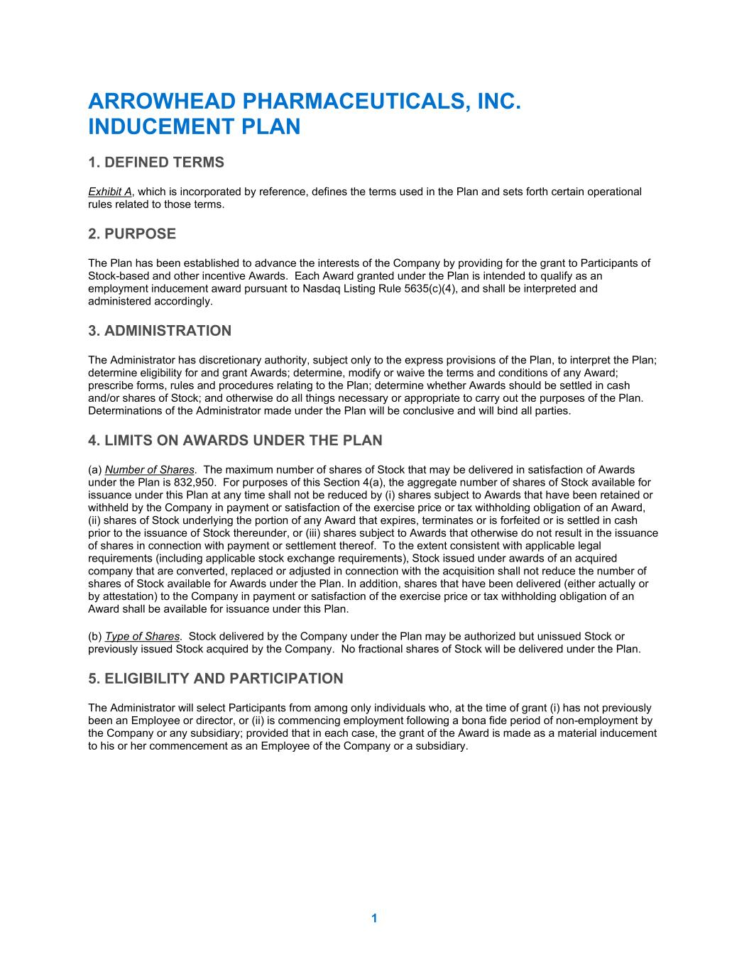
31
1 ARROWHEAD PHARMACEUTICALS, INC. INDUCEMENT PLAN 1. DEFINED TERMS Exhibit A, which is incorporated by reference, defines the terms used in the Plan and sets forth certain operational rules related to those terms. 2. PURPOSE The Plan has been established to advance the interests of the Company by providing for the grant to Participants of Stock-based and other incentive Awards. Each Award granted under the Plan is intended to qualify as an employment inducement award pursuant to Nasdaq Listing Rule 5635(c)(4), and shall be interpreted and administered accordingly. 3. ADMINISTRATION The Administrator has discretionary authority, subject only to the express provisions of the Plan, to interpret the Plan; determine eligibility for and grant Awards; determine, modify or waive the terms and conditions of any Award; prescribe forms, rules and procedures relating to the Plan; determine whether Awards should be settled in cash and/or shares of Stock; and otherwise do all things necessary or appropriate to carry out the purposes of the Plan. Determinations of the Administrator made under the Plan will be conclusive and will bind all parties. 4. LIMITS ON AWARDS UNDER THE PLAN (a) Number of Shares. The maximum number of shares of Stock that may be delivered in satisfaction of Awards under the Plan is 832,950. For purposes of this Section 4(a), the aggregate number of shares of Stock available for issuance under this Plan at any time shall not be reduced by (i) shares subject to Awards that have been retained or withheld by the Company in payment or satisfaction of the exercise price or tax withholding obligation of an Award, (ii) shares of Stock underlying the portion of any Award that expires, terminates or is forfeited or is settled in cash prior to the issuance of Stock thereunder, or (iii) shares subject to Awards that otherwise do not result in the issuance of shares in connection with payment or settlement thereof. To the extent consistent with applicable legal requirements (including applicable stock exchange requirements), Stock issued under awards of an acquired company that are converted, replaced or adjusted in connection with the acquisition shall not reduce the number of shares of Stock available for Awards under the Plan. In addition, shares that have been delivered (either actually or by attestation) to the Company in payment or satisfaction of the exercise price or tax withholding obligation of an Award shall be available for issuance under this Plan. (b) Type of Shares. Stock delivered by the Company under the Plan may be authorized but unissued Stock or previously issued Stock acquired by the Company. No fractional shares of Stock will be delivered under the Plan. 5. ELIGIBILITY AND PARTICIPATION The Administrator will select Participants from among only individuals who, at the time of grant (i) has not previously been an Employee or director, or (ii) is commencing employment following a bona fide period of non-employment by the Company or any subsidiary; provided that in each case, the grant of the Award is made as a material inducement to his or her commencement as an Employee of the Company or a subsidiary.

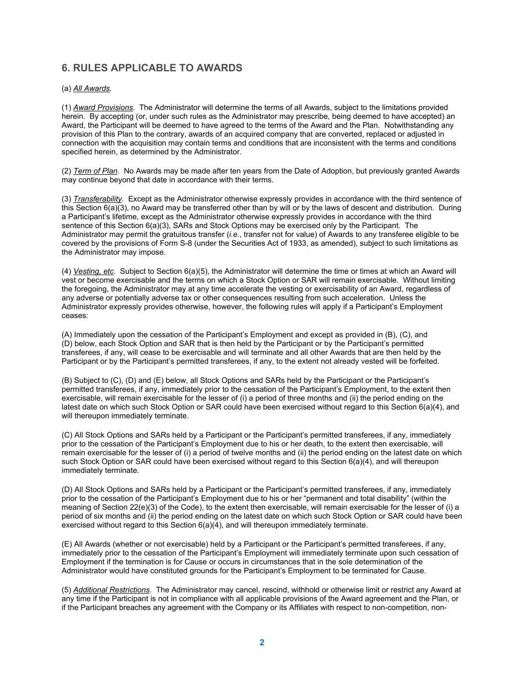
2 6. RULES APPLICABLE TO AWARDS (a) All Awards. (1) Award Provisions. The Administrator will determine the terms of all Awards, subject to the limitations provided herein. By accepting (or, under such rules as the Administrator may prescribe, being deemed to have accepted) an Award, the Participant will be deemed to have agreed to the terms of the Award and the Plan. Notwithstanding any provision of this Plan to the contrary, awards of an acquired company that are converted, replaced or adjusted in connection with the acquisition may contain terms and conditions that are inconsistent with the terms and conditions specified herein, as determined by the Administrator. (2) Term of Plan. No Awards may be made after ten years from the Date of Adoption, but previously granted Awards may continue beyond that date in accordance with their terms. (3) Transferability. Except as the Administrator otherwise expressly provides in accordance with the third sentence of this Section 6(a)(3), no Award may be transferred other than by will or by the laws of descent and distribution. During a Participant’s lifetime, except as the Administrator otherwise expressly provides in accordance with the third sentence of this Section 6(a)(3), SARs and Stock Options may be exercised only by the Participant. The Administrator may permit the gratuitous transfer (i.e., transfer not for value) of Awards to any transferee eligible to be covered by the provisions of Form S-8 (under the Securities Act of 1933, as amended), subject to such limitations as the Administrator may impose. (4) Vesting, etc. Subject to Section 6(a)(5), the Administrator will determine the time or times at which an Award will vest or become exercisable and the terms on which a Stock Option or SAR will remain exercisable. Without limiting the foregoing, the Administrator may at any time accelerate the vesting or exercisability of an Award, regardless of any adverse or potentially adverse tax or other consequences resulting from such acceleration. Unless the Administrator expressly provides otherwise, however, the following rules will apply if a Participant’s Employment ceases: (A) Immediately upon the cessation of the Participant’s Employment and except as provided in (B), (C), and (D) below, each Stock Option and SAR that is then held by the Participant or by the Participant’s permitted transferees, if any, will cease to be exercisable and will terminate and all other Awards that are then held by the Participant or by the Participant’s permitted transferees, if any, to the extent not already vested will be forfeited. (B) Subject to (C), (D) and (E) below, all Stock Options and SARs held by the Participant or the Participant’s permitted transferees, if any, immediately prior to the cessation of the Participant’s Employment, to the extent then exercisable, will remain exercisable for the lesser of (i) a period of three months and (ii) the period ending on the latest date on which such Stock Option or SAR could have been exercised without regard to this Section 6(a)(4), and will thereupon immediately terminate. (C) All Stock Options and SARs held by a Participant or the Participant’s permitted transferees, if any, immediately prior to the cessation of the Participant’s Employment due to his or her death, to the extent then exercisable, will remain exercisable for the lesser of (i) a period of twelve months and (ii) the period ending on the latest date on which such Stock Option or SAR could have been exercised without regard to this Section 6(a)(4), and will thereupon immediately terminate. (D) All Stock Options and SARs held by a Participant or the Participant’s permitted transferees, if any, immediately prior to the cessation of the Participant’s Employment due to his or her “permanent and total disability” (within the meaning of Section 22(e)(3) of the Code), to the extent then exercisable, will remain exercisable for the lesser of (i) a period of six months and (ii) the period ending on the latest date on which such Stock Option or SAR could have been exercised without regard to this Section 6(a)(4), and will thereupon immediately terminate. (E) All Awards (whether or not exercisable) held by a Participant or the Participant’s permitted transferees, if any, immediately prior to the cessation of the Participant’s Employment will immediately terminate upon such cessation of Employment if the termination is for Cause or occurs in circumstances that in the sole determination of the Administrator would have constituted grounds for the Participant’s Employment to be terminated for Cause. (5) Additional Restrictions. The Administrator may cancel, rescind, withhold or otherwise limit or restrict any Award at any time if the Participant is not in compliance with all applicable provisions of the Award agreement and the Plan, or if the Participant breaches any agreement with the Company or its Affiliates with respect to non-competition, non-

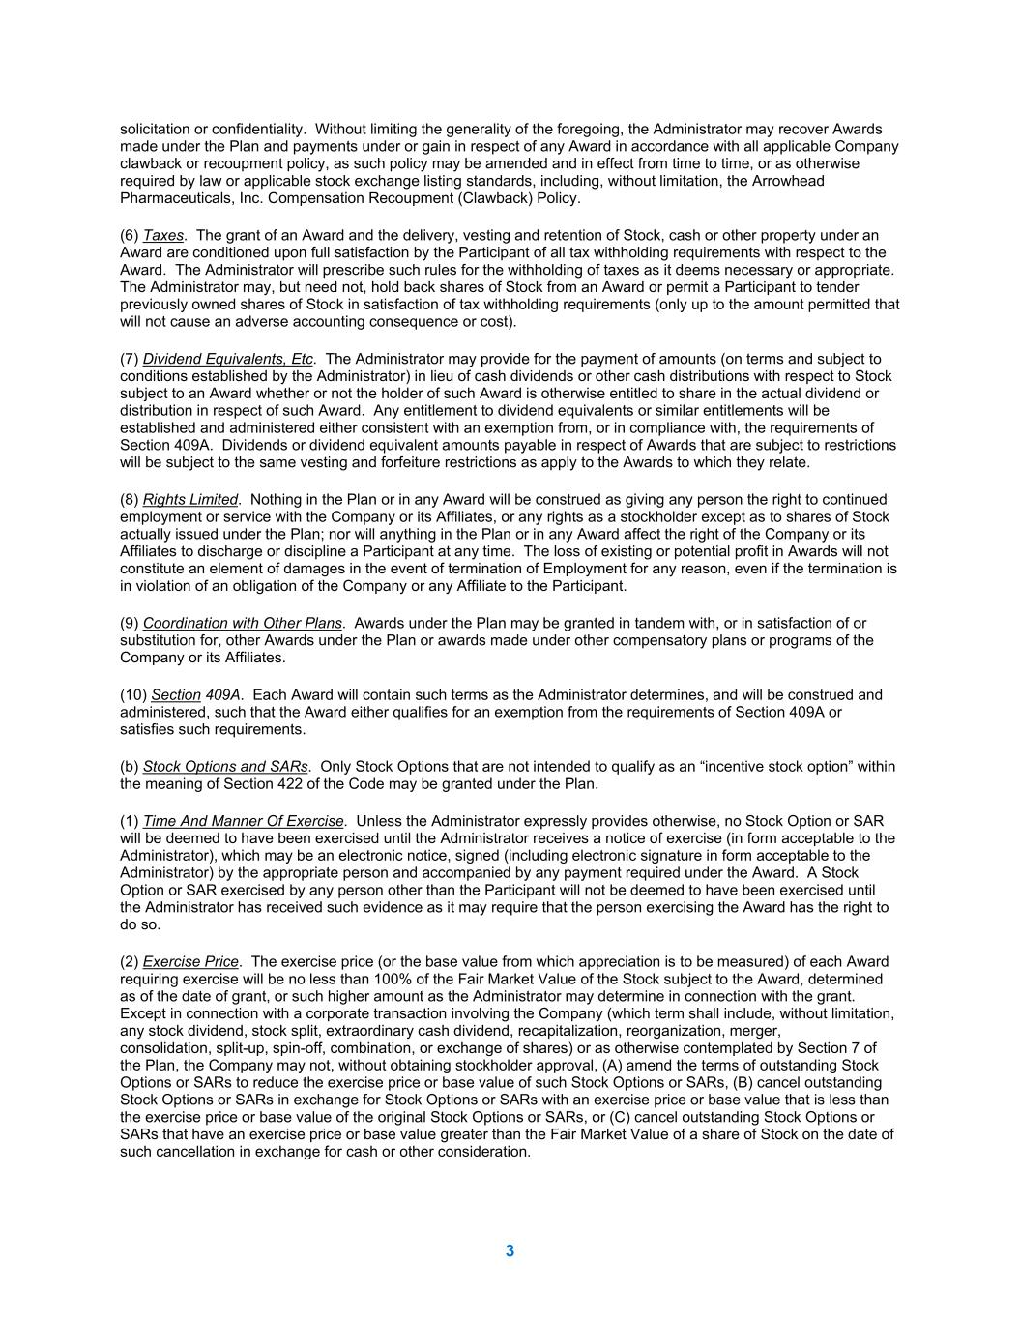
3 solicitation or confidentiality. Without limiting the generality of the foregoing, the Administrator may recover Awards made under the Plan and payments under or gain in respect of any Award in accordance with all applicable Company clawback or recoupment policy, as such policy may be amended and in effect from time to time, or as otherwise required by law or applicable stock exchange listing standards, including, without limitation, the Arrowhead Pharmaceuticals, Inc. Compensation Recoupment (Clawback) Policy. (6) Taxes. The grant of an Award and the delivery, vesting and retention of Stock, cash or other property under an Award are conditioned upon full satisfaction by the Participant of all tax withholding requirements with respect to the Award. The Administrator will prescribe such rules for the withholding of taxes as it deems necessary or appropriate. The Administrator may, but need not, hold back shares of Stock from an Award or permit a Participant to tender previously owned shares of Stock in satisfaction of tax withholding requirements (only up to the amount permitted that will not cause an adverse accounting consequence or cost). (7) Dividend Equivalents, Etc. The Administrator may provide for the payment of amounts (on terms and subject to conditions established by the Administrator) in lieu of cash dividends or other cash distributions with respect to Stock subject to an Award whether or not the holder of such Award is otherwise entitled to share in the actual dividend or distribution in respect of such Award. Any entitlement to dividend equivalents or similar entitlements will be established and administered either consistent with an exemption from, or in compliance with, the requirements of Section 409A. Dividends or dividend equivalent amounts payable in respect of Awards that are subject to restrictions will be subject to the same vesting and forfeiture restrictions as apply to the Awards to which they relate. (8) Rights Limited. Nothing in the Plan or in any Award will be construed as giving any person the right to continued employment or service with the Company or its Affiliates, or any rights as a stockholder except as to shares of Stock actually issued under the Plan; nor will anything in the Plan or in any Award affect the right of the Company or its Affiliates to discharge or discipline a Participant at any time. The loss of existing or potential profit in Awards will not constitute an element of damages in the event of termination of Employment for any reason, even if the termination is in violation of an obligation of the Company or any Affiliate to the Participant. (9) Coordination with Other Plans. Awards under the Plan may be granted in tandem with, or in satisfaction of or substitution for, other Awards under the Plan or awards made under other compensatory plans or programs of the Company or its Affiliates. (10) Section 409A. Each Award will contain such terms as the Administrator determines, and will be construed and administered, such that the Award either qualifies for an exemption from the requirements of Section 409A or satisfies such requirements. (b) Stock Options and SARs. Only Stock Options that are not intended to qualify as an “incentive stock option” within the meaning of Section 422 of the Code may be granted under the Plan. (1) Time And Manner Of Exercise. Unless the Administrator expressly provides otherwise, no Stock Option or SAR will be deemed to have been exercised until the Administrator receives a notice of exercise (in form acceptable to the Administrator), which may be an electronic notice, signed (including electronic signature in form acceptable to the Administrator) by the appropriate person and accompanied by any payment required under the Award. A Stock Option or SAR exercised by any person other than the Participant will not be deemed to have been exercised until the Administrator has received such evidence as it may require that the person exercising the Award has the right to do so. (2) Exercise Price. The exercise price (or the base value from which appreciation is to be measured) of each Award requiring exercise will be no less than 100% of the Fair Market Value of the Stock subject to the Award, determined as of the date of grant, or such higher amount as the Administrator may determine in connection with the grant. Except in connection with a corporate transaction involving the Company (which term shall include, without limitation, any stock dividend, stock split, extraordinary cash dividend, recapitalization, reorganization, merger, consolidation, split-up, spin-off, combination, or exchange of shares) or as otherwise contemplated by Section 7 of the Plan, the Company may not, without obtaining stockholder approval, (A) amend the terms of outstanding Stock Options or SARs to reduce the exercise price or base value of such Stock Options or SARs, (B) cancel outstanding Stock Options or SARs in exchange for Stock Options or SARs with an exercise price or base value that is less than the exercise price or base value of the original Stock Options or SARs, or (C) cancel outstanding Stock Options or SARs that have an exercise price or base value greater than the Fair Market Value of a share of Stock on the date of such cancellation in exchange for cash or other consideration.

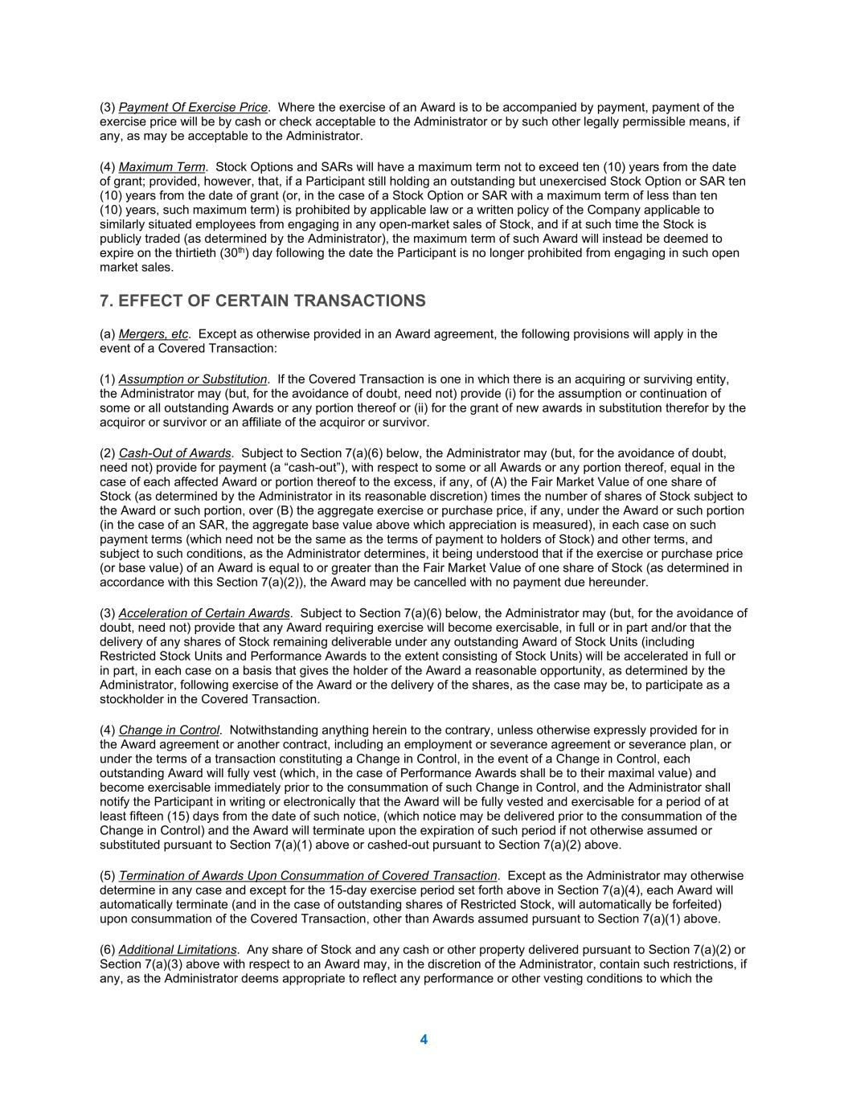
4 (3) Payment Of Exercise Price. Where the exercise of an Award is to be accompanied by payment, payment of the exercise price will be by cash or check acceptable to the Administrator or by such other legally permissible means, if any, as may be acceptable to the Administrator. (4) Maximum Term. Stock Options and SARs will have a maximum term not to exceed ten (10) years from the date of grant; provided, however, that, if a Participant still holding an outstanding but unexercised Stock Option or SAR ten (10) years from the date of grant (or, in the case of a Stock Option or SAR with a maximum term of less than ten (10) years, such maximum term) is prohibited by applicable law or a written policy of the Company applicable to similarly situated employees from engaging in any open-market sales of Stock, and if at such time the Stock is publicly traded (as determined by the Administrator), the maximum term of such Award will instead be deemed to expire on the thirtieth (30th) day following the date the Participant is no longer prohibited from engaging in such open market sales. 7. EFFECT OF CERTAIN TRANSACTIONS (a) Mergers, etc. Except as otherwise provided in an Award agreement, the following provisions will apply in the event of a Covered Transaction: (1) Assumption or Substitution. If the Covered Transaction is one in which there is an acquiring or surviving entity, the Administrator may (but, for the avoidance of doubt, need not) provide (i) for the assumption or continuation of some or all outstanding Awards or any portion thereof or (ii) for the grant of new awards in substitution therefor by the acquiror or survivor or an affiliate of the acquiror or survivor. (2) Cash-Out of Awards. Subject to Section 7(a)(6) below, the Administrator may (but, for the avoidance of doubt, need not) provide for payment (a “cash-out”), with respect to some or all Awards or any portion thereof, equal in the case of each affected Award or portion thereof to the excess, if any, of (A) the Fair Market Value of one share of Stock (as determined by the Administrator in its reasonable discretion) times the number of shares of Stock subject to the Award or such portion, over (B) the aggregate exercise or purchase price, if any, under the Award or such portion (in the case of an SAR, the aggregate base value above which appreciation is measured), in each case on such payment terms (which need not be the same as the terms of payment to holders of Stock) and other terms, and subject to such conditions, as the Administrator determines, it being understood that if the exercise or purchase price (or base value) of an Award is equal to or greater than the Fair Market Value of one share of Stock (as determined in accordance with this Section 7(a)(2)), the Award may be cancelled with no payment due hereunder. (3) Acceleration of Certain Awards. Subject to Section 7(a)(6) below, the Administrator may (but, for the avoidance of doubt, need not) provide that any Award requiring exercise will become exercisable, in full or in part and/or that the delivery of any shares of Stock remaining deliverable under any outstanding Award of Stock Units (including Restricted Stock Units and Performance Awards to the extent consisting of Stock Units) will be accelerated in full or in part, in each case on a basis that gives the holder of the Award a reasonable opportunity, as determined by the Administrator, following exercise of the Award or the delivery of the shares, as the case may be, to participate as a stockholder in the Covered Transaction. (4) Change in Control. Notwithstanding anything herein to the contrary, unless otherwise expressly provided for in the Award agreement or another contract, including an employment or severance agreement or severance plan, or under the terms of a transaction constituting a Change in Control, in the event of a Change in Control, each outstanding Award will fully vest (which, in the case of Performance Awards shall be to their maximal value) and become exercisable immediately prior to the consummation of such Change in Control, and the Administrator shall notify the Participant in writing or electronically that the Award will be fully vested and exercisable for a period of at least fifteen (15) days from the date of such notice, (which notice may be delivered prior to the consummation of the Change in Control) and the Award will terminate upon the expiration of such period if not otherwise assumed or substituted pursuant to Section 7(a)(1) above or cashed-out pursuant to Section 7(a)(2) above. (5) Termination of Awards Upon Consummation of Covered Transaction. Except as the Administrator may otherwise determine in any case and except for the 15-day exercise period set forth above in Section 7(a)(4), each Award will automatically terminate (and in the case of outstanding shares of Restricted Stock, will automatically be forfeited) upon consummation of the Covered Transaction, other than Awards assumed pursuant to Section 7(a)(1) above. (6) Additional Limitations. Any share of Stock and any cash or other property delivered pursuant to Section 7(a)(2) or Section 7(a)(3) above with respect to an Award may, in the discretion of the Administrator, contain such restrictions, if any, as the Administrator deems appropriate to reflect any performance or other vesting conditions to which the

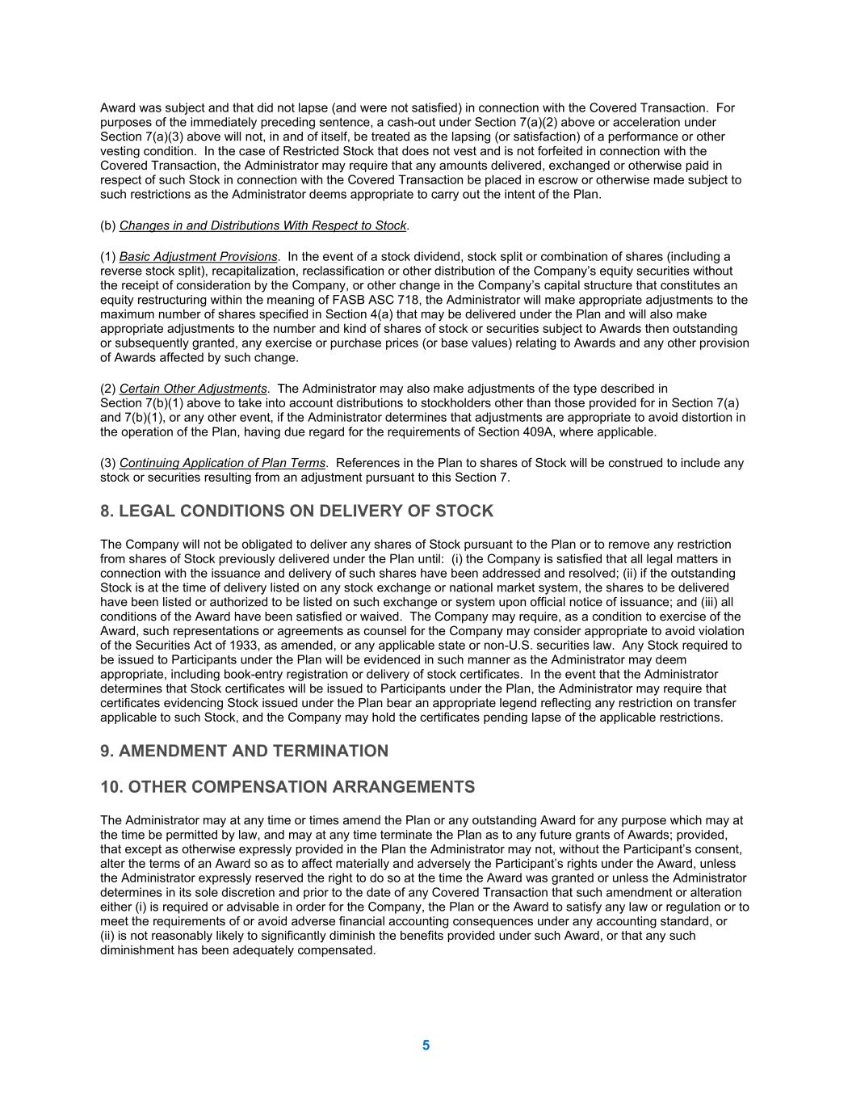
5 Award was subject and that did not lapse (and were not satisfied) in connection with the Covered Transaction. For purposes of the immediately preceding sentence, a cash-out under Section 7(a)(2) above or acceleration under Section 7(a)(3) above will not, in and of itself, be treated as the lapsing (or satisfaction) of a performance or other vesting condition. In the case of Restricted Stock that does not vest and is not forfeited in connection with the Covered Transaction, the Administrator may require that any amounts delivered, exchanged or otherwise paid in respect of such Stock in connection with the Covered Transaction be placed in escrow or otherwise made subject to such restrictions as the Administrator deems appropriate to carry out the intent of the Plan. (b) Changes in and Distributions With Respect to Stock. (1) Basic Adjustment Provisions. In the event of a stock dividend, stock split or combination of shares (including a reverse stock split), recapitalization, reclassification or other distribution of the Company’s equity securities without the receipt of consideration by the Company, or other change in the Company’s capital structure that constitutes an equity restructuring within the meaning of FASB ASC 718, the Administrator will make appropriate adjustments to the maximum number of shares specified in Section 4(a) that may be delivered under the Plan and will also make appropriate adjustments to the number and kind of shares of stock or securities subject to Awards then outstanding or subsequently granted, any exercise or purchase prices (or base values) relating to Awards and any other provision of Awards affected by such change. (2) Certain Other Adjustments. The Administrator may also make adjustments of the type described in Section 7(b)(1) above to take into account distributions to stockholders other than those provided for in Section 7(a) and 7(b)(1), or any other event, if the Administrator determines that adjustments are appropriate to avoid distortion in the operation of the Plan, having due regard for the requirements of Section 409A, where applicable. (3) Continuing Application of Plan Terms. References in the Plan to shares of Stock will be construed to include any stock or securities resulting from an adjustment pursuant to this Section 7. 8. LEGAL CONDITIONS ON DELIVERY OF STOCK The Company will not be obligated to deliver any shares of Stock pursuant to the Plan or to remove any restriction from shares of Stock previously delivered under the Plan until: (i) the Company is satisfied that all legal matters in connection with the issuance and delivery of such shares have been addressed and resolved; (ii) if the outstanding Stock is at the time of delivery listed on any stock exchange or national market system, the shares to be delivered have been listed or authorized to be listed on such exchange or system upon official notice of issuance; and (iii) all conditions of the Award have been satisfied or waived. The Company may require, as a condition to exercise of the Award, such representations or agreements as counsel for the Company may consider appropriate to avoid violation of the Securities Act of 1933, as amended, or any applicable state or non-U.S. securities law. Any Stock required to be issued to Participants under the Plan will be evidenced in such manner as the Administrator may deem appropriate, including book-entry registration or delivery of stock certificates. In the event that the Administrator determines that Stock certificates will be issued to Participants under the Plan, the Administrator may require that certificates evidencing Stock issued under the Plan bear an appropriate legend reflecting any restriction on transfer applicable to such Stock, and the Company may hold the certificates pending lapse of the applicable restrictions. 9. AMENDMENT AND TERMINATION 10. OTHER COMPENSATION ARRANGEMENTS The Administrator may at any time or times amend the Plan or any outstanding Award for any purpose which may at the time be permitted by law, and may at any time terminate the Plan as to any future grants of Awards; provided, that except as otherwise expressly provided in the Plan the Administrator may not, without the Participant’s consent, alter the terms of an Award so as to affect materially and adversely the Participant’s rights under the Award, unless the Administrator expressly reserved the right to do so at the time the Award was granted or unless the Administrator determines in its sole discretion and prior to the date of any Covered Transaction that such amendment or alteration either (i) is required or advisable in order for the Company, the Plan or the Award to satisfy any law or regulation or to meet the requirements of or avoid adverse financial accounting consequences under any accounting standard, or (ii) is not reasonably likely to significantly diminish the benefits provided under such Award, or that any such diminishment has been adequately compensated.

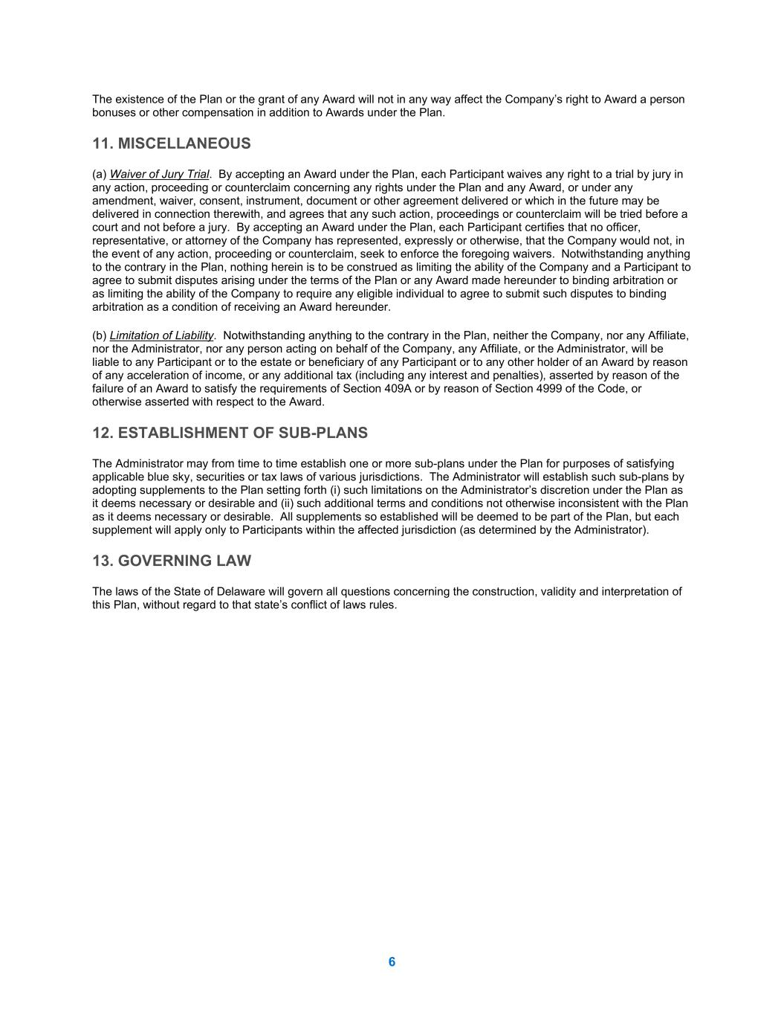
6 The existence of the Plan or the grant of any Award will not in any way affect the Company’s right to Award a person bonuses or other compensation in addition to Awards under the Plan. 11. MISCELLANEOUS (a) Waiver of Jury Trial. By accepting an Award under the Plan, each Participant waives any right to a trial by jury in any action, proceeding or counterclaim concerning any rights under the Plan and any Award, or under any amendment, waiver, consent, instrument, document or other agreement delivered or which in the future may be delivered in connection therewith, and agrees that any such action, proceedings or counterclaim will be tried before a court and not before a jury. By accepting an Award under the Plan, each Participant certifies that no officer, representative, or attorney of the Company has represented, expressly or otherwise, that the Company would not, in the event of any action, proceeding or counterclaim, seek to enforce the foregoing waivers. Notwithstanding anything to the contrary in the Plan, nothing herein is to be construed as limiting the ability of the Company and a Participant to agree to submit disputes arising under the terms of the Plan or any Award made hereunder to binding arbitration or as limiting the ability of the Company to require any eligible individual to agree to submit such disputes to binding arbitration as a condition of receiving an Award hereunder. (b) Limitation of Liability. Notwithstanding anything to the contrary in the Plan, neither the Company, nor any Affiliate, nor the Administrator, nor any person acting on behalf of the Company, any Affiliate, or the Administrator, will be liable to any Participant or to the estate or beneficiary of any Participant or to any other holder of an Award by reason of any acceleration of income, or any additional tax (including any interest and penalties), asserted by reason of the failure of an Award to satisfy the requirements of Section 409A or by reason of Section 4999 of the Code, or otherwise asserted with respect to the Award. 12. ESTABLISHMENT OF SUB-PLANS The Administrator may from time to time establish one or more sub-plans under the Plan for purposes of satisfying applicable blue sky, securities or tax laws of various jurisdictions. The Administrator will establish such sub-plans by adopting supplements to the Plan setting forth (i) such limitations on the Administrator’s discretion under the Plan as it deems necessary or desirable and (ii) such additional terms and conditions not otherwise inconsistent with the Plan as it deems necessary or desirable. All supplements so established will be deemed to be part of the Plan, but each supplement will apply only to Participants within the affected jurisdiction (as determined by the Administrator). 13. GOVERNING LAW The laws of the State of Delaware will govern all questions concerning the construction, validity and interpretation of this Plan, without regard to that state’s conflict of laws rules.

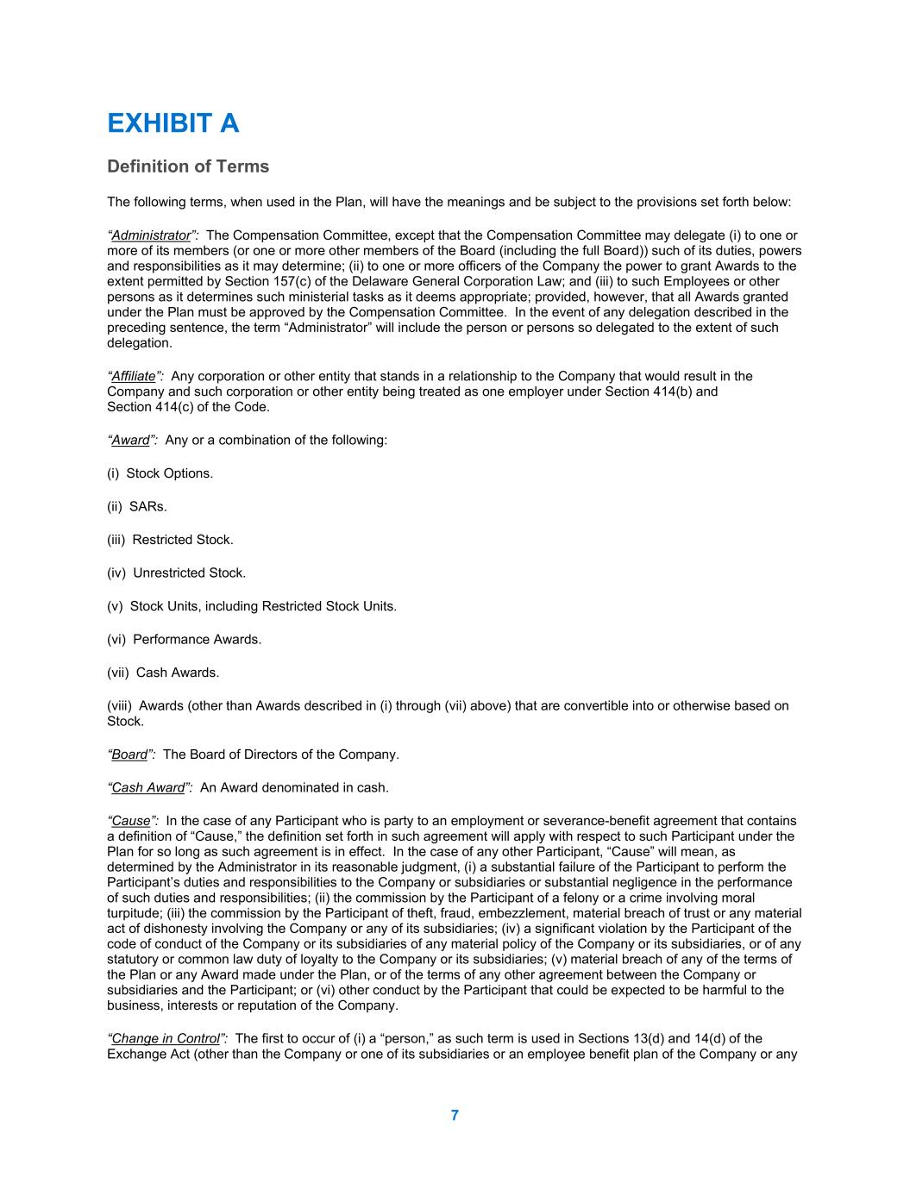
7 EXHIBIT A Definition of Terms The following terms, when used in the Plan, will have the meanings and be subject to the provisions set forth below: “Administrator”: The Compensation Committee, except that the Compensation Committee may delegate (i) to one or more of its members (or one or more other members of the Board (including the full Board)) such of its duties, powers and responsibilities as it may determine; (ii) to one or more officers of the Company the power to grant Awards to the extent permitted by Section 157(c) of the Delaware General Corporation Law; and (iii) to such Employees or other persons as it determines such ministerial tasks as it deems appropriate; provided, however, that all Awards granted under the Plan must be approved by the Compensation Committee. In the event of any delegation described in the preceding sentence, the term “Administrator” will include the person or persons so delegated to the extent of such delegation. “Affiliate”: Any corporation or other entity that stands in a relationship to the Company that would result in the Company and such corporation or other entity being treated as one employer under Section 414(b) and Section 414(c) of the Code. “Award”: Any or a combination of the following: (i) Stock Options. (ii) SARs. (iii) Restricted Stock. (iv) Unrestricted Stock. (v) Stock Units, including Restricted Stock Units. (vi) Performance Awards. (vii) Cash Awards. (viii) Awards (other than Awards described in (i) through (vii) above) that are convertible into or otherwise based on Stock. “Board”: The Board of Directors of the Company. “Cash Award”: An Award denominated in cash. “Cause”: In the case of any Participant who is party to an employment or severance-benefit agreement that contains a definition of “Cause,” the definition set forth in such agreement will apply with respect to such Participant under the Plan for so long as such agreement is in effect. In the case of any other Participant, “Cause” will mean, as determined by the Administrator in its reasonable judgment, (i) a substantial failure of the Participant to perform the Participant’s duties and responsibilities to the Company or subsidiaries or substantial negligence in the performance of such duties and responsibilities; (ii) the commission by the Participant of a felony or a crime involving moral turpitude; (iii) the commission by the Participant of theft, fraud, embezzlement, material breach of trust or any material act of dishonesty involving the Company or any of its subsidiaries; (iv) a significant violation by the Participant of the code of conduct of the Company or its subsidiaries of any material policy of the Company or its subsidiaries, or of any statutory or common law duty of loyalty to the Company or its subsidiaries; (v) material breach of any of the terms of the Plan or any Award made under the Plan, or of the terms of any other agreement between the Company or subsidiaries and the Participant; or (vi) other conduct by the Participant that could be expected to be harmful to the business, interests or reputation of the Company. “Change in Control”: The first to occur of (i) a “person,” as such term is used in Sections 13(d) and 14(d) of the Exchange Act (other than the Company or one of its subsidiaries or an employee benefit plan of the Company or any

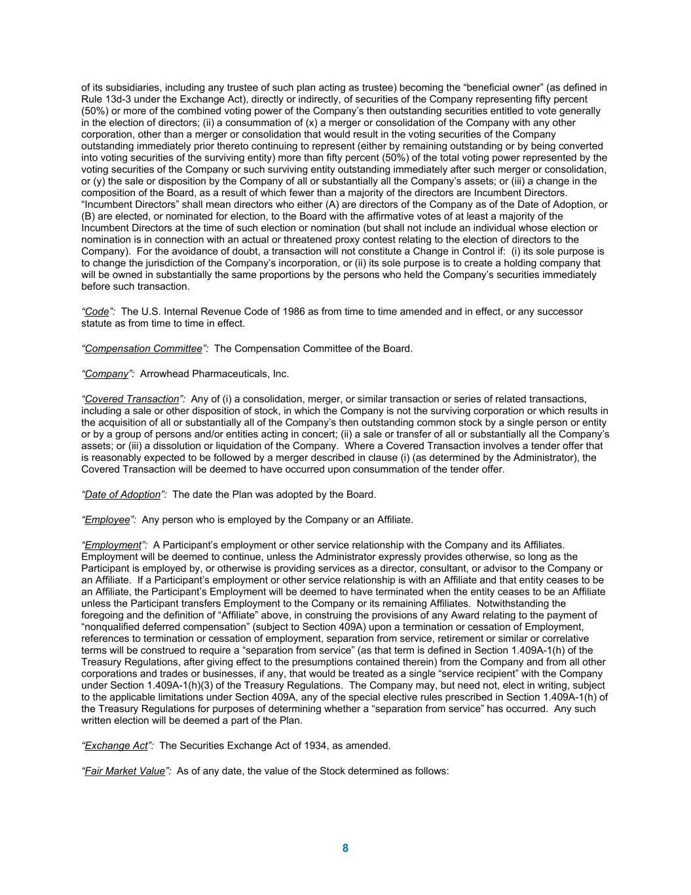
8 of its subsidiaries, including any trustee of such plan acting as trustee) becoming the “beneficial owner” (as defined in Rule 13d-3 under the Exchange Act), directly or indirectly, of securities of the Company representing fifty percent (50%) or more of the combined voting power of the Company’s then outstanding securities entitled to vote generally in the election of directors; (ii) a consummation of (x) a merger or consolidation of the Company with any other corporation, other than a merger or consolidation that would result in the voting securities of the Company outstanding immediately prior thereto continuing to represent (either by remaining outstanding or by being converted into voting securities of the surviving entity) more than fifty percent (50%) of the total voting power represented by the voting securities of the Company or such surviving entity outstanding immediately after such merger or consolidation, or (y) the sale or disposition by the Company of all or substantially all the Company’s assets; or (iii) a change in the composition of the Board, as a result of which fewer than a majority of the directors are Incumbent Directors. “Incumbent Directors” shall mean directors who either (A) are directors of the Company as of the Date of Adoption, or (B) are elected, or nominated for election, to the Board with the affirmative votes of at least a majority of the Incumbent Directors at the time of such election or nomination (but shall not include an individual whose election or nomination is in connection with an actual or threatened proxy contest relating to the election of directors to the Company). For the avoidance of doubt, a transaction will not constitute a Change in Control if: (i) its sole purpose is to change the jurisdiction of the Company’s incorporation, or (ii) its sole purpose is to create a holding company that will be owned in substantially the same proportions by the persons who held the Company’s securities immediately before such transaction. “Code”: The U.S. Internal Revenue Code of 1986 as from time to time amended and in effect, or any successor statute as from time to time in effect. “Compensation Committee”: The Compensation Committee of the Board. “Company”: Arrowhead Pharmaceuticals, Inc. “Covered Transaction”: Any of (i) a consolidation, merger, or similar transaction or series of related transactions, including a sale or other disposition of stock, in which the Company is not the surviving corporation or which results in the acquisition of all or substantially all of the Company’s then outstanding common stock by a single person or entity or by a group of persons and/or entities acting in concert; (ii) a sale or transfer of all or substantially all the Company’s assets; or (iii) a dissolution or liquidation of the Company. Where a Covered Transaction involves a tender offer that is reasonably expected to be followed by a merger described in clause (i) (as determined by the Administrator), the Covered Transaction will be deemed to have occurred upon consummation of the tender offer. “Date of Adoption”: The date the Plan was adopted by the Board. “Employee”: Any person who is employed by the Company or an Affiliate. “Employment”: A Participant’s employment or other service relationship with the Company and its Affiliates. Employment will be deemed to continue, unless the Administrator expressly provides otherwise, so long as the Participant is employed by, or otherwise is providing services as a director, consultant, or advisor to the Company or an Affiliate. If a Participant’s employment or other service relationship is with an Affiliate and that entity ceases to be an Affiliate, the Participant’s Employment will be deemed to have terminated when the entity ceases to be an Affiliate unless the Participant transfers Employment to the Company or its remaining Affiliates. Notwithstanding the foregoing and the definition of “Affiliate” above, in construing the provisions of any Award relating to the payment of “nonqualified deferred compensation” (subject to Section 409A) upon a termination or cessation of Employment, references to termination or cessation of employment, separation from service, retirement or similar or correlative terms will be construed to require a “separation from service” (as that term is defined in Section 1.409A-1(h) of the Treasury Regulations, after giving effect to the presumptions contained therein) from the Company and from all other corporations and trades or businesses, if any, that would be treated as a single “service recipient” with the Company under Section 1.409A-1(h)(3) of the Treasury Regulations. The Company may, but need not, elect in writing, subject to the applicable limitations under Section 409A, any of the special elective rules prescribed in Section 1.409A-1(h) of the Treasury Regulations for purposes of determining whether a “separation from service” has occurred. Any such written election will be deemed a part of the Plan. “Exchange Act”: The Securities Exchange Act of 1934, as amended. “Fair Market Value”: As of any date, the value of the Stock determined as follows:

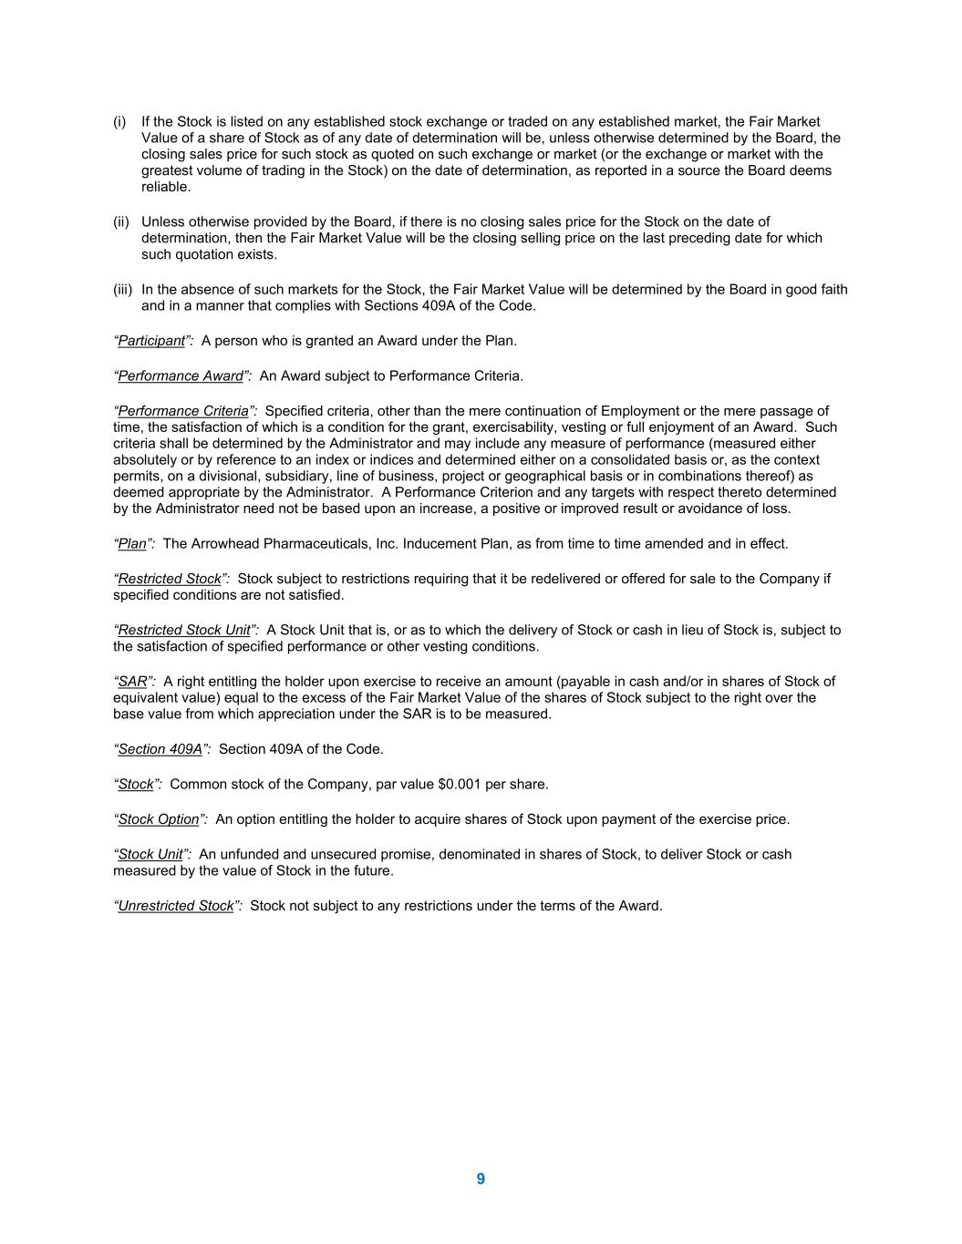
9 (i) If the Stock is listed on any established stock exchange or traded on any established market, the Fair Market Value of a share of Stock as of any date of determination will be, unless otherwise determined by the Board, the closing sales price for such stock as quoted on such exchange or market (or the exchange or market with the greatest volume of trading in the Stock) on the date of determination, as reported in a source the Board deems reliable. (ii) Unless otherwise provided by the Board, if there is no closing sales price for the Stock on the date of determination, then the Fair Market Value will be the closing selling price on the last preceding date for which such quotation exists. (iii) In the absence of such markets for the Stock, the Fair Market Value will be determined by the Board in good faith and in a manner that complies with Sections 409A of the Code. “Participant”: A person who is granted an Award under the Plan. “Performance Award”: An Award subject to Performance Criteria. “Performance Criteria”: Specified criteria, other than the mere continuation of Employment or the mere passage of time, the satisfaction of which is a condition for the grant, exercisability, vesting or full enjoyment of an Award. Such criteria shall be determined by the Administrator and may include any measure of performance (measured either absolutely or by reference to an index or indices and determined either on a consolidated basis or, as the context permits, on a divisional, subsidiary, line of business, project or geographical basis or in combinations thereof) as deemed appropriate by the Administrator. A Performance Criterion and any targets with respect thereto determined by the Administrator need not be based upon an increase, a positive or improved result or avoidance of loss. “Plan”: The Arrowhead Pharmaceuticals, Inc. Inducement Plan, as from time to time amended and in effect. “Restricted Stock”: Stock subject to restrictions requiring that it be redelivered or offered for sale to the Company if specified conditions are not satisfied. “Restricted Stock Unit”: A Stock Unit that is, or as to which the delivery of Stock or cash in lieu of Stock is, subject to the satisfaction of specified performance or other vesting conditions. “SAR”: A right entitling the holder upon exercise to receive an amount (payable in cash and/or in shares of Stock of equivalent value) equal to the excess of the Fair Market Value of the shares of Stock subject to the right over the base value from which appreciation under the SAR is to be measured. “Section 409A”: Section 409A of the Code. “Stock”: Common stock of the Company, par value $0.001 per share. “Stock Option”: An option entitling the holder to acquire shares of Stock upon payment of the exercise price. “Stock Unit”: An unfunded and unsecured promise, denominated in shares of Stock, to deliver Stock or cash measured by the value of Stock in the future. “Unrestricted Stock”: Stock not subject to any restrictions under the terms of the Award.



